**KARNAUGHOVA MAPA**

**Aplikácia Google play**



**Automatizácia**

**Meno Priezvisko: Patrik Tomčík**

**Trieda: II.D**

**Skupina: TL-IS**

**Dátum: 17.3.2020**

1. **Karnaughova mapa pre 2 premenné**

|  |  |  |  |
| --- | --- | --- | --- |
| A | Â | B | Y |
| 1 | 0 | 1 | 1 |
| 1 | 0 | 0 | 0 |
| 0 | 1 | 1 | 1 |
| 0 | 1 | 0 | 1 |

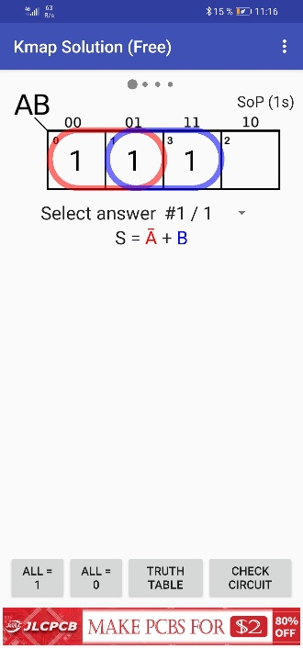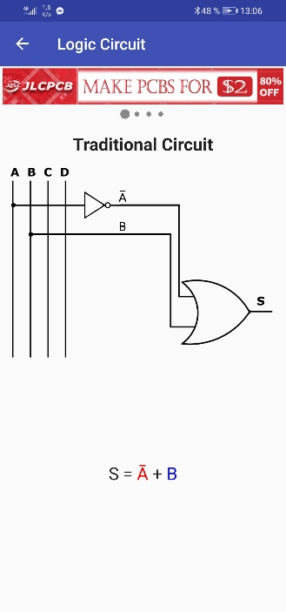

1. **Karnaughova mapa pre 2 premenné**

|  |  |  |
| --- | --- | --- |
| A | B | Y |
| 1 | 1 | 1 |
| 1 | 0 | 1 |
| 0 | 1 | 1 |
| 0 | 0 | 0 |

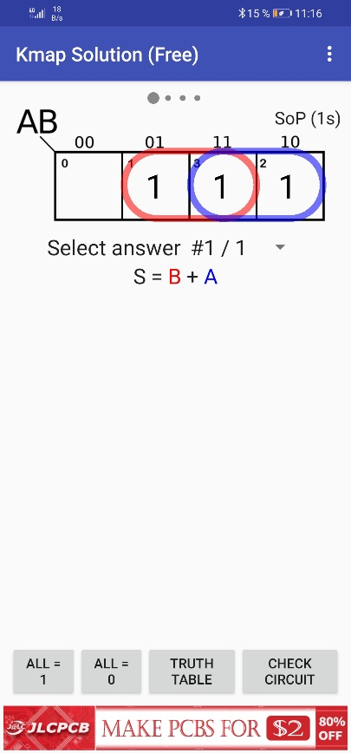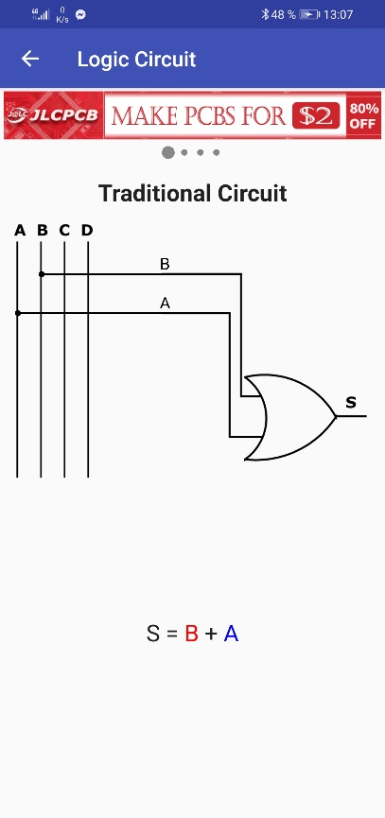

1. **Karnaughova mapa pre 3 premenné**

|  |  |  |  |  |
| --- | --- | --- | --- | --- |
| A | B | _  B | C | Y |
| 0 | 0 | 1 | 0 | 0 |
| 0 | 0 | 1 | 1 | 1 |
| 0 | 1 | 0 | 0 | 0 |
| 0 | 1 | 0 | 1 | 1 |
| 1 | 0 | 1 | 0 | 1 |
| 1 | 0 | 1 | 1 | 1 |
| 1 | 1 | 0 | 0 | 0 |
| 1 | 1 | 0 | 1 | 1 |

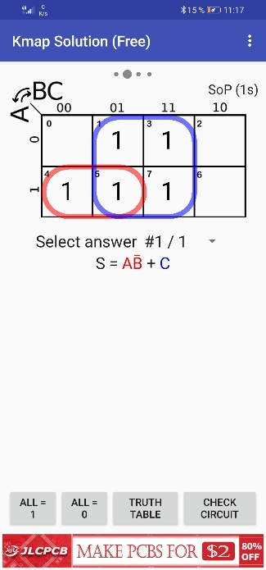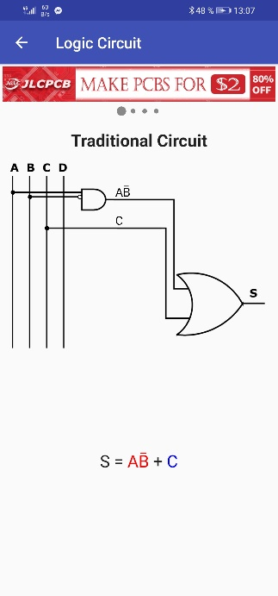

**4.Karnaughova mapa pre 3 premenné**

|  |  |  |  |  |
| --- | --- | --- | --- | --- |
| A | B | _  B | C | Y |
| 0 | 0 | 1 | 0 | 1 |
| 0 | 0 | 1 | 1 | 1 |
| 0 | 1 | 0 | 0 | 0 |
| 0 | 1 | 0 | 1 | 1 |
| 1 | 0 | 1 | 0 | 1 |
| 1 | 0 | 1 | 1 | 1 |
| 1 | 1 | 0 | 0 | 0 |
| 1 | 1 | 0 | 1 | 1 |

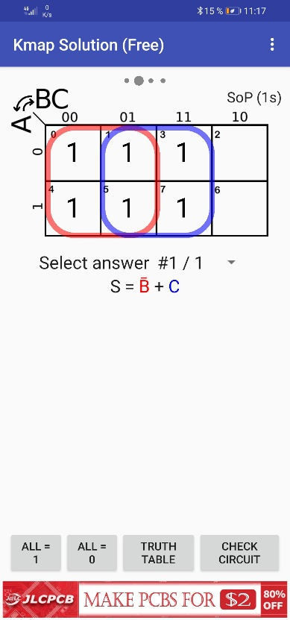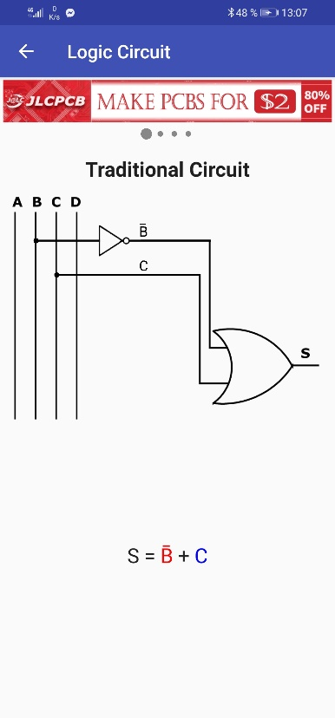

**5.Karnaughova mapa pre 4 premenné**

|  |  |  |  |  |  |  |
| --- | --- | --- | --- | --- | --- | --- |
| A | _  A | B | C | _  C | D | Y |
| 0 | 1 | 0 | 0 | 1 | 0 | 0 |
| 0 | 1 | 0 | 0 | 1 | 1 | 1 |
| 0 | 1 | 0 | 1 | 0 | 0 | 0 |
| 0 | 1 | 0 | 1 | 0 | 1 | 1 |
| 0 | 1 | 1 | 0 | 1 | 0 | 0 |
| 0 | 1 | 1 | 0 | 1 | 1 | 1 |
| 0 | 1 | 1 | 1 | 0 | 0 | 0 |
| 0 | 1 | 1 | 1 | 0 | 1 | 1 |
| 1 | 0 | 0 | 0 | 1 | 0 | 0 |
| 1 | 0 | 0 | 0 | 1 | 1 | 1 |
| 1 | 0 | 0 | 1 | 0 | 0 | 0 |
| 1 | 0 | 0 | 1 | 0 | 1 | 0 |
| 1 | 0 | 1 | 0 | 1 | 0 | 1 |
| 1 | 0 | 1 | 0 | 1 | 1 | 1 |
| 1 | 0 | 1 | 1 | 0 | 0 | 0 |
| 1 | 0 | 1 | 1 | 0 | 1 | 0 |

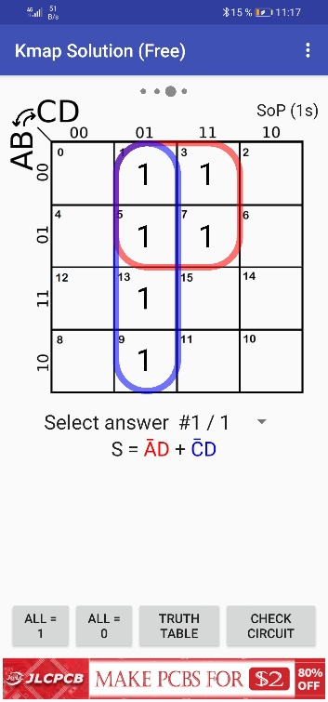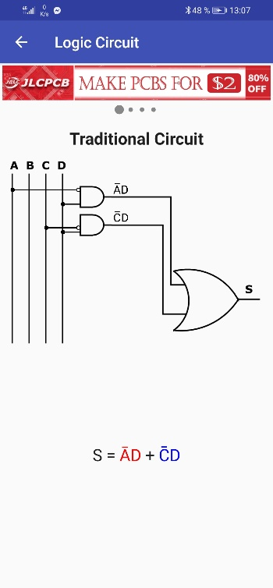

**6.Karnaughova mapa pre 4 premenné**

|  |  |  |  |  |  |  |
| --- | --- | --- | --- | --- | --- | --- |
| A | _  A | B | C | _  C | D | Y |
| 0 | 1 | 0 | 0 | 1 | 0 | 0 |
| 0 | 1 | 0 | 0 | 1 | 1 | 1 |
| 0 | 1 | 0 | 1 | 0 | 0 | 0 |
| 0 | 1 | 0 | 1 | 0 | 1 | 1 |
| 0 | 1 | 1 | 0 | 1 | 0 | 0 |
| 0 | 1 | 1 | 0 | 1 | 1 | 1 |
| 0 | 1 | 1 | 1 | 0 | 0 | 0 |
| 0 | 1 | 1 | 1 | 0 | 1 | 1 |
| 1 | 0 | 0 | 0 | 1 | 0 | 0 |
| 1 | 0 | 0 | 0 | 1 | 1 | 0 |
| 1 | 0 | 0 | 1 | 0 | 0 | 0 |
| 1 | 0 | 0 | 1 | 0 | 1 | 0 |
| 1 | 0 | 1 | 0 | 1 | 0 | 0 |
| 1 | 0 | 1 | 0 | 1 | 1 | 1 |
| 1 | 0 | 1 | 1 | 0 | 0 | 0 |
| 1 | 0 | 1 | 1 | 0 | 1 | 0 |

