***Reading books***

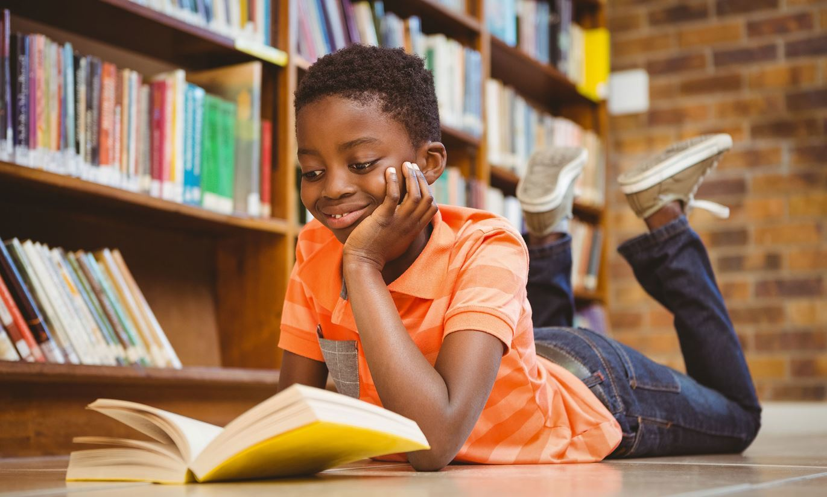

* I can see one young black boy whitch read some book .
* He look like very happy.
* Reasons for reading books
* Why he lay?
* Why people read?

***Reading***

**The Book – a Person’s Friend**  
   
Talk about – rozprávajte o:  
- **Different kinds of books**– rôzne druhy kníh  
- **My attitude to books**– môj vzťah ku knihám  
- **Famous English writers –**slávni anglickí spisovatelia  
- **My favourite book** –  moja obľúbená kniha  
  
**1. Different kinds of books**  
People like reading books – it is one of the most favourite leisure activities. We can buy books in a bookshop or we can borrow them from a library.   
We can read books anywhere - at home, on the bus or train, at the doctors’… The books are a good source of information and entertainment. Reading books can be fun when it is a hobby, but it can also be boring – for example for students who have to study and learn a lot of information when they have to take an exam or a test.  
Every year, the Nobel Prize for Literature is awarded to the writer whose work of fiction is considered unique and great. For example E. Hemingway, J. Steinbeck are the Nobel Prize winners.

**Literature** can be divided into 2 categories:  
**a)  NON-FICTION BOOKS**– náučná literatúra  
**b) FICTION BOOKS**- beletria  
   
**NON-FICTION *BOOKS***/náučné knihy/ – they are usually for information. They can be divided into:  
  
- **textbooks** /učebnice/ - they are educational books which contain information about some subject – for example mathematics, geography, a foreign language …  
- **dictionaries**/slovníky/ - they tell us about the meanings of words  
- **encyclopaedias**/encyklopédie/ - they are large books and they contain a lot of facts and dates about different subjects – e.g. the world encyclopaedias, the animal encyclopaedias and so on.  
- **biographies**/biografie, životopisné knihy/ – they contain information about a life of a famous person – e.g. of a president, scientist … Sometimes there are also biographies about ordinary people.  
- **autobiographies**and **memoirs**/autobiografie a spomienky/   
- **travel books**– cestovné / cestopisné knihy   
- **art books**/knihy o umení/  
- **cookery books**/kuchárske knihy/ - they contain recipes and teach people how to cook different meals or bake cakes  
  
**FICTION BOOKS** /beletria/ - there are 2 types of fiction books:  
-  **POETRY**/poézia/ - poems  
-  **PROSE /**próza/ - it contains:  
- **tales**– príbehy  => **fairy tale** = rozprávka  
- **short stories**– poviedky  
- **westerns**– westerny  
- **science-fiction**– sci-fi  
- **crime/spy novels**– kriminálne/špionážne novely  
- **romantic novels**– romantické novely  
- **historical novel**– historické romány  
- **thrillers**- trilery  
   
**2. My attitude to books**  
a) I like reading books but i haven t got much time for this action  
**3. Famous English writers**  
There are many famous English writers. For example:  
  
- **William Shakespeare**  
- **Charles Dickens**  
- **Brőnte sisters /Emily Brőnte, Charlotte Brőnte/**  
- **Ernest Hemingway**  
- **Oscar Wilde...**  
  
**WILLIAM SHAKESPEARE (1564 – 1616)**  
- **Romantic plays**– romantické hry  
- **Romeo and Juliet**  
- **Tragedies**– tragédie   
- **Othello**  
- **Mackbeth**  
- **King Lear**  
- **Hamlet**  
- **Comedies**– komédie  
- **All’s Well That Ends Well**– Koniec všetko napraví  
- **Historical plays**– historické hry:  
- **Henry VIII.**  
- **Richard III.**  
    
He also wrote:  
- **poetry** – poéziu  
- **sonnets**– sonety  
  
**4. My favourite book**  
My favourite book is …………………….  It is a …………………….. /love story, crime story, spy novel…/ I have read it many times. It is about …………………. I got it as a present for my birthday / I borrowed it from the library / my friend gave it to me.