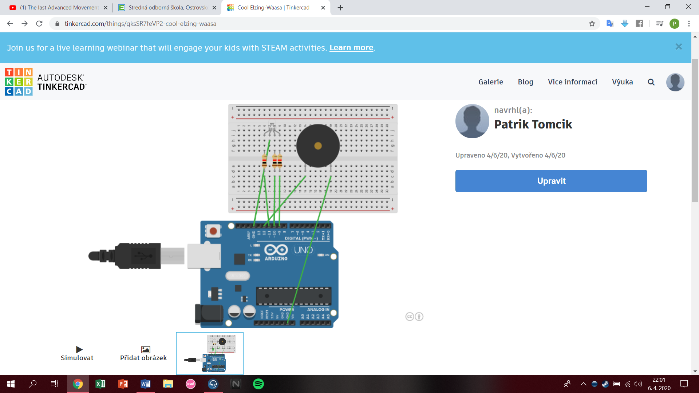

int red_light_pin= 11;

int green_light_pin = 10;

int blue_light_pin = 9;

int buzz_pin = 12;

void setup() {

pinMode(red_light_pin, OUTPUT);

pinMode(green_light_pin, OUTPUT);

pinMode(blue_light_pin, OUTPUT);

pinMode(buzz_pin, OUTPUT);

}

void loop() {

RGB_color(255, 0, 0);

tone(buzz_pin,100);

delay(1000);

RGB_color(0, 255, 0);

tone(buzz_pin,150);

delay(1000);

RGB_color(0, 0, 255);

tone(buzz_pin,200);

delay(1000);

RGB_color(255, 255, 125);

tone(buzz_pin,250);

delay(1000);

RGB_color(0, 255, 255);

tone(buzz_pin,300);

delay(1000);

RGB_color(255, 0, 255);

tone(buzz_pin,350);

delay(1000);

}

void RGB_color(int red_light_value, int green_light_value, int blue_light_value)

{

analogWrite(red_light_pin, red_light_value);

analogWrite(green_light_pin, green_light_value);

analogWrite(blue_light_pin, blue_light_value);

}