int p= A0;

int l= 9;

int readValue;

int writeValue;

void setup() {

pinMode(p, INPUT);

pinMode(l, OUTPUT);

Serial.begin(9600);

}

void loop() {

readValue = analogRead(p);

writeValue = (255./1023.) \* readValue;

analogWrite(l, writeValue);

}

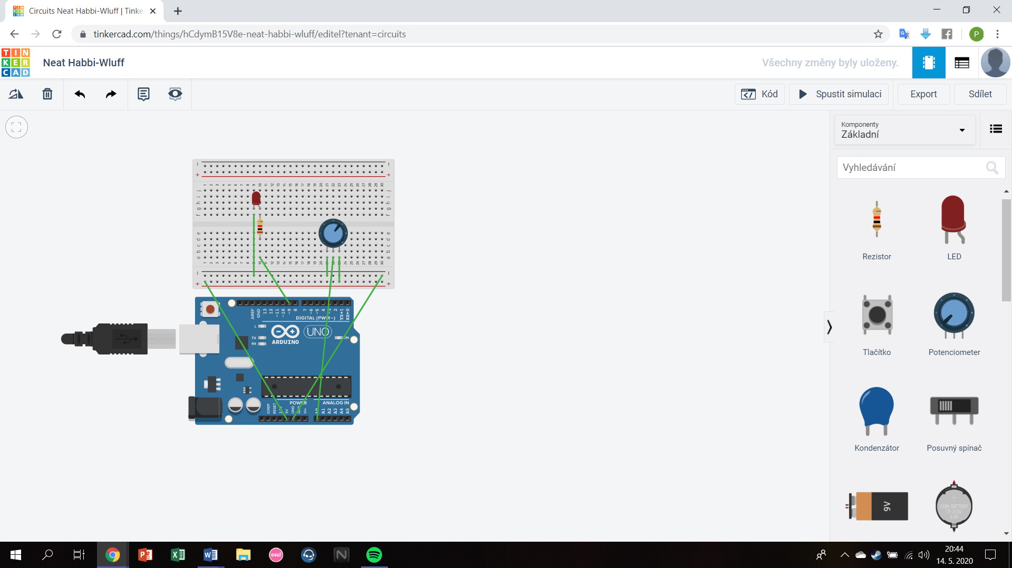

V mojom programe kontrolujem intenzitu diody pomocou potenciometra