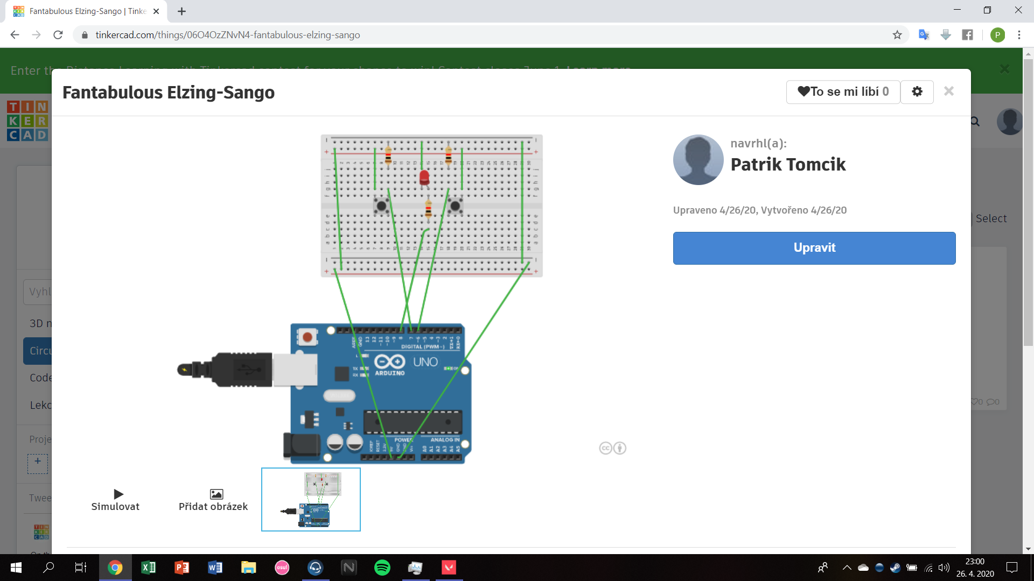

int buttonPin1 = 7;

int ledPin1 = 8;

int buttonPin2 = 6;

void setup() {

pinMode(buttonPin1, INPUT);

pinMode(ledPin1, OUTPUT);

pinMode(buttonPin2,INPUT);

}

void loop() {

if ((digitalRead(buttonPin1) == HIGH) && (digitalRead(buttonPin2) == LOW)) {

for (int fadeValue1 = 0 ; fadeValue1 <= 255; fadeValue1 += 1){

analogWrite(ledPin1, fadeValue1);

}}

if ((digitalRead(buttonPin1) == LOW)&&(digitalRead(buttonPin2)) == HIGH) {

for (int fadeValue = 255 ; fadeValue >= 0; fadeValue -= 1){

analogWrite(ledPin1, fadeValue);

}}

}