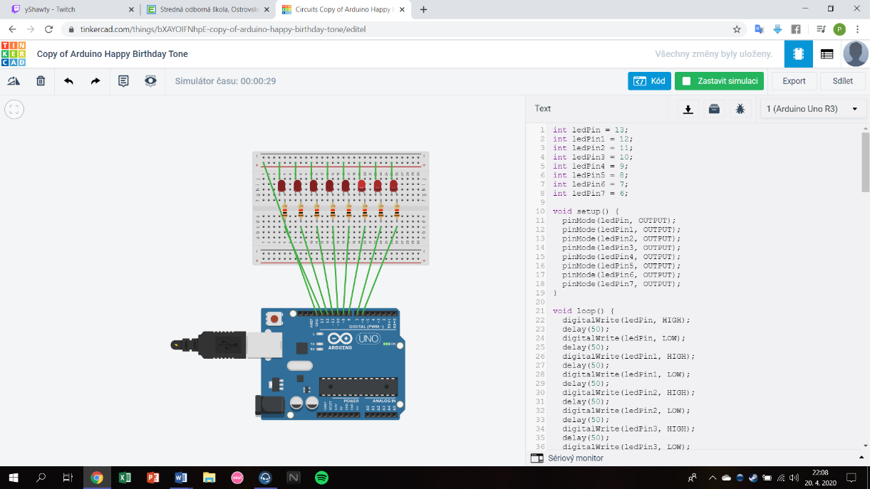int ledPin = 13;

int ledPin1 = 12;

int ledPin2 = 11;

int ledPin3 = 10;

int ledPin4 = 9;

int ledPin5 = 8;

int ledPin6 = 7;

int ledPin7 = 6;

void setup() {

pinMode(ledPin, OUTPUT);

pinMode(ledPin1, OUTPUT);

pinMode(ledPin2, OUTPUT);

pinMode(ledPin3, OUTPUT);

pinMode(ledPin4, OUTPUT);

pinMode(ledPin5, OUTPUT);

pinMode(ledPin6, OUTPUT);

pinMode(ledPin7, OUTPUT);

}

void loop() {

digitalWrite(ledPin, HIGH);

delay(50);

digitalWrite(ledPin, LOW);

delay(50);

digitalWrite(ledPin1, HIGH);

delay(50);

digitalWrite(ledPin1, LOW);

delay(50);

digitalWrite(ledPin2, HIGH);

delay(50);

digitalWrite(ledPin2, LOW);

delay(50);

digitalWrite(ledPin3, HIGH);

delay(50);

digitalWrite(ledPin3, LOW);

delay(50);

digitalWrite(ledPin4, HIGH);

delay(50);

digitalWrite(ledPin4, LOW);

delay(50);

digitalWrite(ledPin5, HIGH);

delay(50);

digitalWrite(ledPin5, LOW);

delay(50);

digitalWrite(ledPin6, HIGH);

delay(50);

digitalWrite(ledPin6, LOW);

delay(50);

digitalWrite(ledPin7, HIGH);

delay(50);

digitalWrite(ledPin7, LOW);

delay(50);

digitalWrite(ledPin7, HIGH);

delay(50);

digitalWrite(ledPin7, LOW);

delay(50);

digitalWrite(ledPin6, HIGH);

delay(50);

digitalWrite(ledPin6, LOW);

delay(50);

digitalWrite(ledPin5, HIGH);

delay(50);

digitalWrite(ledPin5, LOW);

delay(50);

digitalWrite(ledPin4, HIGH);

delay(50);

digitalWrite(ledPin4, LOW);

delay(50);

digitalWrite(ledPin3, HIGH);

delay(50);

digitalWrite(ledPin3, LOW);

delay(50);

digitalWrite(ledPin2, HIGH);

delay(50);

digitalWrite(ledPin2, LOW);

delay(50);

digitalWrite(ledPin1, HIGH);

delay(50);

digitalWrite(ledPin1, LOW);

delay(50);

digitalWrite(ledPin, HIGH);

delay(50);

digitalWrite(ledPin, LOW);

delay(50);

digitalWrite(ledPin, HIGH);

digitalWrite(ledPin7, HIGH);

delay(50);

digitalWrite(ledPin, LOW);

digitalWrite(ledPin7, LOW);

delay(50);

digitalWrite(ledPin1, HIGH);

digitalWrite(ledPin6, HIGH);

delay(50);

digitalWrite(ledPin1, LOW);

digitalWrite(ledPin6, LOW);

delay(50);

digitalWrite(ledPin2, HIGH);

digitalWrite(ledPin5, HIGH);

delay(50);

digitalWrite(ledPin2, LOW);

digitalWrite(ledPin5, LOW);

delay(50);

digitalWrite(ledPin3, HIGH);

digitalWrite(ledPin4, HIGH);

delay(50);

digitalWrite(ledPin3, LOW);

digitalWrite(ledPin4, LOW);

delay(50);

digitalWrite(ledPin4, HIGH);

digitalWrite(ledPin3, HIGH);

delay(50);

digitalWrite(ledPin4, LOW);

digitalWrite(ledPin3, LOW);

delay(50);

digitalWrite(ledPin5, HIGH);

digitalWrite(ledPin2, HIGH);

delay(50);

digitalWrite(ledPin5, LOW);

digitalWrite(ledPin2, LOW);

delay(50);

digitalWrite(ledPin6, HIGH);

digitalWrite(ledPin1, HIGH);

delay(50);

digitalWrite(ledPin6, LOW);

digitalWrite(ledPin1, LOW);

delay(50);

digitalWrite(ledPin7, HIGH);

digitalWrite(ledPin, HIGH);

delay(50);

digitalWrite(ledPin7, LOW);

digitalWrite(ledPin, LOW);

delay(50);

digitalWrite(ledPin, HIGH);

digitalWrite(ledPin7, HIGH);

delay(50);

digitalWrite(ledPin, LOW);

digitalWrite(ledPin7, LOW);

delay(50);

digitalWrite(ledPin1, HIGH);

digitalWrite(ledPin6, HIGH);

delay(50);

digitalWrite(ledPin1, LOW);

digitalWrite(ledPin6, LOW);

delay(50);

digitalWrite(ledPin2, HIGH);

digitalWrite(ledPin5, HIGH);

delay(50);

digitalWrite(ledPin2, LOW);

digitalWrite(ledPin5, LOW);

delay(50);

digitalWrite(ledPin3, HIGH);

digitalWrite(ledPin4, HIGH);

delay(50);

digitalWrite(ledPin3, LOW);

digitalWrite(ledPin4, LOW);

delay(50);

digitalWrite(ledPin4, HIGH);

digitalWrite(ledPin3, HIGH);

delay(50);

digitalWrite(ledPin4, LOW);

digitalWrite(ledPin3, LOW);

delay(50);

digitalWrite(ledPin5, HIGH);

digitalWrite(ledPin2, HIGH);

delay(50);

digitalWrite(ledPin5, LOW);

digitalWrite(ledPin2, LOW);

delay(50);

digitalWrite(ledPin6, HIGH);

digitalWrite(ledPin1, HIGH);

delay(50);

digitalWrite(ledPin6, LOW);

digitalWrite(ledPin1, LOW);

delay(50);

digitalWrite(ledPin7, HIGH);

digitalWrite(ledPin, HIGH);

delay(50);

digitalWrite(ledPin7, LOW);

digitalWrite(ledPin, LOW);

delay(50);}

Môj program preklikáva ledky z prava do ľavá, smerom do stredu, zo stredu, rôzne