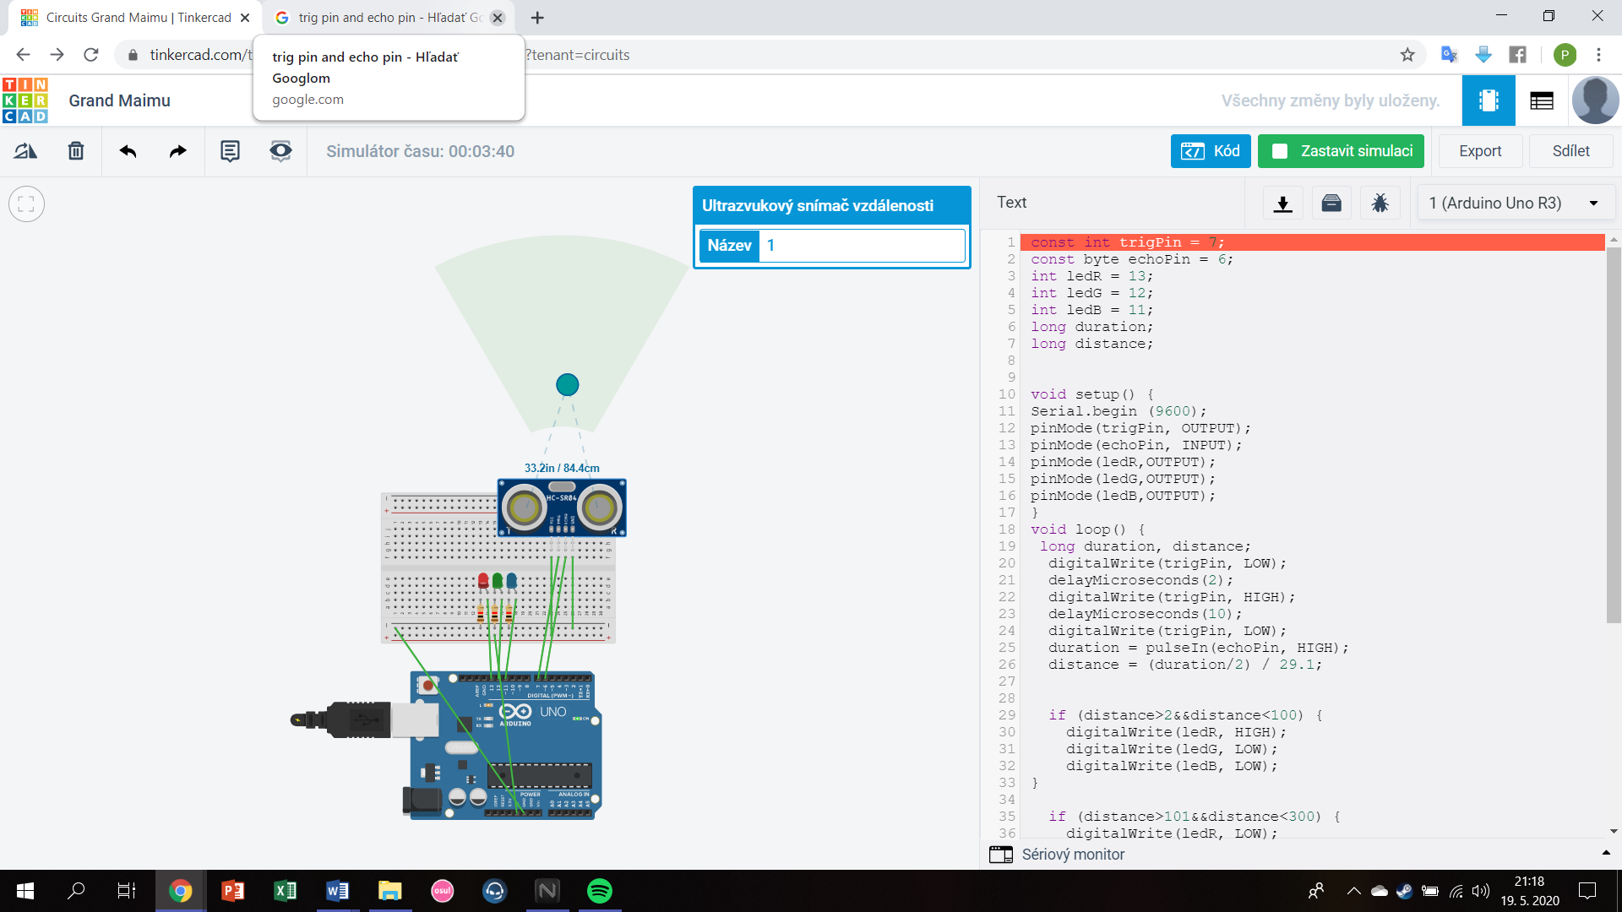

const int trigPin = 7;

const byte echoPin = 6;

int ledR = 13;

int ledG = 12;

int ledB = 11;

long duration;

long distance;

void setup() {

Serial.begin (9600);

pinMode(trigPin, OUTPUT);

pinMode(echoPin, INPUT);

pinMode(ledR,OUTPUT);

pinMode(ledG,OUTPUT);

pinMode(ledB,OUTPUT);

}

void loop() {

long duration, distance;

digitalWrite(trigPin, LOW);

delayMicroseconds(2);

digitalWrite(trigPin, HIGH);

delayMicroseconds(10);

digitalWrite(trigPin, LOW);

duration = pulseIn(echoPin, HIGH);

distance = (duration/2) / 29.1;

if (distance>2&&distance<100) {

digitalWrite(ledR, HIGH);

digitalWrite(ledG, LOW);

digitalWrite(ledB, LOW);

}

if (distance>101&&distance<300) {

digitalWrite(ledR, LOW);

digitalWrite(ledG, HIGH);

digitalWrite(ledB, LOW);

}

if (distance>301&&distance<400) {

digitalWrite(ledR, LOW);

digitalWrite(ledG, LOW);

digitalWrite(ledB, HIGH);

}

if (distance > 401 || distance <= 0){

Serial.println("Out of range");

}

else {

Serial.print(distance);

Serial.println(" cm");

}

delay(500);

}