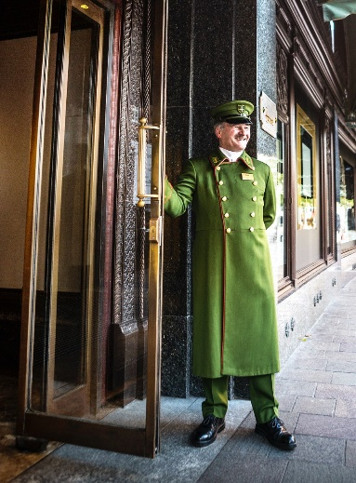

LOWER GROUND FLOOR  
Beauty Events & Services  
Fine Wines & Spirits  
Gifts & Bookshop

GROUND FLOOR  
The Beauty Halls  
Fine Jewellery & Watches  
The Food Halls  
Luxury Accessories

FIRST FLOOR  
Womenswear

***HARRODS***

SECOND FLOOR  
Menswear

THIRD FLOOR  
Home & Furniture

FOURTH FLOOR  
Childrenswear, Toys & Wizarding World  
Women's Contemporary & Denim  
The Wellness Clinic

FIFTH FLOOR  
Hair & Beauty Salon  
Shoe Heaven  
Technology

SIXTH FLOOR  
Salon de Parfums