**dýchanie živočíchov**

Dýchacie plyny sú: ....................................................................................................................................... . Kyslík v bunkách je potrebný pri ..........................................................................................................., pričom sa ..................................................................................................................................................... .

|  |  |  |
| --- | --- | --- |
| Skupina živočíchov | | Spôsob dýchania |
|  | | povrchom tela |
| vodné bezstavovce | |  |
| suchozemské bezstavovce | dážďovka |  |
| hmyz |  |
| pavúky |  |
| vodné stavovce | |  |
| suchozemské stavovce | |  |
| suchozemské stavovce obojživelníky | |  |
| suchozemské stavovce vtáky | |  |

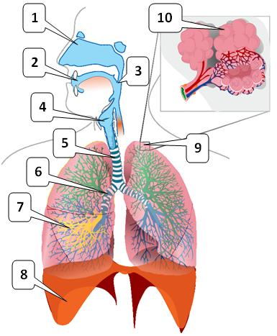

Stavba dýchacej sústavy stavovcov:

1. ................................................................
2. ................................................................
3. ................................................................
4. ................................................................
5. ................................................................
6. ................................................................
7. ................................................................
8. ................................................................
9. ................................................................
10. ................................................................

Vonkajšie dýchanie: ............................................................................................................................................................................................................................................................................................................................................................................................................................................................................................................................................ Vnútorné dýchanie: .............................................................................................................................................................................................................................................................................................................................................................