**Project 2: Visualizing Relationships between Education & Crime in New Jersey**

**Matt Krenicki, Nina Anderson, Mir Ahmed, Dan Zanoria, Aksheta Jain**

**Objective and Approach:**

* Extract and load data from multiple sources (below)
* Load the data to a hosted javascript page using Flask
* Utilize D3, Plotly, Leaflet, and other js packages to visualize data and draw conclusions

**Data Sources:**

* NJ County Crime Data: <https://www.njsp.org/ucr/current-crime-data1.shtml?agree=0>
  + Metadata screenshot

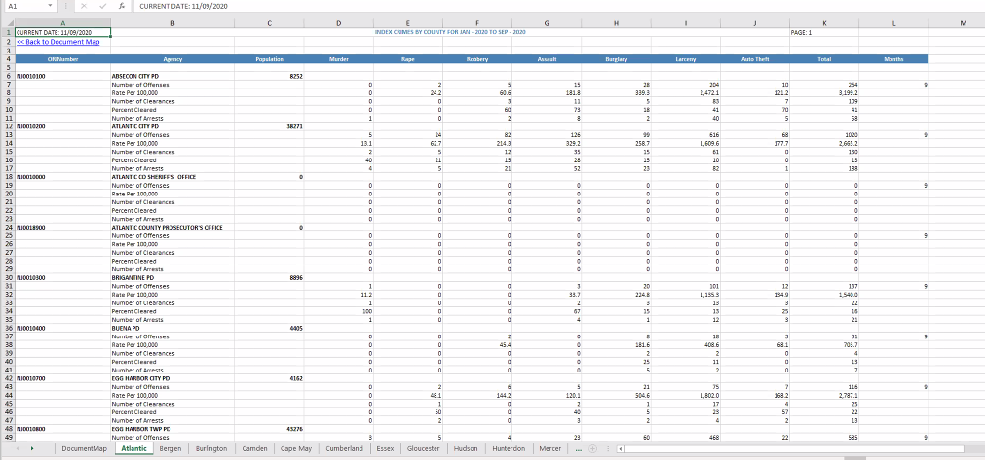

* NJ County geoJSON: <http://data.ci.newark.nj.us/dataset/new-jersey-counties-polygon/resource/95db8cad-3a8c-41a4-b8b1-4991990f07f3>
  + Metadata screenshot:

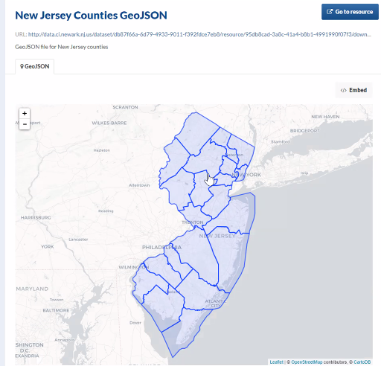

* NJ School Ratings: <https://www.nj.com/education/2019/03/nj-just-graded-its-public-schools-from-0-100-heres-how-every-school-scored.html>
  + Metadata screenshot:

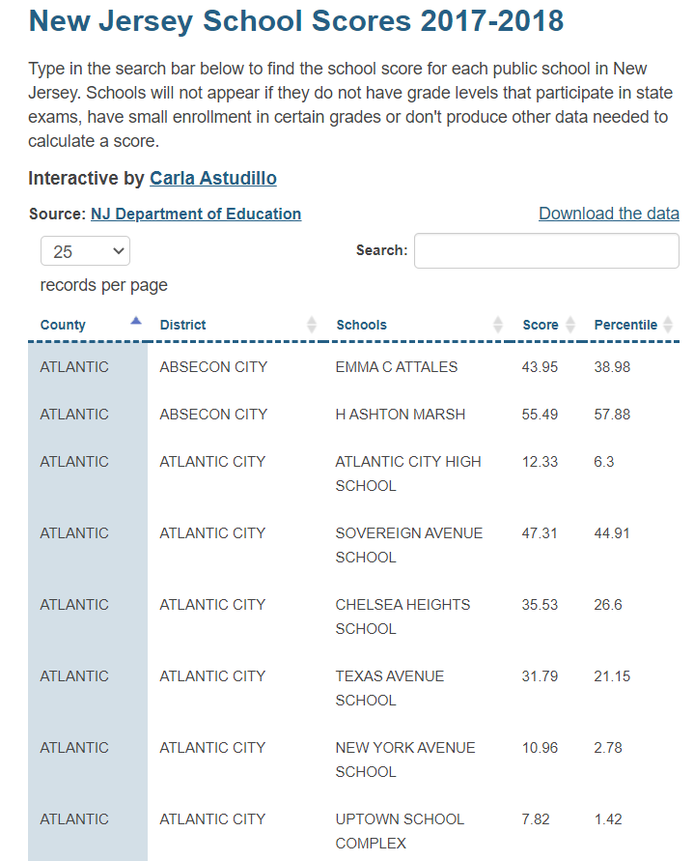

* NJ Poverty (Census API): [https://api.census.gov/data/timeseries/poverty/saipe?get=NAME,SAEMHI_PT,SAEMHI_MOE,S[…]MOE,SAEPOVRTALL_PT,STABREV&for=county:*&in=state:34&YEAR=2019](https://api.census.gov/data/timeseries/poverty/saipe?get=NAME,SAEMHI_PT,SAEMHI_MOE,S%5b…%5dMOE,SAEPOVRTALL_PT,STABREV&for=county:*&in=state:34&YEAR=2019)
  + Metadata:

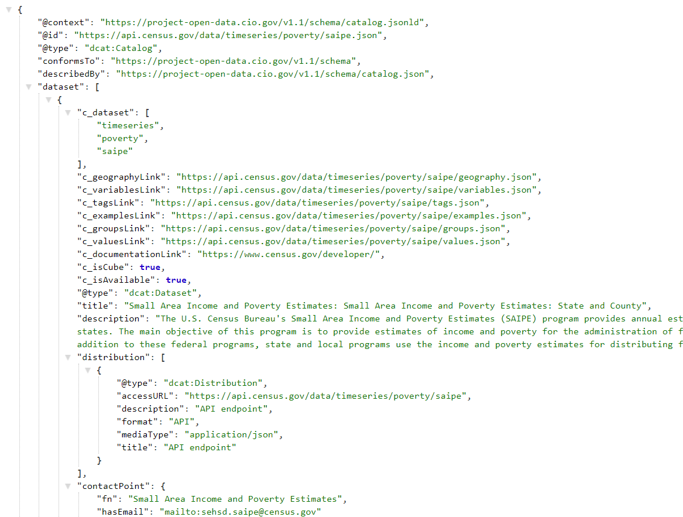

**Practical Questions to Examine:**

* What relationships exist between education and crime in New Jersey?
* How do these vary by geography/county?

**Visualization Ideas/Inspiration:**

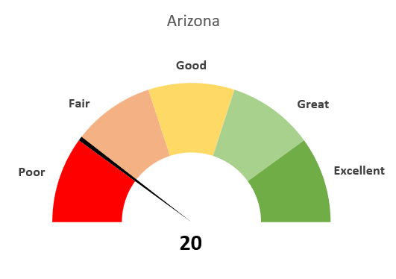 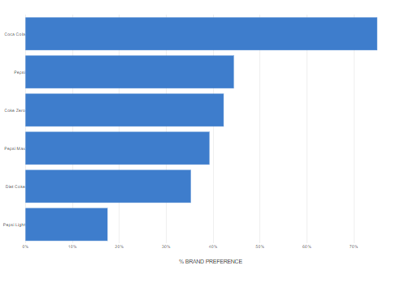 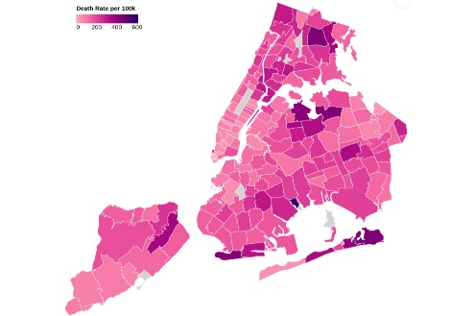  
 *Example performance dial graph Example comparison bar chart Example education/poverty heatmap*

**Github Link:** <https://github.com/DanZanoria/project2>

**Sketch of Final Design:**

