Screenshot - 2014

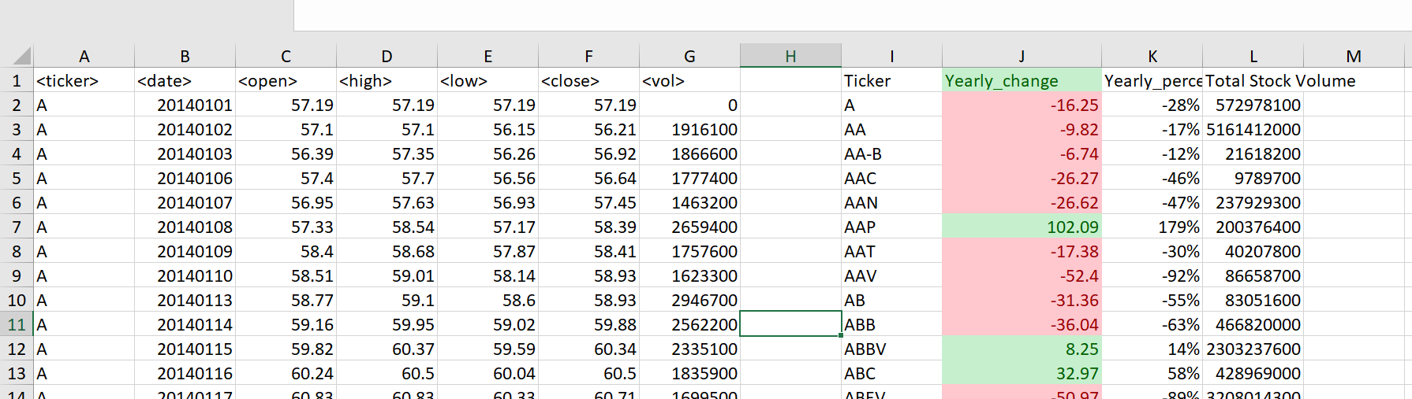

Screenshot - 2015

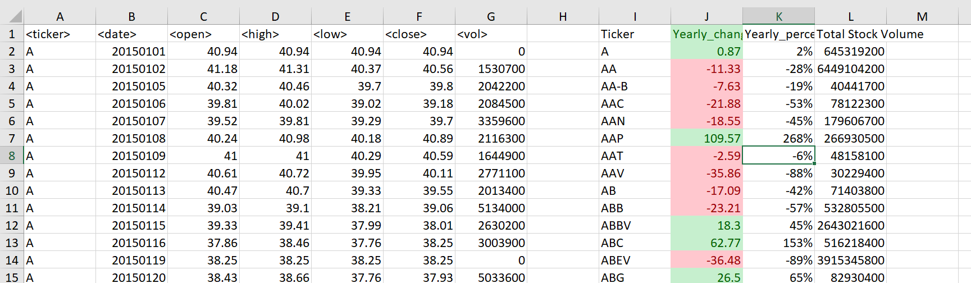

Screenshot - 2016

