analyses judgment new

2023-09-29

Table of Contents

## H3a frequency wave 1

### H3a

mean.abs.error

Predictors

Estimates

CI

p

(Intercept)

0.88

0.77 – 1.00

<0.001

gender [male]

-0.04

-0.07 – -0.00

0.031

age

-0.00

-0.00 – -0.00

<0.001

country Switzerland

0.02

-0.01 – 0.06

0.162

income wave1 [<1’500€<3’100CHF]

0.02

-0.03 – 0.08

0.348

income wave1 [> 4’000€>5’900 CHF]

-0.00

-0.05 – 0.05

0.949

income wave1 [2’500-4’000€ <4’300- 5’899CHF]

-0.03

-0.07 – 0.02

0.266

education [middle school]

-0.00

-0.05 – 0.04

0.865

education [no formaleducation]

0.09

0.03 – 0.15

0.004

education [obligatoryschool]

0.05

0.01 – 0.09

0.019

climate concern

-0.02

-0.04 – -0.01

<0.001

mean freq clean

0.01

-0.02 – 0.05

0.400

Observations

1036

R2 / R2 adjusted

0.063 / 0.053

### H3a cleaned

mean.abs.error

Predictors

Estimates

CI

p

(Intercept)

0.80

0.70 – 0.91

<0.001

gender [male]

-0.03

-0.07 – -0.00

0.027

age

-0.00

-0.00 – -0.00

<0.001

country Switzerland

0.02

-0.01 – 0.05

0.298

income wave1 [<1’500€<3’100CHF]

0.02

-0.03 – 0.07

0.389

income wave1 [> 4’000€>5’900 CHF]

0.02

-0.03 – 0.06

0.483

income wave1 [2’500-4’000€ <4’300- 5’899CHF]

-0.02

-0.06 – 0.03

0.429

education [middle school]

0.02

-0.03 – 0.06

0.443

education [no formaleducation]

0.09

0.03 – 0.15

0.002

education [obligatoryschool]

0.06

0.02 – 0.10

0.002

climate concern

-0.01

-0.03 – -0.00

0.032

mean freq clean

-0.00

-0.03 – 0.03

0.979

Observations

980

R2 / R2 adjusted

0.046 / 0.035

## H3b wave 2

### certainty and accuracy

#### Model with certainty and numeracy

absolute.error.log

Predictors

Estimates

CI

p

(Intercept)

0.66

0.56 – 0.77

<0.001

certainty

0.01

-0.00 – 0.02

0.077

numeracy f [numeracy low]

0.12

0.08 – 0.16

<0.001

education [middle school]

0.03

-0.01 – 0.08

0.165

education [no formaleducation]

0.07

0.01 – 0.13

0.019

education [obligatoryschool]

0.04

0.00 – 0.09

0.046

country Switzerland

0.05

0.01 – 0.08

0.007

gender [male]

-0.02

-0.06 – 0.01

0.159

income [<1’500€<3’100CHF]

0.05

-0.01 – 0.10

0.082

income [> 4’000€ >5’900CHF]

0.01

-0.04 – 0.05

0.806

income [2’500- 4’000€<4’300- 5’899CHF]

0.02

-0.03 – 0.06

0.475

age

-0.00

-0.00 – -0.00

<0.001

concern scaled

-0.03

-0.04 – -0.02

<0.001

Random Effects

σ2

0.22

τ00 m

0.04

τ00 behavior

0.01

ICC

0.19

N m

1036

N behavior

8

Observations

8288

Marginal R2 / Conditional R2

0.032 / 0.219

#### Model with exponential certainty

absolute.error.log

Predictors

Estimates

CI

p

(Intercept)

0.81

0.69 – 0.93

<0.001

certainty

-0.11

-0.16 – -0.06

<0.001

numeracy f [numeracy low]

0.12

0.08 – 0.16

<0.001

certainty^2

0.02

0.01 – 0.03

<0.001

education [middle school]

0.04

-0.01 – 0.08

0.129

education [no formaleducation]

0.08

0.02 – 0.14

0.012

education [obligatoryschool]

0.05

0.00 – 0.09

0.035

country Switzerland

0.05

0.01 – 0.08

0.006

gender [male]

-0.02

-0.06 – 0.01

0.152

income [<1’500€<3’100CHF]

0.05

-0.00 – 0.10

0.066

income [> 4’000€ >5’900CHF]

0.01

-0.04 – 0.05

0.701

income [2’500- 4’000€<4’300- 5’899CHF]

0.02

-0.03 – 0.07

0.394

age

-0.00

-0.00 – -0.00

<0.001

concern scaled

-0.03

-0.04 – -0.02

<0.001

Random Effects

σ2

0.22

τ00 m

0.04

τ00 behavior

0.01

ICC

0.19

N m

1036

N behavior

8

Observations

8288

Marginal R2 / Conditional R2

0.036 / 0.220

## Model contains polynomial or cubic / quadratic terms. Consider using  
## `terms="certainty [all]"` to get smooth plots. See also package-vignette  
## 'Marginal Effects at Specific Values'.

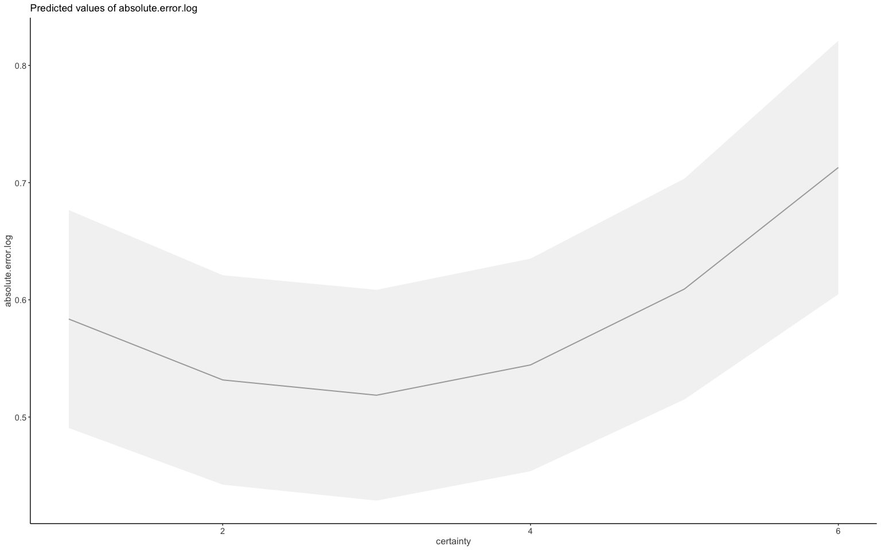

#### H3b cleaned

Model with certainty and numeracy

absolute.error.log

Predictors

Estimates

CI

p

(Intercept)

0.65

0.55 – 0.76

<0.001

certainty

0.01

-0.00 – 0.02

0.099

numeracy f [numeracy low]

0.10

0.07 – 0.14

<0.001

education [middle school]

0.03

-0.01 – 0.07

0.180

education [no formaleducation]

0.07

0.02 – 0.13

0.014

education [obligatoryschool]

0.05

0.00 – 0.09

0.029

country Switzerland

0.04

0.01 – 0.07

0.018

gender [male]

-0.04

-0.07 – -0.00

0.023

income [<1’500€<3’100CHF]

0.03

-0.02 – 0.08

0.214

income [> 4’000€ >5’900CHF]

-0.00

-0.04 – 0.04

0.984

income [2’500- 4’000€<4’300- 5’899CHF]

0.02

-0.03 – 0.06

0.467

age

-0.00

-0.00 – -0.00

<0.001

concern scaled

-0.02

-0.03 – -0.01

<0.001

Random Effects

σ2

0.22

τ00 m

0.03

τ00 behavior

0.01

ICC

0.17

N m

980

N behavior

8

Observations

7840

Marginal R2 / Conditional R2

0.024 / 0.190

#### H3b plot (cleaned)

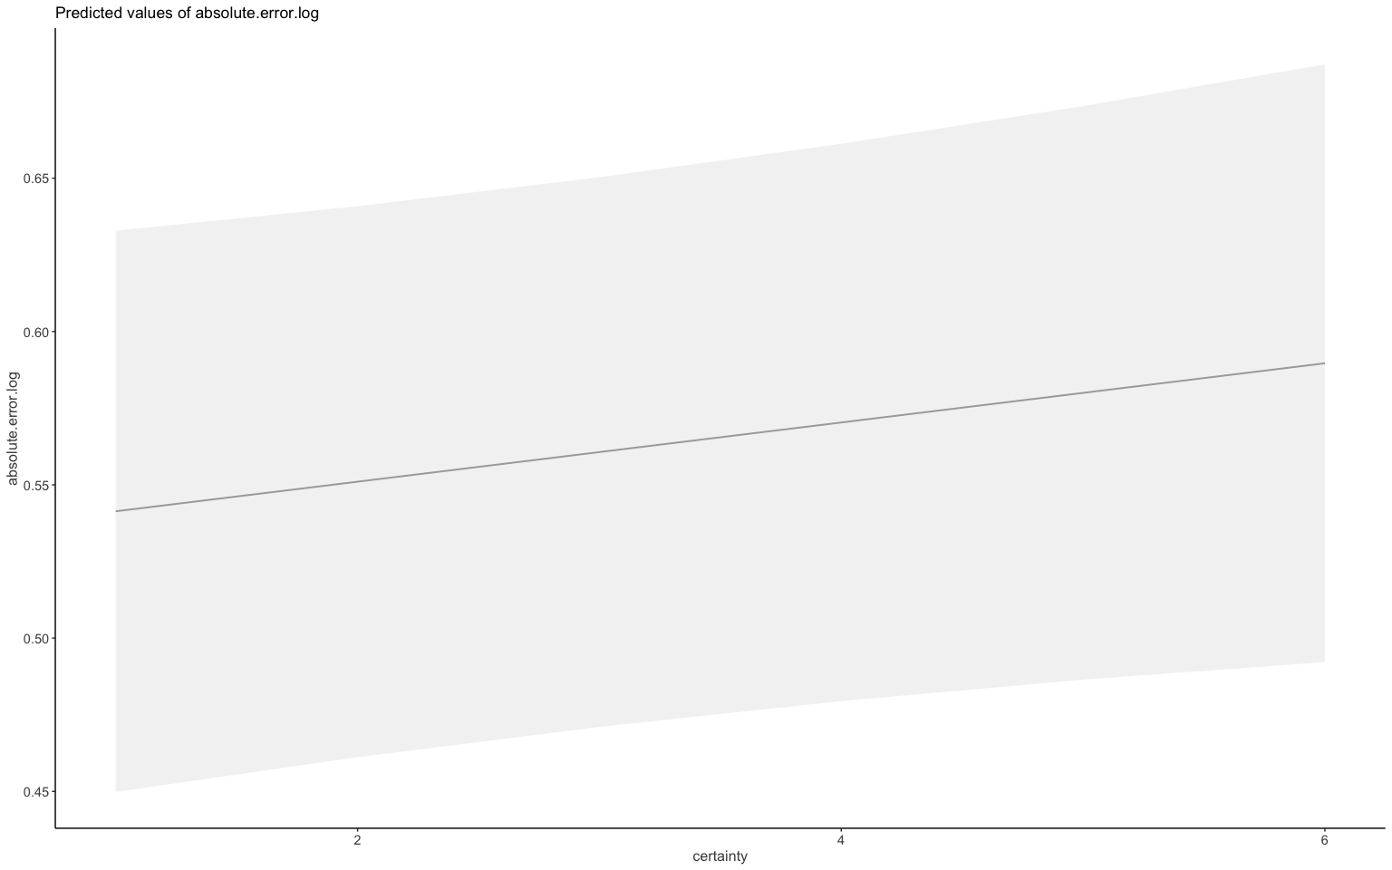

#### H3b cleaned, exponential

absolute.error.log

Predictors

Estimates

CI

p

(Intercept)

0.78

0.66 – 0.90

<0.001

certainty

-0.10

-0.14 – -0.05

<0.001

numeracy f [numeracy low]

0.10

0.06 – 0.14

<0.001

certainty^2

0.02

0.01 – 0.02

<0.001

education [middle school]

0.03

-0.01 – 0.08

0.154

education [no formaleducation]

0.08

0.02 – 0.14

0.009

education [obligatoryschool]

0.05

0.01 – 0.09

0.023

country Switzerland

0.04

0.01 – 0.07

0.016

gender [male]

-0.04

-0.07 – -0.00

0.024

income [<1’500€<3’100CHF]

0.03

-0.02 – 0.08

0.174

income [> 4’000€ >5’900CHF]

0.00

-0.04 – 0.05

0.912

income [2’500- 4’000€<4’300- 5’899CHF]

0.02

-0.02 – 0.06

0.409

age

-0.00

-0.00 – -0.00

<0.001

concern scaled

-0.02

-0.03 – -0.01

<0.001

Random Effects

σ2

0.22

τ00 m

0.03

τ00 behavior

0.01

ICC

0.17

N m

980

N behavior

8

Observations

7840

Marginal R2 / Conditional R2

0.028 / 0.192

#### H3b (cleaned) exponential plot

## Model contains polynomial or cubic / quadratic terms. Consider using  
## `terms="certainty [all]"` to get smooth plots. See also package-vignette  
## 'Marginal Effects at Specific Values'.

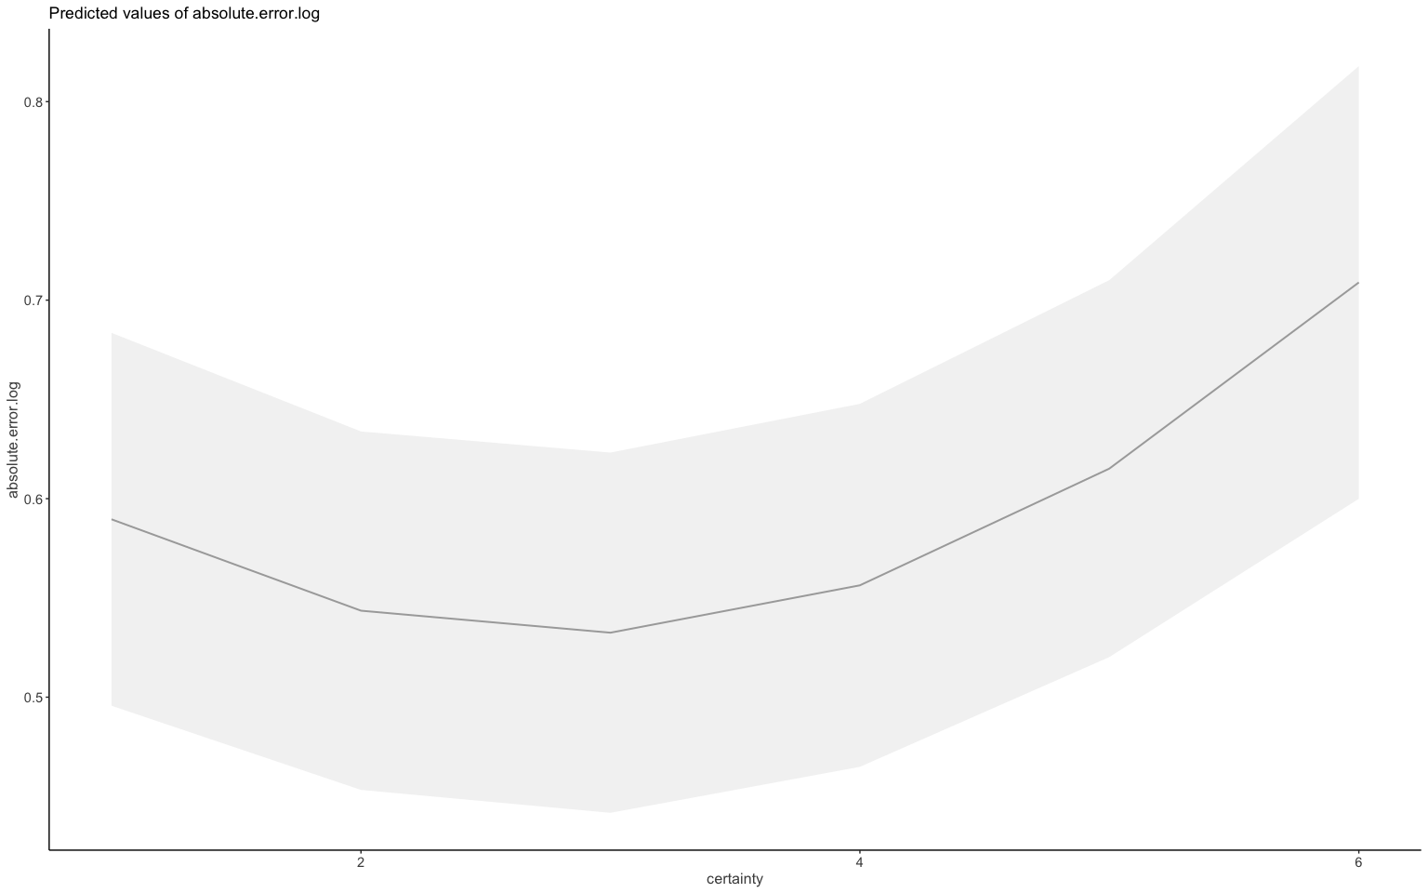

## Judgment estimates and actual values both waves together

### cleaned for pattern people Fig 2a

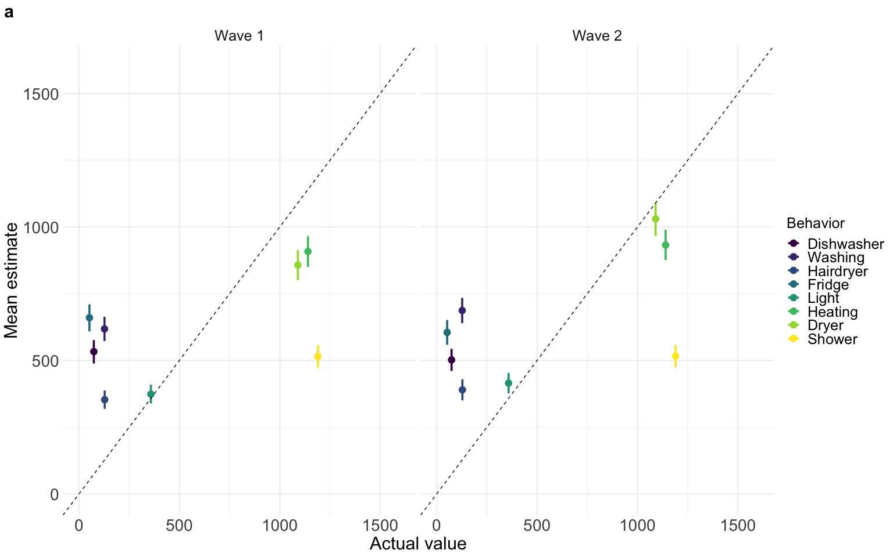

## misestimation of impact across waves

### not cleaned

## impact wave n Mean Conf.level Trad.lower Trad.upper Mean.2  
## 1 high wave1 3108 0.649 0.95 0.623 0.676 1.5408320  
## 2 high wave2 3108 0.722 0.95 0.694 0.750 1.3850416  
## 3 low wave1 5180 5.550 0.95 5.290 5.800 0.1801802  
## 4 low wave2 5180 5.590 0.95 5.340 5.840 0.1788909  
## Trad.lower2 Trad.upper2  
## 1 1.6051364 1.4792899  
## 2 1.4409222 1.3333333  
## 3 0.1890359 0.1724138  
## 4 0.1872659 0.1712329

##   
## Paired t-test  
##   
## data: data.accuracy.waves.long.total2.l$mis.estimation by data.accuracy.waves.long.total2.l$wave  
## t = -0.62413, df = 8287, p-value = 0.5326  
## alternative hypothesis: true mean difference is not equal to 0  
## 95 percent confidence interval:  
## -0.2302919 0.1190601  
## sample estimates:  
## mean difference   
## -0.05561587

## ANOVA Table (type III tests)  
##   
## Effect DFn DFd F p p<.05 ges  
## 1 wave 1 1035 0.249 6.18e-01 4.75e-05  
## 2 impact 1 1035 1215.529 8.96e-177 * 2.44e-01  
## 3 wave:impact 1 1035 0.018 8.95e-01 2.46e-06

### cleaned

## impact wave n Mean Conf.level Trad.lower Trad.upper Mean.2  
## 1 high wave1 2940 0.672 0.95 0.645 0.70 1.4880952  
## 2 high wave2 2940 0.732 0.95 0.703 0.76 1.3661202  
## 3 low wave1 4900 5.710 0.95 5.440 5.98 0.1751313  
## 4 low wave2 4900 5.610 0.95 5.360 5.86 0.1782531  
## Trad.lower2 Trad.upper2  
## 1 1.5503876 1.4285714  
## 2 1.4224751 1.3157895  
## 3 0.1838235 0.1672241  
## 4 0.1865672 0.1706485

##   
## Paired t-test  
##   
## data: data.accuracy.waves.long.total_clean2$mis.estimation by data.accuracy.waves.long.total_clean2$wave  
## t = 0.46993, df = 7839, p-value = 0.6384  
## alternative hypothesis: true mean difference is not equal to 0  
## 95 percent confidence interval:  
## -0.1344126 0.2191787  
## sample estimates:  
## mean difference   
## 0.04238306

## ANOVA Table (type III tests)  
##   
## Effect DFn DFd F p p<.05 ges  
## 1 wave 1 979 0.192 6.62e-01 6.19e-05  
## 2 impact 1 979 7624.582 0.00e+00 * 2.83e-01  
## 3 wave:impact 1 979 16.174 6.22e-05 * 4.01e-04

## Analysis of Deviance Table (Type III Wald F tests with Kenward-Roger df)  
##   
## Response: Mean  
## F Df Df.res Pr(>F)   
## (Intercept) 125.7957 1 979 < 2e-16 ***  
## impact 2967.6195 1 2937 < 2e-16 ***  
## wave 0.4645 1 2937 0.49559   
## impact:wave 3.0118 1 2937 0.08277 .   
## ---  
## Signif. codes: 0 '***' 0.001 '**' 0.01 '*' 0.05 '.' 0.1 ' ' 1

## Mean judgment error across waves by numeracy

### witout pattern people fig 2b

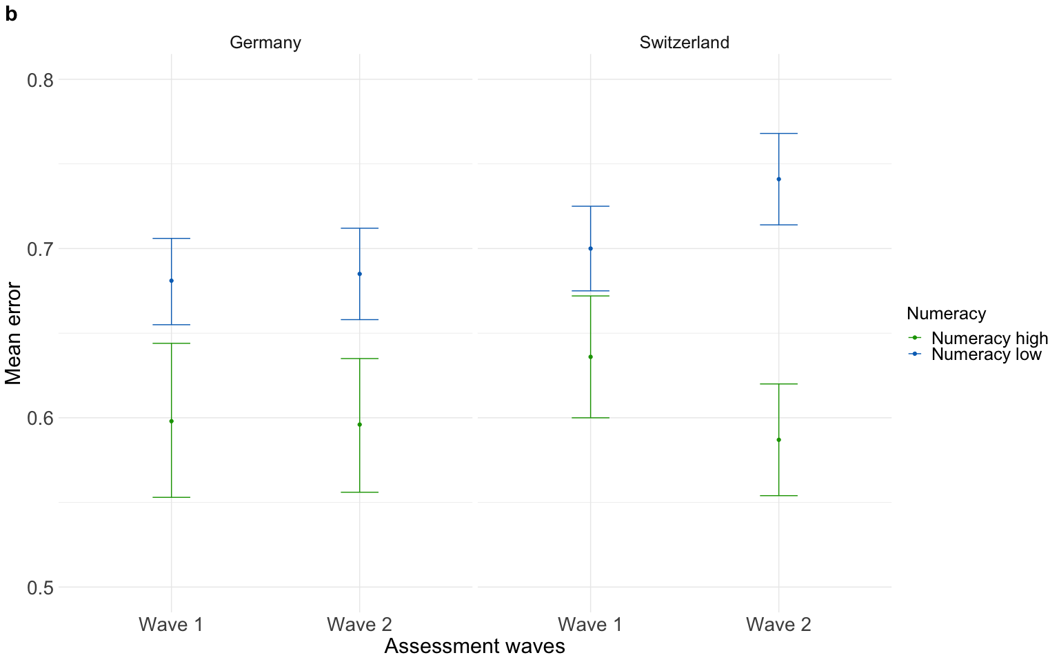

Both judgment figures 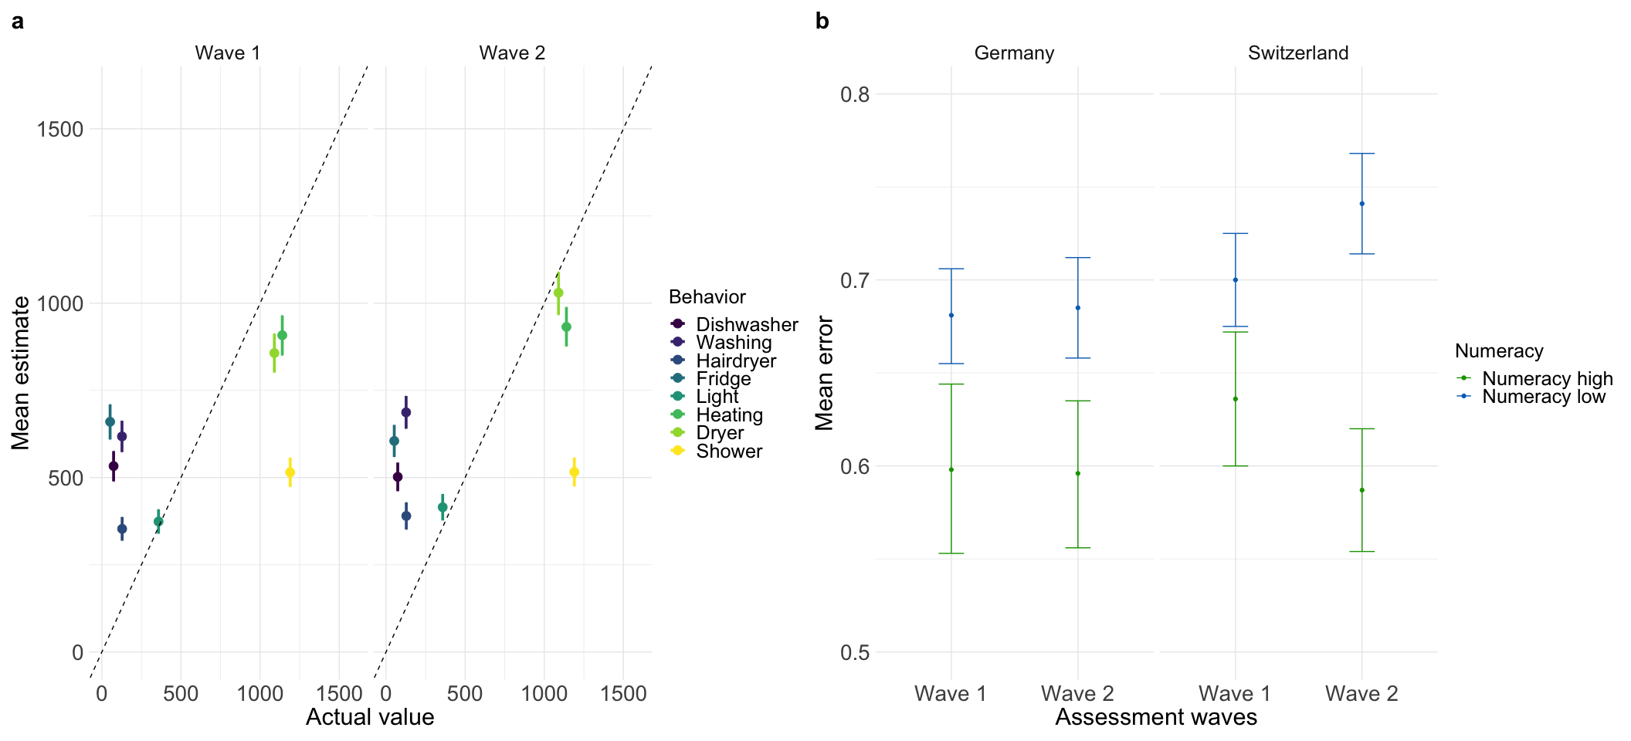

## Across waves judgment error

same approach as misestimation for judgment error

Models cleaned for pattern people

## numeracy.f wave n Mean Conf.level Trad.lower Trad.upper Mean.2  
## 1 numeracy high wave1 1800 0.617 0.95 0.594 0.639 1.620746  
## 2 numeracy high wave2 1800 0.592 0.95 0.570 0.613 1.689189  
## 3 numeracy low wave1 6040 0.690 0.95 0.677 0.702 1.449275  
## 4 numeracy low wave2 6040 0.710 0.95 0.697 0.724 1.408451  
## Trad.lower2 Trad.upper2  
## 1 1.683502 1.564945  
## 2 1.754386 1.631321  
## 3 1.477105 1.424501  
## 4 1.434720 1.381215

##   
## Paired t-test  
##   
## data: accuracy.waves.error.num$Mean by accuracy.waves.error.num$wave  
## t = -0.44352, df = 1959, p-value = 0.6574  
## alternative hypothesis: true mean difference is not equal to 0  
## 95 percent confidence interval:  
## -0.02606782 0.01645201  
## sample estimates:  
## mean difference   
## -0.004807908

## Analysis of Deviance Table (Type III Wald F tests with Kenward-Roger df)  
##   
## Response: error  
## F Df Df.res Pr(>F)   
## (Intercept) 7296.7998 1 1011.3 < 2.2e-16 ***  
## numeracy.f 41.0589 1 977.0 2.294e-10 ***  
## wave 0.6490 1 14696.0 0.420482   
## impact 4.4170 1 14696.0 0.035601 *   
## country 6.4215 1 977.0 0.011430 *   
## numeracy.f:wave 6.2639 1 14696.0 0.012333 *   
## wave:impact 7.1343 1 14696.0 0.007571 **   
## ---  
## Signif. codes: 0 '***' 0.001 '**' 0.01 '*' 0.05 '.' 0.1 ' ' 1

## # Effect Size for ANOVA (Type III)  
##   
## Parameter | Eta2 (partial) | 95% CI  
## -----------------------------------------------  
## numeracy.f | 0.04 | [0.02, 1.00]  
## wave | 4.42e-05 | [0.00, 1.00]  
## impact | 3.00e-04 | [0.00, 1.00]  
## country | 6.53e-03 | [0.00, 1.00]  
## numeracy.f:wave | 4.26e-04 | [0.00, 1.00]  
## wave:impact | 4.85e-04 | [0.00, 1.00]  
##   
## - One-sided CIs: upper bound fixed at [1.00].

error

Predictors

Estimates

CI

p

(Intercept)

0.65

0.64 – 0.67

<0.001

numeracy f1

-0.05

-0.06 – -0.03

<0.001

wave1

0.00

-0.01 – 0.01

0.420

impact1

0.01

0.00 – 0.02

0.036

country1

-0.02

-0.03 – -0.00

0.011

numeracy f1 × wave1

0.01

0.00 – 0.02

0.012

wave1 × impact1

-0.01

-0.02 – -0.00

0.008

Random Effects

σ2

0.23

τ00 m

0.02

ICC

0.10

N m

980

Observations

15680

Marginal R2 / Conditional R2

0.008 / 0.104

### Plots: Judgment error for impact of actions across waves

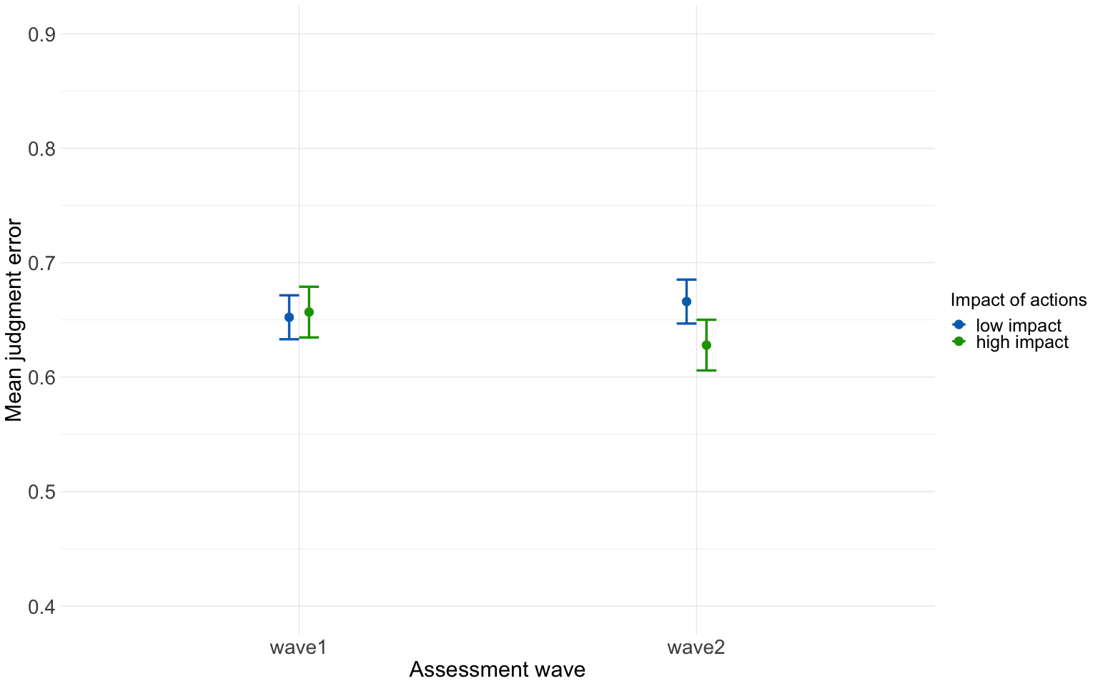

### Plot: Judgment error for numeracy across waves

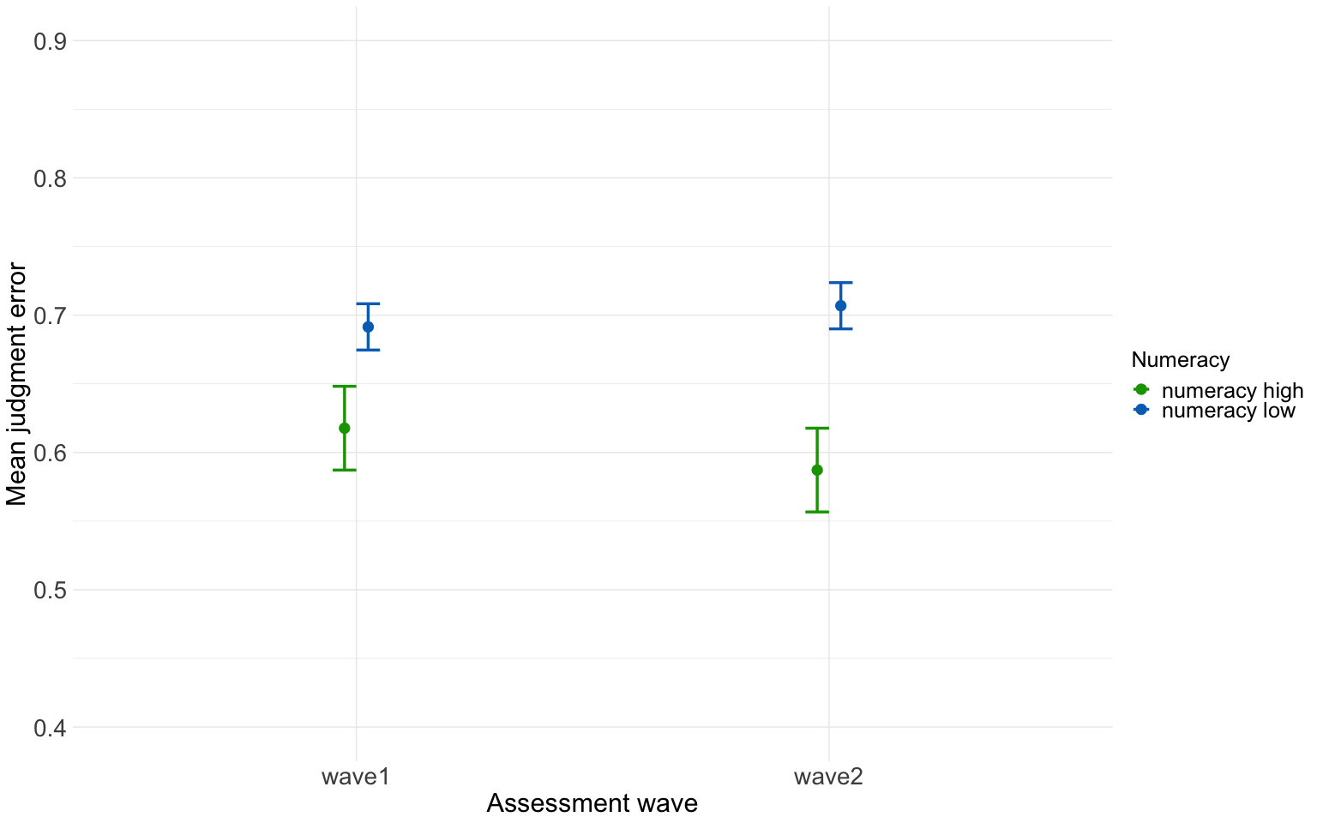

### Plot: numeracy by wave and country

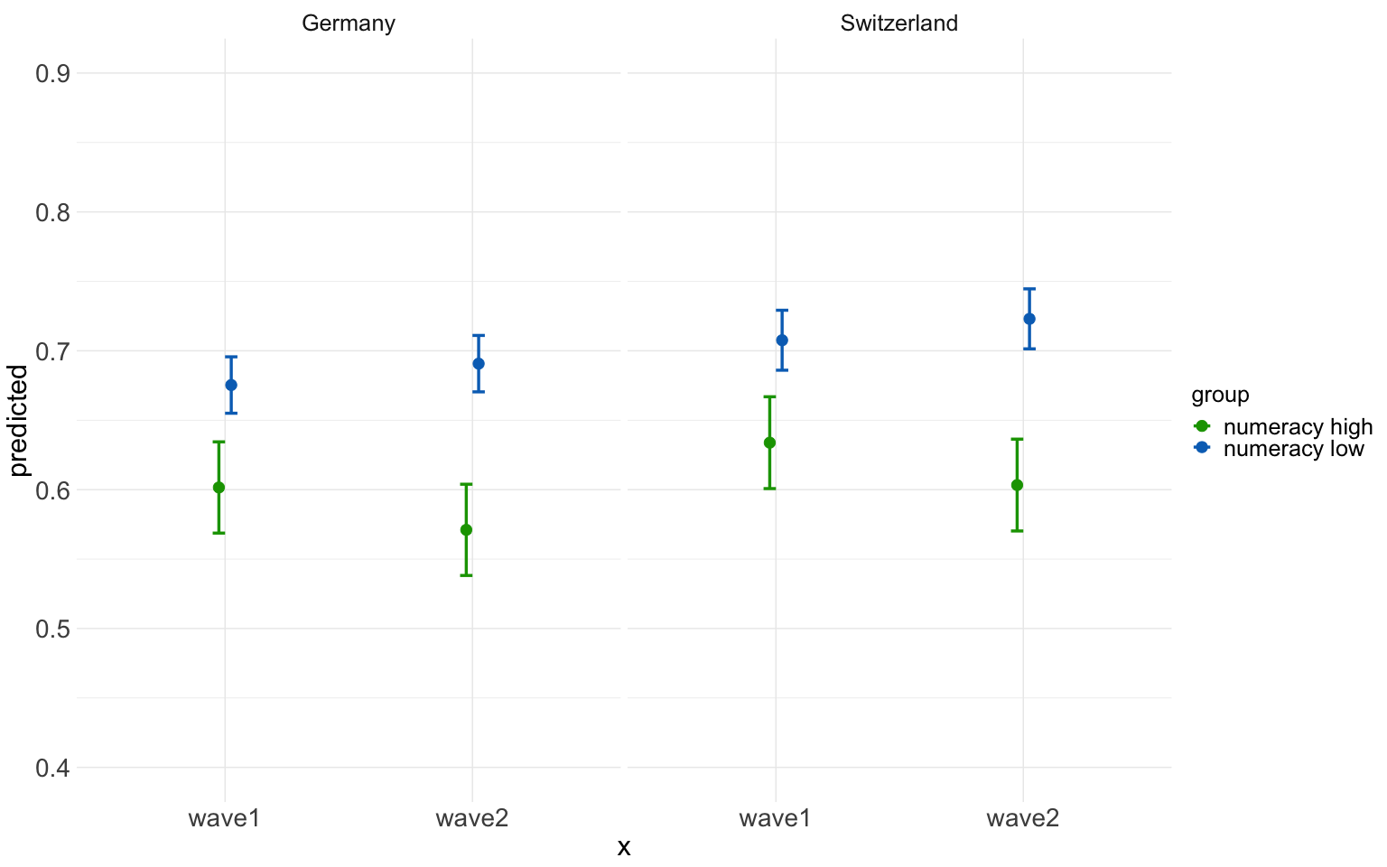

### Plot: Everything in one plot

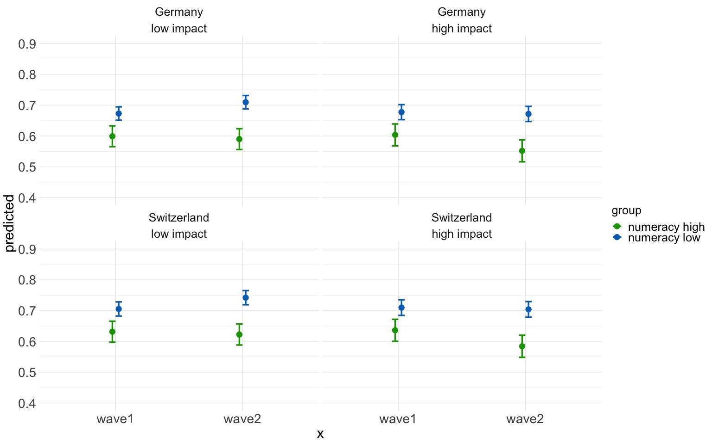

### Plot: Everything in one plot2

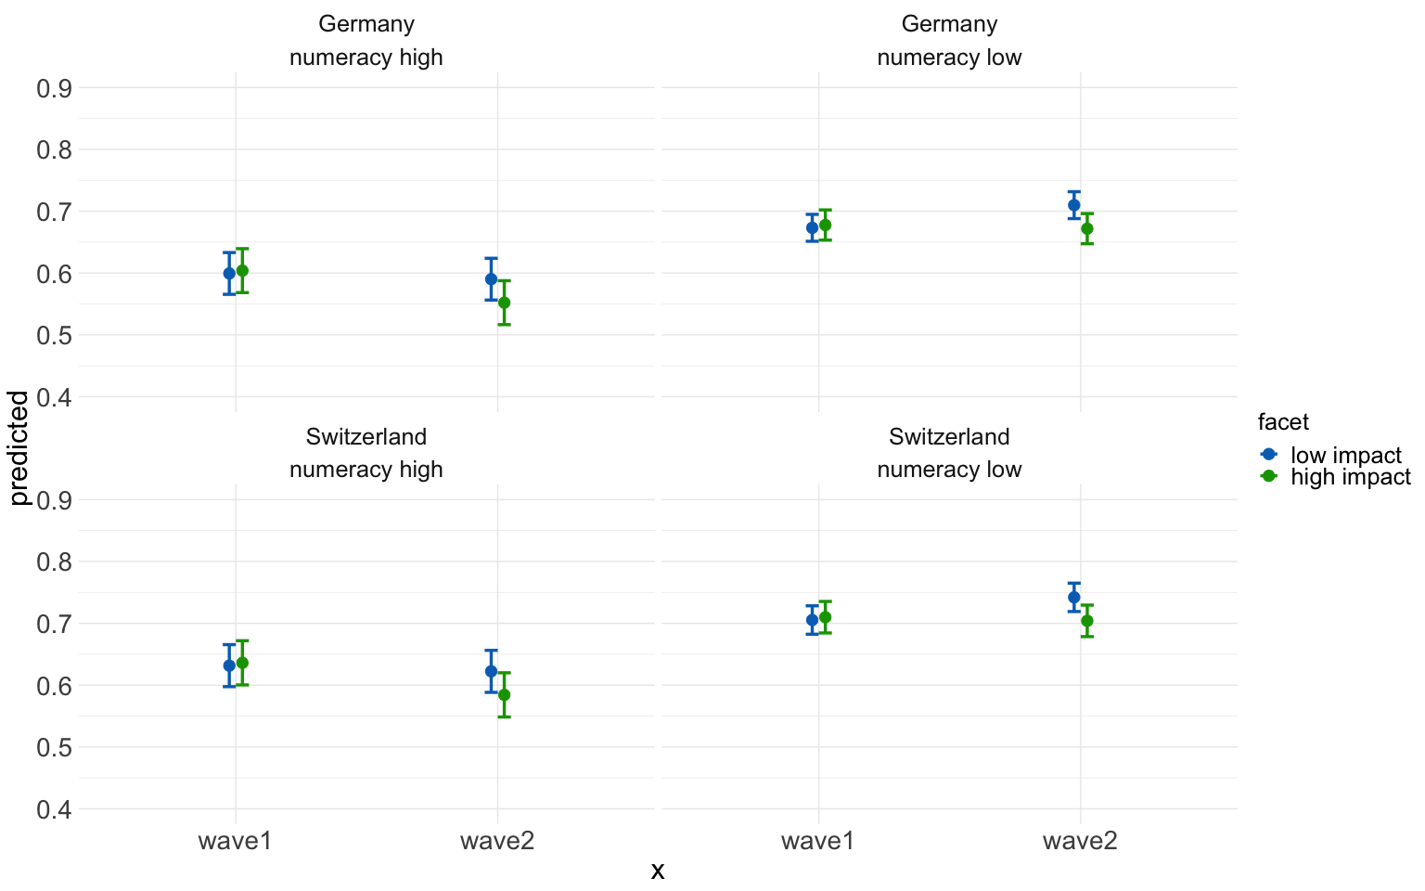

## By country

### Switzerland

## Analysis of Deviance Table (Type III Wald F tests with Kenward-Roger df)  
##   
## Response: error  
## F Df Df.res Pr(>F)   
## (Intercept) 4372.6574 1 474.4 < 2.2e-16 ***  
## numeracy.f 31.0434 1 453.0 4.336e-08 ***  
## wave 0.4455 1 6821.0 0.5044796   
## impact 87.6079 1 6821.0 < 2.2e-16 ***  
## numeracy.f:wave 10.9238 1 6821.0 0.0009543 ***  
## wave:impact 3.0367 1 6821.0 0.0814473 .   
## ---  
## Signif. codes: 0 '***' 0.001 '**' 0.01 '*' 0.05 '.' 0.1 ' ' 1

## # Effect Size for ANOVA (Type III)  
##   
## Parameter | Eta2 (partial) | 95% CI  
## -----------------------------------------------  
## numeracy.f | 0.06 | [0.03, 1.00]  
## wave | 6.53e-05 | [0.00, 1.00]  
## impact | 0.01 | [0.01, 1.00]  
## numeracy.f:wave | 1.60e-03 | [0.00, 1.00]  
## wave:impact | 4.45e-04 | [0.00, 1.00]  
##   
## - One-sided CIs: upper bound fixed at [1.00].

error

Predictors

Estimates

CI

p

(Intercept)

0.65

0.63 – 0.67

<0.001

numeracy f1

-0.05

-0.07 – -0.04

<0.001

wave1

0.00

-0.01 – 0.02

0.504

impact1

0.06

0.04 – 0.07

<0.001

numeracy f1 × wave1

0.02

0.01 – 0.04

0.001

wave1 × impact1

-0.01

-0.02 – 0.00

0.081

Random Effects

σ2

0.24

τ00 m

0.02

ICC

0.06

N m

455

Observations

7280

Marginal R2 / Conditional R2

0.021 / 0.084

### Plot Switzerland

## Scale for y is already present.  
## Adding another scale for y, which will replace the existing scale.

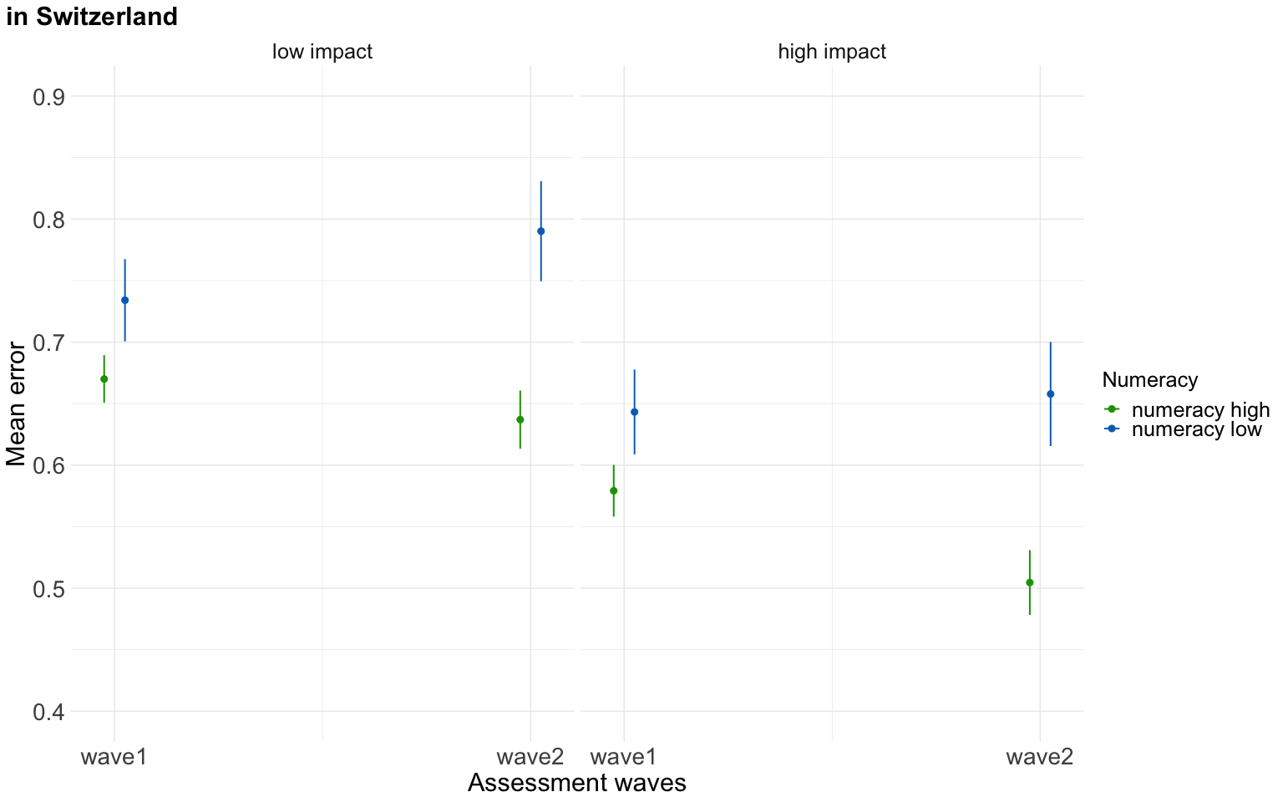

### Germany

error

Predictors

Estimates

CI

p

(Intercept)

0.65

0.63 – 0.67

<0.001

numeracy f1

-0.04

-0.07 – -0.02

<0.001

wave1

0.00

-0.01 – 0.01

0.704

impact1

-0.03

-0.04 – -0.02

<0.001

numeracy f1 × wave1

0.00

-0.01 – 0.01

0.782

wave1 × impact1

-0.01

-0.02 – -0.00

0.041

Random Effects

σ2

0.22

τ00 m

0.03

ICC

0.13

N m

525

Observations

8400

Marginal R2 / Conditional R2

0.009 / 0.135

## Analysis of Deviance Table (Type III Wald F tests with Kenward-Roger df)  
##   
## Response: error  
## F Df Df.res Pr(>F)   
## (Intercept) 3218.1250 1 537.4 < 2.2e-16 ***  
## numeracy.f 14.2630 1 523.0 0.0001772 ***  
## wave 0.1445 1 7871.0 0.7038393   
## impact 38.0391 1 7871.0 7.276e-10 ***  
## numeracy.f:wave 0.0766 1 7871.0 0.7819412   
## wave:impact 4.1912 1 7871.0 0.0406683 *   
## ---  
## Signif. codes: 0 '***' 0.001 '**' 0.01 '*' 0.05 '.' 0.1 ' ' 1

## # Effect Size for ANOVA (Type III)  
##   
## Parameter | Eta2 (partial) | 95% CI  
## -----------------------------------------------  
## numeracy.f | 0.03 | [0.01, 1.00]  
## wave | 1.84e-05 | [0.00, 1.00]  
## impact | 4.81e-03 | [0.00, 1.00]  
## numeracy.f:wave | 9.73e-06 | [0.00, 1.00]  
## wave:impact | 5.32e-04 | [0.00, 1.00]  
##   
## - One-sided CIs: upper bound fixed at [1.00].

### Plot Germany

## Scale for y is already present.  
## Adding another scale for y, which will replace the existing scale.

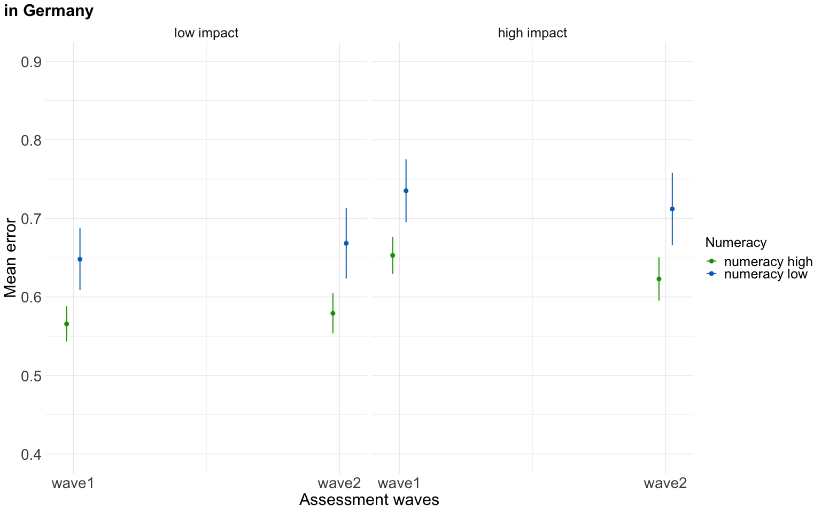

## across waves cohens q

Original pre-registered plan to compare cohens q

For high numeracy people ths difference does approach a small effect (such that the correlation between estimates and actual values ist higher in wave2)

## Cohens q = -0.0491670467886844

high numeracy

## Cohens q = -0.0932812950061401

For high numeracy people the cohens q (rounded) can be categorized as a small effect

without pattern people

## Cohens q = -0.0497625254424904

high numeracy no pattern people

## Cohens q = -0.0912862921460136

For high numeracy people the cohens q (rounded) can be categorized as a small effect