Label 1 – Shallow Breathing
Clear reduction in amplitude of respiratory belt signals (lungs + diaphragm), without complete disappearance, with preserved or even increased respiratory rate.
Conditions:
- Amplitude reduction: 20–35% of reference amplitude (60-second analysis windows of stable recording).
- Duration: sustained ≥30 s.
- No desaturation (SpO₂ < 90% or SpO₂ drop ≥3–4% below baseline – baseline defined as mean from first 30–60 s of recording).

Label 2 – Irregular Breathing
Irregular breathing means that durations of consecutive breathing cycles and amplitudes vary unpredictably and without a clear pattern.
Conditions:
Inter-breath intervals (IBI) calculated as time between consecutive respiratory peaks (30–60 s segments).
- Coefficient of variation (CoV) of respiratory intervals.
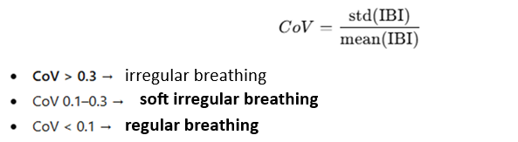
- Root mean square of successive differences (RMSSD).
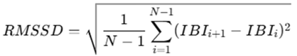
If CoV ≥ 0.3 or RMSSD ≥ 0.5 s → label: irregular breathing.
Note: Calculated separately for lungs and abdomen. No breathing pauses (≥10 s) allowed in the analyzed signal.

Label 3 – Slow Breathing (Bradypnea)
Reduced respiratory rate.
Mean respiratory rate (RR) ≤ 10 breaths/min sustained for ≥30 s.
60-second windows analyzed. If fewer than 10 breaths occur for at least 30 s → slow breathing.
Notes:
- Distinguish “slow + deep” vs “slow + shallow” using amplitude analysis (as in shallow breathing).
- If accompanied by SpO₂ drop ≥3% → label as slow breathing with desaturation (possible delay in SpO₂ signal).

Label 4 – Rapid Breathing (Tachypnea)
Increased respiratory rate.
Mean RR ≥20 breaths/min sustained for ≥30 s.
If more than 20 breaths for at least 30 s → rapid breathing.
Notes:
- Distinguish “fast + deep” vs “fast + shallow” via amplitude analysis.
- If SpO₂ drop ≥3% accompanies rapid breathing → label as rapid breathing with desaturation (possible SpO₂ delay).

Label 5 – Respiratory Asynchrony / Dyssynchrony
Lack of synchronization between lungs and diaphragm movements.
Possible cases:
- Mild asynchrony – phase shift
- Paradoxical breathing – movements in opposite directions (e.g., chest rises while abdomen falls)
Possible detection methods:
- Time–frequency methods (e.g., mathematical framework used by Tomislav)
- Phase coherence between diaphragm and chest signals in 60-second windows

Label 6 – Desaturation (Hypoxia)
Desaturation = episode where SpO₂ significantly decreases relative to baseline or crosses a low absolute threshold.
Criteria:
Episode = (ΔSpO₂ ≥3% or SpO₂ <90% relative to defined baseline) and duration ≥10 s.
Baseline: median SpO₂ from first 60s of stable recording.
Relation to other signals:
- ECG: HR often increases during desaturation
- BP: sudden increases/decreases may accompany acute SpO₂ drops

Label 7 – Apnea
Episode with near-complete absence of respiratory movements (no ventilation) for at least 10 s.
- Amplitude criterion: lungs ≤10% reference amplitude AND diaphragm ≤10% reference amplitude (≥90% reduction).
- Duration ≥10 s.
- Optional: accompanying SpO₂ drop (e.g., ≥3% within 30–60 s) – increases diagnostic certainty.
Note: With current measurements, it is not possible to distinguish central apnea (no respiratory effort) from obstructive apnea (respiratory effort present but no airflow – requires mask measurement).

Label 8 – Sigh
Single breath with clearly larger amplitude and/or prolonged inspiratory phase compared to normal cycles.
Conditions:
Cycle amplitude (max–min) ≥1.5 × median amplitude from previous 60 s of stable recording.
Additionally:
Frequency ≥7–10 sighs per 30 minutes.
Sighs may co-occur with:
- prolonged irregular breathing
- frequent SpO₂ drops
- significant chest–diaphragm asynchrony
- notable HR/BP changes

