AgriConnect
System Design Case Study
Empowering Farmers, Redefining Agricultural Procurement
Prepared by Ninad Patil
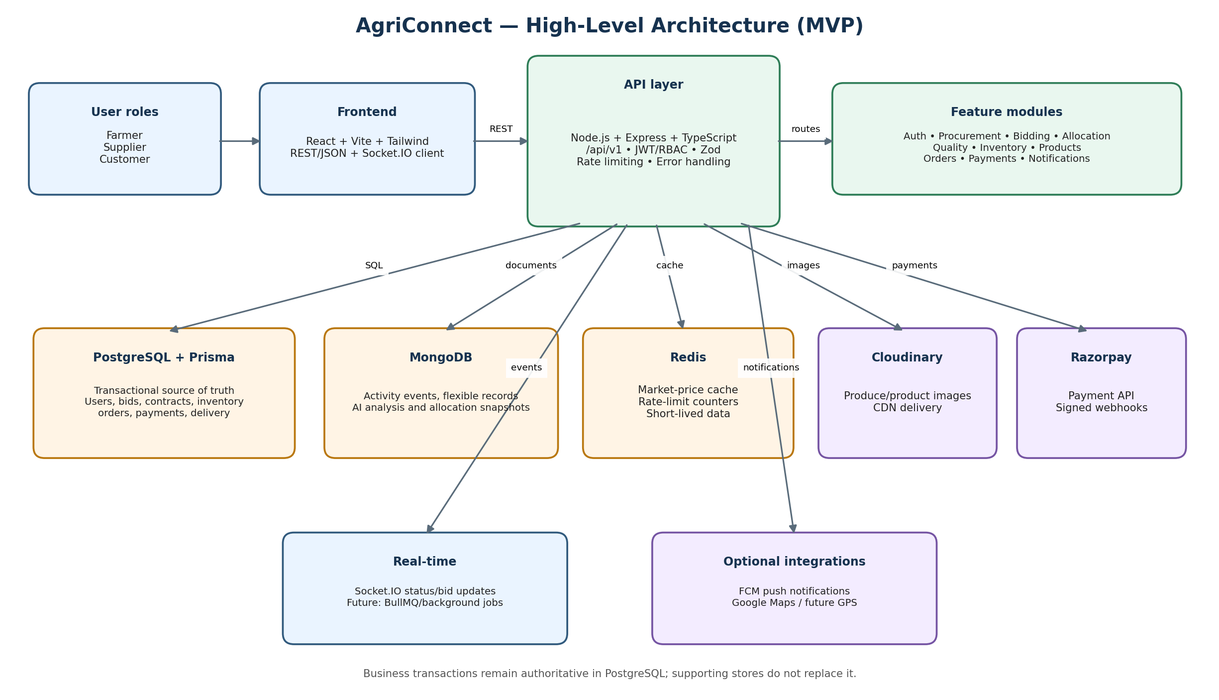

Document Guide
- 1. Executive Summary
- 2. Problem Statement and Proposed Solution
- 3. Goals, Scope, and Assumptions
- 4. Requirements
- 5. Capacity Estimation
- 6. High-Level Architecture
- 7. Core User Workflows
- 8. API Design
- 9. Data Model and Persistence
- 10. Smart Allocation Design
- 11. Consistency, Transactions, and Idempotency
- 12. Security
- 13. Reliability and Failure Handling
- 14. Scalability and Performance
- 15. Observability and Deployment
- 16. Design Trade-offs
- 17. Risks, Gaps, and Validation Plan
- 18. Future Roadmap
- 19. Conclusion
- 20. References and Appendix

1. Executive Summary
AgriConnect is a role-based agricultural procurement and marketplace platform connecting farmers, suppliers, and customers. It digitizes procurement requests, open bidding, bid recommendations, quality verification, inventory ownership transfer, B2C listings, orders, payments, and delivery status.
The MVP uses a modular monolith: a React frontend communicates with a Node.js/Express/TypeScript API. PostgreSQL is the transactional source of truth, MongoDB stores flexible activity and analysis records, Redis supports caching and rate-limit counters, Socket.IO provides real-time updates, Cloudinary stores images, and Razorpay handles payment collection.
The central design principle is to keep business-critical state changes consistent and auditable while keeping the first deployment simple enough for a small team.

2. Problem Statement and Proposed Solution
Traditional agricultural supply chains can suffer from opaque pricing, fragmented procurement, delayed payments, quality disputes, weak traceability, and mismatches between available produce and buyer demand.
AgriConnect lets suppliers publish demand, farmers submit visible bids, and suppliers use explainable allocation recommendations while retaining the final decision. After delivery, quality verification determines whether accepted produce moves into supplier inventory. Verified inventory can then be listed for customers.

3. Goals, Scope, and Assumptions
Goals: improve price transparency; make procurement decisions traceable; support fair, explainable bid ranking; prevent inventory overselling; verify payments server-side; and provide low-latency status updates.
In-scope roles are exactly Farmer, Supplier, and Customer. Core features include authentication, procurement, bidding, contracts, quality verification, inventory, product listings, carts/orders, payments, delivery status, notifications, and cached market prices.
MVP exclusions: admin panel, multi-supplier cart, live GPS tracking, AI-based automatic quality grading, advanced analytics, and microservices. Development assumes local/Docker database services, Razorpay test credentials when payments are exercised, and Cloudinary for image storage.

4. Requirements
Functional: registration/login and role-based routes; suppliers create and close procurement requests; farmers browse requests and submit/update/withdraw bids before deadlines; suppliers review ranked recommendations and accept bids; contracts record allocation; delivery and quality checks determine ownership transfer; inventory becomes product listings; customers checkout and track orders; payments are confirmed through verified webhooks; notifications and market-price data are available.
Non-functional: transactional consistency for critical writes; idempotent payment processing; authenticated and authorized access; request validation; rate limiting; responsive UI; cache-backed market prices; graceful error responses; auditability; and a modular structure that can evolve without premature service decomposition.
Initial performance targets are hypotheses, not measured guarantees: typical API responses under roughly 200 ms for uncomplicated requests, and an MVP pilot of around 1,000–10,000 registered users, 50–200 concurrent users, and approximately 20–50 total requests per second at peak. Validate these estimates with load tests.

5. Capacity Estimation
Users: plan for 1k–10k registered users and 50–200 concurrent users in the initial pilot. These are planning assumptions.
Traffic: lightweight authentication and read requests may account for 10–30 RPS; bidding and checkout may account for 5–20 RPS, for an approximate peak planning range of 20–50 RPS. Actual traffic distribution must be measured.
Storage: PostgreSQL should hold core relational data such as users, bids, contracts, inventory, orders, and payments. The initial relational footprint is expected to be modest (a few GB). MongoDB growth depends on activity logs and snapshots. Redis is for short-lived/cache data rather than durable business records.
Media: upload images to Cloudinary and serve them through its delivery network; avoid storing large image blobs in relational tables.

6. High-Level Architecture
Architectural style: modular monolith with feature boundaries inside one backend deployment. This reduces deployment and operational overhead while allowing transactions to span related business operations. Extract services only when scale, ownership boundaries, or operational needs justify the cost.
Frontend: React + Vite + Tailwind. It calls the versioned REST API and uses Socket.IO for live updates.
Application/API: Node.js + Express + TypeScript under /api/v1. Shared middleware handles JWT authentication, role authorization, request validation, rate limiting, security headers, CORS, and structured errors. Feature modules include auth, procurement, bidding, allocation, quality, inventory, products, orders, payments, notifications, market prices, and tracking.
Persistence: PostgreSQL + Prisma is the authoritative store for business transactions. MongoDB stores flexible activity events, AI-analysis records, notification payloads, and allocation snapshots. Redis supports cache-aside market-price reads and rate-limit counters. Cache loss must not corrupt business state.
External systems: Cloudinary for images, Razorpay for customer payment collection, optional Firebase Cloud Messaging for push notifications, and optional Google Maps for future mapping/tracking. Socket.IO delivers best-effort live events; persisted database state remains authoritative.

7. Core User Workflows
7.1 Authentication: a user registers or logs in; the backend validates credentials, issues a signed JWT, and enforces role-specific permissions on protected routes.
7.2 Procurement and bidding: a supplier creates an OPEN procurement request with quantity, grade, deadline, transport responsibility, and terms. Farmers can browse requests and submit bids. Bids are visible to other farmers for transparency. Bid changes and withdrawals are allowed only before the deadline and while the bid remains eligible.
7.3 Allocation: after closing a request, the system calculates a weighted ranking. The supplier sees recommendations and decides which bids to accept. Accepting bids creates separate farmer contracts linked to the original procurement request, preserving partial fulfillment and audit history.
7.4 Delivery and quality: produce is physically verified after delivery. ACCEPTED or ADJUSTED quantities may transfer to supplier inventory. REJECTED produce remains under the farmer's ownership according to contract terms. DISPUTED outcomes require resolution.
7.5 Failure and re-bidding: a late delivery may receive a supplier-approved grace period. If the contract becomes FAILED, undelivered quantity returns to remaining procurement demand and can be opened for re-bidding. Preserve the original contract and failure reason for audit.
7.6 Customer purchase: supplier lists verified inventory as products. Checkout reserves stock transactionally and creates a PAYMENT_PENDING order. The backend creates a Razorpay order. A verified payment webhook confirms the order and commits the stock decrement. Delivery status changes generate notifications and real-time events.

8. API Design
Base path: /api/v1. Use REST with JSON over HTTPS in production and Bearer JWT authentication for protected endpoints. Keep a consistent success envelope such as { success: true, data: ... } and structured errors through the shared error handler. Validate incoming data using Zod.
Representative endpoints: POST /auth/register; POST /auth/login; GET /auth/me; POST /procurements; GET /procurements; PATCH /procurements/:id/close; POST /procurements/:id/accept-bids; POST /bids; PATCH /bids/:id; DELETE /bids/:id; GET /allocation/recommend/:procurementId; POST /quality/receive; POST /quality/verify; GET /inventory; POST /products; GET /products; POST /orders/checkout; GET /orders; POST /payments/create-order; POST /payments/webhook; GET /market-prices; GET /notifications.
Authorization must verify both role and resource ownership; knowing an ID must not grant access to another user's order, bid, or contract. Add pagination and filtering to list endpoints as data grows.

9. Data Model and Persistence
PostgreSQL entities include User and role profiles; ProcurementRequest; Bid and BidImage; FarmerContract; QualityVerification; InventoryItem; ProductListing; Cart and CartItem; Address; CustomerOrder and OrderItem; Payment; Delivery; Notification; Rating; and AllocationWeight. Use foreign keys, unique constraints, enums for state, and indexes for common status/date filters.
MongoDB collections may include AiAnalysis, ActivityEvent, NotificationPayload, ChatSession, and AllocationSnapshot. These are supporting/flexible records, not a second authority for payment or inventory state.
Redis stores cached market-price responses keyed by crop and date range, plus rate-limit counters and explicitly short-lived data. Use configurable TTLs and cache-aside reads.
Store images in Cloudinary and keep URLs and metadata in application records.

10. Smart Allocation Design
Use a normalized weighted score with initial configurable weights: price 30%, quality 25%, quantity fit 15%, delivery 10%, distance 10%, and farmer reliability 10%. Normalize each factor to a comparable 0–1 scale; lower prices should score better, while quality, fit, reliability, and delivery suitability score higher under defined rules.
Reject ineligible bids before ranking—for example, bids after the deadline or bids that fail hard quantity/grade constraints. Explain score components to the supplier and store a snapshot of weights and ranked results for audit.
The algorithm recommends; it does not automatically award contracts. This human-in-the-loop choice preserves supplier accountability.

11. Consistency, Transactions, and Idempotency
Bid acceptance: in a transaction, verify procurement and bid states, create accepted contracts, update bid statuses, and update remaining quantity. Prevent double acceptance through state checks and suitable database constraints.
Checkout: reserve inventory in a transaction and ensure available quantity is sufficient before creating the reservation. Use conditional updates or suitable locking/isolation to prevent concurrent checkouts from overselling stock.
Payment: create a provider order server-side, persist its reference, verify webhook signatures using the original raw request body, and process confirmations idempotently. Use provider event identifiers where available and a durable processed-event record or uniqueness constraint. Never trust a frontend success callback as proof of payment.
Inventory: on successful capture, reduce physical stock and release the reservation exactly once. On payment failure or expiry, release reservations through a safe, idempotent expiry path. Reconcile payment/order state if webhook delivery is delayed.
A transaction alone does not automatically prevent every race condition. Verify these correctness properties with database constraints and concurrency tests.

12. Security
Authentication: bcrypt password hashing and signed JWTs with a strong secret. Authorization: role middleware plus resource ownership checks.
Use HTTPS in production, Helmet security headers, explicit CORS allow-list, request size limits, rate limiting, and Zod validation.
Payments: keep Razorpay secrets server-side, use test keys in development, verify webhook signatures against raw request bytes, validate expected order/amount/currency, and make processing idempotent.
Uploads: restrict allowed image types and sizes; do not trust filename or client-provided MIME type alone. Keep Cloudinary credentials on the backend.
Keep real credentials in ignored .env files locally and a secret manager in production. Never commit credentials or expose server-side keys to the React bundle.

13. Reliability and Failure Handling
Database outage: fail critical writes clearly and do not pretend they succeeded. Check database readiness at startup and use timeouts/retry policies carefully.
Redis outage: fall back to the source for cacheable market-price reads where safe; define a rate-limiting fallback. Never make Redis the only record of a payment, contract, or inventory movement.
Payment failure: leave the order in an appropriate pending/failed state, do not confirm without verified provider evidence, and reconcile delayed or duplicate webhooks.
Socket.IO is best-effort: clients should refetch persisted state after reconnecting. Store important notifications/events durably where required.
Production recovery: schedule PostgreSQL and MongoDB backups, test restore procedures, and define retention policies for logs and images.

14. Scalability and Performance
Start with a single backend instance and vertical scaling. Keep API instances stateless so horizontal scaling behind a load balancer is possible later; use shared Redis for cross-instance coordination where required.
Add indexes based on query plans and workload measurements. Avoid N+1 queries, return only needed fields, paginate large results, and tune connection pools.
Use cache-aside for market prices and Cloudinary for media delivery. If asynchronous work becomes material, add a queue such as BullMQ for retries, notifications, or expensive analysis. Ensure jobs are idempotent.
Potential bottlenecks include concurrent bid submissions, inventory reservation writes, payment/webhook bursts, and large procurement lists. Load test before adding read replicas, queues, or service decomposition.

15. Observability and Deployment
Development: Docker Compose runs PostgreSQL, MongoDB, and Redis, while backend and frontend can run locally. Keep environment variables separate. Provide /health for a basic service check.
Production: serve the built frontend through a static host/CDN or web server; run the Node API behind HTTPS/reverse proxy; use managed databases where practical; store secrets securely; and apply schema migrations through a controlled release process.
CI/CD should run linting, TypeScript checks, unit/integration tests, Prisma validation, builds, and dependency/security review. Use structured logs, metrics, and alerts for API errors, latency, database connections, payment failures, and webhook retries.
A basic health endpoint may prove API liveness without proving that every dependency is healthy unless dependency checks are included.

16. Design Trade-offs
Modular monolith over microservices: faster development, simpler deployment, and easier cross-domain transactions; the trade-off is less independent scaling and deployment. Revisit when domain boundaries and team/traffic needs justify extraction.
PostgreSQL + MongoDB + Redis: each store serves a distinct purpose, but multiple stores increase operational complexity. Keep PostgreSQL authoritative for core business state.
Recommendation-only allocation: preserves supplier control and explainability, but requires a human decision.
Reserve-then-decrement inventory: protects against overselling during pending payments, but requires reliable reservation expiry and failure handling.
Socket.IO over polling: improves freshness, but events are not durable truth; clients must recover by reading from the API.

17. Risks, Gaps, and Validation Plan
Before production, verify raw-body webhook signature handling, event deduplication, amount/currency validation, inventory reservation expiry, concurrent checkout behavior, and exactly-once stock transitions.
Add automated tests for role authorization, bid deadlines, partial procurement fulfillment, quality outcomes, failed-delivery re-bidding, duplicate webhooks, payment failure, and concurrent inventory reservations.
Confirm ownership transfer and payment policies match contract requirements. Define dispute resolution, refund/cancellation behavior, and rejected produce handling explicitly.
Run a small load test against procurement and checkout flows. Treat current RPS and latency values as estimates until measured.

18. Future Roadmap
Near term: complete automated tests, strengthen webhook verification and inventory concurrency, add structured observability, and document the API and data model.
Medium term: add background jobs for notifications/retries, push notifications, improved market-price source integration, analytics, and audit tooling.
Long term: AI-assisted quality grading, live GPS tracking/ETA, fraud detection, and extraction of high-change or high-scale domains into services only when justified by evidence.

19. Conclusion
AgriConnect centers on transparent procurement, supplier-controlled bid allocation, quality-driven ownership transfer, verified inventory, and secure customer checkout. A modular monolith with PostgreSQL as the transactional authority provides a practical MVP foundation. MongoDB, Redis, Socket.IO, Cloudinary, and Razorpay support flexible records, caching, live updates, media, and payments.
The design is intentionally evolvable: validate workflows and transactional correctness first, then use measured traffic and operational evidence to decide where asynchronous processing, stronger observability, or service decomposition is necessary.

20. References and Appendix
Project artifacts: README.md; Explanation.md; backend/prisma/schema.prisma; backend/src/app.ts; backend/src/modules/payments/payment.service.ts; docker-compose.yml.
Consult official PostgreSQL, Prisma, MongoDB, Redis, Express, Socket.IO, Razorpay, Cloudinary, React, Vite, and Tailwind documentation.
Appendix: the architecture diagram is included in this document. Capacity estimates are initial assumptions and should be recalibrated after pilot telemetry.

