**Bookmarks**

**How to use bookmarks:**

Step 1: First create Buttons

Step 2: Under Visualization 🡪 Under Style 🡪 On Text Button 🡪Write name as per requirement

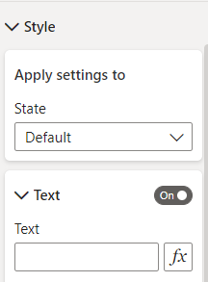

Step 3: Click on View Tab 🡪 Click on Selection Pane 🡪 Also Click on Bookmark Pane

Step 4: In Selection Pane 🡪 Hide Chart

Step 5: Click on Add Button 🡪 Rename Bookmark

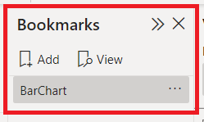

Step 6: Under Visualization 🡪 On Action Pane 🡪 Under Type Choose Bookmark 🡪 Under Bookmark Choose Bookmark Name

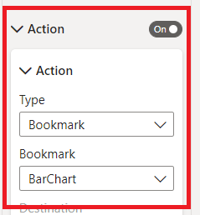

Final Output: CTRL + Click on that Button