**DRILLTHROUGH**

**How to use Drill Through:**

Step 1: First Create Target Page

Step 2: In Target Page 🡪 Create Table or Matrix Visualization

Step 3: Choose columns what you want to filter out in table or matrix visualization

Step 4: In Target Page 🡪 Under Drill Through Drag & Drop all the Text columns which you want to filter the data

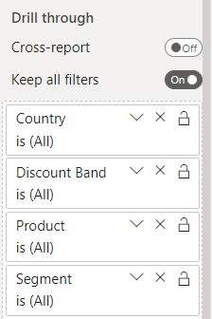

Step 5: In Visualization where we select above Text Columns, automatically filters will apply

Step 6: Right Click on Visualization and Choose that page 🡪 It will take you to drill through page

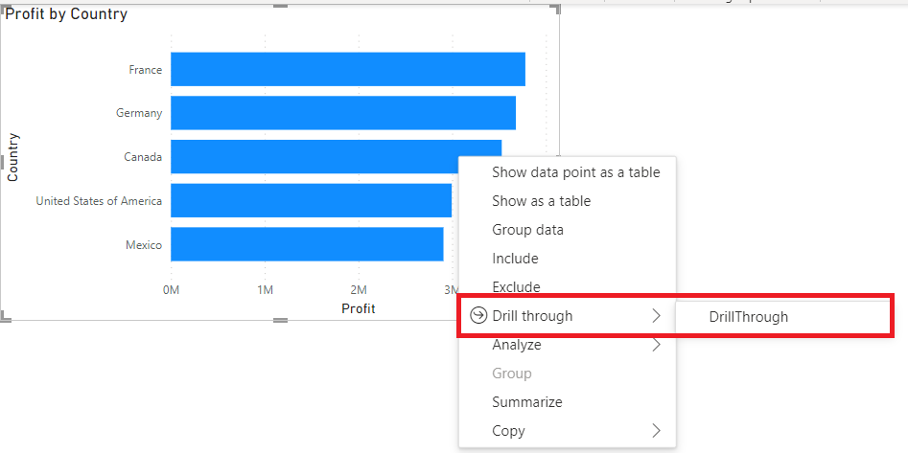

Output:

**We can create Button too for Drill Through**

Step 1: First create Buttons

Step 2: Under Visualization 🡪 Under Style 🡪 On Text Button 🡪Write name as per requirement

Step 3: Under Visualization 🡪 On Action Pane 🡪 Under Type Choose Drill Through 🡪 Under Destination Choose Drill Through Page

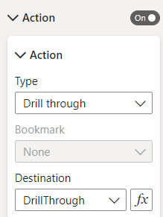

Step 4: Button Directly will not appear 🡪 First Click on one bar or slice 🡪 which you want to filter 🡪 than only that button will appear 🡪 CTRL + Click 🡪 It will take you to drill through page

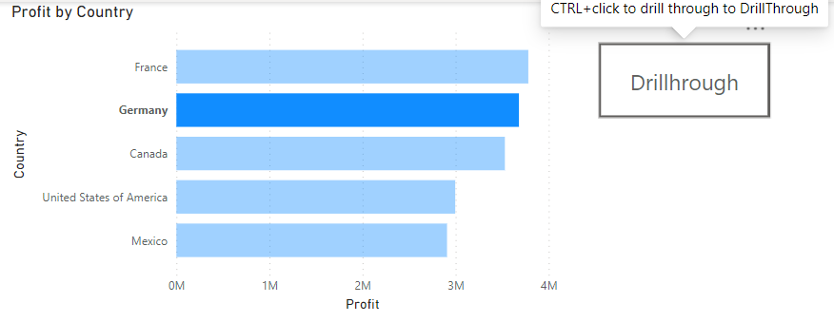

Output:

