**Design and Analysis of an Electric Kart**

Final report for the course: Automotive Electronics (Summer Semester 2025)

|  |  |
| --- | --- |
| Student name: Ninad Deshpande | Mentor name: Prof. Yingping Huang |

**1. Introduction to Electric Vehicles**

**1.1 Concepts of Electric Vehicles (EVs)**

Electric Vehicles (EVs) are automobiles powered by electric motors instead of internal combustion engines (ICEs). They rely on rechargeable battery packs to store energy, which is then converted into mechanical motion. EVs can be fully electric (BEVs), hybrid (HEVs), or plug-in hybrid (PHEVs).

**1.2 Advantages of Electric Vehicles**

* Environmentally Friendly: Zero tailpipe emissions reduce air pollution.
* Energy Efficiency: EVs convert over 77% of electrical energy into motion, compared to 12-30% in ICEs.
* Lower Operating Costs: Electricity is cheaper than gasoline, and EVs have fewer moving parts, reducing maintenance.
* Regenerative Braking: Recovers kinetic energy during deceleration, improving efficiency.

**1.3 Challenges of Electric Vehicles**

* Limited Range: Battery capacity restricts travel distance.
* Charging Infrastructure: Insufficient charging stations in some regions.
* High Initial Cost: Battery technology is expensive.
* Battery Degradation: Performance decreases over time.

**1.4 Examples of Electric Vehicles with different architectures**

**Tesla Model S (Battery Electric Vehicle - BEV)**

* Architecture: Pure electric, no internal combustion engine (ICE).
* Key Features:
  + High-capacity lithium-ion battery pack (100 kWh).
  + Dual-motor all-wheel-drive (AWD) system.
  + Supercharger network for fast DC charging.
* Mainstream, long-range BEV with advanced battery management.

**BMW i3 with Range Extender (Plug-in Hybrid - PHEV)**

* Architecture: Series hybrid with a small gasoline engine acting as a generator.
* Key Features:
  + Primary propulsion via electric motor (BEV mode).
  + Small ICE (647cc) recharges the battery when depleted (no direct drive).
  + Carbon-fibre-reinforced body for weight savings.
* Transitional PHEV design for urban mobility with extended range.

**BYD Han (Dual-Motor Plug-in Hybrid - PHEV)**

* Architecture: Parallel hybrid with both ICE and electric motor driving the wheels.
* Key Features:
  + Combines a 2.0L turbocharged ICE with an electric motor.
  + Blade Battery (LFP chemistry) for improved safety.
  + Can operate in EV-only, hybrid, or ICE-only modes.
* Focus on cost-effective, flexible PHEV systems

**1.5 History of Electric Vehicles**

The first electric car was developed in the 1830s, but ICE dominance in the 20th century delayed EV adoption. Recent advancements in battery tech (Li-ion) and environmental concerns have revived EVs, with Tesla leading the market since the 2000s.

**2. Architectural Overview of Electric Vehicles**

The fundamental architecture of electric vehicles (EVs) represents a paradigm shift in automotive engineering, replacing traditional internal combustion systems with an integrated electromechanical propulsion system. At the heart of this architecture lies an advanced energy storage system that powers a highly efficient electric drivetrain, supported by sophisticated power electronics and control systems. This configuration eliminates numerous mechanical components found in conventional vehicles while introducing new electrical subsystems that require precise energy management and thermal regulation. The key components of an EV architecture are:

**2.1 Battery**

Battery is a key component that allows an electric vehicle to function without having a constant direct connection, by storing electric energy in the form of chemical energy. There are different types of chemical compositions used in batteries based on the application, like Lithium-ion (Li-ion) batteries are preferred for flagship EVs with long range and high-power ratings, Nickel-Metal Hydride (NiMH) batteries are more in use for hybrid EVs and low-cost applications and Lead-Acid batteries are mostly used in low cost and short range applications in accessory vehicles like Golf karts.

**2.2 Power Converter**

The power converter is a critical component in electric vehicles, responsible for regulating voltage and current between the battery and the motor. It comes in different types, including DC-DC converters (which adjust DC voltage levels) and inverters (which convert DC to AC for AC motors). Its operation relies on semiconductor switches like MOSFETs and IGBTs, which rapidly turn on and off to control power flow efficiently. By managing energy conversion, the power converter ensures optimal motor performance and battery utilization.

**2.3 Motor/Generator**

The motor/generator serves a dual role in electric vehicles, functioning either as a motor to convert electrical energy into mechanical motion or as a generator to transform kinetic energy back into electricity during regenerative braking. Common types include DC motors, AC induction motors, and Permanent Magnet Synchronous Motors (PMSM), each suited for different performance needs. Its operation is based on fundamental electromagnetic principles: DC motors rely on the Lorentz force, while AC motors work through electromagnetic induction, enabling efficient energy conversion and propulsion in modern EVs.

**2.4 Regenerative Braking**

The regenerative braking system enhances energy efficiency in electric vehicles by recovering kinetic energy during deceleration and storing it back in the battery. This process works by reversing the motor’s role instead of consuming electricity to produce motion, it acts as a generator, converting the vehicle’s kinetic energy into electrical energy through electromagnetic induction. By capturing energy that would otherwise be lost as heat in traditional friction brakes, regenerative braking extends driving range while reducing wear on mechanical brake components. This smart energy-recycling principle is a key advantage of electric and hybrid vehicle systems.

**Conclusion on EV Architecture**

The transition to electric vehicle architecture demonstrates significant engineering advantages in terms of energy efficiency and system simplification. Current EV designs achieve superior energy conversion efficiency compared to internal combustion vehicles while offering greater design flexibility in vehicle packaging. Ongoing advancements in battery technology, power electronics, and vehicle control systems continue to enhance the performance and viability of this architecture. Furthermore, the inherent compatibility of EV systems with emerging autonomous driving technologies positions electric vehicles as the foundational platform for future mobility solutions. This architectural evolution reflects broader trends in sustainable transportation and represents a critical area for continued research and development in automotive engineering.

**3. Modelling and Simulation of a DC motor driving system**

**3.1 Working Principle of a DC Motor**

A DC motor converts electrical energy into mechanical rotation through electromagnetic interaction governed by Lorentz force law. The Lorentz forces act through the interaction between its armature circuit and stator magnetic field. When powered, current flows through the armature coils wound around the rotor, creating a magnetic field that reacts with the stator's fixed field to produce rotational torque. As the rotor turns, the commutator and brushes reverse current direction in the coils to maintain continuous motion. The spinning rotor simultaneously generates a back-EMF voltage that opposes the input voltage, naturally regulating speed. This electromechanical energy conversion drives the connected load while offering responsive speed control, making DC motors particularly effective for small electric vehicles and precision applications.

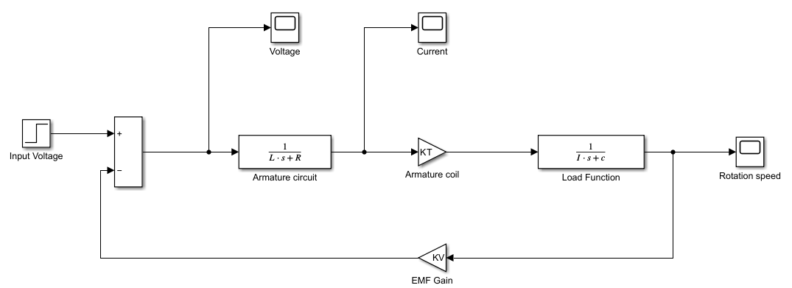

Figure 1:DC motor block diagram with transfer functions

**3.2 Mathematical model of a DC Motor:**

Starting with the input voltage at the Armature circuit, the input voltage at armature circuit can be represented as: $$V=Va-Vemf$$ where *Va* is the input voltage supply and *Vemf* is the back EMF voltage due to the rotary motion

The equation for the armature circuit is represented as: $$V=Ra*I+ La*\frac{dI}{dt}$$

After applying Laplace transforms to simplify the algebraic equations, the transfer function can be represented as a ratio of Output to Input.

$$V\left(s\right)=R*I\left(s\right)+L*s*I\left(s\right)$$

$$\frac{I\left(s\right)}{V\left(s\right)}=\frac{1}{R+L*s}$$

The output current from the armature circuit induces Torque in the rotor through the armature coil.

$$T=Kt*I\left(s\right)$$

The torque is then transferred to the load, which can be represented with this equation: $$T=J*\frac{dω}{dt}+c*ω$$

Which is again, Laplace transformed for simplification, resulting in the equation: $$T\left(s\right)=J*s*ω\left(s\right)+c*ω\left(s\right)$$

The transfer function is then represented as the ratio of output to input: $$\frac{ω\left(s\right)}{T\left(s\right)}=\frac{1}{J*s+c}$$

And thus, the rotation speed ω is generated

Additionally, because of the rotary motion, EMF voltage is generated through the function: $$Vemf= Kv*ω$$

**3.3 Solving for the Overall Transfer Function of the System**

Now, to find the overall transfer function, the individual element transfer functions are considered at each block

The forward transfer function for the series elements is calculated as: $$G\left(s\right)=\frac{Output}{Input}=A\left(s\right)*B\left(s\right)*C(s)$$

Which can be represented by: $$G\left(s\right)= \frac{ω}{V}=\frac{1}{Ra+La*s}*Kt*\frac{1}{I*s+c}$$

Now, adding the feedback element H(s) to achieve overall transfer function, using formula: $$\frac{Output}{Input}=\frac{G\left(s\right)}{1+ H\left(s\right)*G\left(s\right)}$$

$$\frac{ω}{Va}= \frac{Kt}{J*La*s^{2}+\left(J*Ra+c*La\right)*s+\left(c*Ra+Kv*Kt\right)}$$

And resultantly, the overall transfer function of the system is achieved.

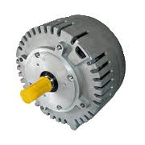

Figure 2: Mars Etec 48v DC motor for EVs

Figure 3: DC motor Simulation parameters

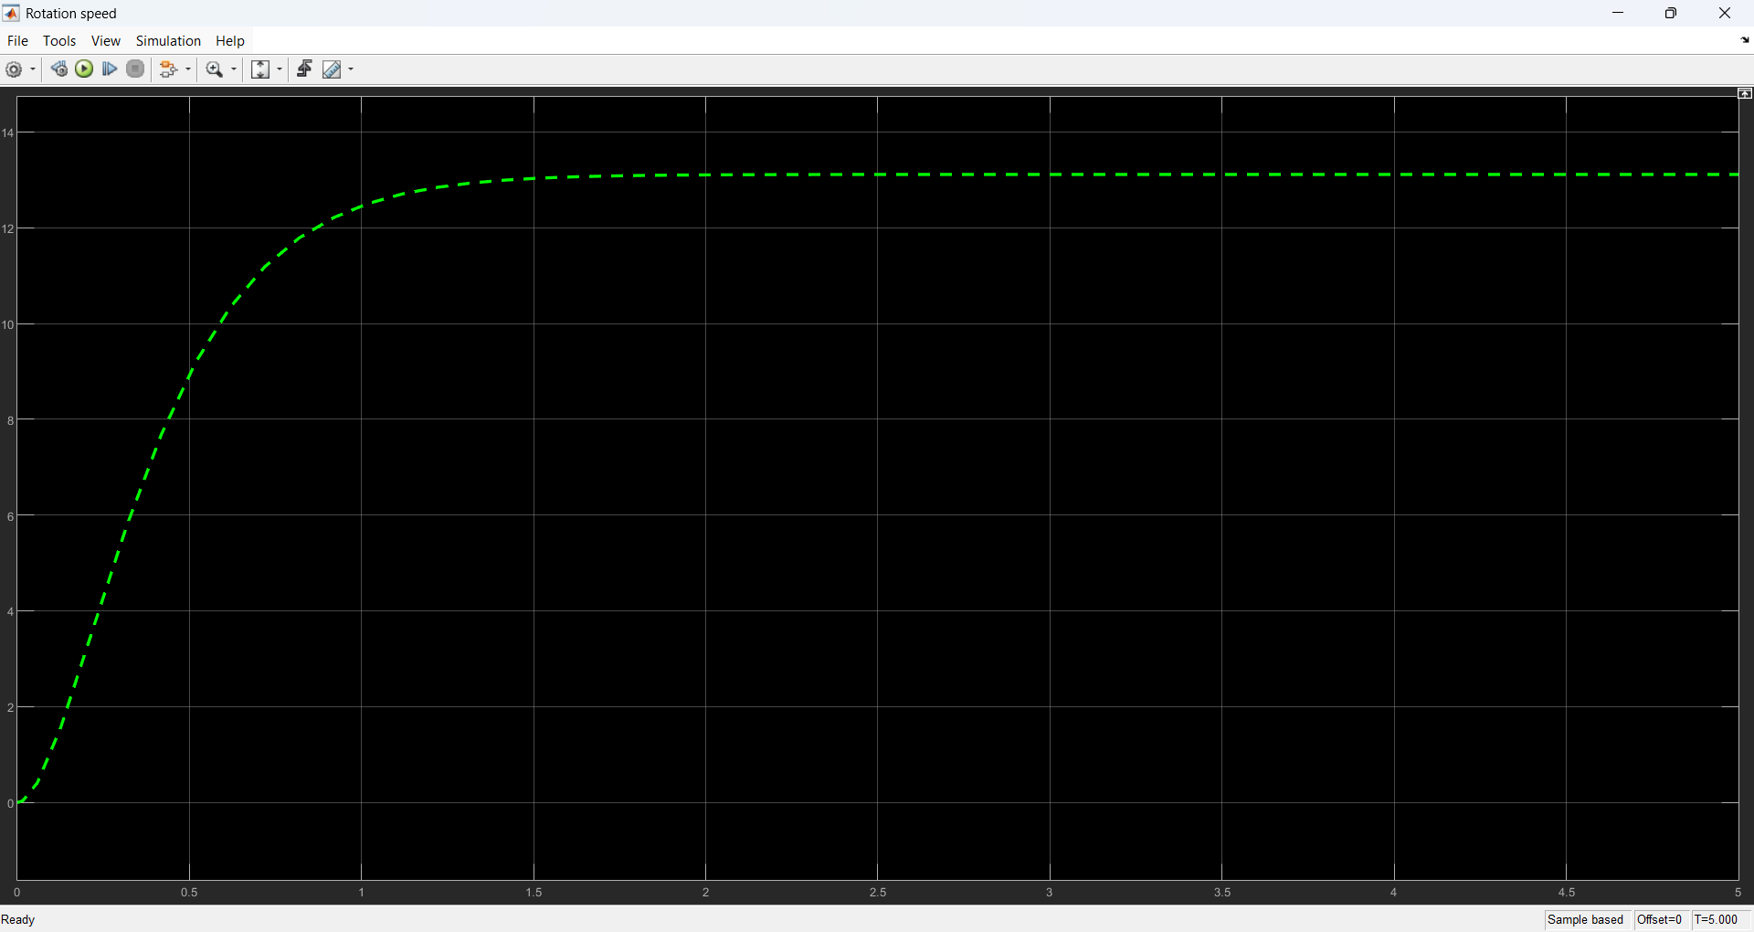

Figure 4: DC motor Rotation Speed Output

**4. Modelling and Simulation of the Electric Kart**

**4.1 Kart Model Subsystems**

**Driver**

The kart's trajectory follows an oval racing circuit comprising two semicircular segments with a 25-meter radius connected by two 100-meter straight sections. The driver model implements an optimal racing strategy where maximum acceleration is applied during straight segments until braking is required for corner entry. The cornering phase is constrained by a lateral acceleration limit of 8 m/s², with a target cornering speed of 14.14 m/s. Given a maximum braking deceleration capability of 5 m/s², this establishes a velocity profile that determines the maximum achievable speed at any position along the track. This reference velocity profile is stored in a lookup table, serving as the target speed trajectory for the vehicle control system. The control system correlates the kart's position x(t) with the target speed v(t) and generates the corresponding current demand for the power conversion system.

**Power Conversion System**

The power conversion subsystem consists of voltage transformation and power amplification components that translate the driver's current demand into appropriate motor terminal voltages. A closed-loop control architecture is implemented where the difference between the target current (derived from the desired velocity profile) and the actual armature current iₐ is processed through voltage conversion modules. These modules employ power amplification to generate the required excitation voltage for the DC motor.

**Braking System**

The braking system operates in a discrete activation mode, engaging only when the vehicle's actual velocity exceeds the target velocity profile. The control system generates a braking force through a gain module (Gain1) that implements the prescribed deceleration characteristics.

**DC Motor Model**

The DC motor is modelled through three primary components: the armature circuit, field coil, and back-EMF generation. The armature circuit dynamics are described by: $$Va-Vemf= Ra*I+ La*\frac{dI}{dt}$$ 
  
yielding the transfer function: $$\frac{1}{R+L*s}$$

**Battery System**  
The battery energy management system calculates instantaneous power consumption as the product of armature voltage and current. Battery state of charge is determined through continuous integration of the power consumption over time.

**Vehicle Dynamics**  
The drivetrain system converts motor torque T to tractive force FT at the wheels through a gear ratio Gᵣ and wheel radius Rw. The net force acting on the vehicle is given by:  
F = FT - FD - FA - FB  
where FD represents rolling resistance, FA denotes aerodynamic drag, and FB is the braking force. Vehicle acceleration is derived from Newton's second law (a = F/m), with velocity and position obtained through successive integration of the acceleration signal.

**4.2 Target Speed Profile**

The velocity reference trajectory is generated based on optimal racing principles: maximum acceleration during straight segments followed by controlled braking for corner entry. The cornering phase is constrained to 8 m/s² lateral acceleration with a target speed of 14.14 m/s at turn initiation. Given the 5 m/s² maximum braking capability, this produces a well-defined speed profile that determines the velocity upper bound at any track position, stored as a reference table for control system implementation. The output profile of the target speed in comparison with the actual speed with respect to the distance travelled on the track can be demonstrated through this graph:

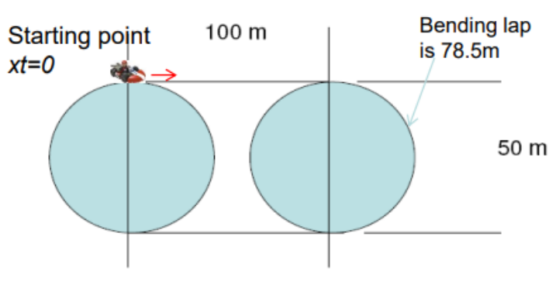

Figure 5: Electric Kart Simulation track

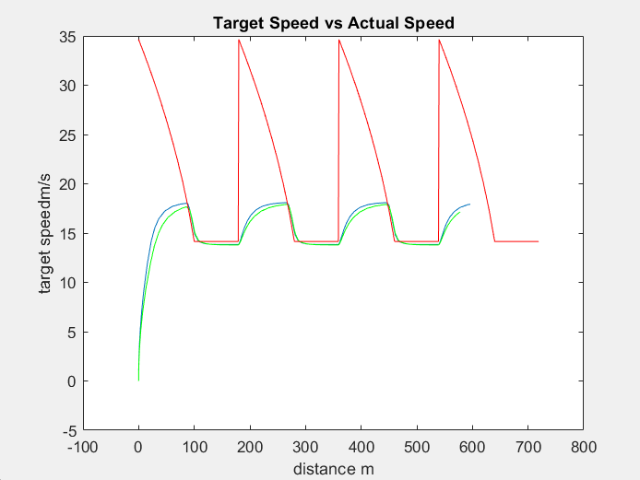

Figure 6: Electric Kart Target speed vs Actual speed

**4.3 Back-EMF Voltage justification**

The Equation that governs back EMF voltage for an Electric vehicle motor can be represented by: $$V_{b}=K_{v}ωG_{r}$$

Where Vb is the EMF voltage induced in the circuit, Gr is the gear ratio of the load, ω is the rotation speed of the load attached to the motor and Kv is the back-EMF constant. Here, in context of the Electric vehicle motor, ω can also be represented as: $$X_{d}=ωR_{w}$$

Where Rw is the wheel radius and Xd is the linear velocity of the vehicle.

Hence, the final equation comes out to be: $$V_{b}=\frac{K_{v}G_{r}X_{d}}{R_{w}}$$

**4.4 Kart Simulation and Analysis**

**4.4.1 Simulation model and Parameters**

The simulation model is divided into three components to simplify the design process.

First component is the Simulink block diagram of the model is loaded as follows:

Figure 7: Block Diagram of the Electric Kart system

Second component is an input data script that declares all the variable parameters of the model, making way for further testing options.

Figure 8: Electric Kart Simulation Parameters

Thirdly, a script to plot performance metrics of the vehicle model based on the changes made in the input data script. The results of which are compared in the next section. The graphs compare **blue (modified configuration) curves** to the **Green (default configuration) curves**, for various performance metrics like Acceleration, Velocity, Power and energy consumption.

A short analysis has been conducted to demonstrate the model and compare the vehicle performance.

**4.4.2** **Comparison of results for vehicle weight 200kg vs 150kg.**

By reducing the vehicle mass from 200kg to 150kg, the key variation in the performance of the kart is observed are:

|  |  |
| --- | --- |
| * Faster Acceleration and higher top speed, due to lesser rolling resistance at the tyre contact patch. * Lower Power consumption due to reduced Torque demand for the motor.   In conclusion, the reduced weight improves the performance characteristics of the vehicle greatly, by decreasing load on the motor and reduced rolling resistance on the tyre contact patch. |  |
|  |  |
|  |  |
|  |  |

**4.4.3 Comparison of results for Wheel radius 0.1m vs 0.125m.**

By increasing the Wheel radius from 0.1m to 0.125m, the key variation in the performance of the kart is observed are:

|  |  |
| --- | --- |
| * Slower Acceleration, due to increased Angular moment of Inertia. * Higher Top speeds, due to larger wheel circumference. * Higher Energy Consumption, to fulfil higher torque requirement for the wheels.   In Conclusion, bigger wheel size can result in a more abrupt riding experience since the vehicle has higher top speeds and slower acceleration, which will result in consecutive drops and slow rise of speed on the given track. |  |
|  |  |
|  |  |
|  |  |

**5. Simulation of a Spring-Dashpot-Mass Suspension system**

The aim of this exercise is to demonstrate suspension behaviour when interacting with a displacement in form of a vertical step function. The result is observed in the Rider vertical displacement monitor.

**5.1 Simulink model Overview**

The overall Simulink model consists of three main subsystems, namely Sprung mass, Suspension and Unsprung mass

Figure 9: Suspension model overall

Figure 10: Suspension model Unsprung mass

Figure 11: Suspension model spring-damper

Figure 12: Suspension model Sprung mass

**5.2 Suspension behaviour demonstration**

The input step is represented in the graph shown below:

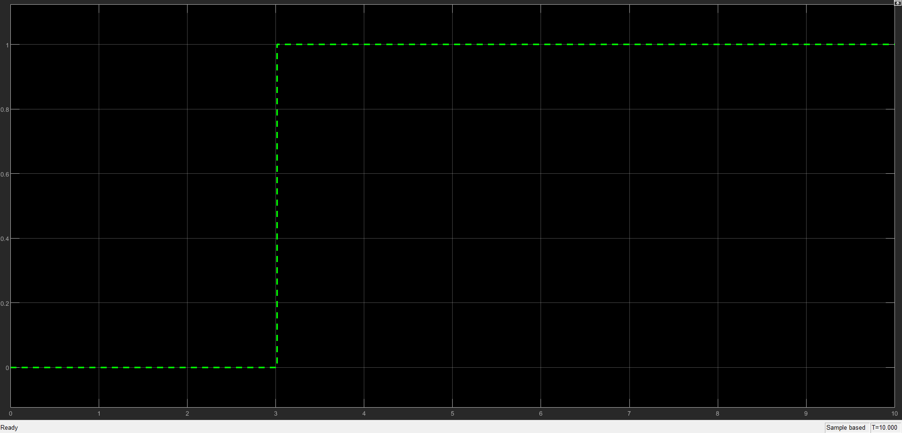

Figure 13: Suspension simulation step input

The output profile of the suspension behaviour is observed through the displacement at the other end of suspension, the graph is as follows:

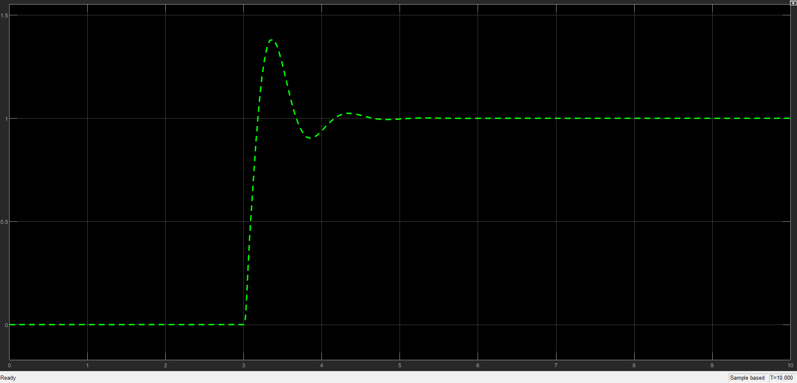

Figure 14: Suspension simulation Result

The output graph clearly demonstrates damping of the step displacement by the suspension towards the rider.

**6. Conclusion & Course Learning Outcomes**

Over the course of eight lectures, this module provided a comprehensive exploration of key concepts in electric vehicle (EV) systems and intelligent automotive technologies. The curriculum emphasized both theoretical foundations and practical applications, with a focus on modern vehicular communication, control systems, and predictive modeling techniques.

The first segment covered automotive networking protocols, including Controller Area Network (CAN), Local Interconnect Network (LIN), Media-Oriented Systems Transport (MOST), and FlexRay, which form the backbone of real-time intra-vehicle communication. Subsequent lectures introduced neural networks and regression analysis as tools for predictive performance modeling in EVs, enabling data-driven optimization of energy efficiency and drivetrain behaviour.

A significant portion of the course was dedicated to control system theory, with emphasis on Laplace and Fourier transforms for frequency-domain analysis, transfer function derivation, and dynamic system modeling. These mathematical frameworks were applied to EV motor control and vehicle dynamics simulations. The module concluded with an overview of intelligent vehicle technologies, particularly Advanced Driver-Assistance Systems (ADAS) such as adaptive cruise control and lane-keeping assist.

A major part of the course was utilised in training hands-on with simulation and testing platforms like MATLAB and Simulink. The hands-on tasks covered basics and foundational knowledge and helped improve the skills with each task, unlocking a new level of functions and capabilities, ending with a combined task of EV modelling and simulation and vehicle suspension behaviour simulation.

Through hands-on electric kart design exercises, students gained practical experience in EV architecture development, system simulation, and control algorithm implementation. This applied component reinforced theoretical concepts while preparing participants to contribute to emerging advancements in sustainable transportation technologies. The integrated approach of this course bridged fundamental engineering principles with cutting-edge automotive applications, equipping learners with both analytical and practical competencies in modern EV development.