**Flow Diagrams:**

1. Authentication Gateway

1. Citizen Flow

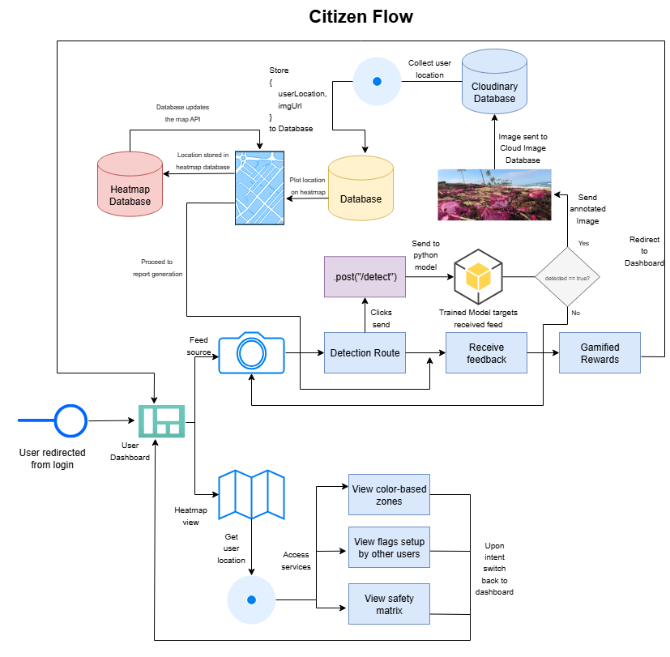

1. Registered Official Flow

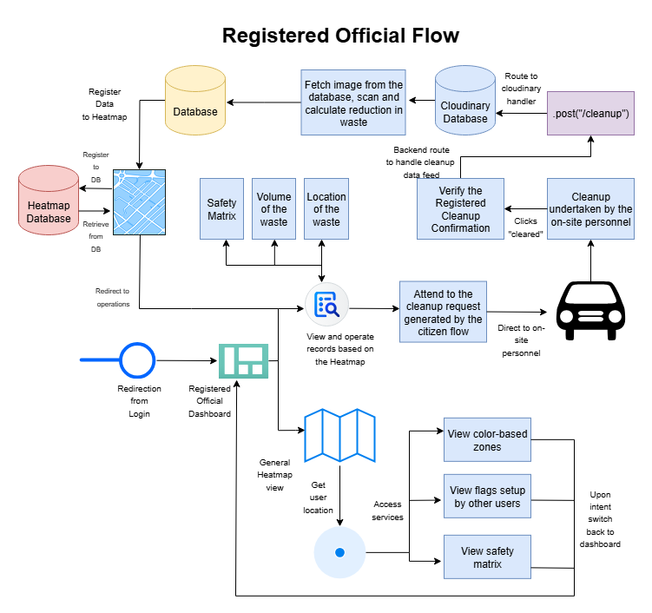

1. Admin Dashboard Flow

