综合实战（定义表单）：

每一个HTML元素对于JavaScript而言都属于一个对象。取得元素对象靠document.getElementById();

**开发房贷计算器：**

1.

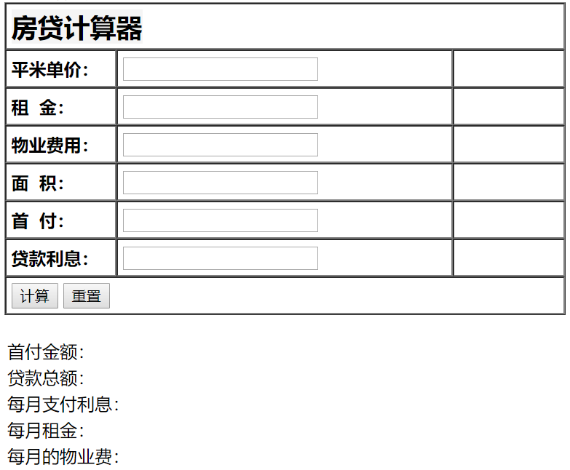

1. 数据验证

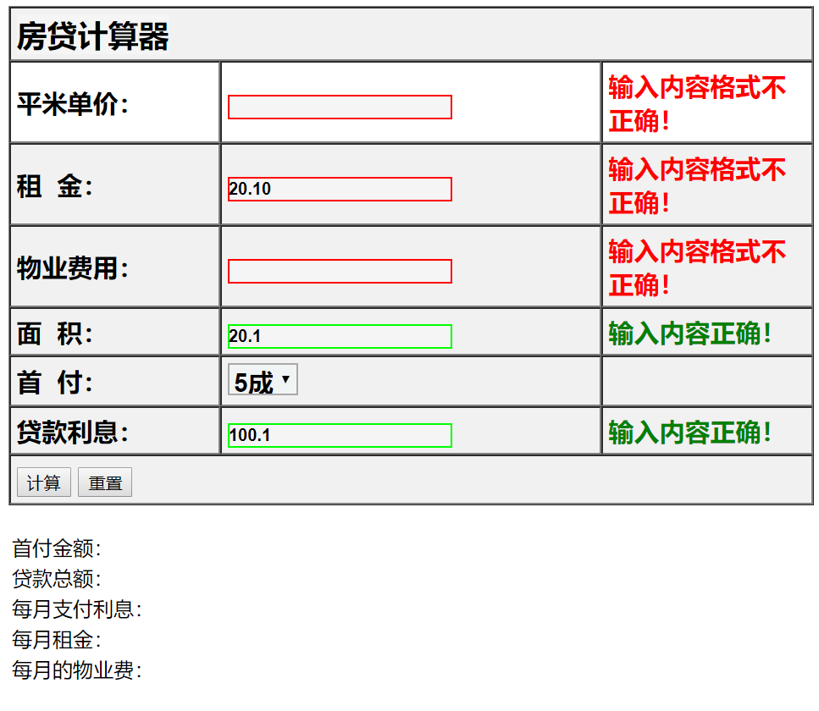

1. **数据计算**

代码如下：

<!DOCTYPE html>  
<html lang=**"en"**>  
<head>  
 <meta charset=**"UTF-8"**>  
 <link type=**"text/css"** rel=**"stylesheet"** href=**"myStyle/style.css"**>  
 <title>**房贷计算器**</title>  
 <script type=**"text/javascript"** src=**"js/house.js"**></script>  
 <script type=**"text/javascript"** src=**"js/wenpan.js"**></script>  
  
</head>  
<body>  
 <form>  
 <table border=**"1"** cellpadding=**"5"**cellspacing=**"0"** width=**"100%"** class=**"init"**>  
  **<tr id="tabRow">**  
 <td colspan=**"3"** ><span class=**"title"**>**房贷计算器**</span> </td>  
 </tr>  
 <tr id=**"tabRow"**>  
 <td width=**"25%"**><strong>**平米单价：**</strong></td>  
 <td width=**"45%"**><input type=**"text"** name=**"unitprice"** id=**"unitprice"** class=**"init"**></td>  
 <td width=**"25%"**><span id=**"unitpriceMsg"**></span> </td>  
 </tr>  
 <tr id=**"tabRow"**>  
 <td><strong>**租&nbsp;&nbsp;金：**</strong></td>  
 <td><input type=**"text"** name=**"rent"** id=**"rent"** class=**"init"**></td>  
 <td><span id=**"rentMsg"**></span> </td>  
 </tr>  
 <tr id=**"tabRow"**>  
 <td><strong>**物业费用：**</strong></td>  
 <td><input type=**"text"** name=**"cost"** id=**"cost"** class=**"init"**></td>  
 <td><span id=**"costMsg"**></span> </td>  
 </tr>  
 <tr id=**"tabRow"**>  
 <td><strong>**面&nbsp;&nbsp;积：**</strong></td>  
 <td><input type=**"text"** name=**"area"** id=**"area"** class=**"init"**></td>  
 <td><span id=**"areaMsg"**></span> </td>  
 </tr>  
 <tr id=**"tabRow"**>  
 <td><strong>**首&nbsp;&nbsp;付：**</strong></td>  
 <td>  
 <select id = **"first"** name = **"first"** class=**"init"**>  
 <option value=**"2"**>**2成**</option>  
 <option value=**"3"**>**3成**</option>  
 <option value=**"4"**>**4成**</option>  
 <option value=**"5"** selected>**5成**</option>  
 <option value=**"6"**>**6成**</option>  
 <option value=**"7"**>**7成**</option>  
 <option value=**"8"**>**8成**</option>  
 <option value=**"9"**>**9成**</option>  
 </select>  
 </td>  
 <td><span id=**"firstMsg"**></span> </td>  
 </tr>  
 <tr id=**"tabRow"**>  
 <td><strong>**贷款利息：**</strong></td>  
 <td><input type=**"text"** name=**"interest"**id=**"interest"** class=**"init"**></td>  
 <td><span id=**"interestMsg"**></span> </td>  
 </tr>  
 <tr id=**"tabRow"**>  
 <td colspan=**"3"**>  
 <input type=**"button"** value=**"计算"** id=**"calBut"**>  
 <input type=**"reset"**value=**"重置"**>  
 </td>  
 </tr>  
  
  
 </table>  
 <div style=**"**height: 20**px**;clear: **both**;**"**></div>  
 <div id=**"resultDiv"**>  
 <table>  
 <tr>  
 <td>**首付金额：**</td>  
 <td><span id=**"firstResult"**></span> </td>  
 </tr>  
 <tr>  
 <td>**贷款总额：**</td>  
 <td><span id=**"totalResult"**></span> </td>  
 </tr>  
 <tr>  
 <td>**每月支付利息：**</td>  
 <td><span id=**"monthResult"**></span> </td>  
 </tr>  
 <tr>  
 <td>**每月租金：**</td>  
 <td><span id=**"rentResult"**></span> </td>  
 </tr>  
 <tr>  
 <td>**每月的物业费：**</td>  
 <td><span id=**"costResult"**></span> </td>  
 </tr>  
 </table>  
 </div>  
 </form>  
  
</body>  
</html>

function validateEmpty(eleName) { //验证空  
 var obj = document.getElementById(eleName);  
 var msg = document.getElementById(eleName+ "Msg");  
 if(obj != ""){  
 obj.className = "right";  
 if(msg != null){  
 msg.innerHTML = "<font color='green'>内容输入正确！</font>"  
 }  
 return true;  
 }else{  
 obj.className = "wrong";  
 if (msg != null){  
 msg.innerHTML = "<font color = 'green'>内容不允许为空！</font>"  
 }  
 return false;  
 }  
}  
  
function validateRegex(eleName,regex) { //正则验证  
 var obj = document.getElementById(eleName);  
 var msg = document.getElementById(eleName + "Msg");  
 if(regex.test(obj.value)){  
 obj.className = "right";  
 if(msg != null){  
 msg.innerHTML = "<font color = 'green'>输入内容正确！</font>"  
 }  
 return true;  
 }else {  
 obj.className = "wrong";  
 if(msg != null){  
 msg.innerHTML = "<font color = 'red'>输入内容格式不正确！</font>";  
 }  
 return false;  
 }  
}  
  
function changeColor(obj,color) { //当鼠标移动时添加监听事件  
 obj.bgColor = color;  
}  
  
function rount(obj,num) { //保留指定小数位  
 return ((*Math*.round(obj * *Math*.pow(10,num)))) / *Math*.pow(10,num);  
}

window.onload = function () { //对数据进行验证  
 **document.getElementById("unitprice").addEventListener("blur",validateUnitprice,false);**  //失去焦点时添加监听事件  
 document.getElementById("rent").addEventListener("blur",validateRent,false);  
 document.getElementById("cost").addEventListener("blur",validateCost,false);  
 document.getElementById("area").addEventListener("blur",validateArea,false);  
 document.getElementById("interest").addEventListener("blur",validateInterest,false);  
 **document.getElementById("calBut").addEventListener("click",cal,false);**  
  
 **var trElement = document.all("tabRow"); //得到每一行  
 for(var x = 0;x <trElement.length;x++){ //对每一行添加监听  
 trElement[x].addEventListener("mousemove",function () {  
 changeColor(this,'#FFFFFF');  
 },false);**

**trElement[x].addEventListener("mouseout",function () {  
 changeColor(this,'#F1F1F1');  
 },false)  
 }**  
  
}  
  
function validateUnitprice() {  
 return validateRegex("unitprice",/^\d+(\.\d{1,2})?$/)  
}  
function validateRent() {  
 return validateRegex("rent",/^\d+(\.\d{1,2})?$/)  
}  
function validateCost() {  
 return validateRegex("cost",/^\d+(\.\d{1,2})?$/)  
}  
function validateArea() {  
 return validateRegex("area",/^\d+(\.\d{1,2})?$/)  
}  
function validateInterest() {  
 return validateRegex("interest",/^\d+(\.\d{1,2})?$/)  
}  
  
**function validate() { //判断所有验证是否通过  
 return validateUnitprice() && validateRent() &&  
 validateArea() && validateCost() && validateInterest();  
}**  
  
function cal() {  
 if(validate()){  
 var t_unitprice = document.getElementById("unitprice");  
 var t_rent = document.getElementById("rent");  
 var t_area = document.getElementById("area");  
 var t_interest = document.getElementById("interest"); //贷款利息  
 var t_cost = document.getElementById("cost"); //物业费  
 var t_first = document.getElementById("first"); //首付  
 var firstResult = document.getElementById("firstResult");  
  
 //计算首付  
 firstResult.innerHTML = "￥" + rount(parseFloat(t_unitprice.value) * parseFloat(t_area.value) *  
 parseFloat(t_first.value)/10,2);  
  
 //计算贷款总额  
 document.getElementById("totalResult").innerHTML = "￥" + rount(parseFloat(t_unitprice.value) *  
 parseFloat(t_area.value) * (1 - parseFloat(t_first.value)/10),2);  
  
 //计算每月支付利息  
 document.getElementById("monthResult").innerHTML = "￥" + rount(parseFloat(t_unitprice.value) *  
 parseFloat(t_area.value) *  
 (1 - parseFloat(t_first.value)/10) * (t_interest.value / 1200),2);  
  
 //每月租金  
 document.getElementById("rentResult").innerHTML = "￥" + rount(parseFloat(t_rent.value) * parseFloat(t_area.value),2);  
  
 //每月物业费  
 document.getElementById("costResult").innerHTML = "￥" + rount(parseFloat(t_cost.value) * parseFloat(t_area.value),2);  
 }  
}

.init{  
 background: #F1F5F5F5;  
 font-weight: **bold**;  
 color: #000000;  
 font-size: 20**px**;  
}  
.wrong{  
 background: #F5F5F5;  
 font-weight: **bold** ;  
 border: 1**px** #FF0000 **solid**;  
 color: #000000;  
}  
.right{  
 background: #F5F5F5;  
 font-weight: **bold**;  
 border: 1**px** #00FF00 **solid**;  
 color: #000000;  
}  
.title{  
 background: #F5F5F5;  
 font-weight: **bold**;  
 color: #000000;  
 font-size: 24**px**;  
}

结果图如下：

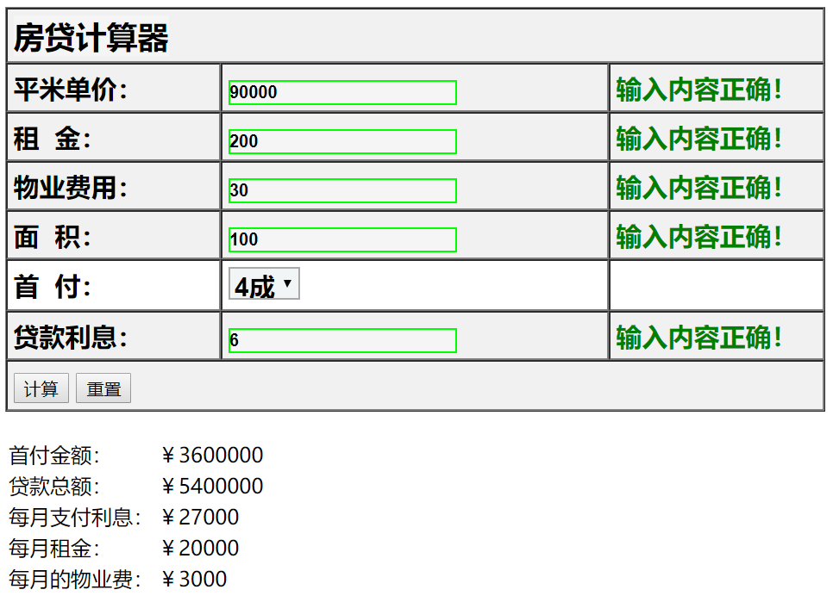

**总结：**

1. **四舍五入的操作（一个负数即使是五也不会入，eg：-15.5 === -15， -15.51 === -16）。**
2. **字符串进行整型和浮点型的转换。**