CREATE TABLE Employee (

EID INT PRIMARY KEY,

Ename VARCHAR(50),

Ephoneno VARCHAR(15),

DeptID INT

);



CREATE TABLE Department (

DeptID INT PRIMARY KEY,

Dname VARCHAR(50),

managedby INT,

DJOM DATE,

budget DECIMAL(10, 2)

);



CREATE TABLE Phones (

Phoneno VARCHAR(15) PRIMARY KEY,

DeptID INT,

FOREIGN KEY (DeptID) REFERENCES Department (DeptID)

);



Ques 2 )

Queries for Employee table

INSERT INTO Employee (EID, Ename, Ephoneno, DeptID)

VALUES (1, 'John Doe', '555-1234', 1);

INSERT INTO Employee (EID, Ename, Ephoneno, DeptID)

VALUES (2, 'Jane Smith', '555-5678', 1);

INSERT INTO Employee (EID, Ename, Ephoneno, DeptID)

VALUES (3, 'Michael Johnson', '555-9876', 2);

INSERT INTO Employee (EID, Ename, Ephoneno, DeptID)

VALUES (4, 'Emily Davis', '555-4321', 2);

INSERT INTO Employee (EID, Ename, Ephoneno, DeptID)

VALUES (5, 'David Wilson', '555-8765', 3);

C:\Users\RMC1\Pictures\Screenshots\Screenshot 2023-05-08 123432.png

Queries for Department Table

INSERT INTO Department (DeptID, Dname, managedby, DJOM, budget)

VALUES (1, 'Sales', 1, '2022-01-01', 100000.00);

INSERT INTO Department (DeptID, Dname, managedby, DJOM, budget)

VALUES (2, 'Marketing', 2, '2022-02-01', 75000.00);

INSERT INTO Department (DeptID, Dname, managedby, DJOM, budget)

VALUES (3, 'Finance', 3, '2022-03-01', 120000.00);

INSERT INTO Department (DeptID, Dname, managedby, DJOM, budget)

VALUES (4, 'Human Resources', 4, '2022-04-01', 90000.00);

INSERT INTO Department (DeptID, Dname, managedby, DJOM, budget)

VALUES (5, 'Research and Development', 5, '2022-05-01', 150000.00);

C:\Users\RMC1\Pictures\Screenshots\Screenshot 2023-05-08 123432.png

Queries for phone table

INSERT INTO Phones (Phoneno, DeptID)

VALUES ('555-1001', 1);

INSERT INTO Phones (Phoneno, DeptID)

VALUES ('555-1002', 1);

INSERT INTO Phones (Phoneno, DeptID)

VALUES ('555-2001', 2);

INSERT INTO Phones (Phoneno, DeptID)

VALUES ('555-2002', 2);

INSERT INTO Phones (Phoneno, DeptID)

VALUES ('555-3001', 3);

C:\Users\RMC1\Pictures\Screenshots\Screenshot 2023-05-08 123432.png

Ques 3)

a)

SELECT Phoneno FROM Phones

WHERE DeptID IN (

SELECT DeptID FROM Department

WHERE Dname = 'Production'

);



b)

SELECT DeptID, COUNT(*) AS TotalEmployees

FROM Employee

GROUP BY DeptID;

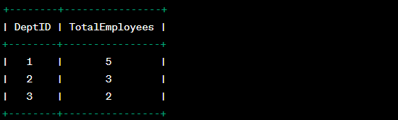

c)

ALTER TABLE Department

ADD Dlocation VARCHAR(50);



d)

SELECT Ename

FROM Employee

WHERE EID IN (

SELECT managedby

FROM Department

WHERE DATEDIFF(CURRENT_DATE(), DJOM) > 1095

);



e)

SELECT E.Ename AS EmployeeName, E.managedby AS ManagerID, M.Ename AS ManagerName, D.Dname AS DepartmentName

FROM Employee E

INNER JOIN Employee M ON E.managedby = M.EID

INNER JOIN Department D ON E.DeptID = D.DeptID

ORDER BY M.Ename;

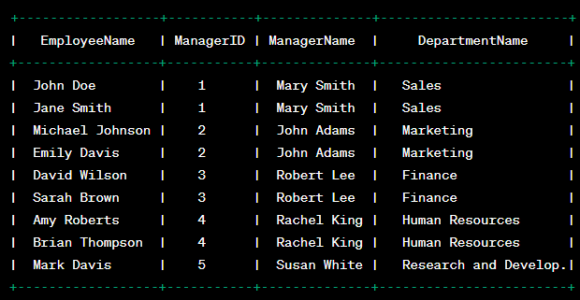

f)

ALTER TABLE Employee

CHANGE managedby manager INT;



g)

SELECT Ename

FROM Employee

WHERE EID IN (

SELECT managedby

FROM Department

WHERE DJOM < '2017-01-01'

);



h)

SELECT SUM(budget) AS TotalBudget

FROM Department

WHERE Dname = 'Sales';

