==INSTALLATION PROCEDURE==

1. Create a new IP:

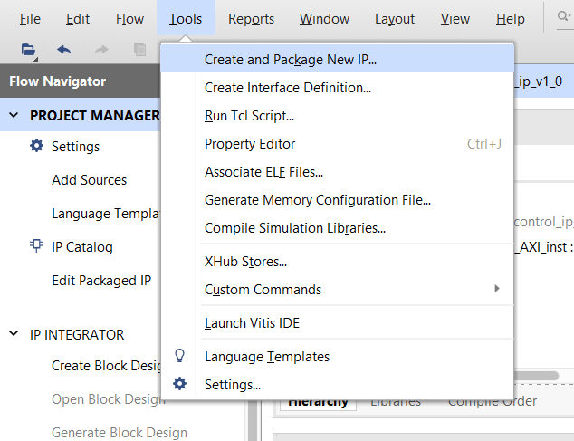

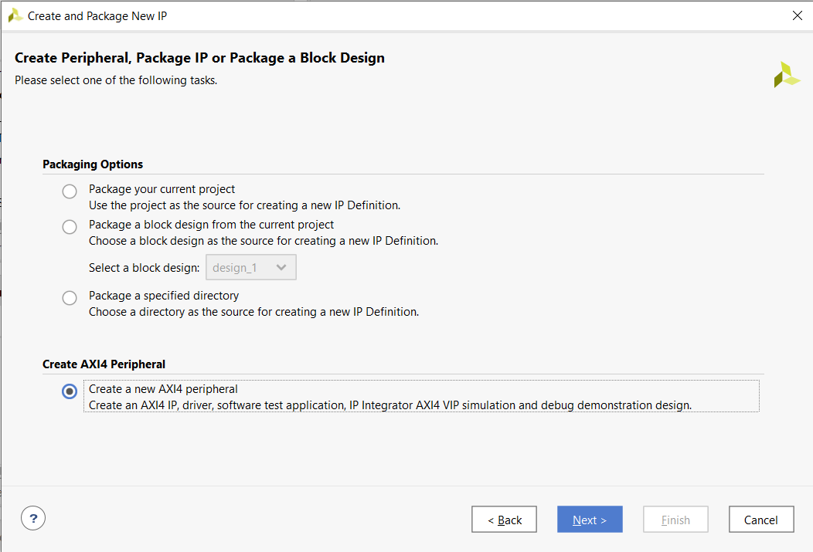

* It must be an AXI4 peripheral.

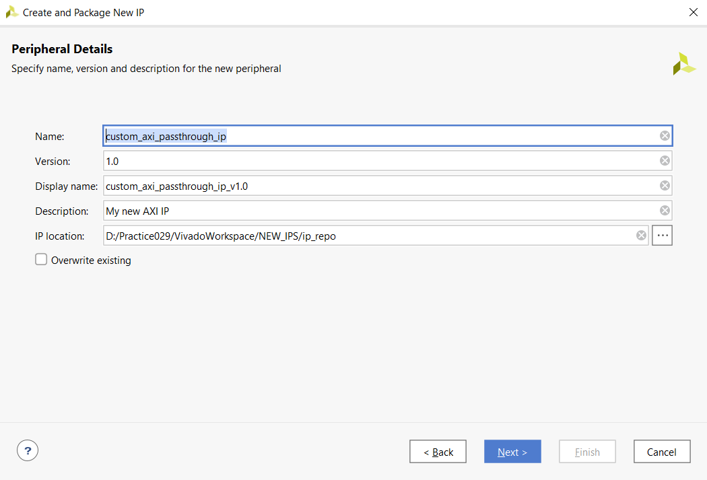

* It must be «named custom_axi_passthrough_ip» specifically.

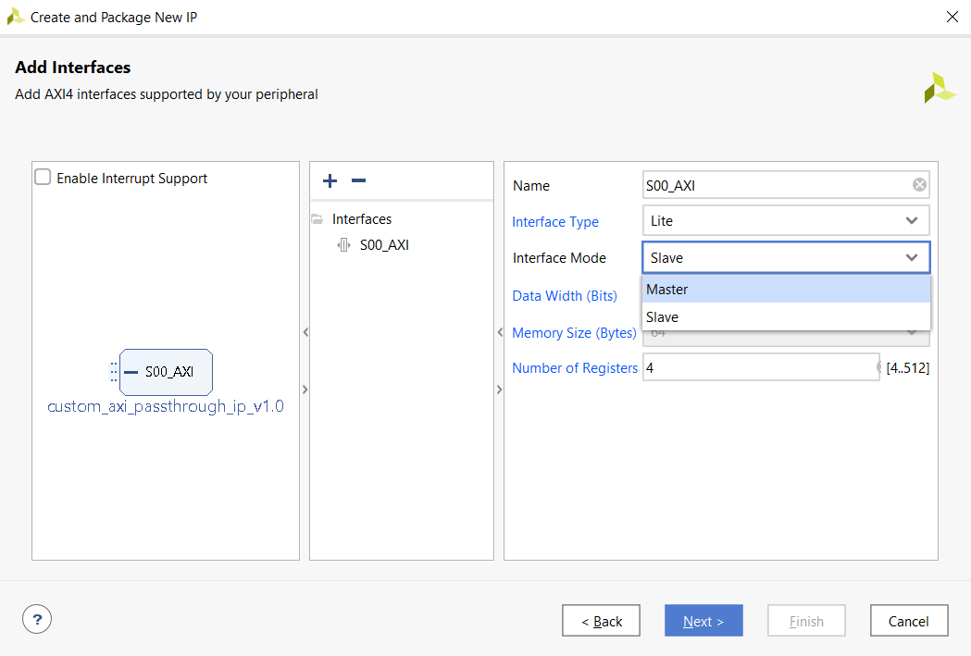

* Switch the default slave AXI interface to master and click «Next».

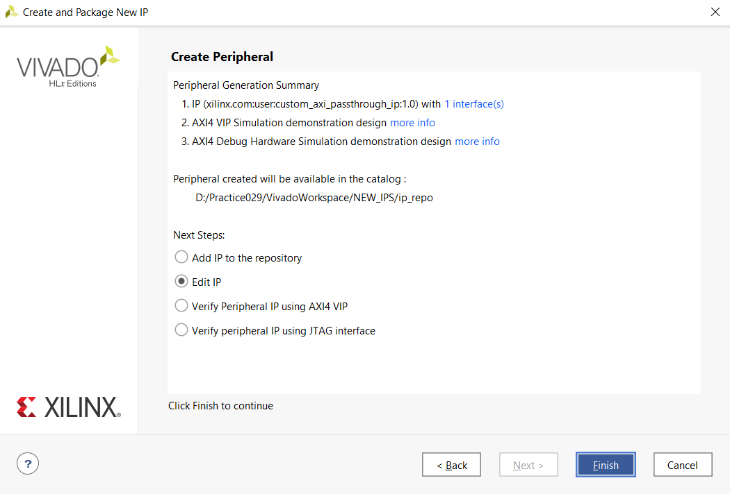

* Choose «Edit IP», click «Finish». After the project window opens, close it.

1. Download the entire project:

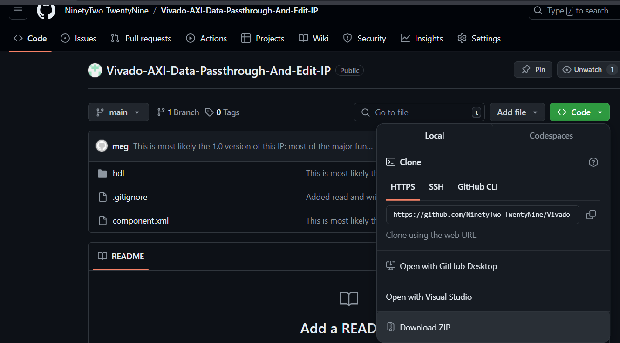

1. Extract the files into the main IP folder:

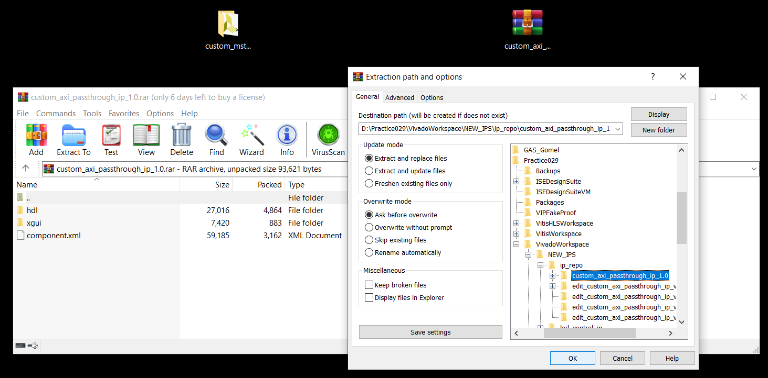

* If everything was done properly, then 4 files in the IP folder should get replaced.

1. Open the IP project again and set it up:

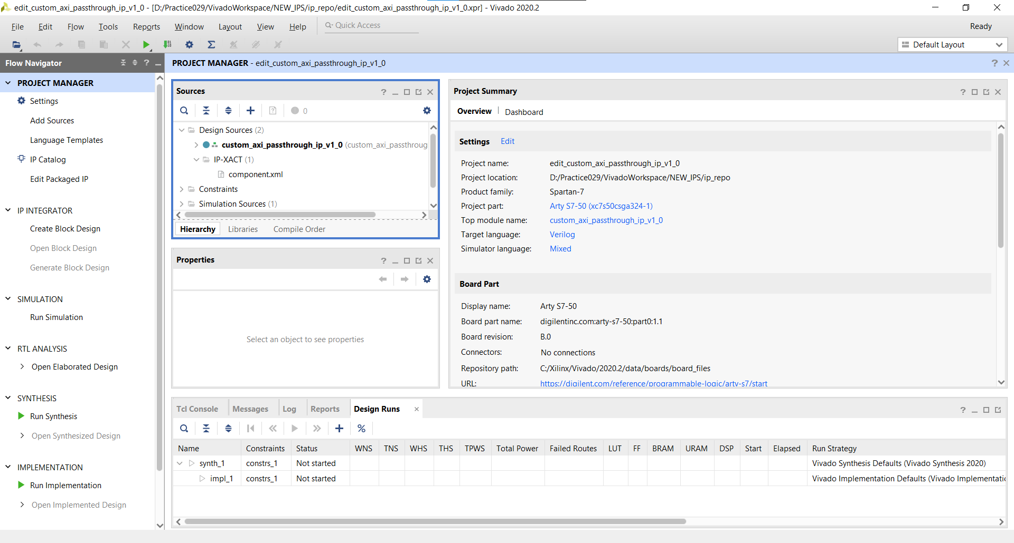

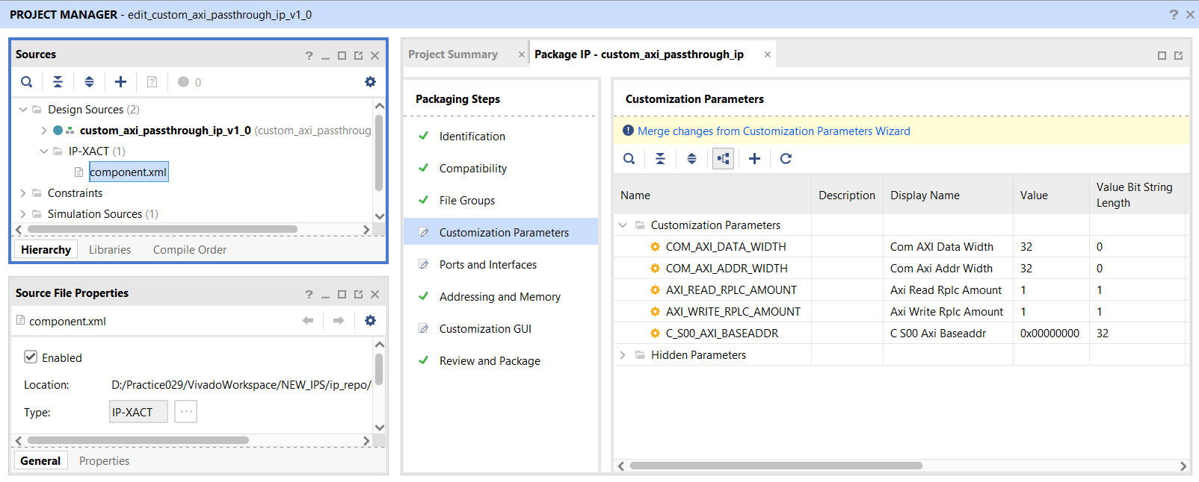

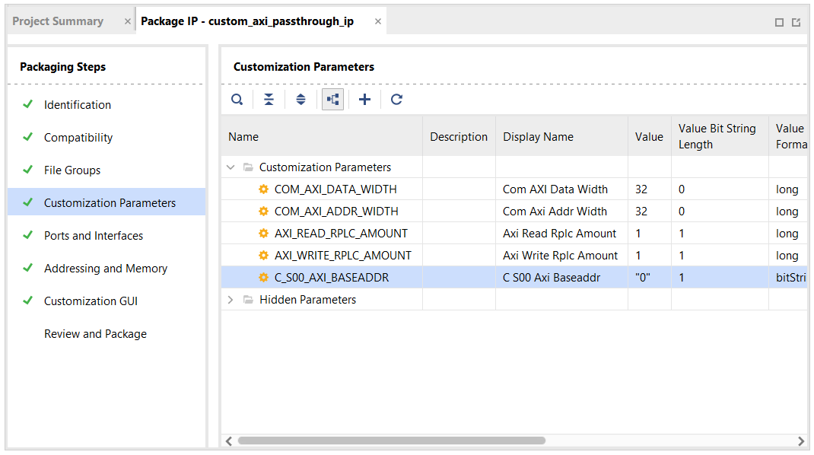

* After pressing the «Merge changes» button, the width and default value of the «C_S00_AXI_BASEADDR» parameter get reset. It has to be fixed manually.

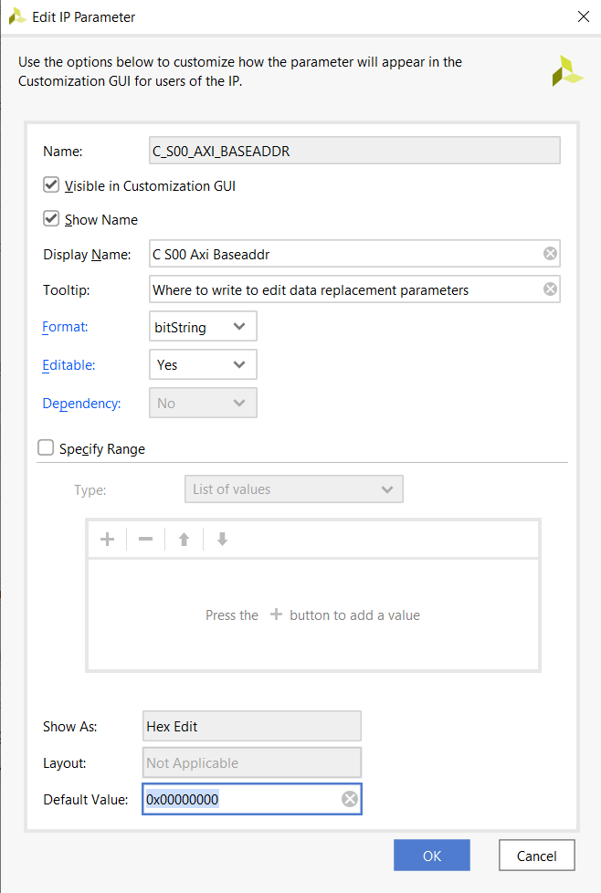

* Set the default value of this parameter to «0x00000000» (or something else of 32-bit width) and click «OK».

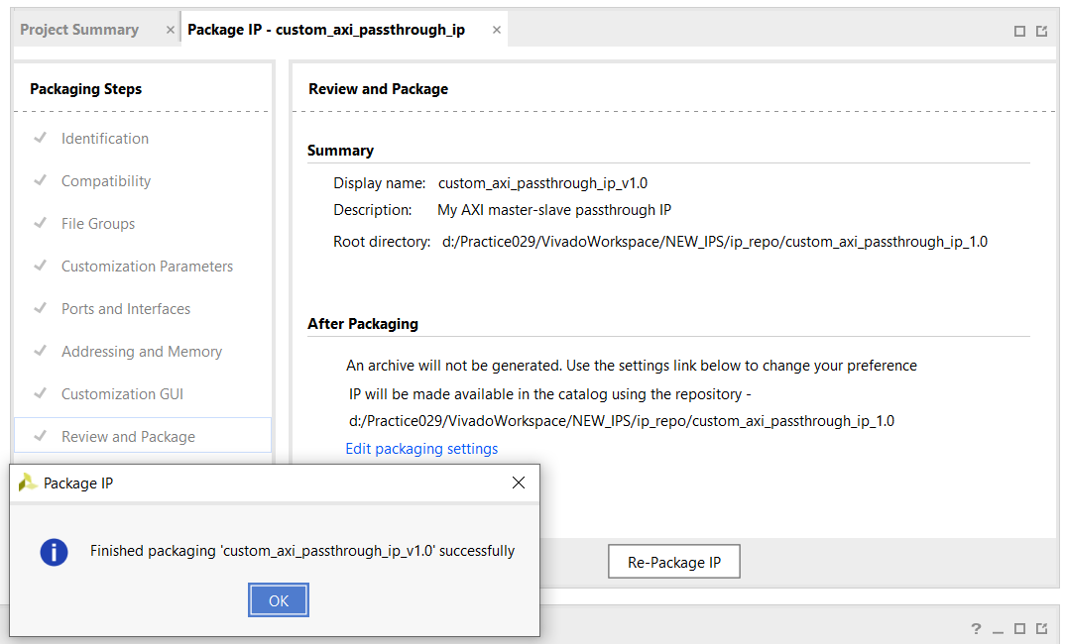

* Repackage the IP.

1. Include necessary directories (with the IP) in any of your projects:

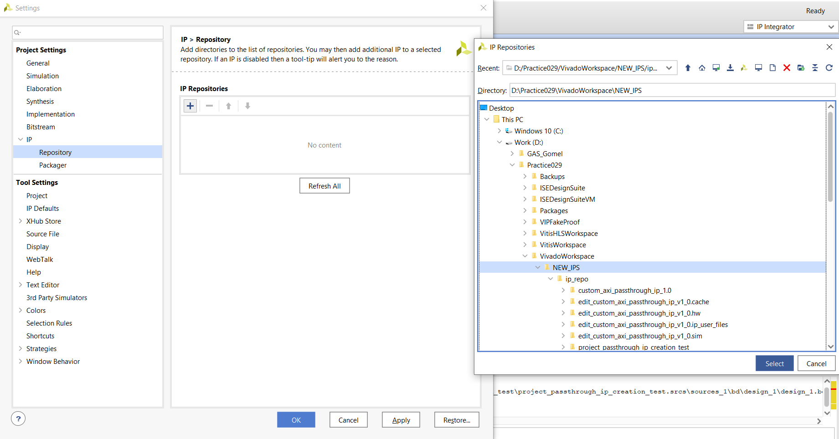

1. The IP can now be used in that project:

