**Environment:**

macOS 10.15.7

Node.js 15.13.0

Node.js modules:

mysql@2.18.1

ws@7.4.4

MySQL 8.0.23

**Usage:**

MySQL server is required to save the posts.

Open demo_server.js with a text editor. Change the value of ‘user’ and ‘password’, so that the Node.js server can connect to a MySQL server.

Change directory to the coding_exercise_web_service folder. Run the following command to start the Node.js server:

node demo_server.js

Open index.html in a few web browser windows as clients. Each client will try to establish a WebSocket connection with the server. If the connection is successfully, a message will be displayed:

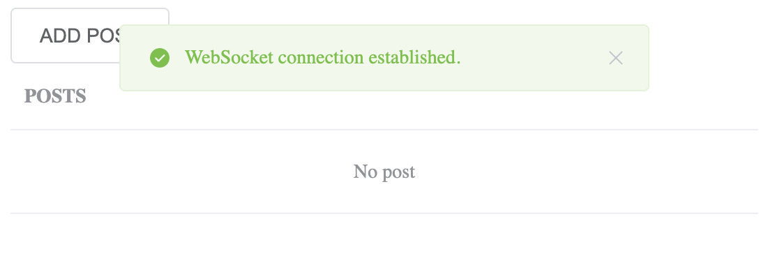

Click ‘ADD POST’. Input a post, and click ‘POST’. 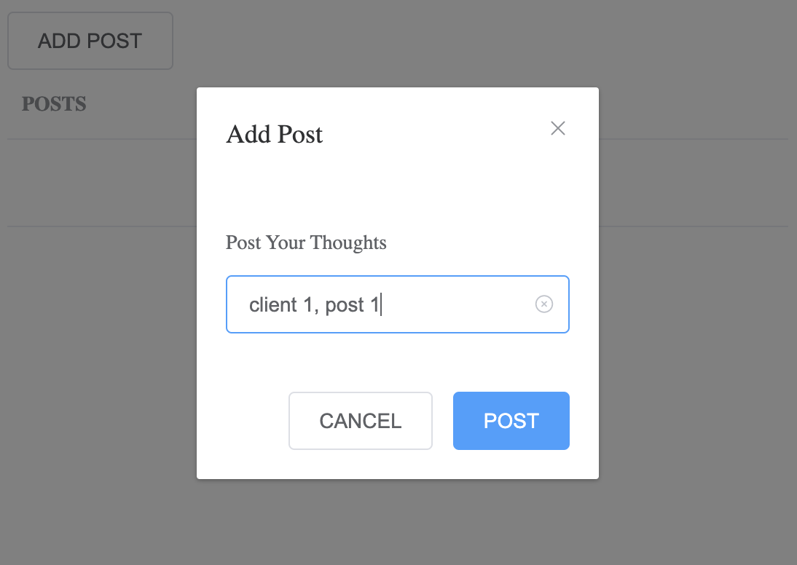

The published post is shown on the page, and is pushed to all other connected clients.

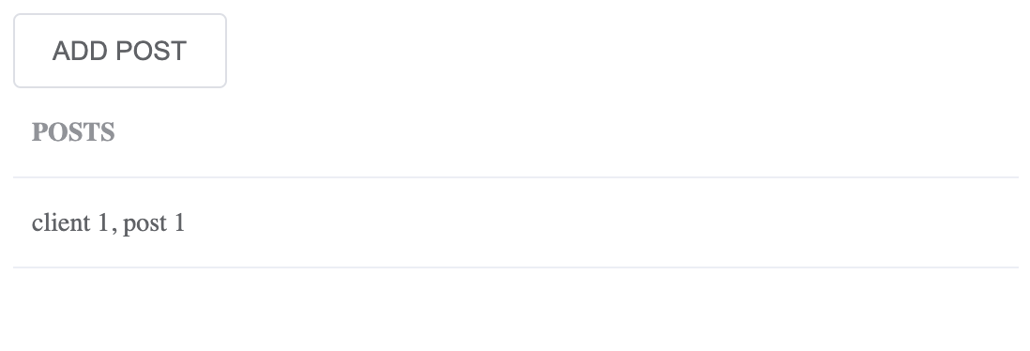

All posts are saved in a MySQL database.

