搭建Zabbix监控服务器(192.168.31.205)

一 部署服务运行环境 (LAMP/LNMP)

安装PHP5.6

[root@zabbix-server ~]# rpm -ivh <http://repo.webtatic.com/yum/el6/latest.rpm>

[root@zabbix-server ~]# yum -y install php56w php56w-gd php56w-mysql php56w-bcmath php56w-mbstring php56w-xml php56w-ldap httpd net-snmp*

[root@zabbix-server ~]# vim /etc/php.ini

date.timezone = Asia/Shanghai

max_execution_time = 300

post_max_size = 32M

max_input_time = 300

always_populate_raw_post_data = -1

[root@zabbix-server ~]# vim /var/www/html/test.php

<?php

phpinfo();

?>

[root@zabbix-server ~]# /etc/init.d/httpd start

[root@zabbix-server ~]# chkconfig httpd on

安装数据库5.6

[root@zabbix-server ~]# rpm -ivh <http://dev.mysql.com/get/mysql-community-release-el6-5.noarch.rpm>

[root@zabbix-server ~]# yum install -y mysql-server mysql-devel mysql

[root@zabbix-server ~]# vim /etc/my.cnf //修改数据库默认字符和引擎

[mysqld]

default-storage-engine=INNODB

character_set_server=utf8

init_connect='SET NAMES utf8'

innodb_file_per_table #独立表空间模式

[root@zabbix-server ~]# /etc/init.d/mysqld start

[root@zabbix-server ~]# chkconfig mysqld on

[root@zabbix-server ~]# mysql_secure_installation

Enter current password for root (enter for none): <–初次运行直接回车

Set root password? [Y/n] 123456 <– 是否设置root用户密码，输入y并回车或直接回车

Remove anonymous users? [Y/n] <– 是否删除匿名用户,生产环境建议删除，所以直接回车

Disallow root login remotely? [Y/n] n <–是否禁止root远程登录,根据自己的需求选择Y/n并回车,建议禁止

Remove test database and access to it? [Y/n] <– 是否删除test数据库,直接回车

Reload privilege tables now? [Y/n] <– 是否重新加载权限表，直接回车

[root@zabbix-server ~]# mysql -uroot –p //登陆数据库建表并授权

mysql> create database zabbixdb character set utf8 COLLATE utf8_bin;

mysql> grant all on zabbixdb.* to zabbix@localhost identified by 'zabbix';

mysql> flush privileges;

[root@zabbix-server ~]# mysql -hlocalhost -uzabbix -pzabbix zabbixdb

[root@zabbix-server ~]# vim /var/www/html/linkdb.php //测试是否能连接数据库

<?php

$linkdb=mysql_connect("localhost","zabbix","zabbix");

if($linkdb){

echo "linkdb ok";

}else{

echo "linkdb no";

}

?>

浏览器打开 http://192.168.31.205/linkdb.php

二 安装zabbix软件包

[root@zabbix-server ~]# yum install -y gcc gcc-c++ libxml2-devel unixODBC-devel net-snmp-devel libcurl-devel libssh2-devel OpenIPMI-devel openssl-devel openldap-devel libpng libjpeg-turbo freetype-devel

[root@zabbix-server ~]# groupadd zabbix

[root@zabbix-server ~]# useradd -g zabbix zabbix

[root@zabbix-server ~]# cd /download/zabbix-3.2.3

[root@zabbix-server zabbix-3.2.3]# ./configure --prefix=/usr/local/zabbix --enable-server --enable-proxy --enable-agent --enable-java --with-mysql --with-net-snmp --with-libcurl --with-libxml2 --with-unixodbc --with-ssh2 --with-openipmi --with-openssl

[root@zabbix-server zabbix-3.2.3]# make && make install

[root@zabbix-server zabbix-3.2.3]# ls /usr/local/zabbix/

bin etc lib sbin share

创建存储配置信息的表

[root@zabbix-server zabbix-3.2.3]# cd database/mysql/

[root@zabbix-server mysql]# mysql -uzabbix -pzabbix zabbixdb<schema.sql

[root@zabbix-server mysql]# mysql -uzabbix -pzabbix zabbixdb<images.sql

[root@zabbix-server mysql]# mysql -uzabbix -pzabbix zabbixdb<data.sql

拷贝网页文件到网站目录下

[root@zabbix-server mysql]# cd /download/zabbix-3.2.3

[root@zabbix-server zabbix-3.2.3]# cp -r frontends/php/ /var/www/html/zabbix

[root@zabbix-server zabbix-3.2.3]# chown -R apache:apache /var/www/html/zabbix/

[root@zabbix-server zabbix-3.2.3]# ln -s /usr/local/zabbix/etc /etc/zabbix

[root@zabbix-server zabbix-3.2.3]# ln -s /usr/local/zabbix/bin/* /usr/bin/

[root@zabbix-server zabbix-3.2.3]# ln -s /usr/local/zabbix/sbin/* /usr/sbin/

访问url路径 安装

http://192.168.31.205/zabbix

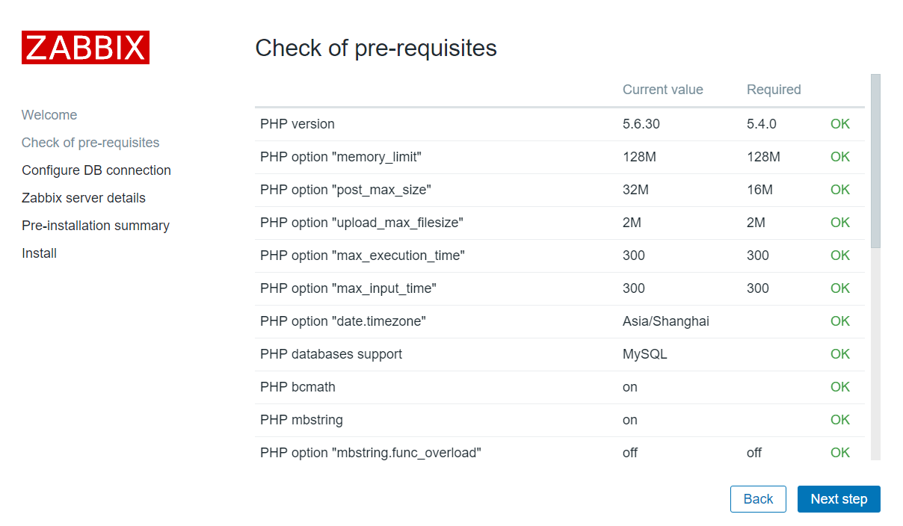

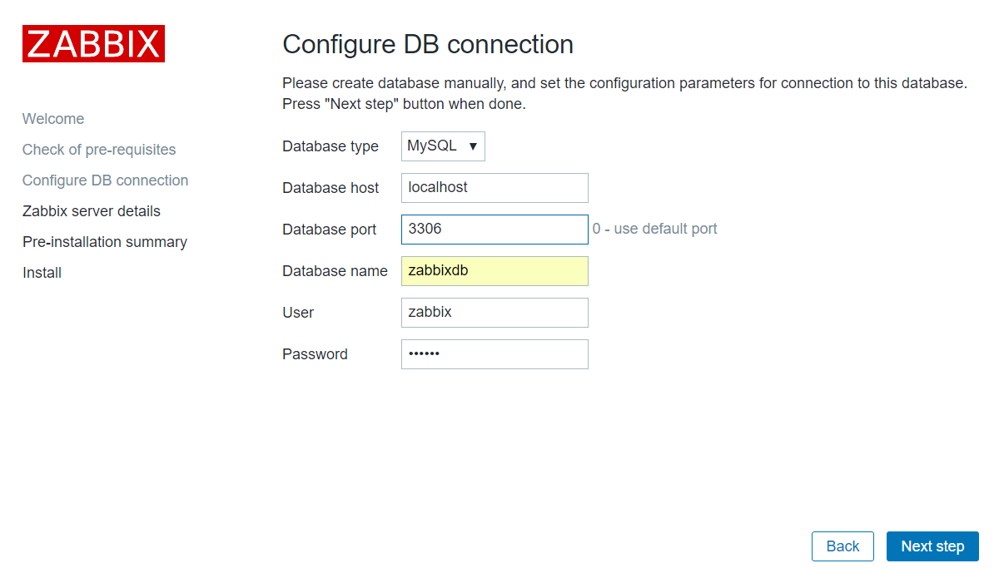

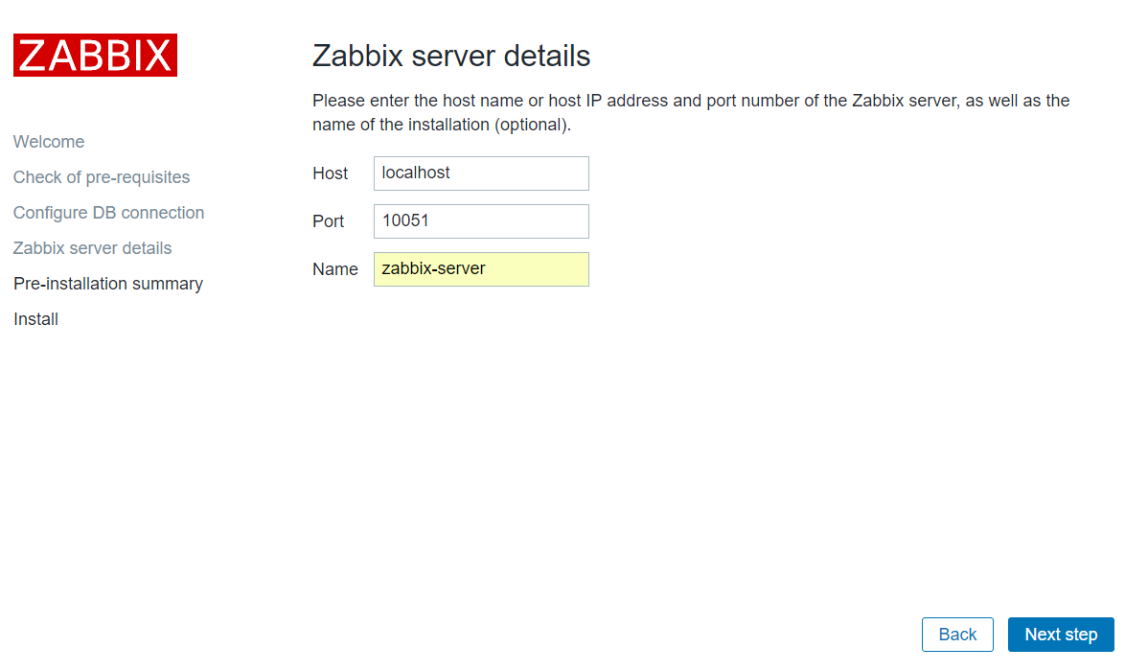

# cat /var/www/html/zabbix/conf/zabbix.conf.php 查看安装信息

用户名 Admin (尼玛的大写)

密码 zabbix

乱码解决方法

[root@zabbix-server zabbix-3.2.3]# cd /var/www/html/zabbix/fonts

找到本地C:\Windows\Fonts SIMKAI.TTF(楷体) 上传到/var/www/html/zabbix/fonts目录下

[root@zabbix-server fonts]# mv simkai.ttf SIMKAI.ttf

[root@zabbix-server fonts]# vim /var/www/html/zabbix/include/defines.inc.php

define('ZBX_GRAPH_FONT_NAME', 'SIMKAI'); // font file name

define('ZBX_FONT_NAME', 'SIMKAI');



三、运行监控服务zabbix_server

[root@zabbix-server zabbix-3.2.3]# vim /usr/local/zabbix/etc/zabbix_server.conf

38 LogFile=/tmp/zabbix_server.log

87 DBName=zabbixdb

103 DBUser=zabbix

111 DBPassword=zabbix

[root@zabbix-server zabbix-3.2.3]# cp misc/init.d/fedora/core/zabbix_server /etc/init.d/

[root@zabbix-server zabbix-3.2.3]# chmod +x /etc/init.d/zabbix_server

[root@zabbix-server zabbix-3.2.3]# chkconfig --add zabbix_server

[root@zabbix-server zabbix-3.2.3]# chkconfig zabbix_server on

[root@zabbix-server zabbix-3.2.3]# vim /etc/init.d/zabbix_server

22 BASEDIR=/usr/local/zabbix

[root@zabbix-server zabbix-3.2.3]# service zabbix_server start

[root@zabbix-server zabbix-3.2.3]# netstat -untlap | grep :10051

++++++++++++++++++++++++++++++++++++++++++++++++++++++

四、监控远端主机192.168.31.206

4.1 配置远端主机

[root@zabbix-agent ~]# yum install -y gcc gcc-c++

[root@zabbix-agent ~]# groupadd zabbix

[root@zabbix-agent ~]# useradd -g zabbix zabbix

[root@zabbix-agent zabbix-3.2.3]# cd /download/zabbix-3.2.3

[root@zabbix-agent zabbix-3.2.3]# ./configure --prefix=/usr/local/zabbix --enable-agent

[root@zabbix-agent zabbix-3.2.3]# make && make install

[root@zabbix-agent zabbix-3.2.3]# ls /usr/local/zabbix/

[root@zabbix-agent zabbix-3.2.3]# vim /usr/local/zabbix/etc/zabbix_agentd.conf

91 Server=127.0.0.1,192.168.31.207

132 ServerActive=192.168.31.207:10051

143 Hostname=192.168.31.206

278 UnsafeUserParameters=1

[root@zabbix-agent zabbix-3.2.3]# cp misc/init.d/fedora/core/zabbix_agentd /etc/init.d/

[root@zabbix-agent zabbix-3.2.3]# chmod +x /etc/init.d/zabbix_agentd

[root@zabbix-agent zabbix-3.2.3]# chkconfig --add zabbix_agentd

[root@zabbix-agent zabbix-3.2.3]# chkconfig zabbix_agentd on

[root@zabbix-agent zabbix-3.2.3]# vim /etc/init.d/zabbix_agentd

22 BASEDIR=/usr/local/zabbix

[root@zabbix-agent zabbix-3.2.3]# service zabbix_agentd start

[root@zabbix-agent zabbix-3.2.3]# netstat -untnalp | grep :10050

[root@zabbix-server ~]# /usr/local/zabbix/bin/zabbix_get -s 192.168.31.206 -p 10050 -k "system.uptime" ##在Server端207使用以下命令测试是否能连接到Agent端

[root@zabbix-agent zabbix-3.2.3]# /usr/local/zabbix/sbin/zabbix_agentd -c /usr/local/zabbix/etc/zabbix_agentd.conf -t system.uptime ##测试下zabbix agent是否正常工作

五、监控本机 （自己监控自己192.168.31.205）

[root@zabbix-server ~]# vim /usr/local/zabbix/etc/zabbix_agentd.conf

30 LogFile=/tmp/zabbix_agentd.log

91 Server=127.0.0.1

132 ServerActive=127.0.0.1:10051

[root@zabbix-server zabbix-3.2.3]# cp misc/init.d/fedora/core/zabbix_agentd /etc/init.d/

[root@zabbix-server zabbix-3.2.3]# chmod +x /etc/init.d/zabbix_agentd

[root@zabbix-server zabbix-3.2.3]# chkconfig --add zabbix_agentd

[root@zabbix-server zabbix-3.2.3]# chkconfig zabbix_agentd on

[root@zabbix-server zabbix-3.2.3]# vim /etc/init.d/zabbix_agentd

22 BASEDIR=/usr/local/zabbix

[root@zabbix-server zabbix-3.2.3]# /etc/init.d/zabbix_agentd start

[root@zabbix-server zabbix-3.2.3]# netstat -anptul | grep zabbix

1 添加监控的主机

2 选择监控模版

3 查看监控信息

六 自定义监控模版

案例：监控远端主机206系统的总用户数量

主机206(被监控端)

1 允许自定义监控命令

[root@zabbix-agent ~]# vim /usr/local/zabbix/etc/zabbix_agentd.conf

264 Include=/usr/local/zabbix/etc/zabbix_agentd.conf.d/

278 UnsafeUserParameters=1

[root@zabbix-agent ~]# vim /usr/local/zabbix/etc/zabbix_agentd.conf.d/count.line.passwd

UserParameter=count.line.passwd,wc -l /etc/passwd | awk '{print $1}' ## UserParameter=自定义键值名称,命令

[root@zabbix-agent ~]# /etc/init.d/zabbix_agentd restart

测试自定义命令

[root@zabbix-agent ~]# /usr/local/zabbix/bin/zabbix_get -s 127.0.0.1 -p 10050 -k count.line.passwd

配置监控服务器（192.168.31.207）测试能否使用206 自定义监控命令

[root@zabbix-server ~]# /usr/local/zabbix/bin/zabbix_get -s 192.168.31.206 -p 10050 -k count.line.passwd

2 创建新模版

3 在模版里创建应用集

4 在应用集里创建项目

5 监控主机206时调用新模版

6 查看监控信息

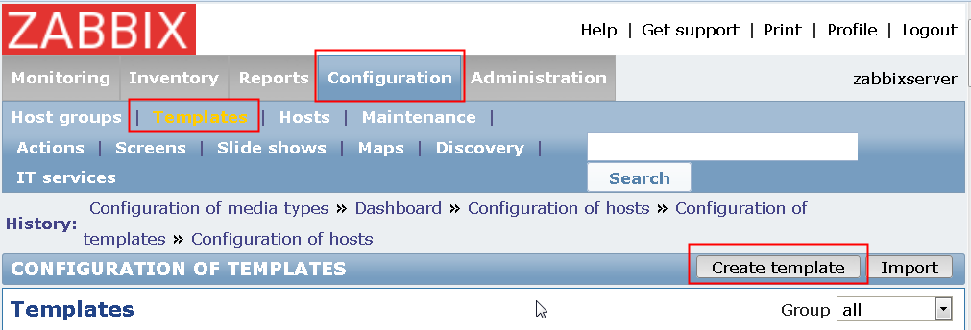

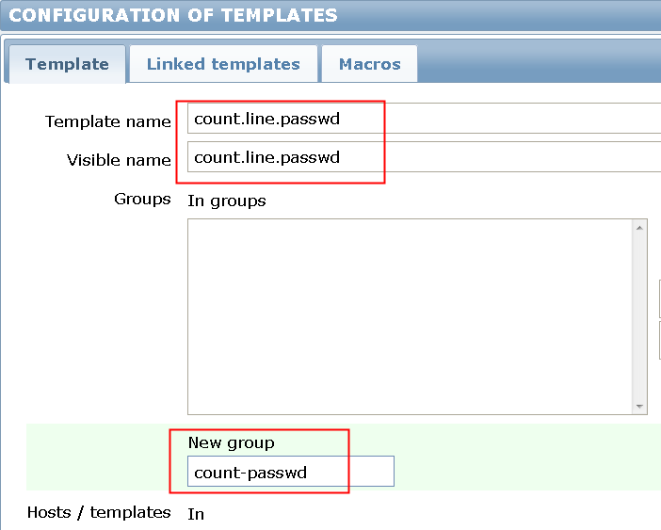

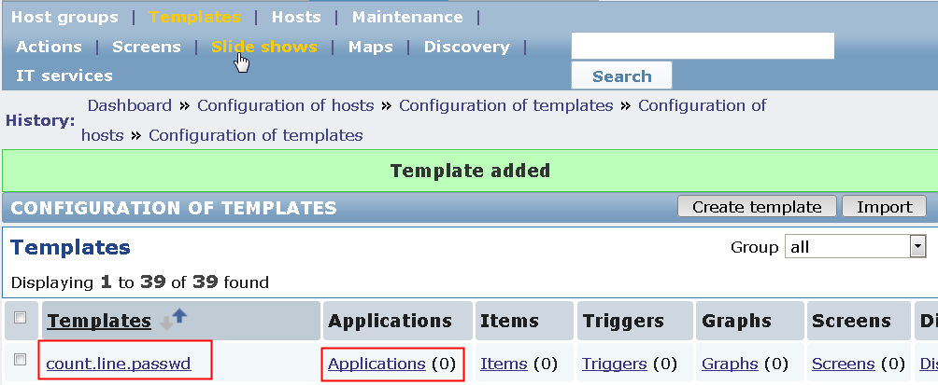

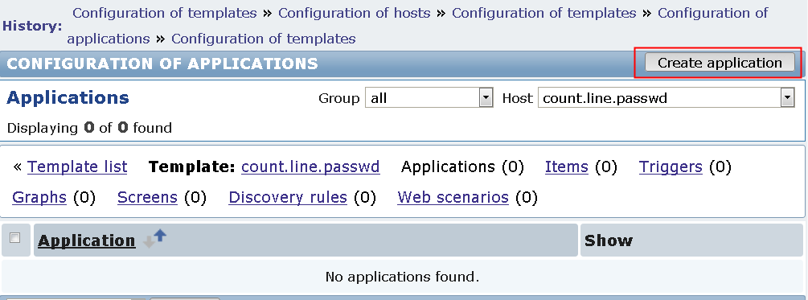

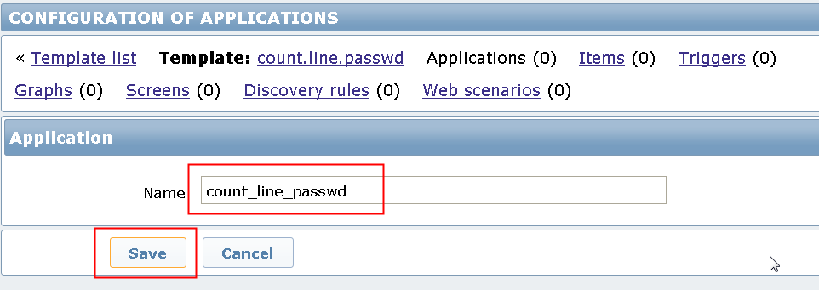

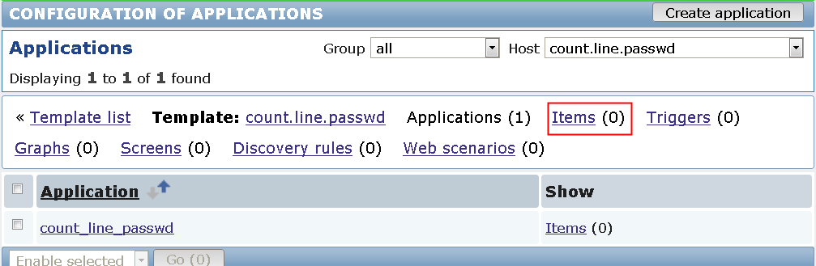

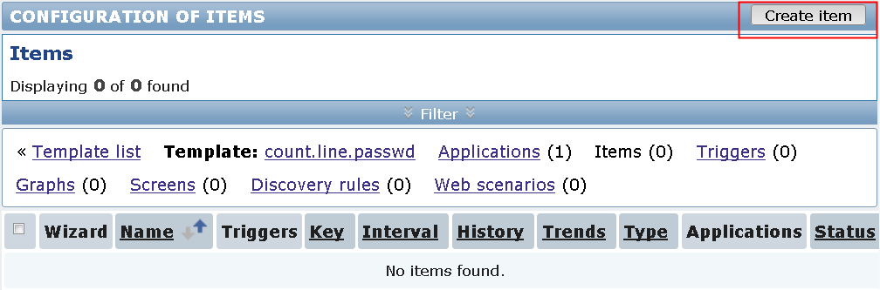

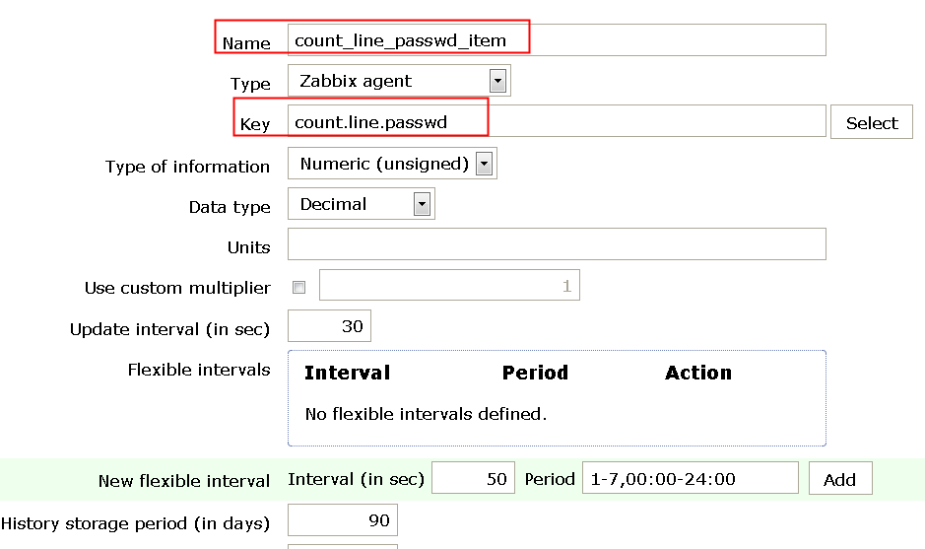

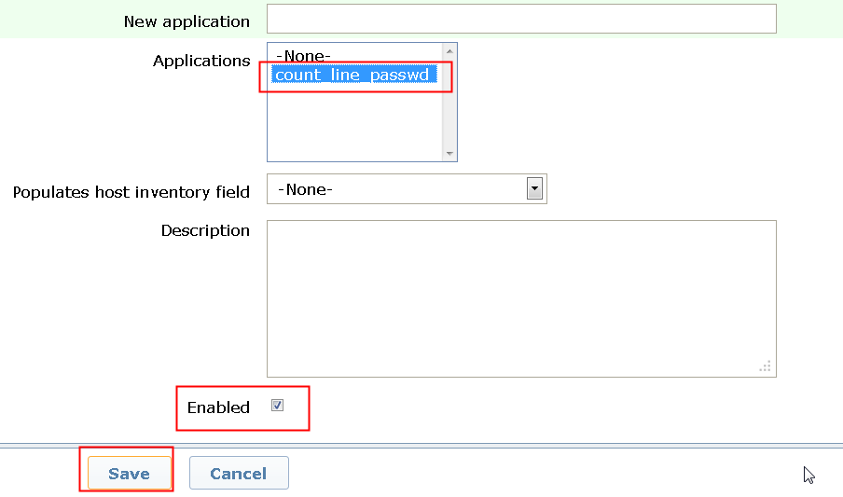

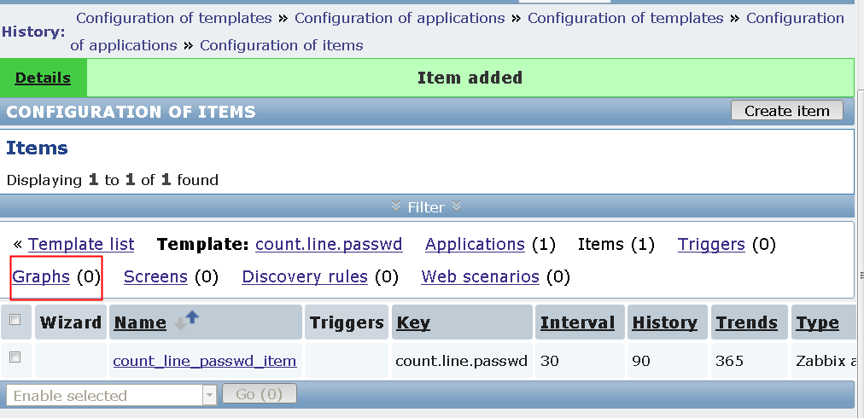

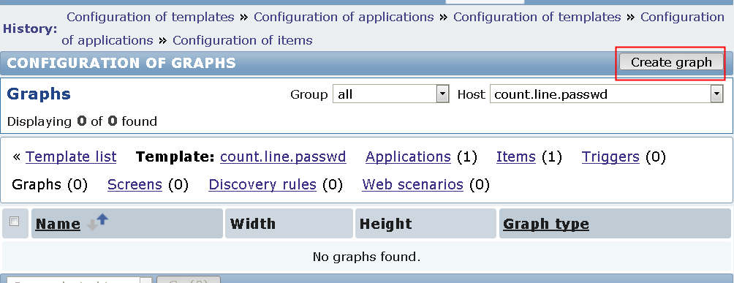

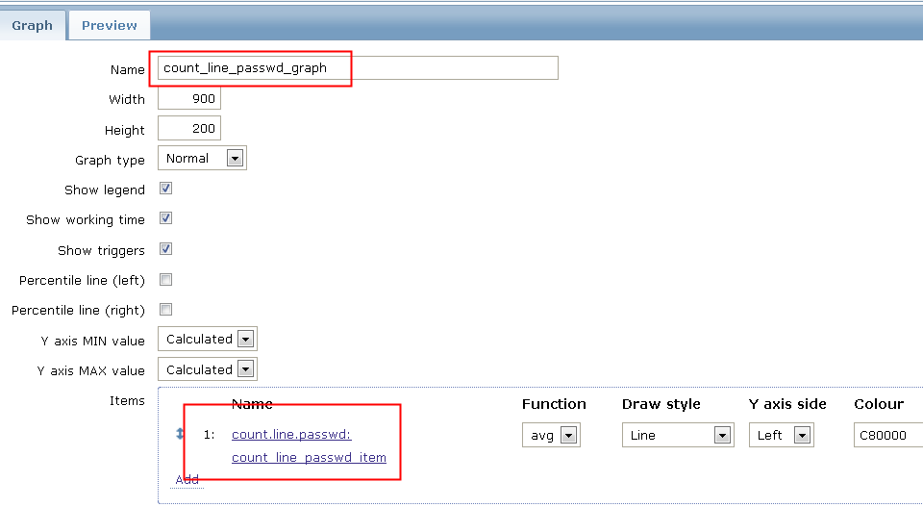

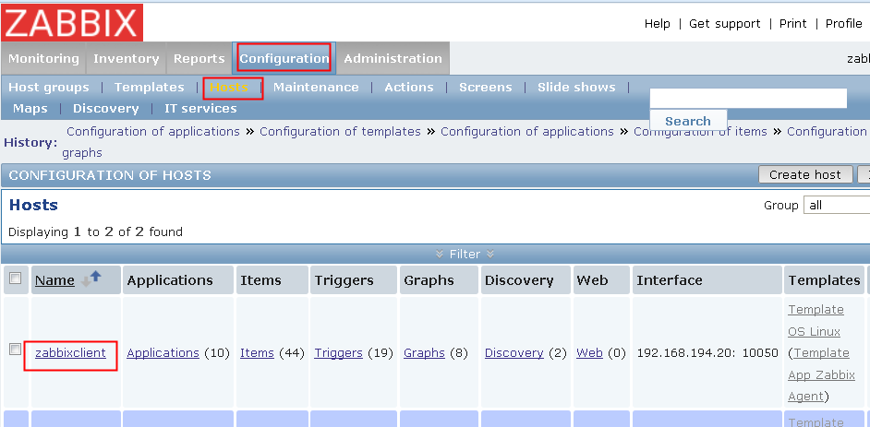

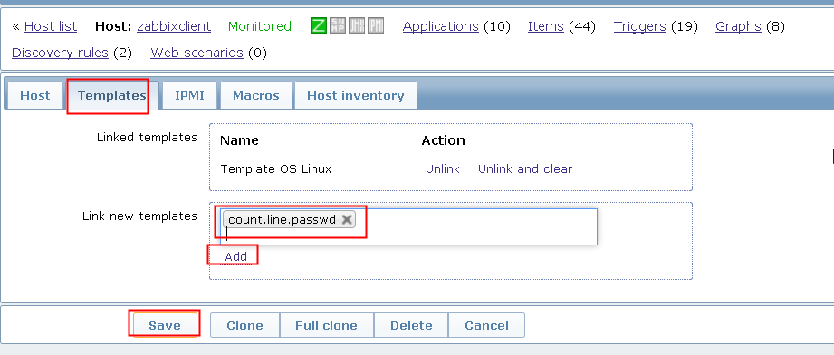

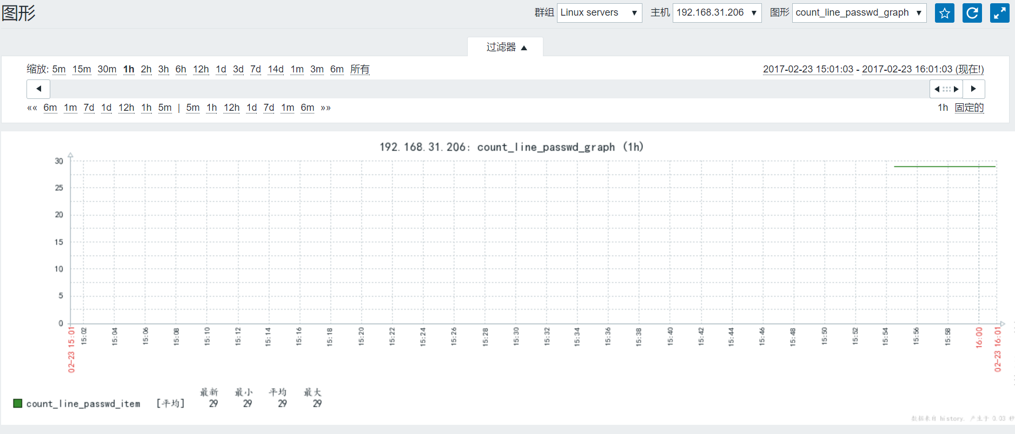

创建triggers触发器

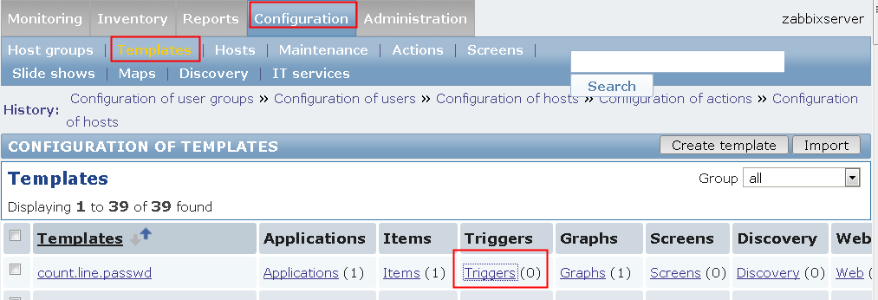

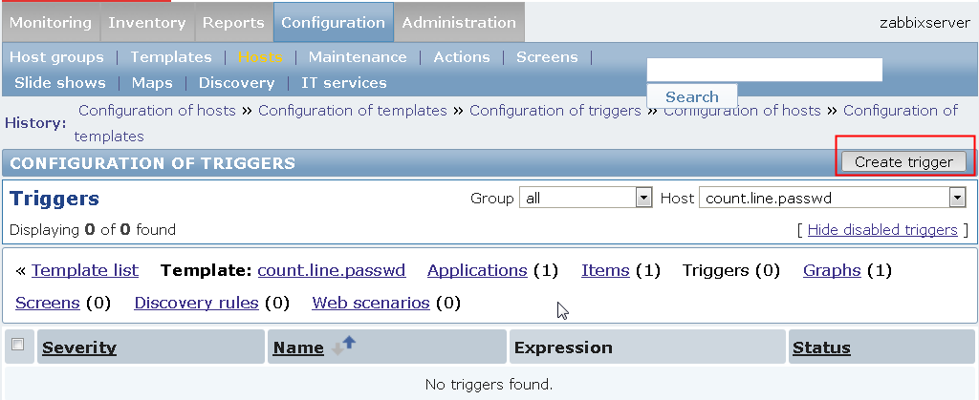

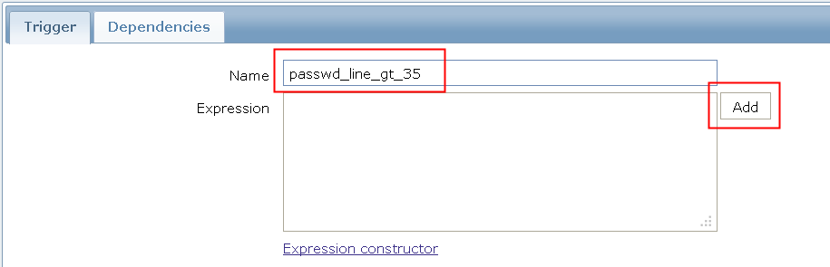

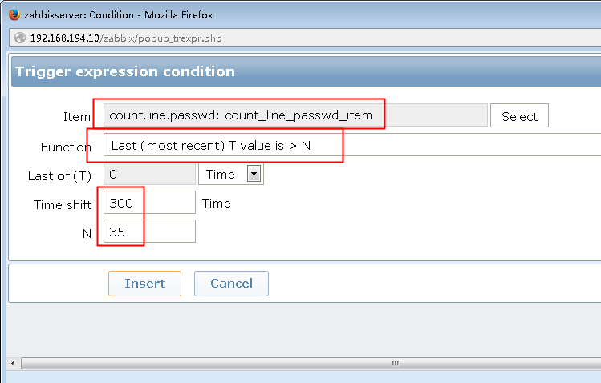

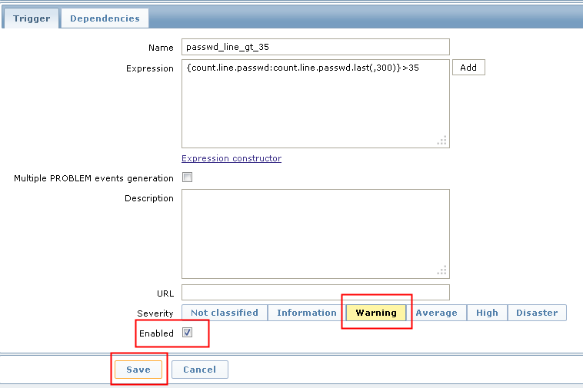

测试。创建用户，使得count.line.passwd的值超过35

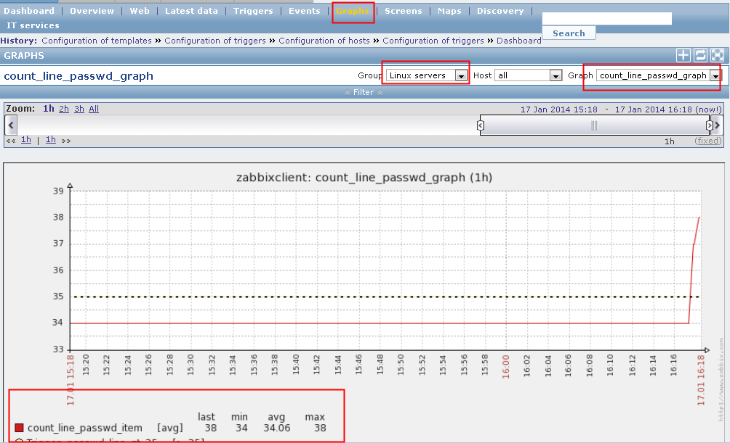

查看事件

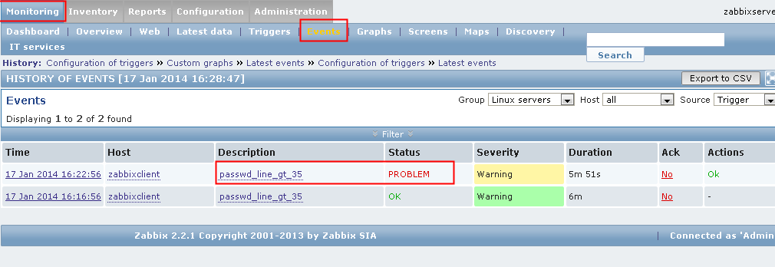

注：



Function是函数，parameter是参数，operator是操作符，constant是常量

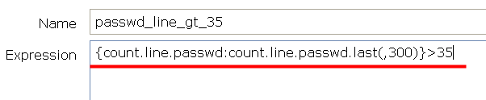

上面自定义的触发器，count.line.passwd对就server，count.line.passwd对应key，last对应的是function，(,300) 对应的是(<parameter>)，>对应的是operator，35对应的是constant。