# Freemarker入门

---模板框架

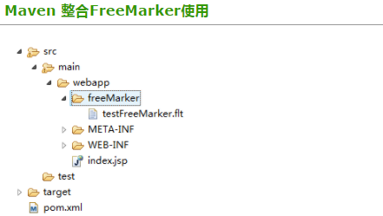

### pom.xml增加依赖包

|  |
| --- |
| <!-- freemarker jar -->  <dependency>  <groupId>org.freemarker</groupId> <artifactId>freemarker</artifactId>  <version>2.3.20</version>  </dependency> |

### testFreeMarker.flt

 1 您好${name}，现在在测试FreeMarker功能

### FreeMarkerUtil.java

|  |
| --- |
| package com.chenjx.common.utils;  import java.io.IOException;  import java.io.StringWriter;  import java.util.Map;  import javax.servlet.http.HttpServletRequest;  import freemarker.template.Configuration;  import freemarker.template.Template;  import freemarker.template.TemplateException;  /**  * @Author: chenjx  * @Description:  * @Date: Created in 13:47 2017-09-28  * @Modified By:  */ public class FreeMarkerUtil {   private static FreeMarkerUtil instance;  private Configuration config;   String templatePath = "/freeMarker/";   /**  * instance FreeMarkerUtil  * @return  */  public static FreeMarkerUtil instance() {  if (instance == null) {  instance = new FreeMarkerUtil();  }  return instance;  }   /**  * instance Configuration  * @param request  */  private void configInstance(HttpServletRequest request) {  if (this.config == null) {  this.config = new Configuration();  this.config.setServletContextForTemplateLoading(request.getSession().getServletContext(),templatePath);  }  }   /**  * 通过模板文件生成字符串  * @param request  * @param templateFileName  * @param propMap  * @return  */  public String geneFileStr(HttpServletRequest request,String templateFileName, Map<String, Object> propMap) {  configInstance(request);  StringWriter out = new StringWriter();  Template tmp;  try {  tmp = this.config.getTemplate(templateFileName,"UTF-8");  tmp.setEncoding("UTF-8");  tmp.process(propMap, out);  } catch (IOException e) {  e.printStackTrace();  } catch (TemplateException e) {  e.printStackTrace();  }  return out.getBuffer().toString();  } } |

### TestController.java

|  |
| --- |
| package pers.kangxu.test.controller;  import java.util.HashMap;  import java.util.Map;  import javax.servlet.http.HttpServletRequest;  import org.springframework.stereotype.Controller;  import org.springframework.web.bind.annotation.RequestMapping;  import org.springframework.web.bind.annotation.ResponseBody;  import pers.kangxu.test.util.FreeMarkerUtil;  @Controller  @RequestMapping("/test-default")  public class TestController {    @RequestMapping(value="test-freemarker",produces = "application/json; charset=utf-8")  @ResponseBody  public String testFreeMarker(HttpServletRequest request){    Map<String,Object> map = new HashMap<String,Object>();  map.put("name", "【我是名字】");    return FreeMarkerUtil.instance().geneFileStr(request, "testFreeMarker.flt", map);  }  } |