FUNCTION
作用：通过订单表初始化初始化收益表
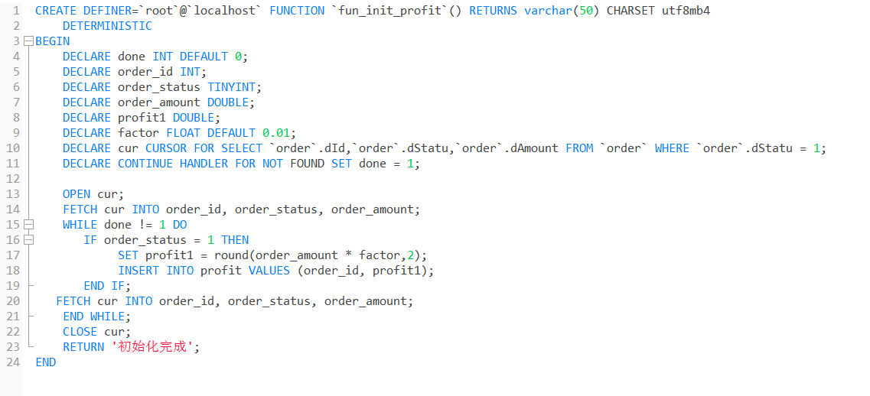
CREATE DEFINER=`root`@`localhost` FUNCTION `fun_init_profit`() RETURNS varchar(50) CHARSET utf8mb4
DETERMINISTIC
BEGIN
DECLARE done INT DEFAULT 0;
DECLARE order_id INT;
DECLARE order_status TINYINT;
DECLARE order_amount DOUBLE;
DECLARE profit1 DOUBLE;
DECLARE factor FLOAT DEFAULT 0.01;
DECLARE cur CURSOR FOR SELECT `order`.dId,`order`.dStatu,`order`.dAmount FROM `order` WHERE `order`.dStatu = 1;
DECLARE CONTINUE HANDLER FOR NOT FOUND SET done = 1;

OPEN cur;
FETCH cur INTO order_id, order_status, order_amount;
WHILE done != 1 DO
IF order_status = 1 THEN
SET profit1 = round(order_amount * factor,2);
INSERT INTO profit VALUES (order_id, profit1);
END IF;
FETCH cur INTO order_id, order_status, order_amount;
END WHILE;
CLOSE cur;
RETURN '初始化完成';
END

TRIGGER
作用：新增已支付订单记录时计算收益
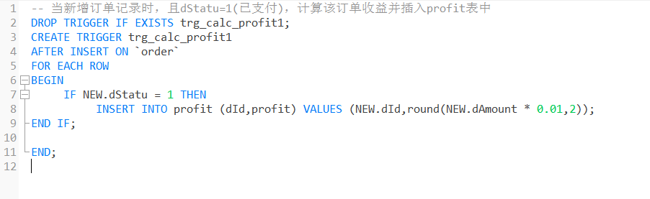
DROP TRIGGER IF EXISTS trg_calc_profit1;
CREATE TRIGGER trg_calc_profit1
AFTER INSERT ON `order`
FOR EACH ROW
BEGIN
IF NEW.dStatu = 1 THEN
INSERT INTO profit (dId,profit) VALUES (NEW.dId,round(NEW.dAmount * 0.01,2));
END IF;

END;

作用：更改订单状态时(0→1)，计算收益
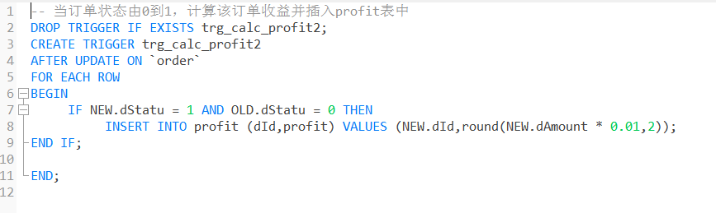
DROP TRIGGER IF EXISTS trg_calc_profit2;
CREATE TRIGGER trg_calc_profit2
AFTER UPDATE ON `order`
FOR EACH ROW
BEGIN
IF NEW.dStatu = 1 AND OLD.dStatu = 0 THEN
INSERT INTO profit (dId,profit) VALUES (NEW.dId,round(NEW.dAmount * 0.01,2));
END IF;

END;

作用：创建订单时应先判断购买数量与库存量的关系：如果购买数量>库存量，则不予购买，并给出提示信息；如果购买数量<=库存量，则更新库存量。

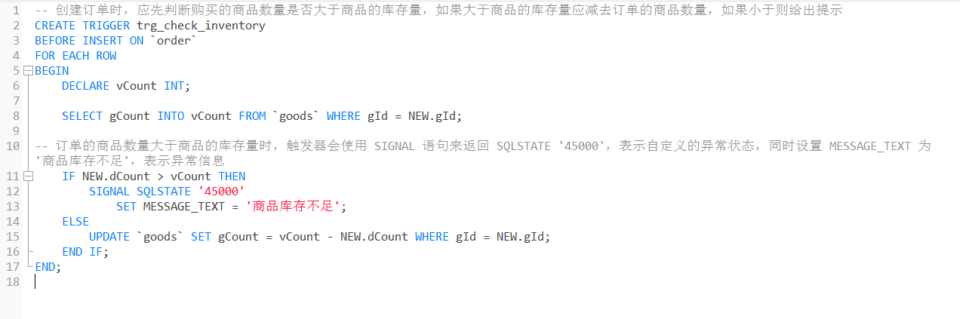
CREATE TRIGGER trg_check_inventory
BEFORE INSERT ON `order`
FOR EACH ROW
BEGIN
DECLARE vCount INT;

SELECT gCount INTO vCount FROM `goods` WHERE gId = NEW.gId;

-- 订单的商品数量大于商品的库存量时，触发器会使用 SIGNAL 语句来返回 SQLSTATE '45000'，表示自定义的异常状态，同时设置 MESSAGE_TEXT 为 '商品库存不足'，表示异常信息
IF NEW.dCount > vCount THEN
SIGNAL SQLSTATE '45000'
SET MESSAGE_TEXT = '商品库存不足';
ELSE
UPDATE `goods` SET gCount = vCount - NEW.dCount WHERE gId = NEW.gId;
END IF;
END;

作用：删除某个商品时删除其对应的评论
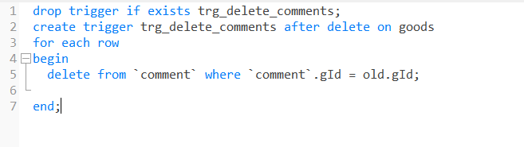
drop trigger if exists trg_delete_comments;
create trigger trg_delete_comments after delete on goods
for each row
begin
delete from `comment` where `comment`.gId = old.gId;

end;

作用：实时更新商品等级：当商品新增一条评论时，会对该商品的等级产生影响
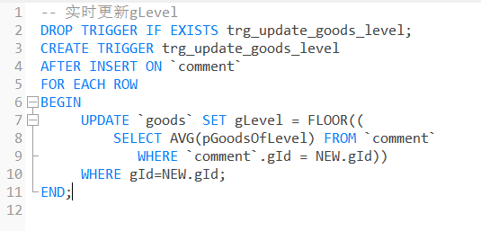
DROP TRIGGER IF EXISTS trg_update_goods_level;
CREATE TRIGGER trg_update_goods_level
AFTER INSERT ON `comment`
FOR EACH ROW
BEGIN
UPDATE `goods` SET gLevel = FLOOR((
SELECT AVG(pGoodsOfLevel) FROM `comment`
WHERE `comment`.gId = NEW.gId))
WHERE gId=NEW.gId;
END;

作用：实时更新用户等级：当商品新增一条评论时，会对售卖该商品的用户的等级产生影响
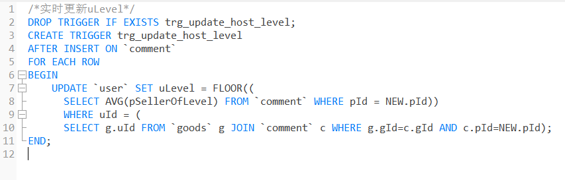
DROP TRIGGER IF EXISTS trg_update_host_level;
CREATE TRIGGER trg_update_host_level
AFTER INSERT ON `comment`
FOR EACH ROW
BEGIN
UPDATE `user` SET uLevel = FLOOR((
SELECT AVG(pSellerOfLevel) FROM `comment` WHERE pId = NEW.pId))
WHERE uId = (
SELECT g.uId FROM `goods` g JOIN `comment` c WHERE g.gId=c.gId AND c.pId=NEW.pId);
END;

PROCUDGE
作用：通过token获取用户信息
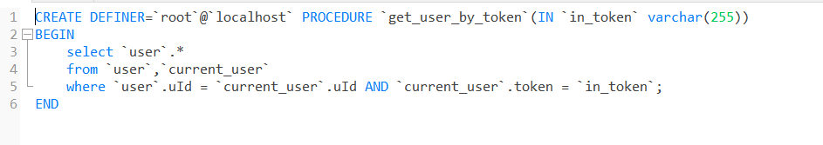
CREATE DEFINER=`root`@`localhost` PROCEDURE `get_user_by_token`(IN `in_token` varchar(255))
BEGIN
select `user`.*
from `user`,`current_user`
where `user`.uId = `current_user`.uId AND `current_user`.token = `in_token`;
END

作用：通过卖家ID获取用户等级

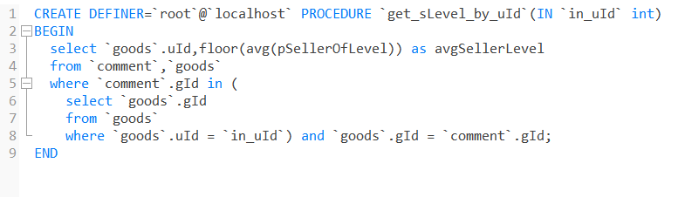

CREATE DEFINER=`root`@`localhost` PROCEDURE `get_sLevel_by_uId`(IN `in_uId` int)
BEGIN
select `goods`.uId,floor(avg(pSellerOfLevel)) as avgSellerLevel
from `comment`,`goods`
where `comment`.gId in (
select `goods`.gId
from `goods`
where `goods`.uId = `in_uId`) and `goods`.gId = `comment`.gId;
END

