计算方法实验

实验二：

姓 名：
学 号：
班 级： 软件工程212班
实验地点：
实验时间： 2023.10.18
- 实验目的和要求
实验目的：
- 熟悉复化梯形方法、复化Simpson方法、龙贝格算法；
- 能编程实现复化梯形方法、复化Simpson方法、梯形递推算法、龙贝格算法；
- 分析实验结果体会各种方法的精确度，建立计算机求解定积分问题的感性认识
程序任务：编程实现对特定函数的定积分近似计算

- 实验环境和工具
Java 11、Windows10、IDEA 2022
- 实验结果
  - 算法流程图
- 根据误差限计算近似积分值算法流程图
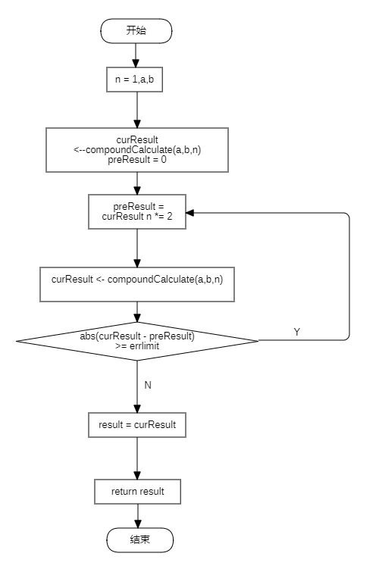
上述compoundCalculate(a,b,n)是计算n等分的近似积分值，每迭代一次，n呈倍数增长，知道计算出误差值小于限定误差即可跳出。
- 复化梯形算法流程图
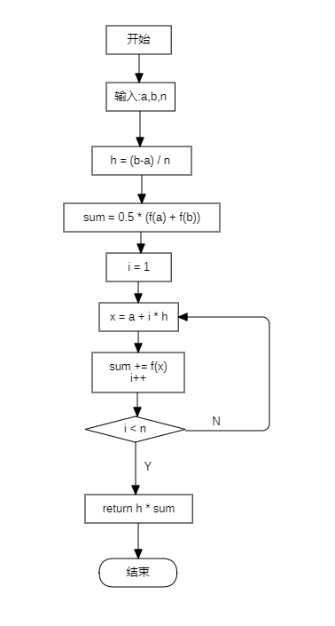
- 复化辛普森算法流程图
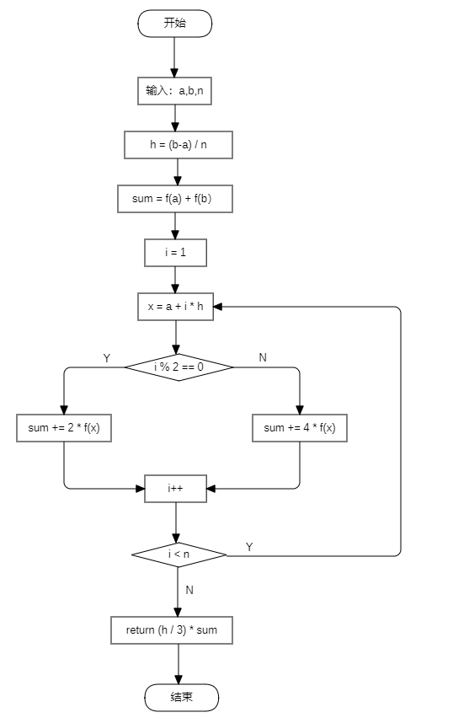
- 龙贝格积分计算流程图
龙贝格积分计算分为两部分，一部分是trapz方法，另外一部分是龙贝格积分计算核心代码。在核心代码处使用了动态规划思想，将矩阵进行了压缩。
Trapz方法流程图：
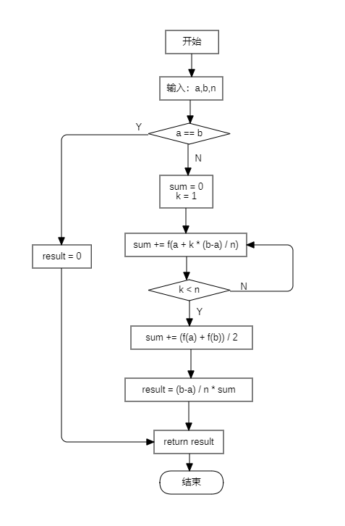

核心代码算法流程图：
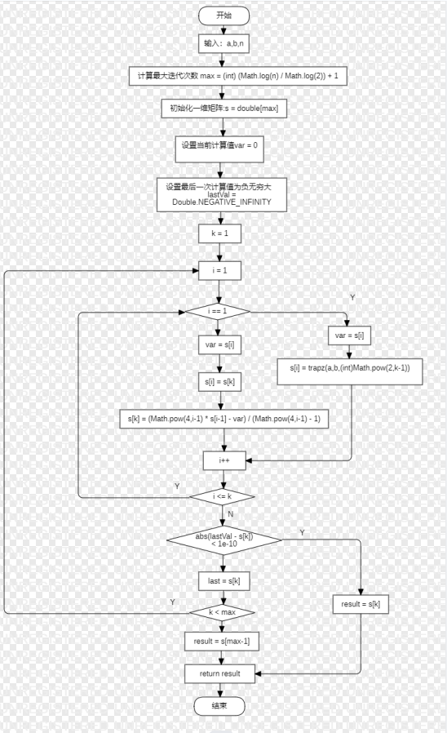

  - 程序核心代码
- Function接口
用于统一函数接口
package experiment2;
public interface Function {
double calculate(double x);
}

- ProblemFunction 类
具体被积函数
package experiment2;
public class ProblemFunction implements Function{
@Override
public double calculate(double x) {
return Math.exp(x) * x / Math.pow(1 + x, 2);
}
}

- CompositeBase 抽象类
具体算法的父类，定义计算接口和基本属性
package experiment2;
public abstract class CompositeBase {
private double[] interval;
private double errorLimit;
private Function function;
private int n;

private double result;

public Function getFunction(){
return function;
}

public double getResult(){
return result;
}

public int getN(){
return n;
}

public CompositeBase(double[] interval,double errorLimit,Function function){
this.interval = interval;
this.errorLimit = errorLimit;
this.function = function;
}

public CompositeBase(double[] interval,Function function,int n){
this.interval = interval;
this.function = function;
this.n = n;
}
public abstract double compoundCalculate(double a,double b,double n);

public void calculateByError(){
n = 1;
double a = interval[0];
double b = interval[1];

double curResult = compoundCalculate(a,b,n);
double preResult = 0;
do {
preResult = curResult;
n *=2 ;
curResult = compoundCalculate(a,b,n);
}while (Math.abs(preResult - curResult) >= errorLimit);
result = curResult;
}

public void calculateByN(){
double a = interval[0];
double b = interval[1];
result = compoundCalculate(a,b,n);
}
}

- CompoundTrapezoid类
复化梯形计算具体实现类
package experiment2;
public class CompoundTrapezoid extends CompositeBase{

public CompoundTrapezoid(double[] interval, double errorLimit, Function function) {
super(interval, errorLimit, function);
}

@Override
public double compoundCalculate(double a, double b, double n) {
double h = (b-a) / n;
double sum = 0.5 * (getFunction().calculate(a) + getFunction().calculate(b));
for (int i = 1; i < n; i++) {
double x = a + i * h;
sum += getFunction().calculate(x);
}
return h * sum;
}
}

- CompoundSimpson类
复化辛普森计算具体实现类
package experiment2;
public class CompositeSimpson extends CompositeBase{
public CompositeSimpson(double[] interval, double errorLimit, Function function) {
super(interval, errorLimit, function);
}
@Override
public double compoundCalculate(double a, double b, double n) {
double h = (b - a) / n;
double sum = getFunction().calculate(a) + getFunction().calculate(b);
for (int i = 1; i < n; i++) {
double x = a + i * h;
if (i % 2 == 0) {
sum += 2 * getFunction().calculate(x);
} else {
sum += 4 * getFunction().calculate(x);
}
}
return (h / 3) * sum;
}
}

- Romberg类
龙贝格积分计算具体实现类
package experiment2;
public class Romberg extends CompositeBase{

public Romberg(double[] interval, Function function, int n) {
super(interval, function, n);
}

@Override
public double compoundCalculate(double a, double b, double n) {
int maxIterations = (int) (Math.log(n) / Math.log(2)) + 1;
double[] s = new double[maxIterations];

double var = 0;
double lastVal = Double.NEGATIVE_INFINITY;

for (int k = 1;k < maxIterations;k++){
for(int i=1;i <= k;i++){
if (i == 1){
var = s[i];
s[i] = trapz(a,b,(int)Math.pow(2,k-1));
}else{
s[k] = (Math.pow(4,i-1) * s[i-1] - var) / (Math.pow(4,i-1) - 1);
var = s[i];
s[i] = s[k];
}
}
if(Math.abs(lastVal - s[k]) < 1e-10){
return s[k];
}else{
lastVal = s[k];
}
}
return s[maxIterations-1];

}

private double trapz(double a,double b,int N){
if(a == b){
return 0;
}
double sum = 0;
for(int k=1;k<N;k++){
sum += getFunction().calculate(a + k * (b-a) / N);
}
sum += (getFunction().calculate(a) + getFunction().calculate(b) ) / 2;
return (b-a) / N * sum;
}
}
- Main类
package experiment2;
import java.util.Scanner;
public class Main {
private static Scanner scanner;

public static void main(String[] args) {
scanner = new Scanner(System.in);
System.out.println("[1] Function one: f(x) = Math.exp(x) * x / Math.pow(1 + x, 2)");
System.out.println("Choose your function:");
int functionChoose = scanner.nextInt();
Function function = null;
if (functionChoose == 1){
function = new ProblemFunction();
}else {
System.out.println("Error!");
return;
}
System.out.println("Enter interval:");
double init = scanner.nextDouble();
double fina = scanner.nextDouble();
double[] interval = {init,fina};
System.out.println("Problem One:");
problemOne(interval,function);
System.out.println("Problem Two:");
problemTwo(interval,function);
System.out.println("Problem Three");
problemThree(interval,function);
}

private static void problemOne(double[] interval, Function function){
System.out.println("Enter error limit:");
double errorLimit = scanner.nextDouble();
CompoundTrapezoid compoundTrapezoid = new CompoundTrapezoid(interval, errorLimit, function);
compoundTrapezoid.calculateByError();
System.out.println("区间等分数："+compoundTrapezoid.getN());
System.out.println("区间近似结果："+compoundTrapezoid.getResult());
}

private static void problemTwo(double[] interval, Function function){
System.out.println("Enter error limit:");
double errorLimit = scanner.nextDouble();
CompositeSimpson compositeSimpson = new CompositeSimpson(interval, errorLimit, function);
compositeSimpson.calculateByError();
System.out.println("区间等分数："+compositeSimpson.getN());
System.out.println("区间近似结果："+compositeSimpson.getResult());
}

private static void problemThree(double[] interval, Function function){
System.out.println("Enter n:");
int n = scanner.nextInt();
Romberg romberg = new Romberg(interval, function, n);
romberg.calculateByN();
System.out.println("积分近似值: " + romberg.getResult());
}
}

  - 运行结果
- Function one: f(x) = Math.exp(x) * x / Math.pow(1 + x, 2)
Choose your function:
1
Enter interval:
0 1
Problem One:
Enter error limit:
0.00001
区间等分数：128
区间近似结果：0.35913928448363586
Problem Two:
Enter error limit:
0.00001
区间等分数：16
区间近似结果：0.3591402190196225
Problem Three:
Enter n:8
积分近似值: 0.35909067628414226

  - 运行结果分析
程序运行结果均在合理误差范围内。

- 实验心得
熟悉了复化梯形方法、复化Simpson方法、龙贝格算法；
学会了编程实现复化梯形方法、复化Simpson方法、梯形递推算法、龙贝格算法；

