**Statistical Consulting Report**

Restricted Entry: Is bias limiting Sikhs’ access to mental health services?

Consultant: Ning Shen

Clients: Maria Stahre, Rajeena Kumar

# Abstract

Studies have shown that in North America Racial/Ethnic (RE) disparities exist among social service providers when providing social services to minority groups [2, 3]. Researchers of this study aim to investigate RE bias within the population of counsellors in the province of British Columbia towards Punjabi Sikh individuals in terms of how receptive the service provider is to provide social services. In this statistical report, logistic regression and ordinal regression are proposed for the two response variables related to responsiveness and reception rate respectively. Potential confounding factors for one of the predictors are also discussed. Furthermore, a power analysis of the logistic regression is included so that the researchers may decide a proper sample size for the experiment.

# Introduction

Research has identified RE disparities in delivery of social services such as counselling in North America. Literatures review of RE biases has found that counselling service providers seem to have an implicit bias, that is, a positive attitude towards Caucasians and a negative attitude towards people of color [2, 3]. This study aims to investigate RE bias at the entry point of social services. Specifically, the study seeks to examine the possibility of RE disparities in accessing mental health services by a particular South Asian (SA) group of individuals (i.e., Punjabi Sikh individuals) in Canada. The main interest is the service providers’ possible bias towards religious individuals of Sikh background in terms of the service providers’ receptiveness to the service recipients. The secondary objective is to investigate the impact of other factors such as gender, accent and/or intergroup contact on the accessibility of the services.

# Data Description

The participants of this study will be randomly selected social service providers, i.e., counsellors, from professional associations or licensure bodies common to BC as found on their public directories. Participants will receive pre-recorded voicemails. Each voicemail represents one of all possible conditions regarding the status of religion, gender and/or accent. A pilot study has identified that certain Sikh names and Christian names are highly likely to conjure up an image of a Sikh or Christian person, respectively. An assumption is thus made that the participants are able to identify the religion of the caller by his/her name. In terms of intergroup contact, the experiment will be performed on counsellors from two cities with distinct percentage of Punjabi Sikh individuals. To reduce the possibility that the phone call will be answered, all calls will be placed after regular working hours (e.g., 8:30 p.m.). A pilot experiment with 20 participants will be conducted to determine the sample size required to obtain a power of 0.8 due to the scarcity of research in this area. Whether the service provider returns the phone message and offers appointments will be recorded as response variables. An example of all possible variables is shown in Table 1. In the real dataset, columns will be variables in Table 1 and rows will be phone messages. Variable *city* is included in the analysis as one of the predictors instead of the level of intergroup contact because of the potential confounding factors, such as demographic characteristics of the participants in different cities. In other words, a higher intergroup contact may not necessarily be the reason why participants in one city are less prejudiced towards Sikh patients; it may also be the reason that there is a higher proportion of Sikh councellors in that city. Therefore. we could only make inference on the *city* factor through the anaylsis rather than the factor of intergroup contact. To infer the causal relationships between RE disparities and level of intergroup contact, further investigation beyond the scope of this study is needed.

# Proposed Statistical Analysis

Since the project is only at its early stage with no data available, simulated data are generated for a clear presentation of the proposed analysis under the assumption that the data structure and possible values in Table 1 are correct. A logistic regression model is proposed for the response coded

|  |  |  |
| --- | --- | --- |
| **Variable Type** | **Variable Name** | **Possible Values** |
| Predictors / independent variables | *religion* | ‘Sikh’ or ‘Non-Sikh’ |
| *gender* | ‘Male’ or ‘Female’ |
| *accent* | ‘Present’ or ‘Absent’ |
| *city* | ‘Richmond’ or ‘Surrey’ |
| Responses / dependent variables | *callback* | ‘True’ (coded as ‘1’) or ‘False’ (coded as ‘0’) |
| *appoint offer* | ‘Yes’, ‘Not sure’ or ‘No’ (coded as ‘2’, ‘1’, ‘0’ respectively) |

**Table 1: Example table of variables included in the analysis**

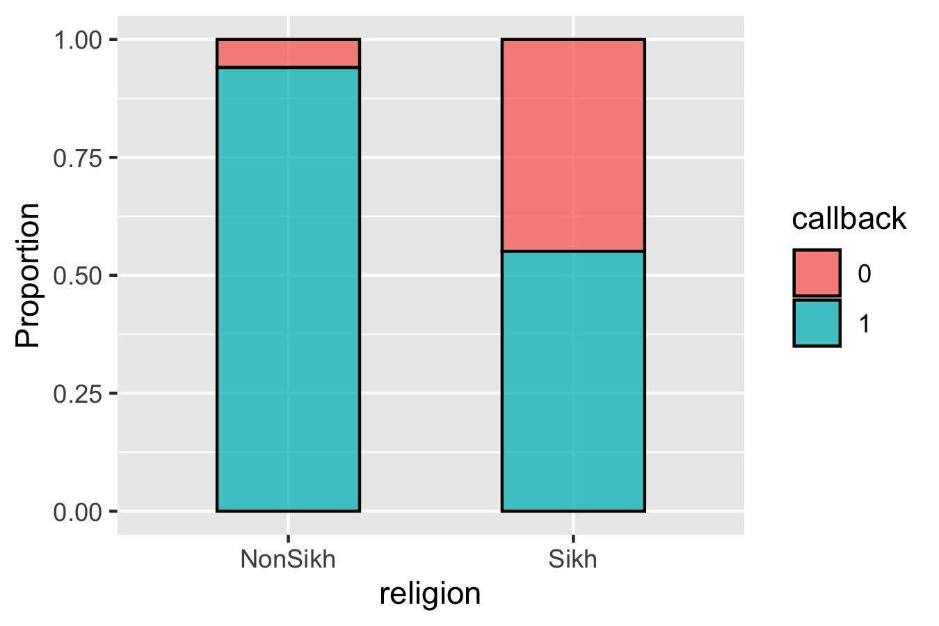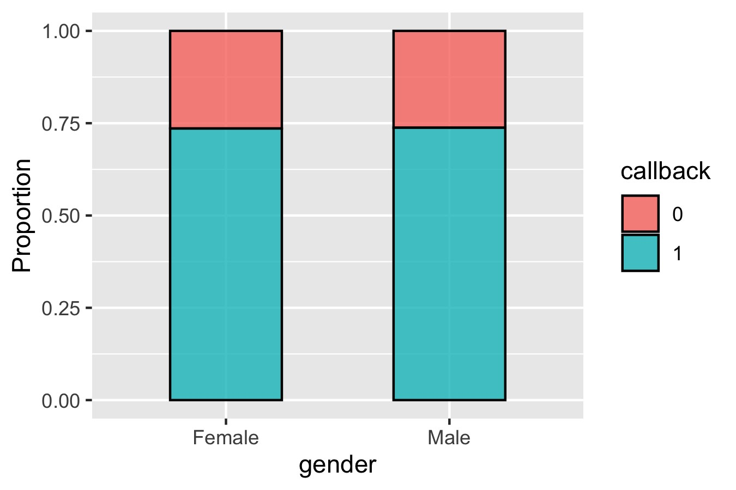

## (a) (b)

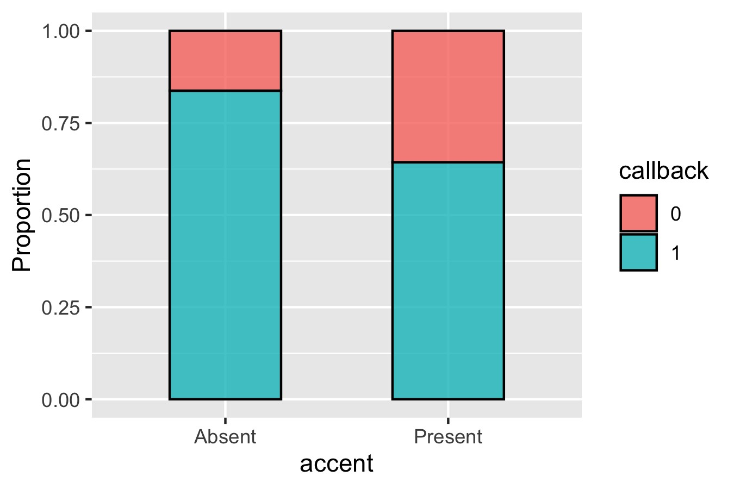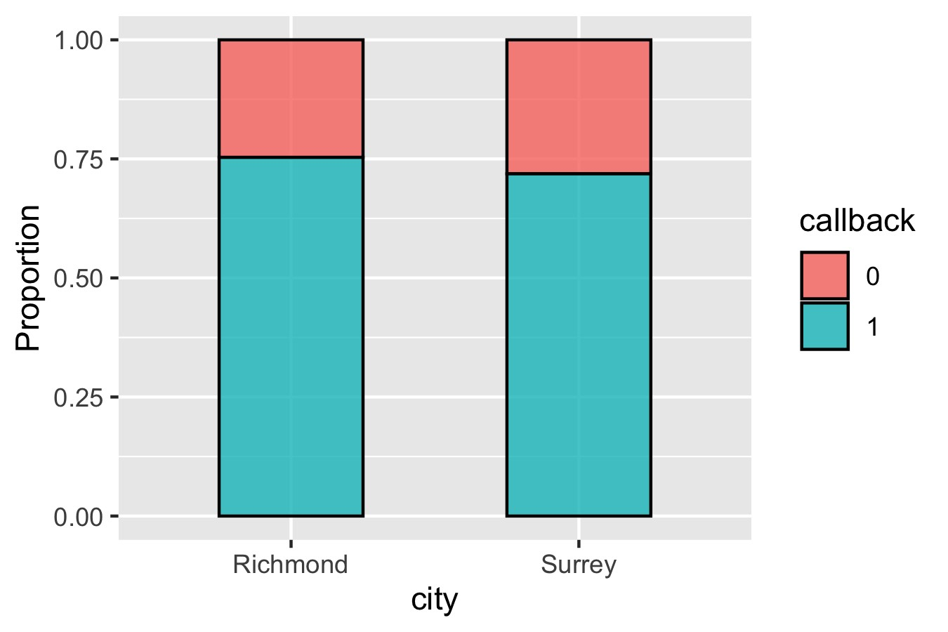

## (c) (d)

**Figure 1: Distribution of** *callback* **in predictors a)** *religion***, b)** *gender***, c)** *accent* **and d)** *city*

as a binary variable (i.e., *callback*). An ordinal regression model, which is an extension of the logistic regression model, is recommended for the case where the response is coded as an ordinal variable with more than two levels. Specifically, an ordinal variable is a variable whose value exists on an arbitrary scale where only the relative ordering between different values is important, such as *appoint offer*. A sample analysis though statistical programme language R is illustrated below as well as interpretation for the results. In the following analysis we include all predictors from Table 1, but choice of the predictors is flexible due to nature of the models. Researchers of the study may choose a desired set of predictors depending on the circumstances. All programming codes can be found in my [Github repository.](https://github.com/NingShen1997/STAT551_Case34)

## Logistic regression on *callback*

As an exploratory analysis, Figure 1 depicts the distribution of *callback* within possible values of the predictors respectively. *Religion* and *accent* are the two factors that have distinctive proportions of ‘no callback’ in different categories, while *gender* and *city* seem to have little influence on the callback rate. Taking all four factors into account as predictors, we build the logistic regression model on response variable *callback*:

 (1)

where *i* represents the *ith* phone message, *µi* = E(*yi*) = P(*yi* = 1) is the probability of *ith* phone message receives callback, *xi*1*,...,xi*4 are the values of each predictor’s for the *ith* phone message, *β*0 is the intercept, and *β*1*,...,β*4 are the regression coefficients for four predictors respectively. A main advantage of the logistic regression model is its attractive interpretation: 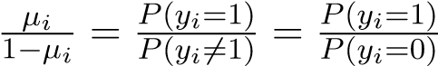

can be interpreted as the **odds** of event “*yi* = 1”, so the parameter (say) *βj* may be interpreted as the change of odds in log-scale when the *jth* predictor is changed from baseline value to alternate value. We can fit the regression coefficients in Equation 1 through R. The following presents a sample code output from applying the glm function to simulated data with the arguments set to perform logistic regression:

> lr.fit <- glm(callback ~ religion + gender + accent + city,

+ data = dat, family=binomial("logit")) ## Fit the parameters

> summary(lr.fit) ## Results summary

Call: glm(formula = callback ~ ., family = binomial("logit"), data = dat)

Deviance Residuals:

Min 1Q Median 3Q Max

-2.2947 -0.9460 0.2638 0.7694 1.4280

Coefficients:

Estimate Std. Error z value Pr(>|z|)

|  |  |
| --- | --- |
| (Intercept) 3.76833 | 0.35272 10.684 < 2e-16 *** |
| religionSikh -2.70256 | 0.28465 -9.494 < 2e-16 *** |
| genderMale -0.02224 | 0.21612 -0.103 0.9180 |
| accentPresent -1.21003 | 0.22274 -5.432 5.56e-08 *** |
| citySurrey -0.40560 | 0.21796 -1.861 0.0628 . |

From the output, the estimated intercept is 3.77 and the estimated regression slope for the four predictors are -2.70, -0.02, -1.21, -0.41 respectively. The output gives us the fitted model:

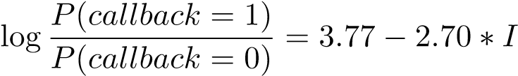(*religion*=‘Sikh’) − 0*.*02 ∗ *I*(*gender*=‘male’)

(2) − 1*.*21 ∗ *I*(*accent*=‘present’) − 0*.*41 ∗ *I*(*city*=‘Surrey’)*,*

where *I*(·) is the indicator function.

Taking *religion* for an example of interpretation. Here the baseline value is set as ”non-Sikh” and the alternate value is “Sikh.” The exponentiated estimate of coefficient for ‘religionSikh’ in the R output, *e*−2*.*70 = 0*.*067, is the factor by which the odds of receiving callback is multiplied when *religion* changes from non-Sikh to Sikh while other variables remain fixed. In other words, the odds of a voicemail from a Sikh person receiving callback is expected to reduce 1 − 0*.*067 = 93*.*3% compared with a non-Sikh person. Correspondingly, we could observe from Figure 1a that the callback rate in the “Sikh” group is notably lower than the “non-Sikh” group. The other three predictor coefficients can be interpreted similarly. Meanwhile, the exponentiated intercept, *e*3*.*77 = 43*.*4, represents the odds that a phone message receives callback when it is from a non-Sikh female with no accent in city Richmond, i.e., the baseline.

## Ordinal regression on *appoint offer*

Instead of the odds of being one category in logistic regression, the ordinal regression model focuses on the odds of being less than or equal to a particular category. In our case, this odd is defined as 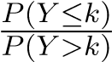 for *k* = 0*,*1 where *Y* is the response variable *appoint offer*, and *k* is the category in the response. Further, the ordinal logistic regression model is parameterized as

*,* (3)

where notations are the same as logistic regression except that the intercept *βk*0 varies with category *k*. We use the polr function in MASS package from R to estimate the parameters in the regression model. The sample code runs as follows:

> or.fit <- polr(appoint_offer ~ religion + gender + accent + city, data = dat, Hess=TRUE) > summary(or.fit) Call:

polr(formula = appoint_offer ~ religion + gender + accent + city, data = dat, Hess = TRUE)

Coefficients:

Value Std. Error t value

|  |  |
| --- | --- |
| religionSikh -3.6144 | 0.2379 -15.1946 |
| genderMale -0.3360 | 0.1838 -1.8281 |
| accentPresent -2.3898 | 0.2131 -11.2122 |
| citySurrey -0.1545 | 0.1844 -0.8377 |

Intercepts:

Value Std. Error t value

0|1 -5.5780 0.3543 -15.7447

1|2 -2.9841 0.2705 -11.0338

According to the output, the estimated model can be written as:

*P*(*appoint offer* ≤ 0)

log= − 5*.*58 − 3*.*61 ∗ *I*(*religion*=‘Sikh’) − 0*.*34 ∗ *I*(*gender*=‘male’)

*P*(*appoint offer >* 0) (4)

− 2*.*39 ∗ *I*(*accent*=‘present’) − 0*.*15 ∗ *I*(*city*=‘Surrey’)

and

*P*(*appoint offer* ≤ 1)

log= − 2*.*98 − 3*.*61 ∗ *I*(*religion*=‘Sikh’) − 0*.*34 ∗ *I*(*gender*=‘male’)

*P*(*appoint offer >* 1) (5)

− 2*.*39 ∗ *I*(*accent*=‘present’) − 0*.*15 ∗ *I*(*city*=‘Surrey’)

The estimated regression slope for the four predictors are the same for the two odds. Interpretations for the coefficients are similar to that of /in the logistic regression model, except for the intercepts. The exponent of first intercept *e*−5*.*58 = 0*.*004 represents the odds that a baseline voicemail receives “Yes” as the answer for requesting appointment offer. The exponent of second intercept *e*−2*.*98 = 0*.*051 represents the odds that a baseline voicemail receives “Yes” or “Not sure” as the answer for requesting appointment offer. In this model output, we could observe that *religion* and *accent* have larger influence on the possibility of receiving appointment offer, which is shown in Figure 2.

# Sample Size Calculation

As mentioned above, a pilot experiment with 20 participants will be conducted for estimation of an appropriate sample size. A power analysis, which allows us to determine the sample size required to detect an effect of a given size with a given significance level, is included in this section. The statistical power of a hypothesis test is the probability of detecting an effect, given that there is a

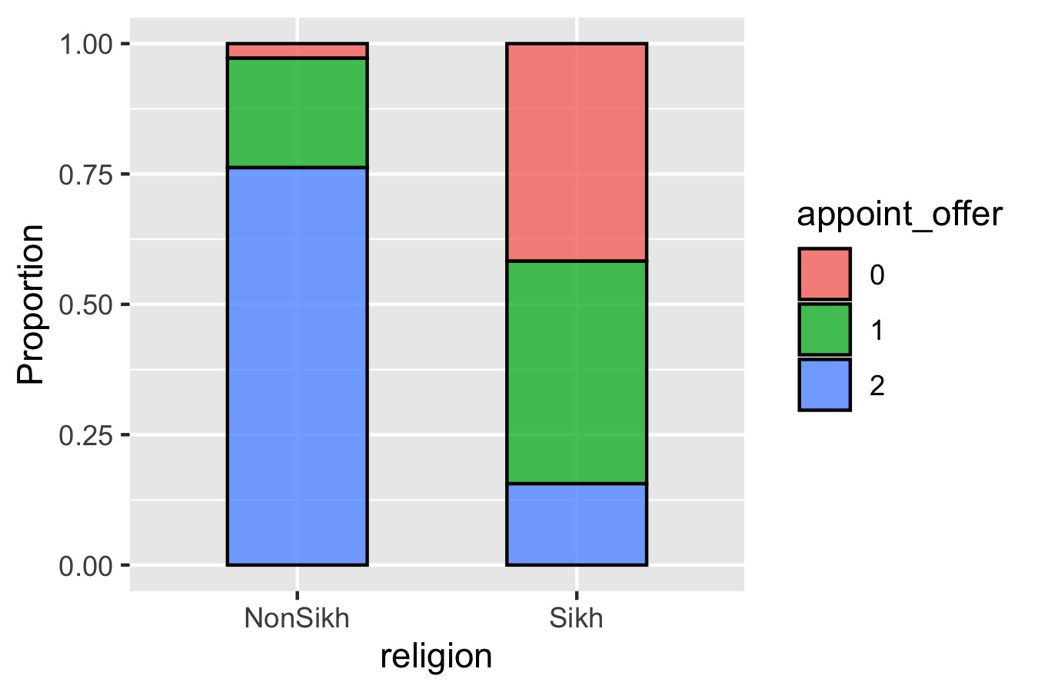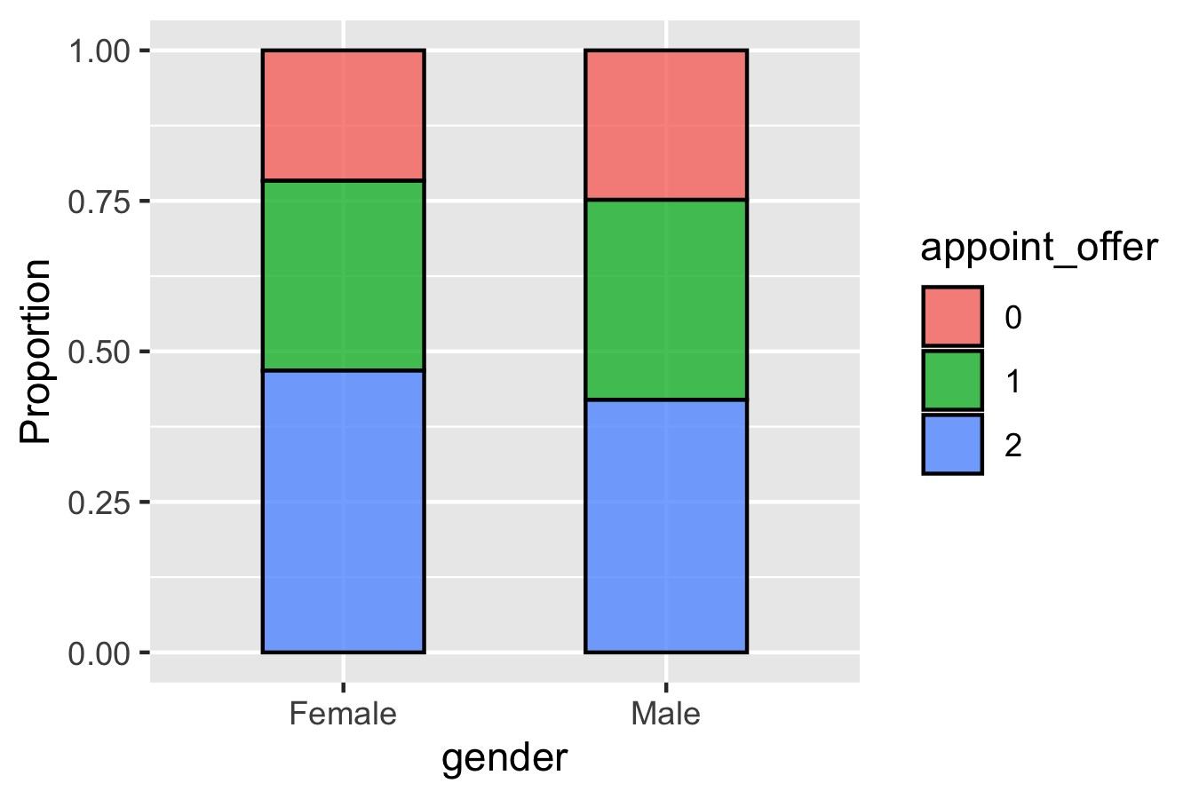

## (a) (b)

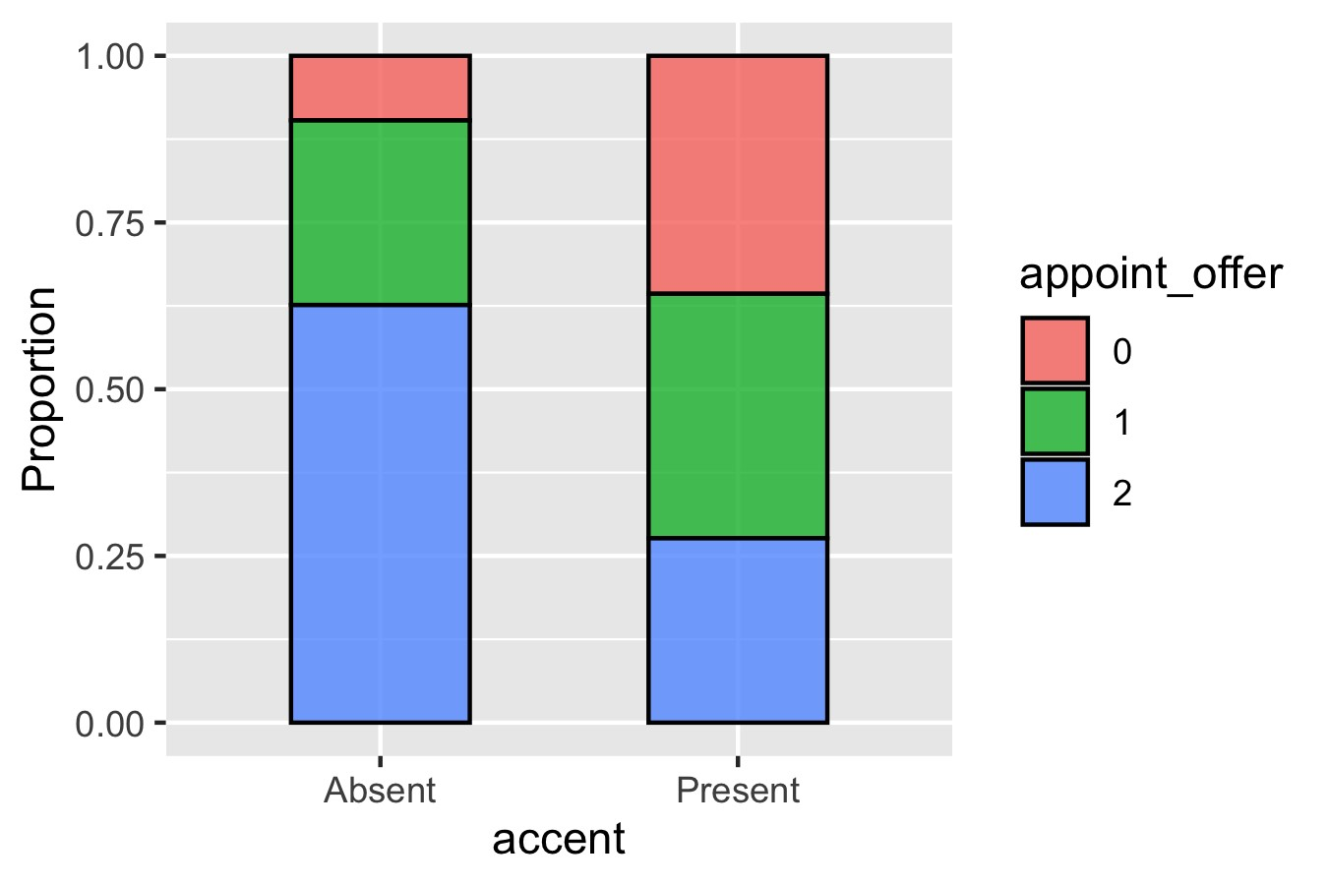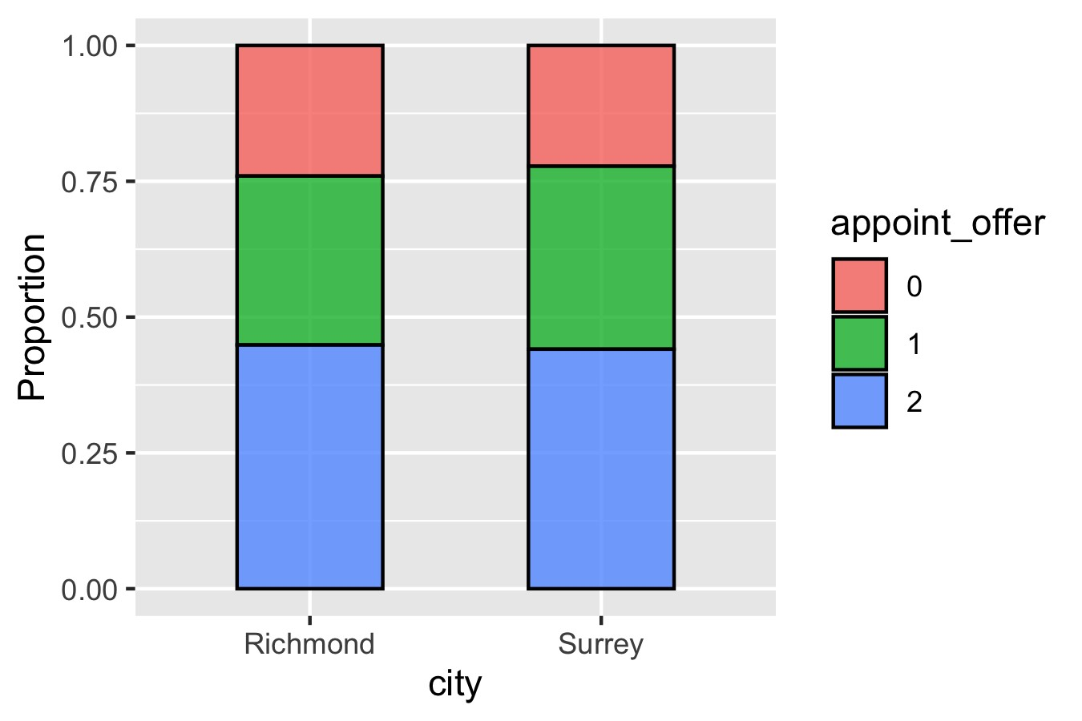

## (c) (d)

**Figure 2: Distribution of** *appoint offer* **in predictors a)** *religion***, b)** *gender***, c)** *accent* **and d)** *city***.**

true effect present. On the contrary, the significance level is the probability of finding an effect that is not there. Since the main objective of the study is associated with religious disparities, we focus on predictor *religion* for the calculation. There are two response variables in the study, but for simplicity we demonstrate the analysis using *callback*. The approach for power analysis on logistic regression introduced by Demidenko [1] is adopted in this analysis, as well as the function wp.logistic from R package WebPower [4] that encodes this approach. For programming details, please refer to my [Github repository.](https://github.com/NingShen1997/STAT551_Case34)

The information to be gathered from the pilot experiment is the proportion of 1’s in *callback* given that *religion* is ‘non-Sikh’, *P*(*Y* = 1|*X* = ‘Sikh’), and the proportion of 1’s in *callback* given that *religion* is ‘Sikh’, *P*(*Y* = 1|*X* = ‘non-Sikh’), where *callback* is denoted as *Y* and *religion* is denoted as *X*. The estimated *P*(*Y* = 1|*X* = ‘non-Sikh’) and *P*(*Y* = 1|*X* = ‘Sikh’) from the pilot experiment is inputted to the R function wp.logistic as arguments p0 and p1. A sample code assuming *P*(*Y* = 1|*X* = ‘non-Sikh’) = 0*.*60, *P*(*Y* = 1|*X* = ‘Sikh’) = 0*.*50 runs as follows:

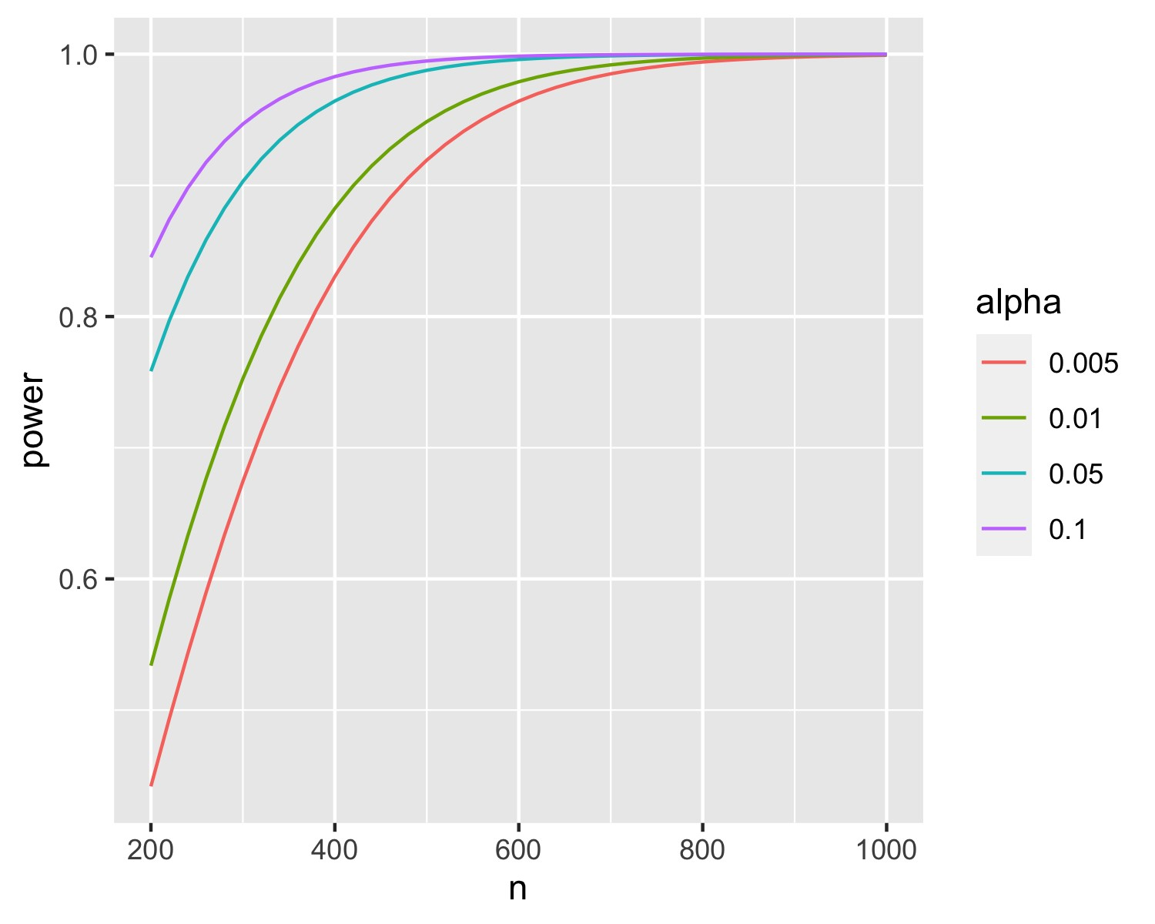

**Figure 3: Power analysis plot for logistic regression with significance level of 0.005,**

**0.01, 0.05 and 0.1**

> wp.logistic(n = 600, p0 = 0.60, p1 = 0.50, alpha = 0.05,

+ power = NULL, alternative = "two.sided", family = "normal")

Power for logistic regression

p0 p1 beta0 beta1 n alpha power

0.6 0.5 0.4054651 -0.4054651 600 0.05 0.9959592

From the R output, we could tell that the statistical power has exceeded 0.99 when significance level *α* is set to 0.05 and sample size is 600.

Figure 3 is a power analysis plot with power calculated by the abovementioned function. It shows the statistical power of a logistic regression with a significance level of 0.005, 0.01, 0.05 and 0.1 under sample size constraints given *P*(*Y* = 1|*X* = ‘non-Sikh’) = 0*.*60, *P*(*Y* = 1|*X* = ‘Sikh’) = 0*.*50. Diagrams corresponding to different estimations of p0 and p1 can be obtained through applying the R codes by researchers themselves.

# Conclusion

To explore the potential bias from counsellors towards Sikh individuals at the entry point of the service, we recommend a logistic regression and an ordinal regression model to estimate the effect of factors like religion and gender on the counsellors’ responsiveness and reception rate. Sample analyses for the regression models are demonstrated in the report and researchers may perform the analysis as depicted on a flexible choice of interested factors. However, the researchers should remain cautious with the factor of intergroup contact as it might be confounded with other factors such as demographic characteristics of the counsellor. An example power analysis for the sample size determination is also presented.

# References

1. Eugene Demidenko. Sample size determination for logistic regression revisited. *Statistics in Medicine*, 26(18):3385–3397, 2007. doi: https://doi.org/10.1002/sim.2771. URL [https://onlinelibrary.wiley.com/doi/abs/10.1002/sim.2771.](https://onlinelibrary.wiley.com/doi/abs/10.1002/sim.2771)
2. Heather Kugelmass. “sorry, i’m not accepting new patients”: An audit study of access to mental health care. *Journal of Health and Social Behavior*, 57(2):168–183, 2016. doi:

10.1177/0022146516647098. URL [https://doi.org/10.1177/0022146516647098.](https://doi.org/10.1177/0022146516647098) PMID: 27251890.

1. Richard Q. Shin, Lance C. Smith, Jamie C. Welch, and Ijeoma Ezeofor. Is allison more likely than lakisha to receive a callback from counseling professionals? a racism audit study. *The Counseling Psychologist*, 44(8):1187–1211, 2016. doi: 10.1177/0011000016668814. URL [https://doi.org/10.1177/0011000016668814.](https://doi.org/10.1177/0011000016668814)
2. Z. Zhang and K.-H. Yuan. *Practical Statistical Power Analysis Using Webpower and R*. Granger, IN: ISDSA Press, 1994.