|  |
| --- |
| Shooter |
| Space shooter |
| **[Centennial college** |
| Version 1.00  All work Copyright © 2012 by shooter Games.  All rights reserved. |
| **Ninghan Huang** |
|  |

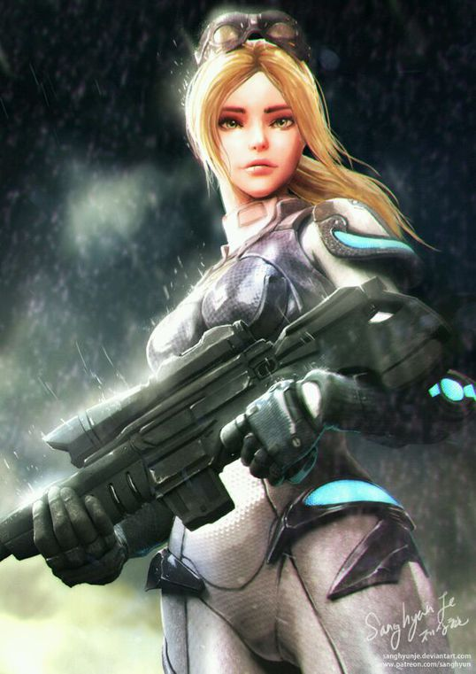

**Insert a Company Logo here**

|  |
| --- |
| Feb 11st 2016 |

**Table of Contents**

Table of Contents

1.Version History 3

2. description 4

# 1.Version History

|  |  |
| --- | --- |
| Version | Demonstrate |
| 1.00 | Demo of game |

# 2. description

1. 1. **Game Overview**

*Player control the plane to void the obstacle and hit the rock to get the point*

1. **Game Overview**

*Player control the plane to void the obstacle and hit the rock to get the point*

1. **Game Play Mechanics**

*Use unity 5 to play this game*

1. **Camera**

*2D camera*

1. **Controls**

*Use W, A, S, D to control the plane move*

1. **Interface Sketch**

*in the right top corner is user score shows user correct score, in the left top corner is plane when game end in the middle of the screen is the score that user get in the game*

1. **Game World**

*You are in the space to void enemy catch you*

1. **Non-player Characters**

Health ,Rock

1. **Enemies**

*Any plane except users plane*

1. **Abilities**

*Plane can move*

1. **Vehicles**

*A plane*

1. **Script**

*GameCtrl, enemyCtrl ,playerscript,playerCollider,background*

1. **Scoring**

*When hit the rock, user get 10 point, hit the enemy plane -10 health and health can heal plane 10 lives*

1. **Sound Index**

*(Include an index of all your sound clips)*

1. **Story Index**

*You are the last human in this area, take this plane and go to the Aiur to ask the Protoss support, move, move, move*

1. **Future Features**

*Plane can use laser to destroy the enemy*