Tribhuvan University
Amrit Science Campus


A Project Report On

XNAP: Casplit–Expense Sharing WebApp

Under supervision of

Asst. Prof. Dabbal Singh Mahara

Submitted by

Kapil Raut(28189/078)

Kshitij Mahato(28192/078)

Ravi Shrestha(28221/078)

Submitted To

Tribhuvan University

Institute of Science and Technology

Amrit Science Campus

In partial fulfillment of the requirement for the Bachelor of Computer Science and Information Technology awarded by Tribhuvan University

October, 2025



Tribhuvan University
Institute of Science and Technology
Amrit Science Campus

CERTIFICATE OF DECLARATION

We hereby declare that no part of this work has been previously submitted to the University or any other institution, either for evaluation or any other purpose. We affirm that the content of this work is the product of our own efforts and has not been derived from any other source.

While the author retains the copyright to this project work, by submitting it for assessment, the author grants the University a perpetual, royalty-free license to exercise all or any of the rights specified in section 16(1) of the Copyright Designs and Patents Act 1988. This includes the rights to reproduce, distribute copies to the public, publicly perform or display the work, broadcast it, or create adaptations thereof.

Declared by:

…………………………. | ………………………… | …………………………
Kshitij Mahato | Kapil Raut | Ravi Shrestha
Symbol No: 28192/078 | Symbol num: 28189/078 | Symbol num: 28221/078

i



Tribhuvan University
Institute of Science and Technology
Amrit Science Campus

SUPERVISOR RECOMMENDATION

It is my pleasure to recommend the report titled “XNAP: Casplit-Expense Sharing Webapp” prepared under my supervision by Mr. Dabbal Singh Mahara in partial fulfillment of the requirements for the degree of Bachelor of Science in Computer Science and Information Technology (BSc. CSIT). I consider this report satisfactory and approve it for further evaluation.

………………………..
Mr. Dabbal Singh Mahara
Project Supervisor
Department of Computer Science and Information Technology
Amrit Campus
Lainchaur, Kathmandu, Nepal

ii



Tribhuvan University


Institute of Science and Technology
Amrit Science Campus


CERTIFICATE OF APPROVAL

The undersigned certifies that he has read and hereby recommends the report titled “XNAP: Casplit-Expense Sharing Webapp” for acceptance by the Department of Computer Science and Information Technology. This report has been prepared and submitted by Kapil Raut, Kshitiz Mahato, and Ravi Shrestha in partial fulfillment of the requirements for the degree of Bachelor of Science in Computer Science and Information Technology (BSc. CSIT) under the Institute of Science and Technology, Tribhuvan University.

………………………… ………………………………
Mr. Dabbal Singh Mahara Mr. Dhirendra Kumar Yadav
Project Supervisor Coordinator Department of CSIT
Amrit Campus Amrit Campus

………………………….. ………………………
External Examiner Internal Examiner
Tribhuvan University Amrit Campus

iii

ACKNOWLEDGEMENT

The successful completion of our final year project, titled “XNAP: Casplit-Expense Sharing Webapp”, would not have been possible without the kind support and help of many people.
First, we are very grateful to Mr. Dabbal Singh Mahara, our respected supervisor. His strong mentorship and guidance kept us motivated and on track. Without his expert guidance, we wouldn’t have reached this far.
We also extend our thanks to Mr. Dhirendra Kumar Yadav, our respected coordinator, for his constant support and provision of essential information throughout the project. His help played a key role in its successful completion.
We further express our sincere gratitude to the team at Amrit Campus for their thorough review, approval, and guidance throughout this transformative journey. We also are grateful to Mr. Akkal Bista for his excellent support during the entire project.
Special thanks and respect also go to the supportive online communities, as well as our friends and families, whose help was vital in the proper design, shaping, and refining of this application.
Finally, we are grateful to extend our deep appreciation to the administration and entire staff of Amrit Science Campus, Department of Computer Science and Information Technology whose constant support and guidance were crucial in completing this project.

With respect
Kapil Raut (28189/078)
Kshitiz Mahato (28192/078)
Ravi Shrestha (28221/078)

iv

ABSTRACT
Managing shared expenses between friends, roommates, or groups can be hard and time-consuming in day-to-day life. So, XNAP: Casplit-Expense sharing webapp is a web-based solution for managing and splitting expenses that makes it easier to track and settle group expenses. Users of the platform can record shared spending, add friends, join groups, and have their individual balances automatically calculated and expenses can be settled and updated.
The MERN stack—MongoDB, Express.js, React.js, and Node.js—was used in the system's construction to guarantee a cutting-edge, responsive, and effective user experience. XNAP improves group cooperation and financial clarity with its straightforward UI and real-time synchronization. This project tackles a real-world financial management issue while showcasing the useful application of full-stack web development techniques. This project serves as a foundation for students and developers to explore full stack development concepts.
Keywords: Expense Management, Expense Splitting, WebApp, Group Creation, MERN, Full Stack

v

TABLE OF CONTENTS

RECOMMENDATION…………………………………………………………...i
CERTIFICATE OF DECLARATION…………………………………………….ii
CERTIFICATE OF APPROVAL………………………………………………….iii
ACKNOWLEDGEMENT………………………………………………………...iv
ABSTRACT……………………………………………………………………….v
TABLE OF CONTENTS…………………………………………………………..vi
LIST OF ABBREVIATIONS……………………………………………………...viii
LIST OF FIGURES………………………………………………………………..ix
LIST OF TABLES…………………………………………………………………x
CHAPTER 1: INTRODUCTION 1
  - Introduction………………………………………………………………..1
  - Problem Statement………………………………………………………...1
  - Objectives………………………………………………………………….1
  - Scope………………………………………………………………………2
  - Limitations…………….…………………………………………………...2
  - Development Methodology………………………………………………..2
  - Testing and Validation……………………………………………………..2
CHAPTER 2: BACKGROUND STUDY AND LITERATURE REVIEW 4
  - Background Study ………………………………………………………………...4
  - Literature Review………………………………………………………………….5
CHAPTER 3: SYSTEM ANALYSIS 6
  - System Analysis……………………………………………………………6
    - Requirement Analysis………………………….…………………………..6
    - Feasibility Study…………………………………………………………...7
Project Schedule and Gantt Chart………………………………………………….8

vi
3.1.3. High Level Design of System………………………………………………9
CHAPTER 4: SYSTEM DESIGN 12
  - Design………………………………………………………………………13
  - AlgorithmDetails……………………………………………………………15
CHAPTER 5: IMPLEMENTATION AND TESTING 17
  - Implementation……………………………………………………………..17
    - Tools Used…………………………………………………………………..17
    - Implementation details of Modules…………………………………………17
  - Testing……………………………………………………………………….19
    - Unit Testing………………………………………………………………….18
CHAPTER 6: CONCLUSION AND FUTURE RECOMMENDATIONS 19
  - Conclusion……………………………………………………………………19
  - Future Recommendations…………………………………………………….19
REFERENCES……………………………………………………………………….20
APPENDICES………………………………………………………………………..21

vii

LIST OF ABBREVIATION

AI Artificial Intelligence
API Application Programming Interface
CSS Cascading Style Sheet
DBMS Database Management System
DOM Document Object Model
HTML Hyper Text Markup Language
HTTP HypeText Transfer Protocol
JS JavaScript
MERN MongoDB, Express.js, React.js, Node.js
MVC Model - View - Controller
NPM Node Package Manager
REST Representational State Transfer
UI User Interface
UX User Experience

viii

LIST OF FIGURES

Figure 3.1: Project Schedule using Gantt chart.……………………………………..8
Figure 3.2 DFD Level 0….…………………………………………………………..9
Figure 3.3: DFD Level 1..…………………………………………………………....10
Figure 3.4: DFD Level 2……………………………………………………………..11
Figure 4.1: Flowchart diagram……………………………………………………….12
Figure 4.2: UML Class Diagrams…………………………………………………....14

ix

LIST OF TABLES

Table 5.1: Test case for user login…………………………………………………….18
Table 5.2: Test case for group creation………………………………………………..18

x

Chapter 1: Introduction

Introduction
Managing shared spending has become a regular requirement in today's collaborative lives. Costs for events, travel, rent, or utilities are often shared by groups of friends, coworkers, or family members. However, certain conventional techniques, such as spreadsheets, manual computations, or casual note-taking, are laborious, error-prone, and opaque.
XNAP: Casplit-Expense sharing webapp, was created to address these issues. The system offers a web-based platform that makes it easier for group members to record, divide, and settle shared expenses. It was developed using the MERN (MongoDB, Express.js, React.js, Node.js) technological stack. This project, which falls under the Financial Technology (FinTech) category, shows how sophisticated algorithms may be integrated with contemporary web technologies to improve financial collaboration and streamline group spending management.

Problem Statement
Spreadsheets and many other unofficial methods are frequently used to manage shared spending among groups. In addition to being prone to mistakes, these methods take a lot of effort. This issue is especially common when several transactions are needed to pay off debts, which causes confusion and delays. There is an obvious need for an automated tool that streamlines group cost management, reduces transaction complexity, and offers process transparency given the growing reliance on digital solutions for financial management. By offering a completely automated, precise, and transparent platform for group spending management, Xnap resolves these problems. It ensures a more seamless and rapid resolution of financial obligations within groups by optimization.

1.3. Objectives
The Xnap project's primary goal is to provide an all-inclusive group expense management system that manages tracking, allocating, and settling costs among group members. The system’s two major objectives are:
- To Implement a proprietary algorithm to reduce the complexity of debt settlement, and minimizing the number of transactions required.
- To Provide real-time balance updates as expenses can be added, edited, or deleted which ensures up-to-date financial records.

1.4. Scope
Registration and Authentication: Users can easily and securely register and can perform profile management.

1

Real Time Balance Updates: System changes the balances and settlements in real time when the expenses get modified.
Group Creation: Create expense groups where you can add multiple members and manage their contribution.
Expense Tracking and Splitting: Users can add, edit and delete expenses while automatically splitting them among members based on predefined rules.

1.5. Limitations
- It cannot integrate with external payment gateways to perform transactions or manage actual payments.
- Live data such as instantaneous financial market data or real-time exchange rates, will not be supported.
- The system will only be able to manage group expenses; it won't be able to handle more general financial responsibilities like personal financial planning or tax management.
- No direct payment integration with group members
- No access to control

1.6. Development Methodology
The project will be developed with continuous feedback, ongoing research, and the flexibility to adapt to changing requirements. To achieve this, we will follow the agile methodology. This approach allows for iterative development, where the platform is built and improved in small, manageable increments. The development process will be divided into the following stages:
- Requirement Gathering: Having conversations with potential users and stakeholders to define functional and non-functional requirements.
- System Design: Algorithm development, database schema design, and architecture planning.
- Implementation: Developing the web application, incorporating the fundamental algorithm, front-end user interface, and backend services (API)
1.7. Testing and Validation
The report is divided into 6 chapters. Each chapter is divided into different headings and sub-headings. The preliminary section contains the overall information about the project. This section includes abstract, table of contents, list of figures and abbreviations. The main report is divided into 6 chapters, which includes:

2

Chapter 1: Introduction
It includes an introduction about the system. The problem statement, objectives, scopes and limitations, and the development methodology of this system has been discussed. It is an expense management app that allows the group of users to manage and control their expenses.
Chapter 2: Background study and Literature Review
It includes the study of the current environment the system will be deployed into. It contains a literature review section where the research works done in the field of the system are discussed in brief.
Chapter 3: System Analysis
It includes the study of functional requirements and non-functional requirements of the system. It will also include the Gantt chart and DFD of the system which specifies the workflow, entities, attributes, and their relationships. So, it is one of the most important phase of it.
Chapter 4: System Design
It includes the design of the database, forms, and interface of the system. It also discusses algorithms that are used in the system.
Chapter 5: Implementation and Testing
It includes the details of the different design and development tools used for the development of the system. It includes details of front-end tools, back-end tools, database technologies which are used for the development of the system. It also includes the testing of the system with different test cases as per the requirements.
Chapter 6: Conclusion and Future Recommendations
It includes the summary of the system and the project. It also includes the possibilities which the system can implement in the future.

3

Chapter 2: Background Study and Literature Review

Background of the Study
Group spending management has historically been laborious and prone to mistakes.Tracking and settling group spending frequently requires manual computations, which can result in errors and confusion, whether roommates share rent, friends split vacation expenses, or coworkers contribute to team meals. Digital solutions, which provide automated ways to manage shared spending, have emerged in response to the growing requirement for effective and transparent financial management.
Conventional approaches are ineffective and prone to mistakes because they mostly rely on spreadsheets or paper-based systems that don't offer real-time updates. The need for automated, error-free, and real-time expense management systems has increased dramatically with the emergence of digital finance tools.
The Xnap was created to overcome these drawbacks by utilizing financial algorithms and modern web technologies (MERN stack).
The Hybrid Debt Simplification Algorithm, which reduces the transactions required to settle debts inside a group, is the system's primary innovation. The system gives groups an easy approach to effectively manage their financial responsibilities by utilizing graph theory and optimization techniques.

Literature Review
According to research, apps like Splitwise, Venmo, and PayPal are widely used for monitoring group spending, but they don't have advanced debt optimization algorithms and provide little information about the group's overall financial behavior. Although they let users split expenses, these platforms usually rely on human entries and do not streamline the debt settlement process. Due to the drawbacks of traditional group payment applications, sophisticated algorithms like graph-based debt simplification have the potential to drastically lower the quantity of transactions needed for settlement [1]. Nevertheless, the majority of applications still employ crude techniques, which leads to more settlements than are necessary. By matching creditors and debtors in the best possible way, the Xnap system's debt simplification algorithm which combines Direct Cancellation and Greedy Optimization—significantly reduces transaction complexity.
The role of algorithmic optimization in group financial applications, noting that greedy algorithms and graph theory techniques can greatly improve the efficiency of financial settlements.Their findings support the idea that hybrid systems, combining various approaches, outperform traditional methods that rely solely on simple rule-based solutions.In terms of real-time financial data, [3] demonstrated how real-time transaction tracking can enhance user engagement and improve financial transparency.

4

These findings align with the core features of the Xnap system, which provides users with real-time balance updates whenever an expense is added or modified, ensuring accuracy and up-to-date information at all times.Xnap implements similar functionalities to allow users from various countries to manage and track their group expenses in their local currencies, reducing the friction involved in cross-border financial interactions.[4]The use of transparent tracking and audit trails is another critical aspect of modern financial management. Providing users with a full record of their financial transactions can increase trust and reduce disputes within groups. [5]
In terms of security, it's critical to use robust authentication procedures and data encryption to safeguard private financial information.[6] This is in line with the JWT-based authentication and password encryption techniques used by the Xnap system to guarantee that user data is safe and shielded from unwanted access.

5

Chapter 3: System Analysis

System Analysis

The detailed methodologies used to develop the application are described in the following subsections.

Requirement Analysis

The Requirements Specification is a crucial document in software engineering that outlines the detailed description of what the software system should accomplish. It serves as a foundation for the entire development process, guiding developers, testers, and stakeholders throughout the project.
Functional Requirements:
Functional requirements define the behavior of the system in terms of its interactions with users, other systems, and the environment. The Functional requirement of the system are listed below:
      - User Authentication: The Allow users to sign up, log in, and manage their profiles and enable secure access with JWT-based authentication.
      - Group Management: The Allow users to create, edit, and manage multiple expense groups. It also provides functionality to add or remove group members.
      - Expense Handling and splitting: The platform will offer users to add, edit, and delete the expenses. It then automatically split expenses between group members based on predefined rules (e.g., equal split, custom share).
      - Debt Optimization: Implement a hybrid debt simplification algorithm to minimize the number of transactions needed to settle debts. Use graph theory to optimize creditor-debtor pairing, reducing settlement complexity from O(n²) to O(n) transactions.
Non-Functional Requirements:
These specify the criteria that the system must meet concerning its quality attributes such as performance, reliability, security, usability, and maintainability. The non-functional requirements of the system are listed below:
  - Performance: The system should handle real-time transactions with sub-100ms response times to ensure smooth user experiences even with

6

large user groups or multiple simultaneous actions.
  - Usability: The system should provide an intuitive and user-friendly interface with clear navigation, ensuring users can easily manage their expenses without requiring technical expertise.
  - Security: All user data, especially sensitive financial information, should be encrypted. Passwords must be stored securely using encryption methods like bycrypt to protect against unauthorized access.
  - Scalability: The architecture should be scalable to accommodate a growing number of users, with support for groups up to 50+ members and multiple concurrent transactions.
  - Reliability: The system must function consistently without failures, ensuring that all transactions and updates are accurately processed and stored.

Feasibility Study
A feasibility study is a comprehensive analysis conducted to determine whether a proposed project or solution is viable and worth pursuing. It evaluates various aspects of the project to assess its practicality, potential for success, and overall value. There is one of the most important aspects of system design and analysis that could be considered before starting a project.
- Technical Feasibility
The project will use React.js for the frontend and Node.js for the backend, both of which are well-suited for building scalable and responsive web applications. MongoDB will be used as the database management system which is used for data persistence, offering a flexible schema and scalability options for managing user profiles, group expenses, and settlement transactions. The hybrid debt simplification algorithm is implemented using JavaScript which ensures optimal performance even with large data sets and multiple concurrent users.
- Operational Feasibility
Operational feasibility describes the system’s ability to function effectively in a real-world environment.
- User Interface: Xnap provides an easy-to-use online interface with straightforward registration, expense tracking, and settlement functions that can be accessed from any contemporary device.
- Administrative Control: Without requiring system outages, the system enables administrators to oversee settlements, manage groups, and update expenses.

7
- Deployment: By using cloud platforms like AWS, the online application may be made globally accessible without the need for complicated infrastructure.
- Economic Feasibility
The development will be done using open-source tools and resources available within the college infrastructure. The absence of financial costs makes the project economically feasible. The project can be developed and tested within the existing college environment, utilizing available resources without incurring additional expenses.

Project Schedule and Gantt chart
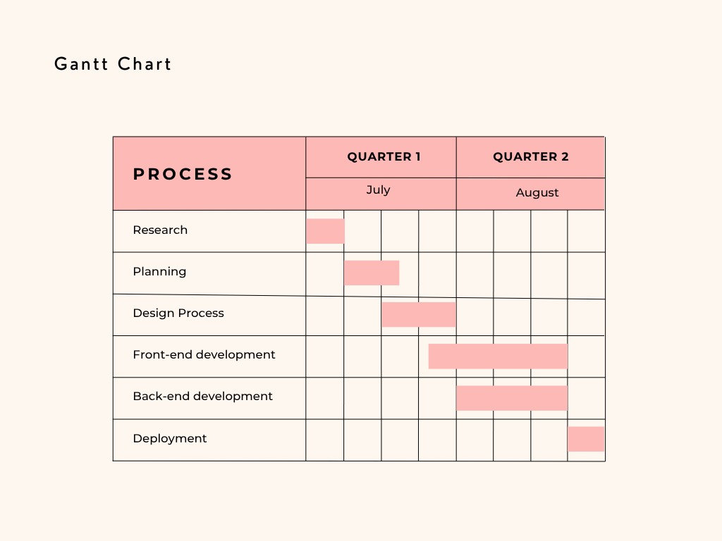

Figure 3.1: Project Schedule Using Gantt Chart

8

3.2 High Level Design of System

3.2.1 Level-0 DFD:
A Level 0 Data Flow Diagram (DFD) provides an overview of the system, depicting its major processes and the flow of data between them at a high level. It represents the system as a single process box, showcasing the interaction between external entities and the system itself. It is nice to use and create a data flow diagram at level 0. It is the starting diagram.

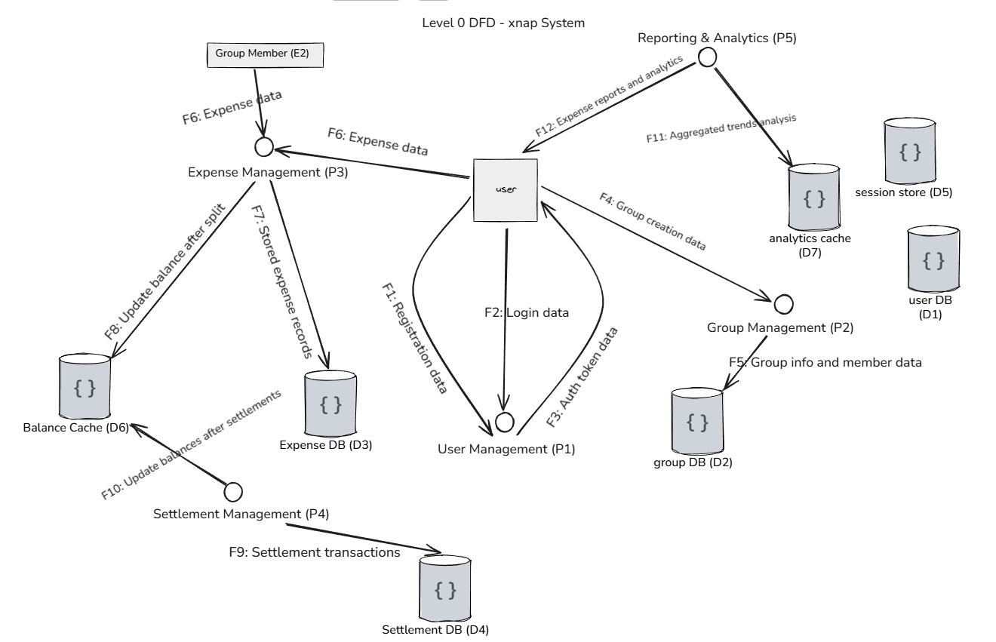
Figure 3.2: DFD Level 0

Level 1 DFD
Level 1 DFD delves deeper into the system's functionalities, breaking down the processes identified in the Level 0 diagram into more detailed sub processes. It illustrates how data flows within each process and between them, offering a more granular view of the system's operations.

9

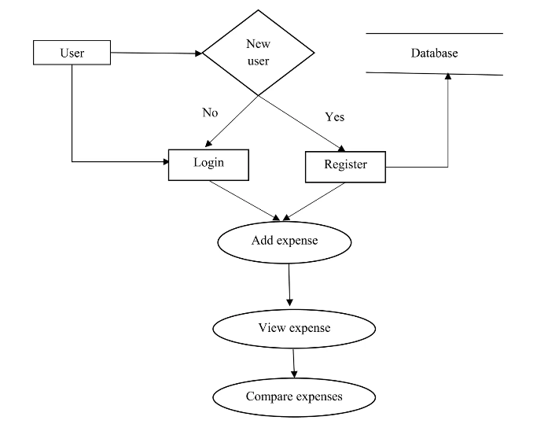
Figure 3.3: DFD LEVEL 1

Level 2 DFD
Level 2 DFD delves deeper into the system's functionalities, breaking down the processes identified in the Level 1 diagram into more detailed sub processes. It illustrates how data flows within each process and between them, offering a more granular view of the system's operations.

10

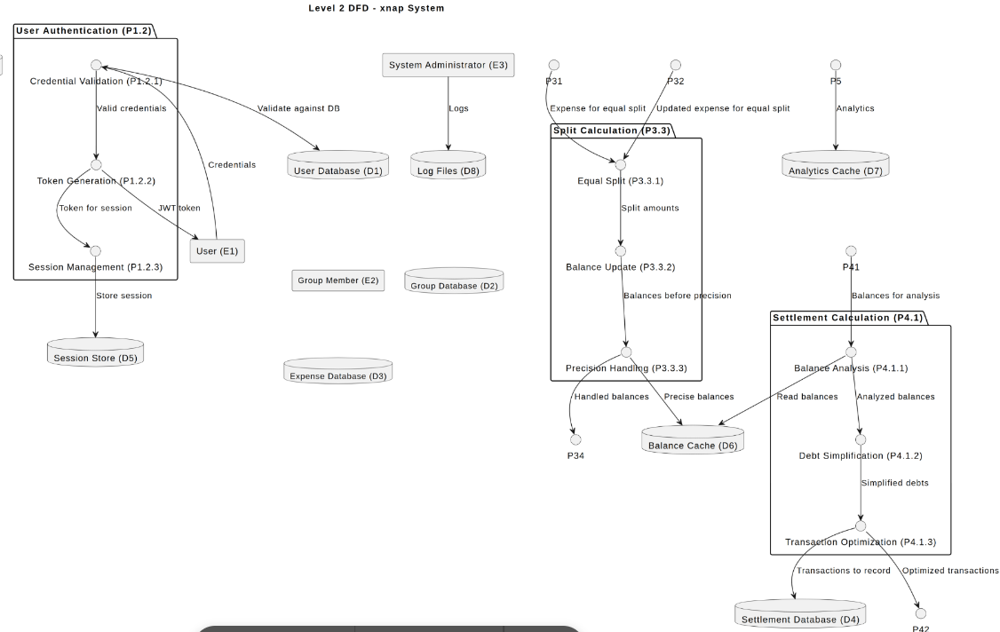

Fig 3.4: DFD Level 2

11

Chapter 4: System Design

Design
System design refers to the process of defining the architecture, components, modules, interface, and data for a software system. It involves creating a blueprint or plan for the system that specifies how it will be built, how it will function, and how it will meet the requirements of the clients.
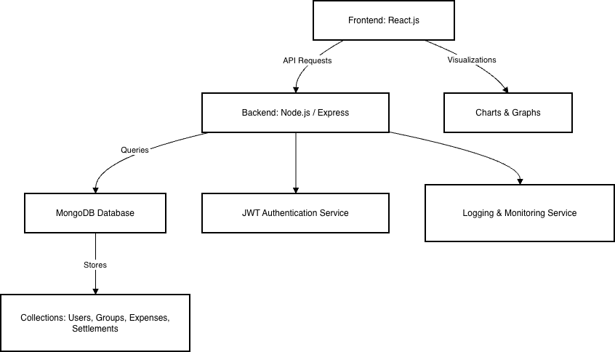

Figure 4.1: Flow Chart Diagram
The input/output design defines how users interact with the system and how the system presents processed information back to them.
Input Design:
Users interact with the system through the frontend interface. The key inputs from the user include:
- Login/Registration Information: Users provide credentials for account creation and authentication.
- Group Information: Users can create or modify groups, adding members and defining group roles.

12

- Expense Details: Users input the expenses they wish to track, along with the amount and category.
- Payment Information: Users record payments or mark expenses as settled.
Output Design:
The system generates the following outputs:
- Expense Summaries: Detailed reports of group expenses, including total expenditures, member contributions, and balance status.
- Debt Settlement Recommendations: The system generates recommendations for reducing group debt through optimized settlement transactions.
- Real-Time Balance Updates: As expenses are added or modified, the system updates balances for all group members instantly.
These outputs are displayed through a clean and responsive interface, ensuring easy navigation and real-time updates on all devices (desktop, tablet, mobile).

4.1.3 Database Design
The Xnap system uses a NoSQL database, MongoDB, to manage dynamic and large datasets for user profiles, expenses, and settlement transactions. The database design supports efficient retrieval of data and ensures that the system can handle increasing numbers of users and transactions as it scales.
Database Architecture Overview:
User Schema:
Stores user information such as email, password, and personal details. This schema also contains JWT tokens for authentication and session management.
Group Schema:
Stores group-related data such as group name, members, and group expenses. Each group has an embedded list of members, allowing the system to easily track who owes whom.
Expense Schema:
Tracks individual expenses added by users, including details like amount, date, category, and members involved. Each expense is linked to the relevant group.

13

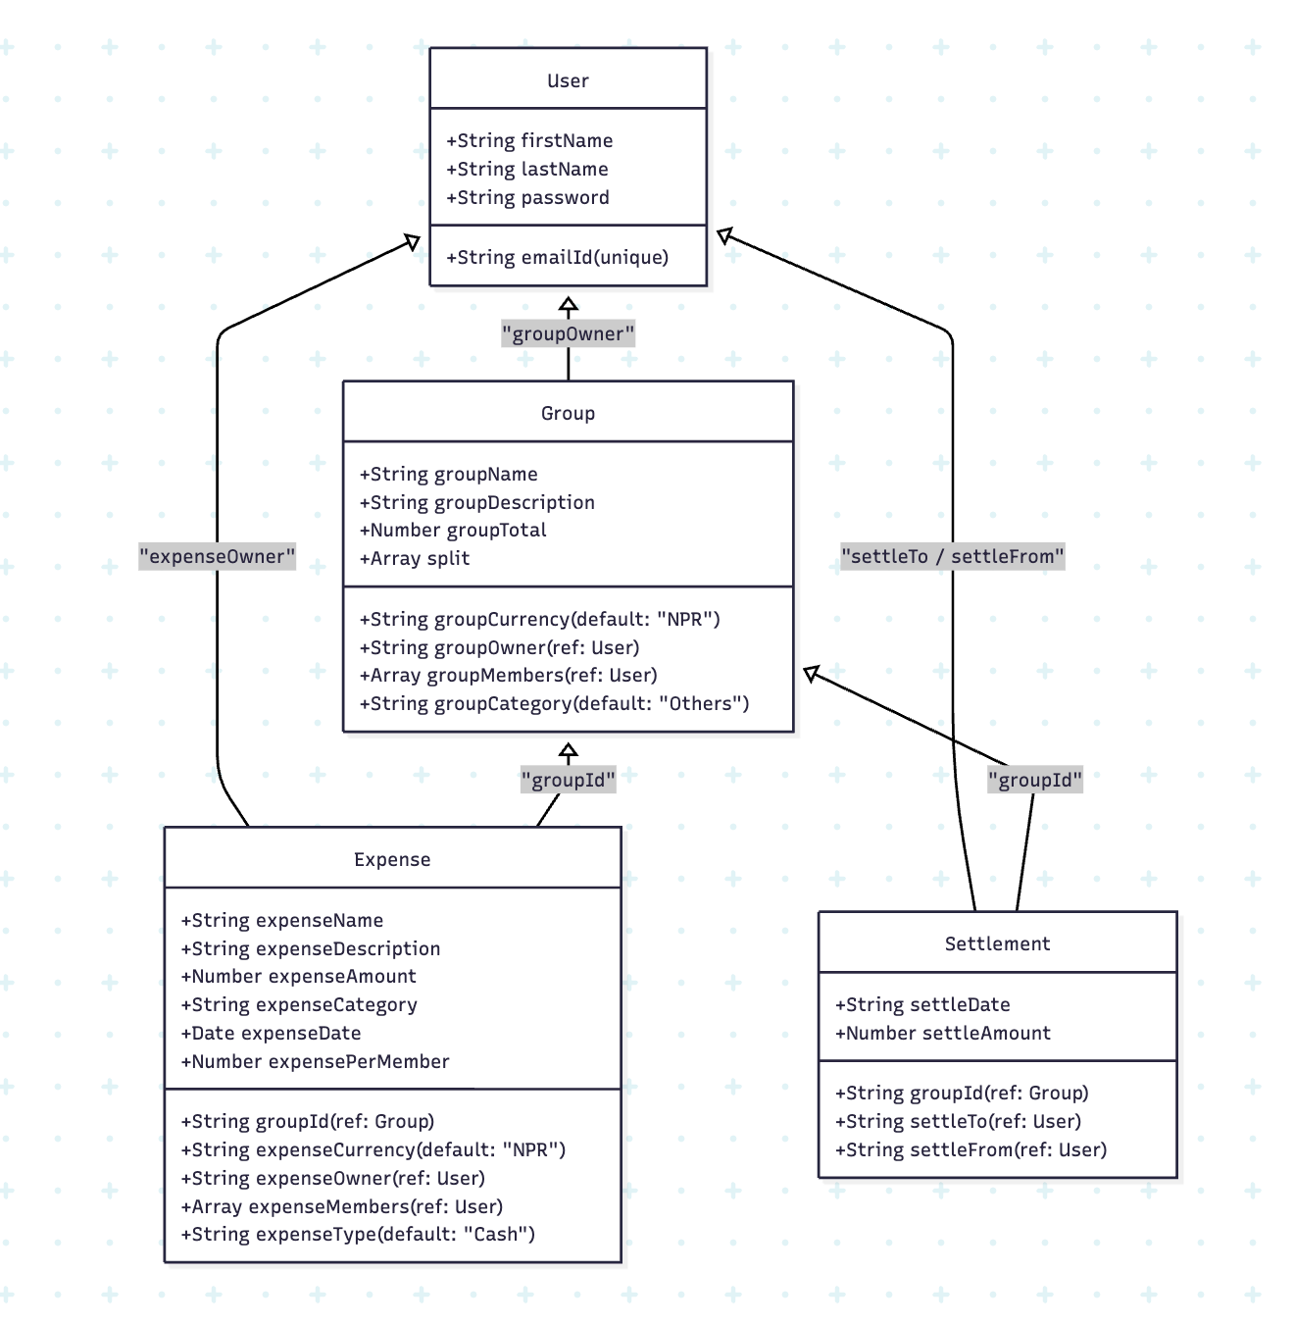
Figure 4.2: UML Class Diagram

14

4.2. Algorithm Details
The core of the Xnap system is its Hybrid Debt Simplification Algorithm, which is designed to efficiently automate the settlement of debts within a group by minimizing the number of transactions required. This algorithm addresses the Minimum Cash Flow Problem, a classic issue in group expense management, and optimizes it to reduce transaction complexity. The algorithm uses a combination of graph theory and greedy optimization methods, ensuring the system operates with both efficiency and scalability.
The Hybrid Debt Simplification Algorithm operates in two main phases:
Direct Settlement: The first phase of the algorithm identifies pairs of members who have exactly opposite balances. For example, if one member is owed $50 and another owes $50, the algorithm recognizes this direct offset and settles the debt immediately. This step reduces the number of outstanding transactions early in the process, simplifying the subsequent steps.
Greedy Matching: In the second phase, the algorithm applies a greedy optimization approach. It identifies the largest creditor (the member who is owed the most money) and the largest debtor (the member who owes the most money). The system then settles the maximum possible debt between these two members, reducing their outstanding balances. The process continues by repeatedly matching the remaining creditors and debtors until all debts are settled. This approach minimizes the total number of transactions by ensuring that each settlement is as large as possible.
The algorithm guarantees that the minimum number of transactions are made to settle the group’s debts, optimizing the financial flow and reducing complexity.
Input Example:
Consider the following transaction data, where each entry represents a group member's balance:
    - Alice is owed $50
    - Bob owes $30
    - Carol owes $20
This data indicates that Alice is a creditor, while Bob and Carol are debtors. The algorithm will process these balances and calculate the optimal transactions to settle the debts.
Output Example:
The algorithm generates a list of transactions, each representing a debt settlement between two members. The result is a set of optimal transactions that minimize the number of settlements required. For example:

15

    - Bob pays Alice $30
    - Carol pays Alice $20
In this case, the algorithm reduces the settlement process to only two transactions, compared to the original three transactions required if each debt were settled individually.

16

Chapter 5: Implementation and Testing

Implementation
    - Tools Used

Frontend
React: ReactJS, is an open-source JavaScript library developed and maintained by Facebook. It is widely used for building user interfaces (UIs) or web applications with a focus on creating interactive and dynamic user experiences.

Backend Tools used
Node.js: Node.js is used as a backend framework for handling the server-side logic of the project.

Database Used:
MongoDB: MongoDB is used as a database system in this project. MongoDB is a popular open-source, NoSQL database system that uses a document-oriented data model
    - Implementation Details of Modules
Modules are the partitions of any project done to ease the task of development. Different modules are designed so that debugging and other development phases get the easiest implementation. The different modules of the system are:
      - Dashboard page
      - Login page
      - Register page
      - Profile Section
      - Expense Section
      - Group Section

Testing
    - Unit Testing
Unit testing is a type of software testing where individual units or components of a software are tested. The purpose is to validate that each unit of the software code performs as expected. The following test scenarios were used to test the system after the build was completed.

17

Table 5.1: Table of Test cases for user login
TestId | Test Case | Input | Expected Outcome | Observed Output | Remarks
1 | Successful User Login | Email: ravistha869@gmail.com  Password:root | On successful login, redirect to profile. | User Successfully Logged in | PASS
2 | User Login Fail | Email: kritima.khanalgmail.com Password:testpass | Login failed: email must be a valid address. | The user was unable to log in to the system. | PASS
3 | User Login Fail | Email: nonexistentemail@gmail.com  Password:2345fsf | Login failed: invalid email or password. | The user was unable to login | PASS

Table 5.2: Test case for group creation
TestId | Test Case | Input | Expected Outcome | Observed Output | Remarks
1 | Group Creation Fail | Group Name:  Currency: INR  Group Description:  A demo group | Creation failed with error message a group name is a required | User was unable to create the group. | PASS
2 | Group Creation Success | Group Name: A Jamacho Hike  Currency: NPR  Group Description: A demo group | Group Creation successful and user to be redirected to newly  created group page | The user was able to create the group successfully | PASS

18

Chapter 6: Conclusion and Future Recommendations

Conclusion
The difficulties with manual expense tracking and settlement in group settings are effectively addressed by project XNAP. Conventional techniques for figuring out and balancing shared costs are frequently ineffective, prone to mistakes, and opaque. An intelligent, automated, and user-friendly web-based platform has been created through this project to streamline these procedures.
In conclusion, XNAP: Casplit effectively transforms traditional expense sharing into an automated digital process, promoting financial clarity, accuracy, and collaboration among users. It stands as a robust example of applying academic knowledge to a real-world financial technology problem.
Future Recommendations
To ensure continued success and growth, the following recommendations are proposed for the future development of the project:
- Development of Mobile Applications: Create native or cross-platform mobile apps with React Native or Flutter to give consumers on-the-go easy access and real-time notifications.
- Connectivity to Online Payment Gateways: Allow direct balance settlement using international gateways like Stripe and PayPal or safe payment APIs like Khalti and eSewa.
- AI-Powered Cost Classification: Use machine learning models to automatically categorize spending into groups (such as food, travel, and rent) and produce insightful financial data.
- Receipt scanning and OCR: Reduce manual data entry by using image recognition to retrieve spending details from uploaded receipts.

19

References

[1] R. Patel and D. Singh, “Optimized algorithms for shared expense settlement using graph theory,” International Journal of Computer Applications, vol. 184, no. 19,pp.22–30,2022.[Online].Available:https://www.ijcaonline.org/archives/volume184/num19/32245-2022912345
[2] A. Kumar, S. Verma, and R. Gupta, “Real-time expense tracking using web-based applications,” Journal of Emerging Technologies in Web Engineering, vol.9,no.3,pp.141–153,2021.[Online].Available:https://www.journalofwebengineering.com/articles/v6/p141
[3] T. Li and Y. Wang, “Designing scalable FinTech platforms using MERN stack architecture,” Journal of Software Engineering and Applications, vol. 13, no. 7, pp. 289–299,2020.[Online].Available:https://www.scirp.org/journal/paperinformation.aspx?paperid=112345
[4] M. Hassan, P. Rahman, and K. Yusuf, “Multi-currency management in group payment systems,” International Journal of Digital Finance, vol. 8, no. 4, pp. 95–109, 2021. [Online]. Available: https://ijdigitalfinance.org/articles/v8n4/df21095
[5] L. Jin, R. Chen, and W. Luo, “Enhancing financial transparency with comprehensive tracking,” Journal of Financial Technology, vol. 5, no. 2, pp. 102–115,2017.[Online].Available:https://www.journalfintech.org/papers/v5n2/jft05102
[6] X. Zhou, H. Lin, and J. Wu, “Securing financial data in cloud-based systems,” Cybersecurity Journal,vol.15, no. 3, pp. 199–210, 2020. [Online]. Available: https://cybersecurityjournal.org/articles/v15n3/cs20199

20

APPENDICES

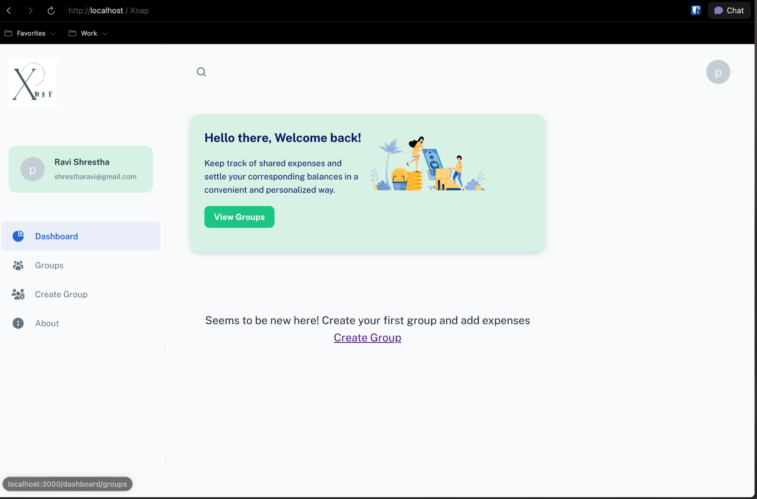
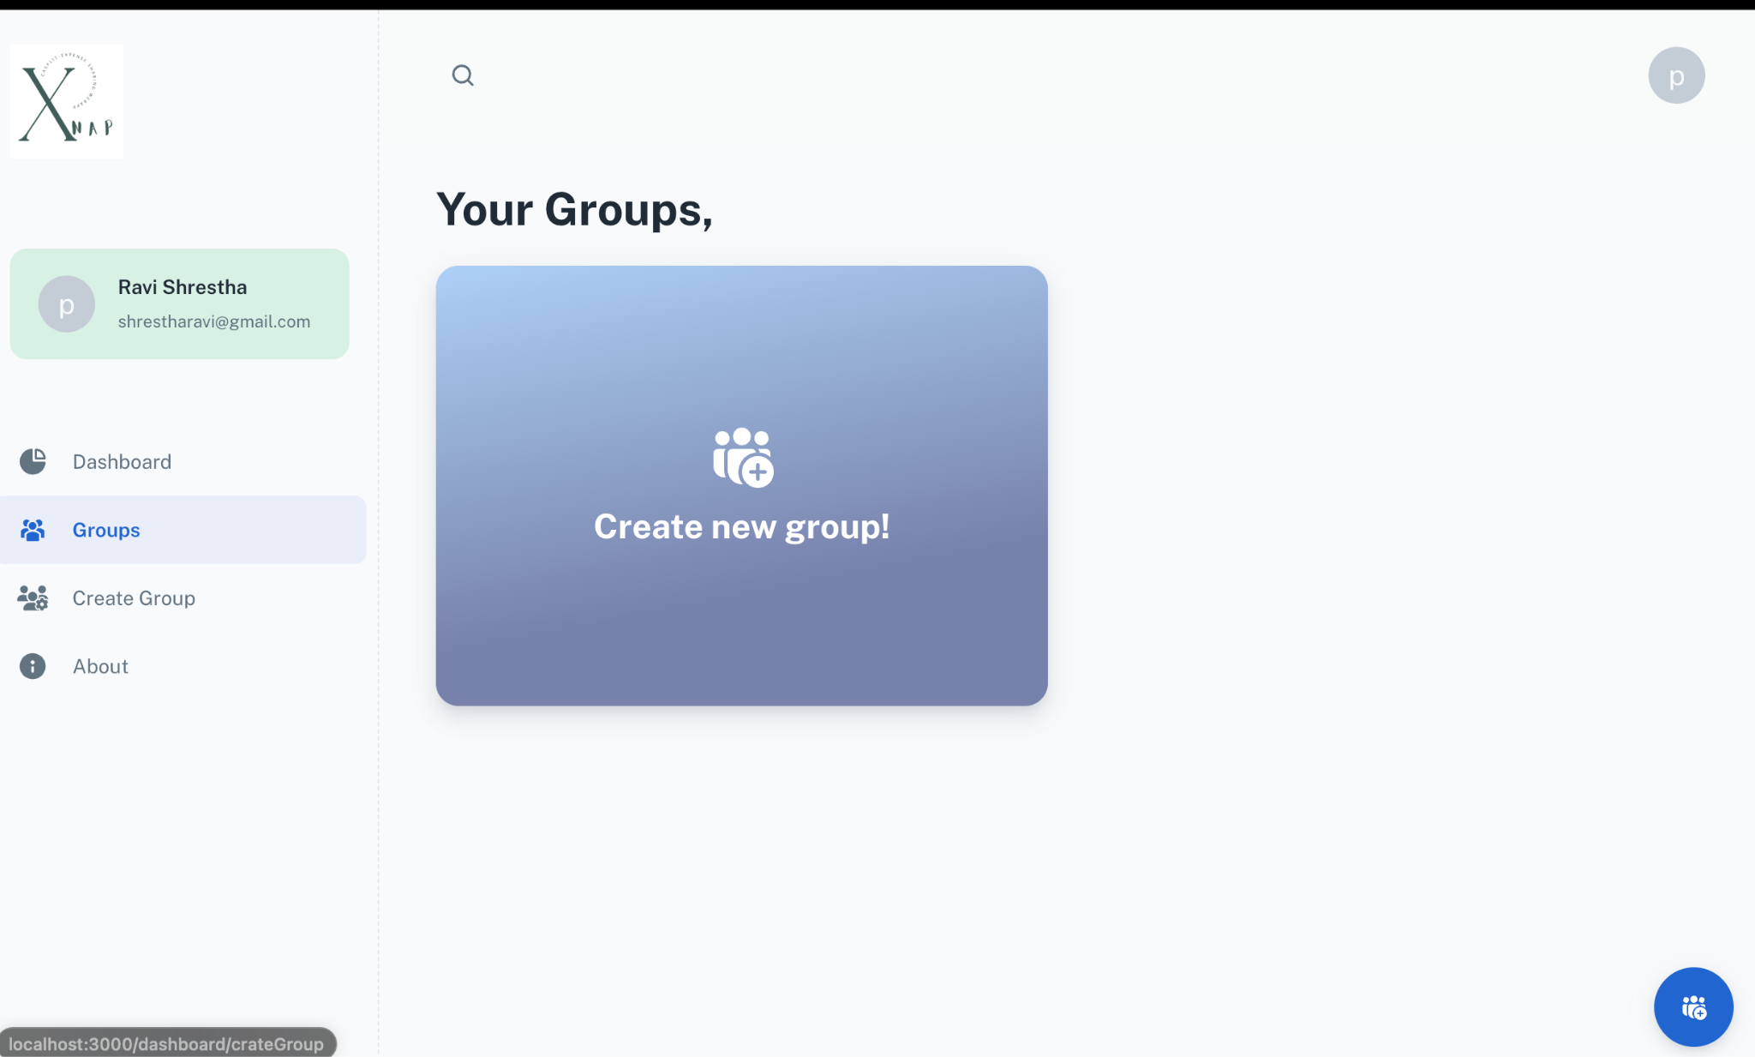

21

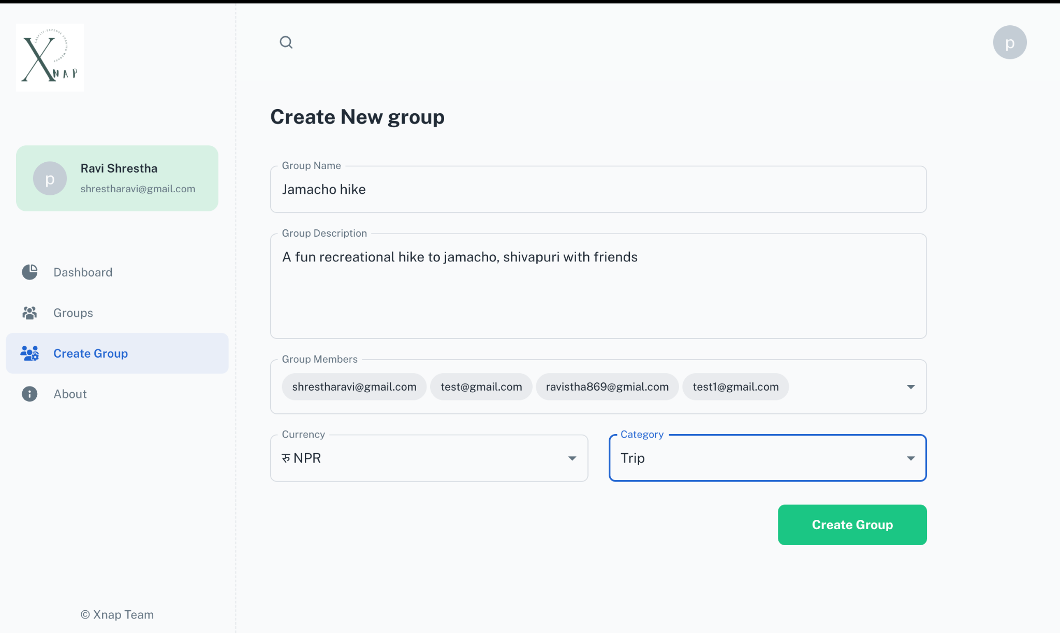

22

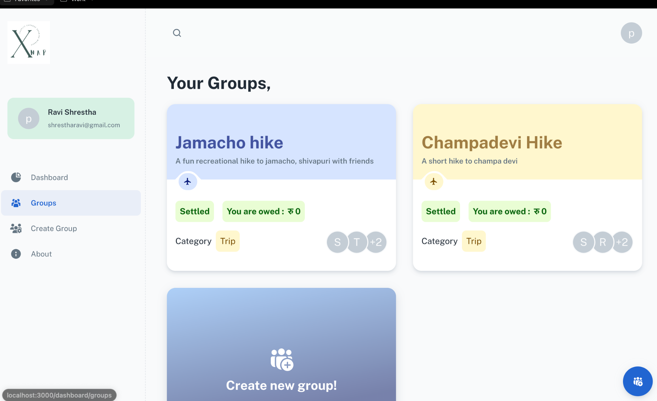

23

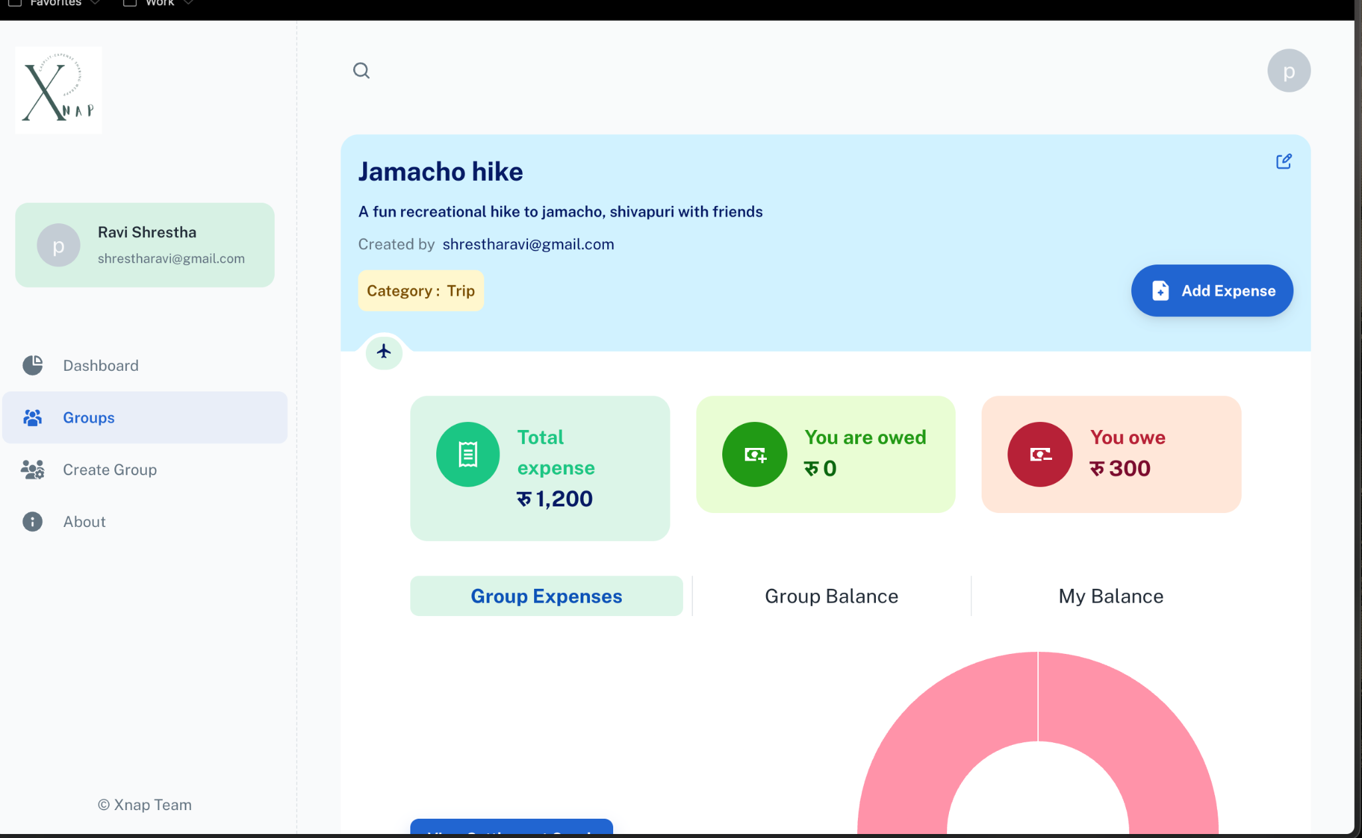

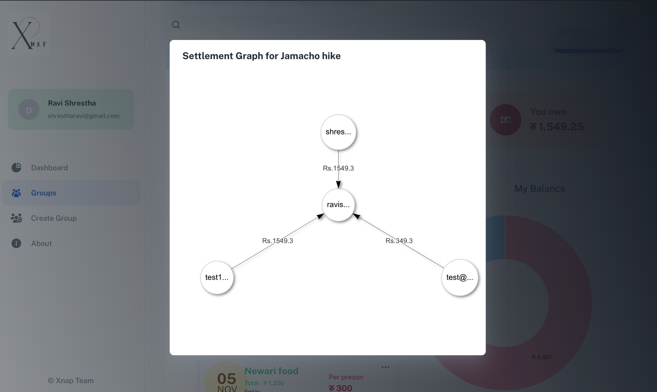

24

