

GuangZhou TRAVEL

Travel Brochure

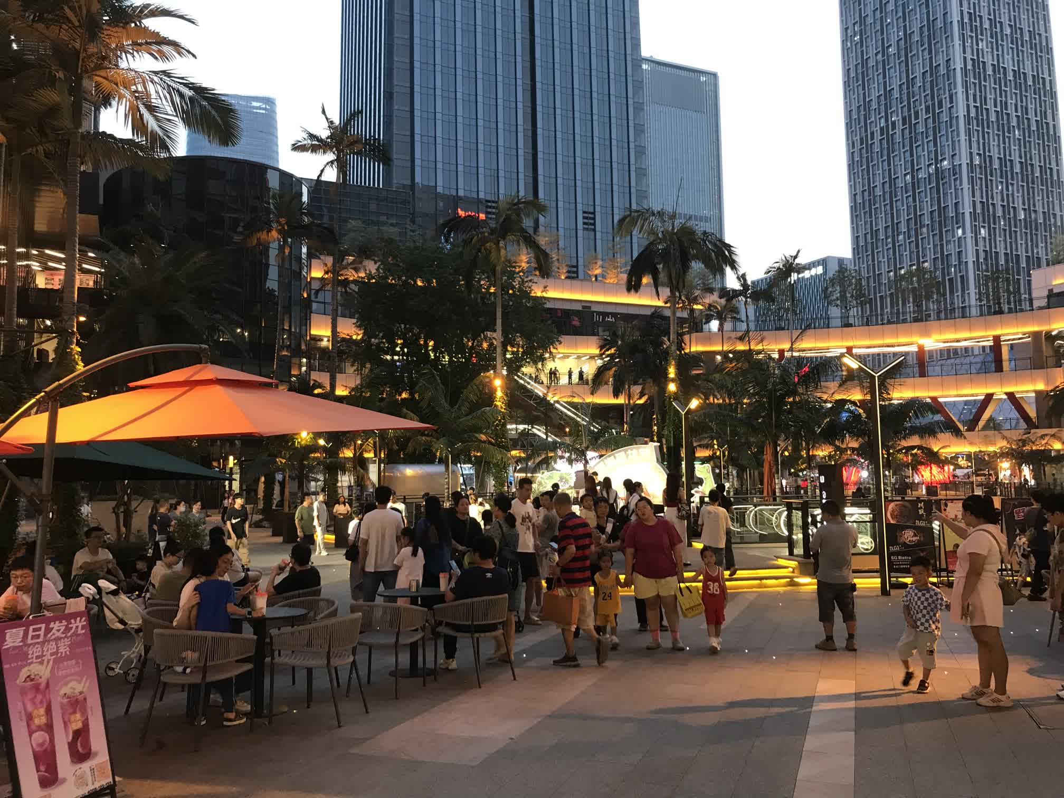

# Traveling in GZ in 2023

- - - - X

A lot happened in 2023, starting a city walk was one of them.

I always perceived it as tiring and using not having friends or loved ones as an excuse to avoid the activity.

In 2023, I had to consider abandoning badminton, a major hobby, due to the joint and organ damage it was causing.

Something else has to become a new hobby. Finding myself always being jealous of people traveling, a sudden urge for traveling erupted, and it started.

# Panyu square - 20231004

- - - - X

Panyu square station was the first stop in this journey.

Nearby the station were the Panyu gov, Panyu square park(which unfortunately closed on that day), Aeon mall, Jisheng wanke.

**Aeon mall** being the more popular one, though mostly selling clothes.I find its own brand to be pricey with low quality. On the higher floors there is a large space with plenty of food options. Not a bad place to try out a variety of food.

**Jisheng Wanke** has a large area but not many customers. May be good for just a short rest and drink.

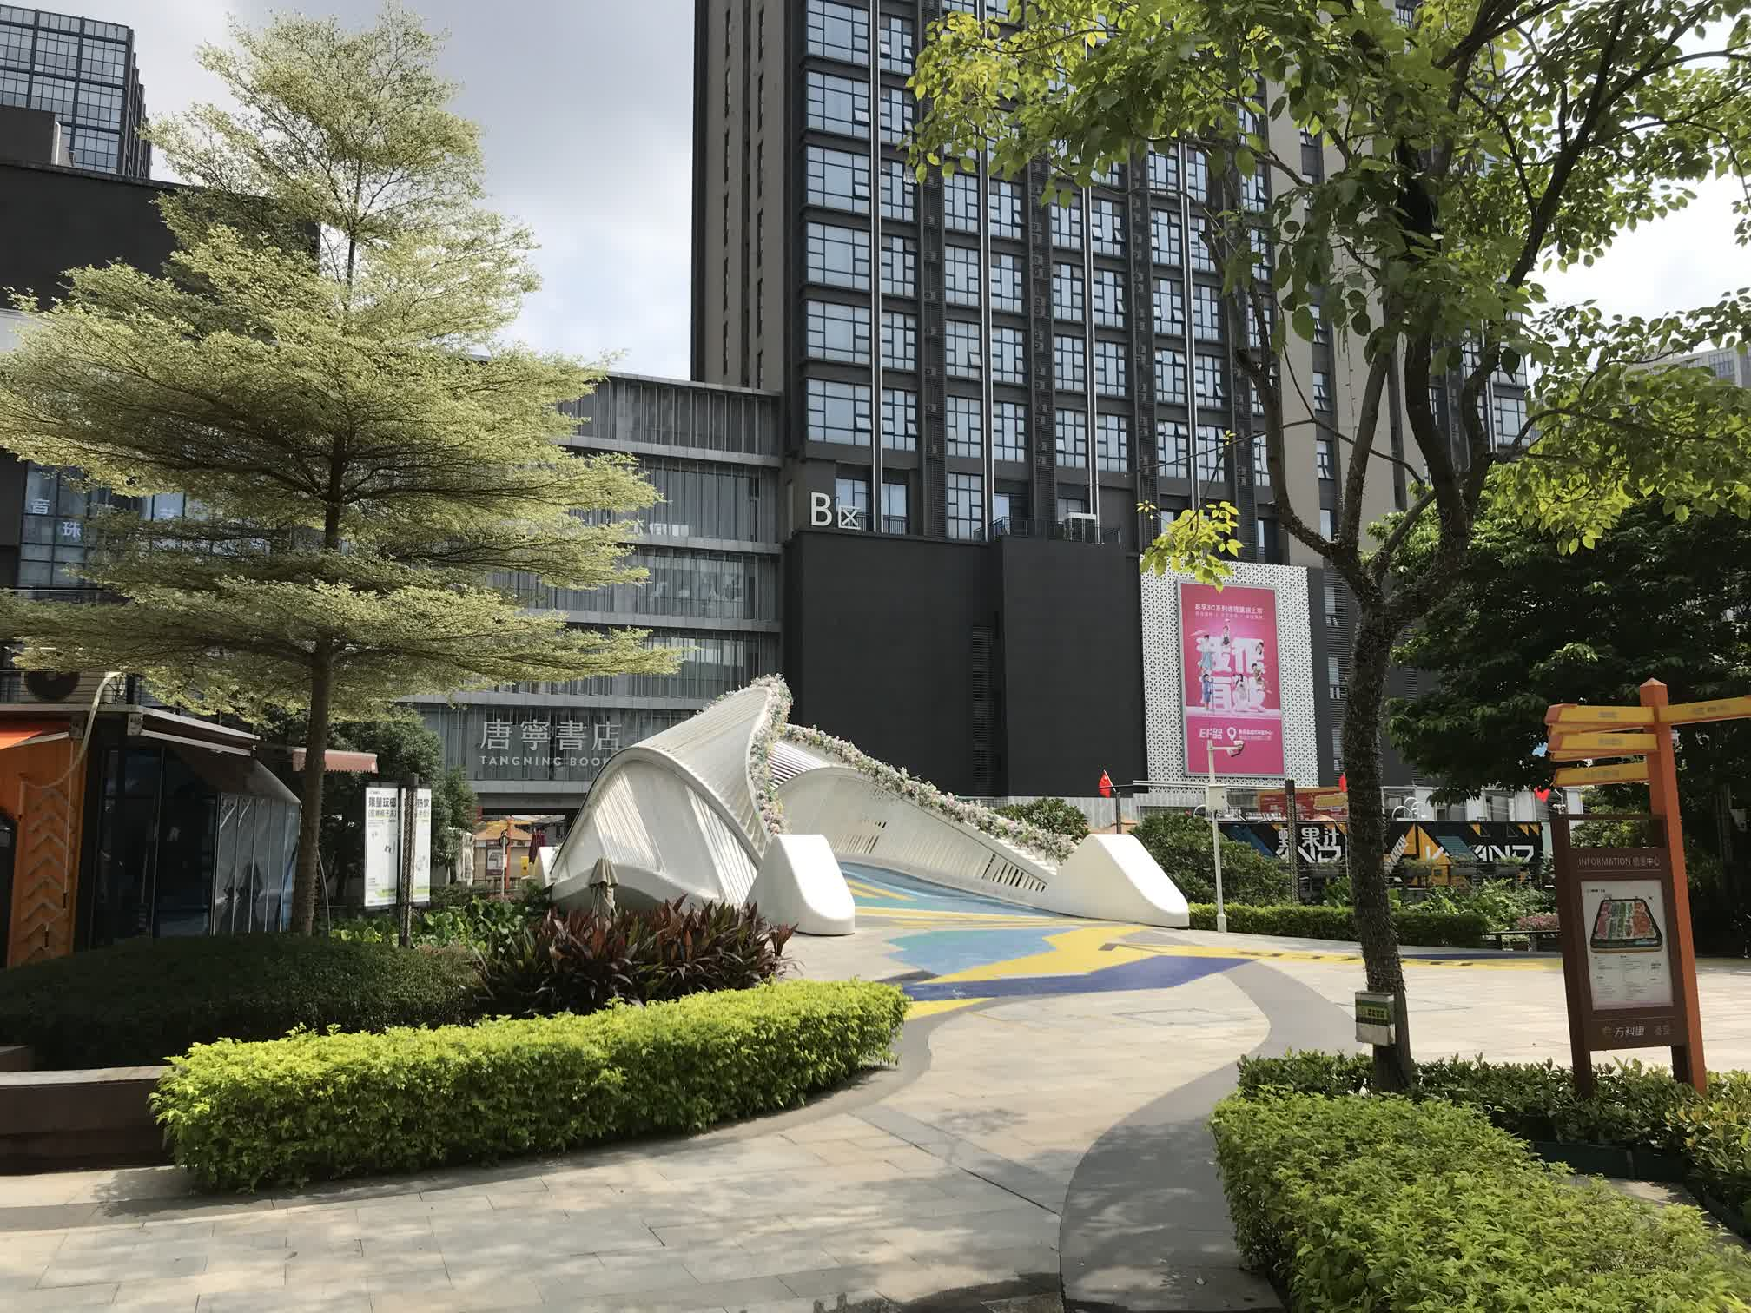

***Jisheng Wanke***

***Aeon mall***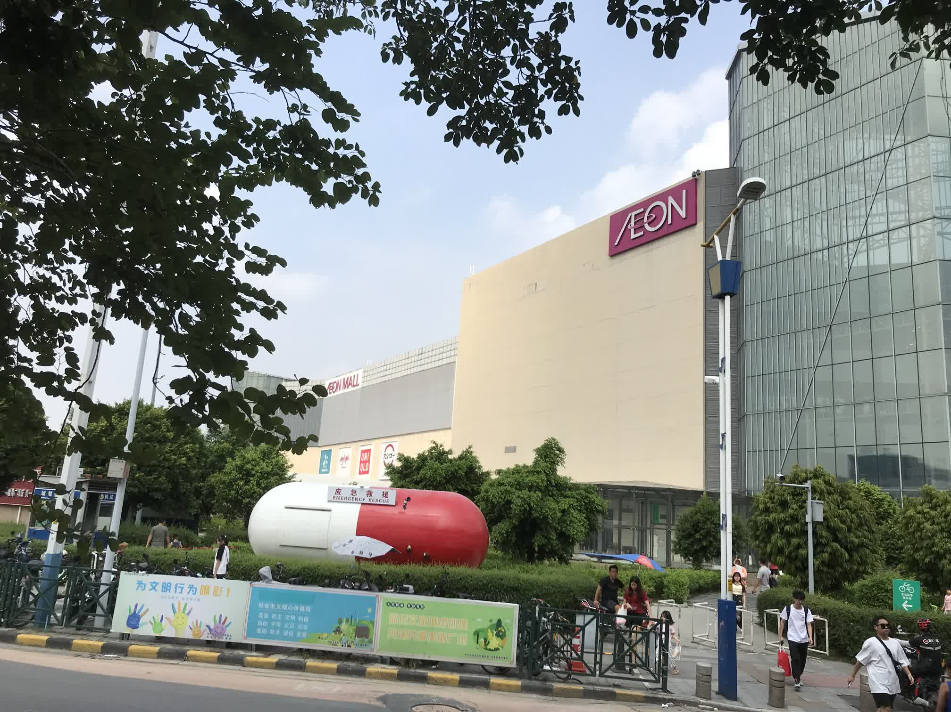

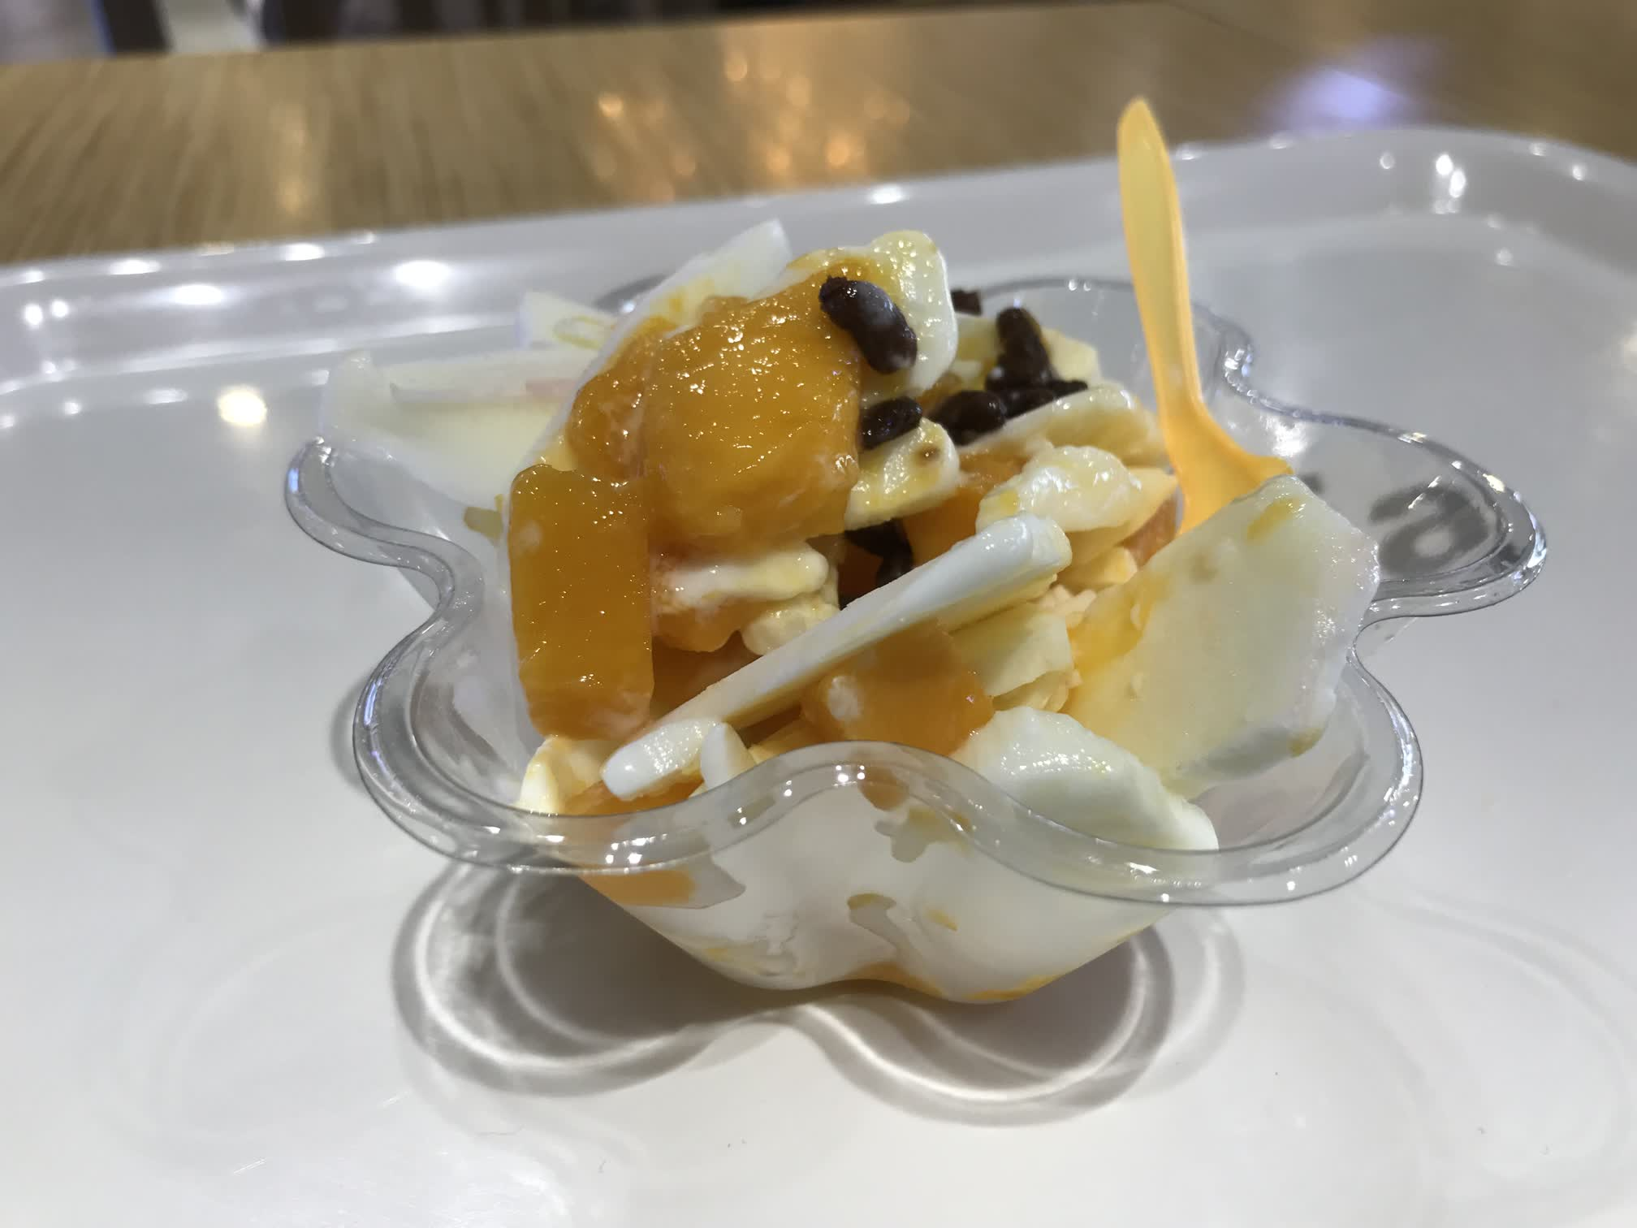

# South railway station, Nancun wanbo, etc - 20231005

- - - - X

The **GZ south railway station** crosses subway line 22, was very crowded, but not a lot of business; much worse than an air station tbh.

**Chentou gang** was under construction, pretty much still a middle-of-nowhere

**Nancun wanbo** was huge. I didn’t get to finish it in one go. There were Panyu **teemall**, **Wanda plaza**, **Sihaicheng**.

Teemall and Wanda plaza were huge shopping areas with mostly clothing stores, restaurants, kids playground, electronics, theaters.

Sihaicheng was more like a large area for restaurants and performances, seemingly connecting to a resident area.

***Teemall***

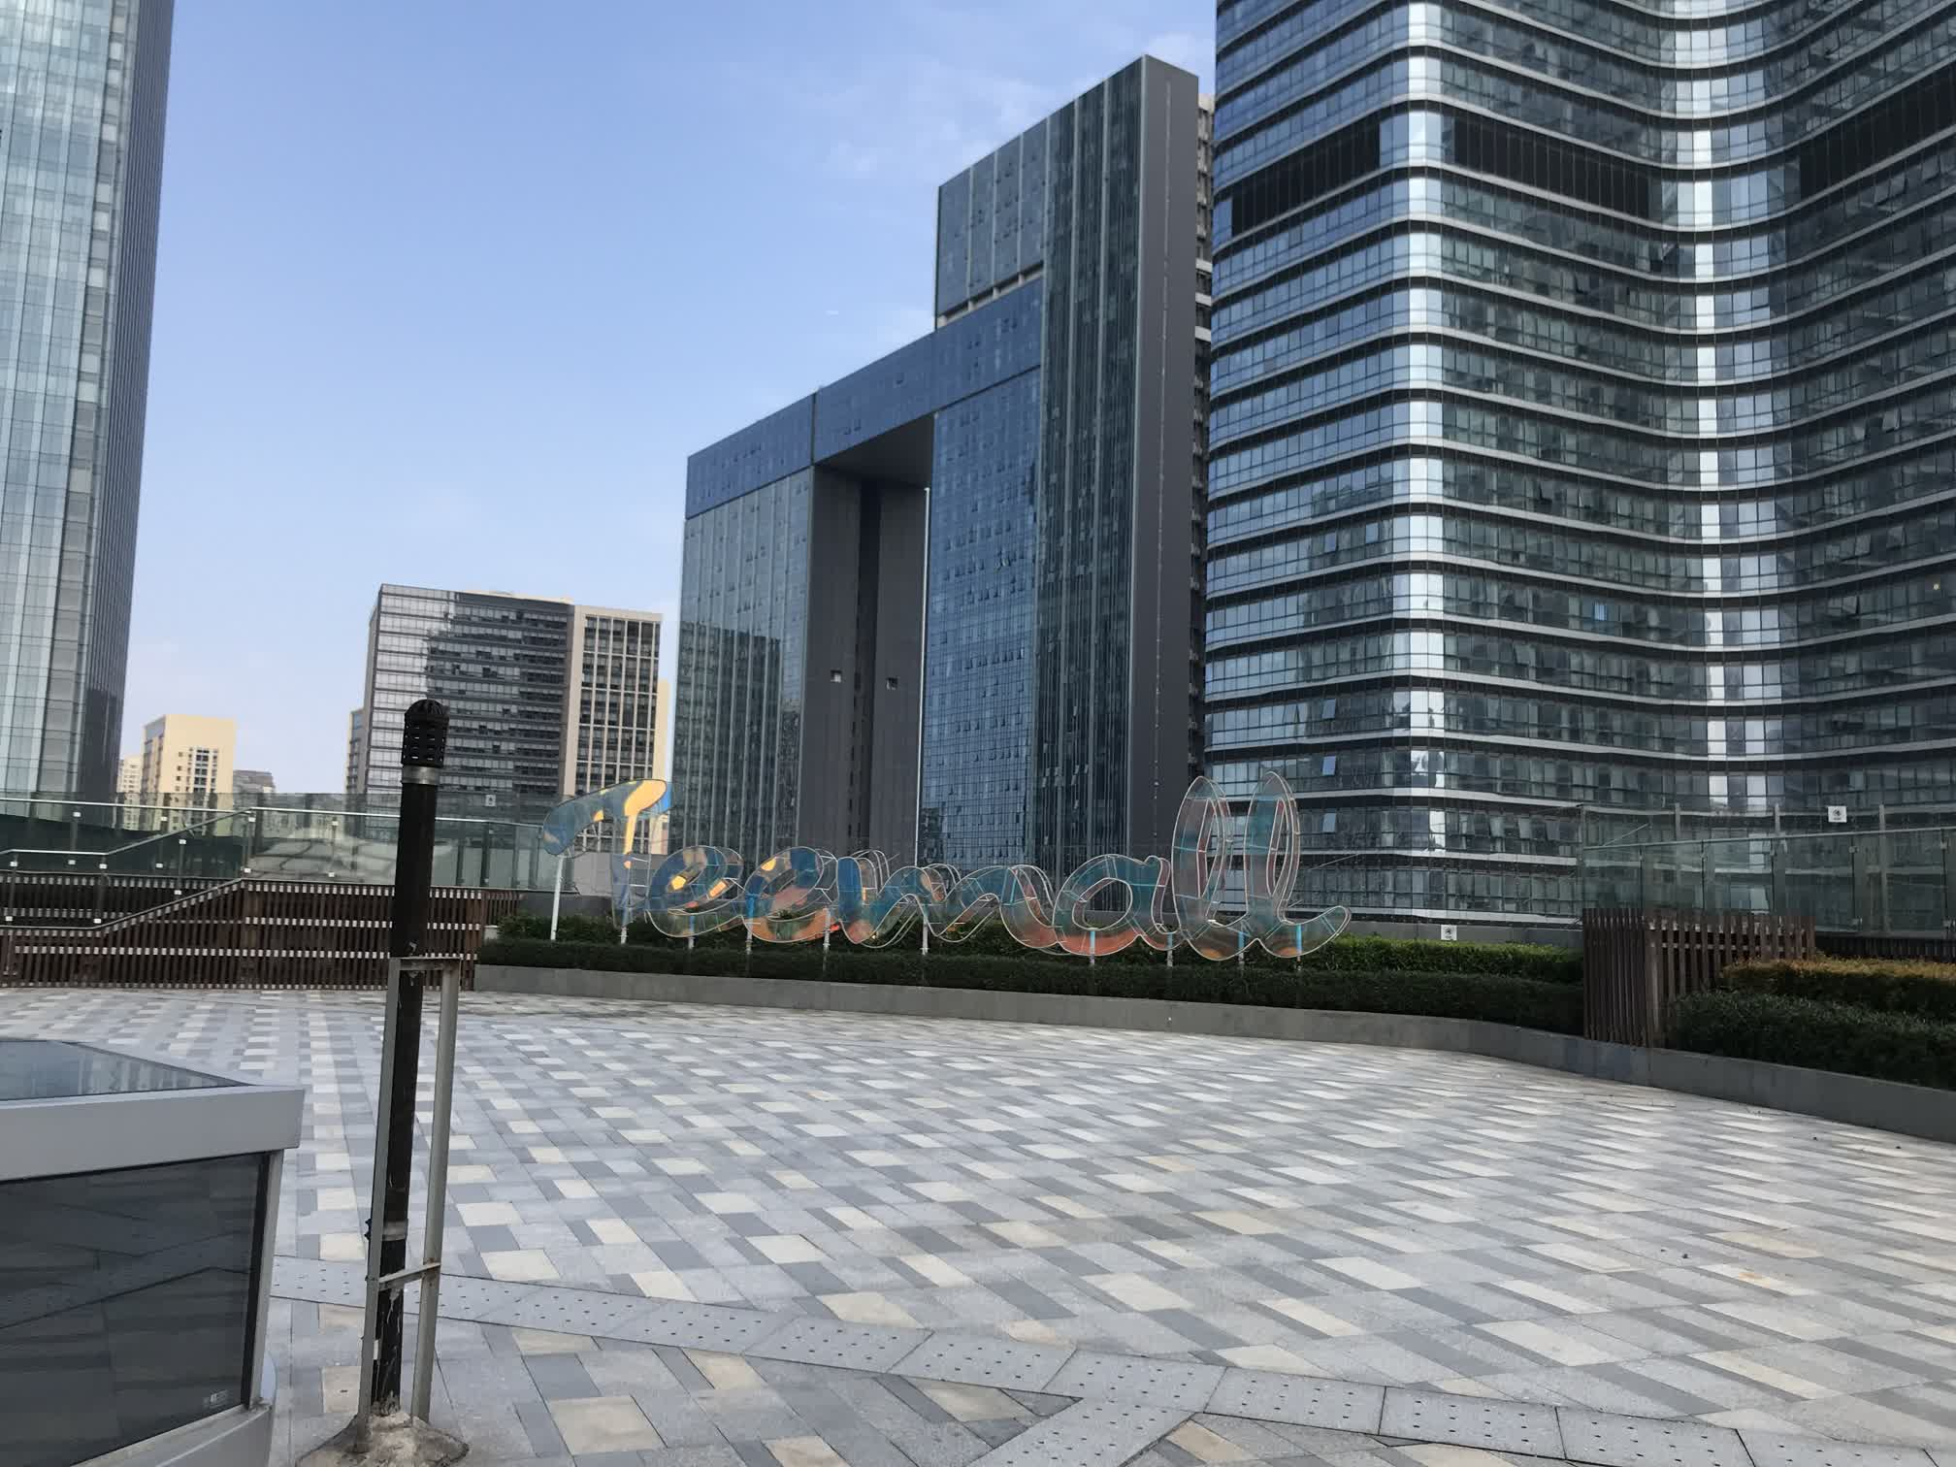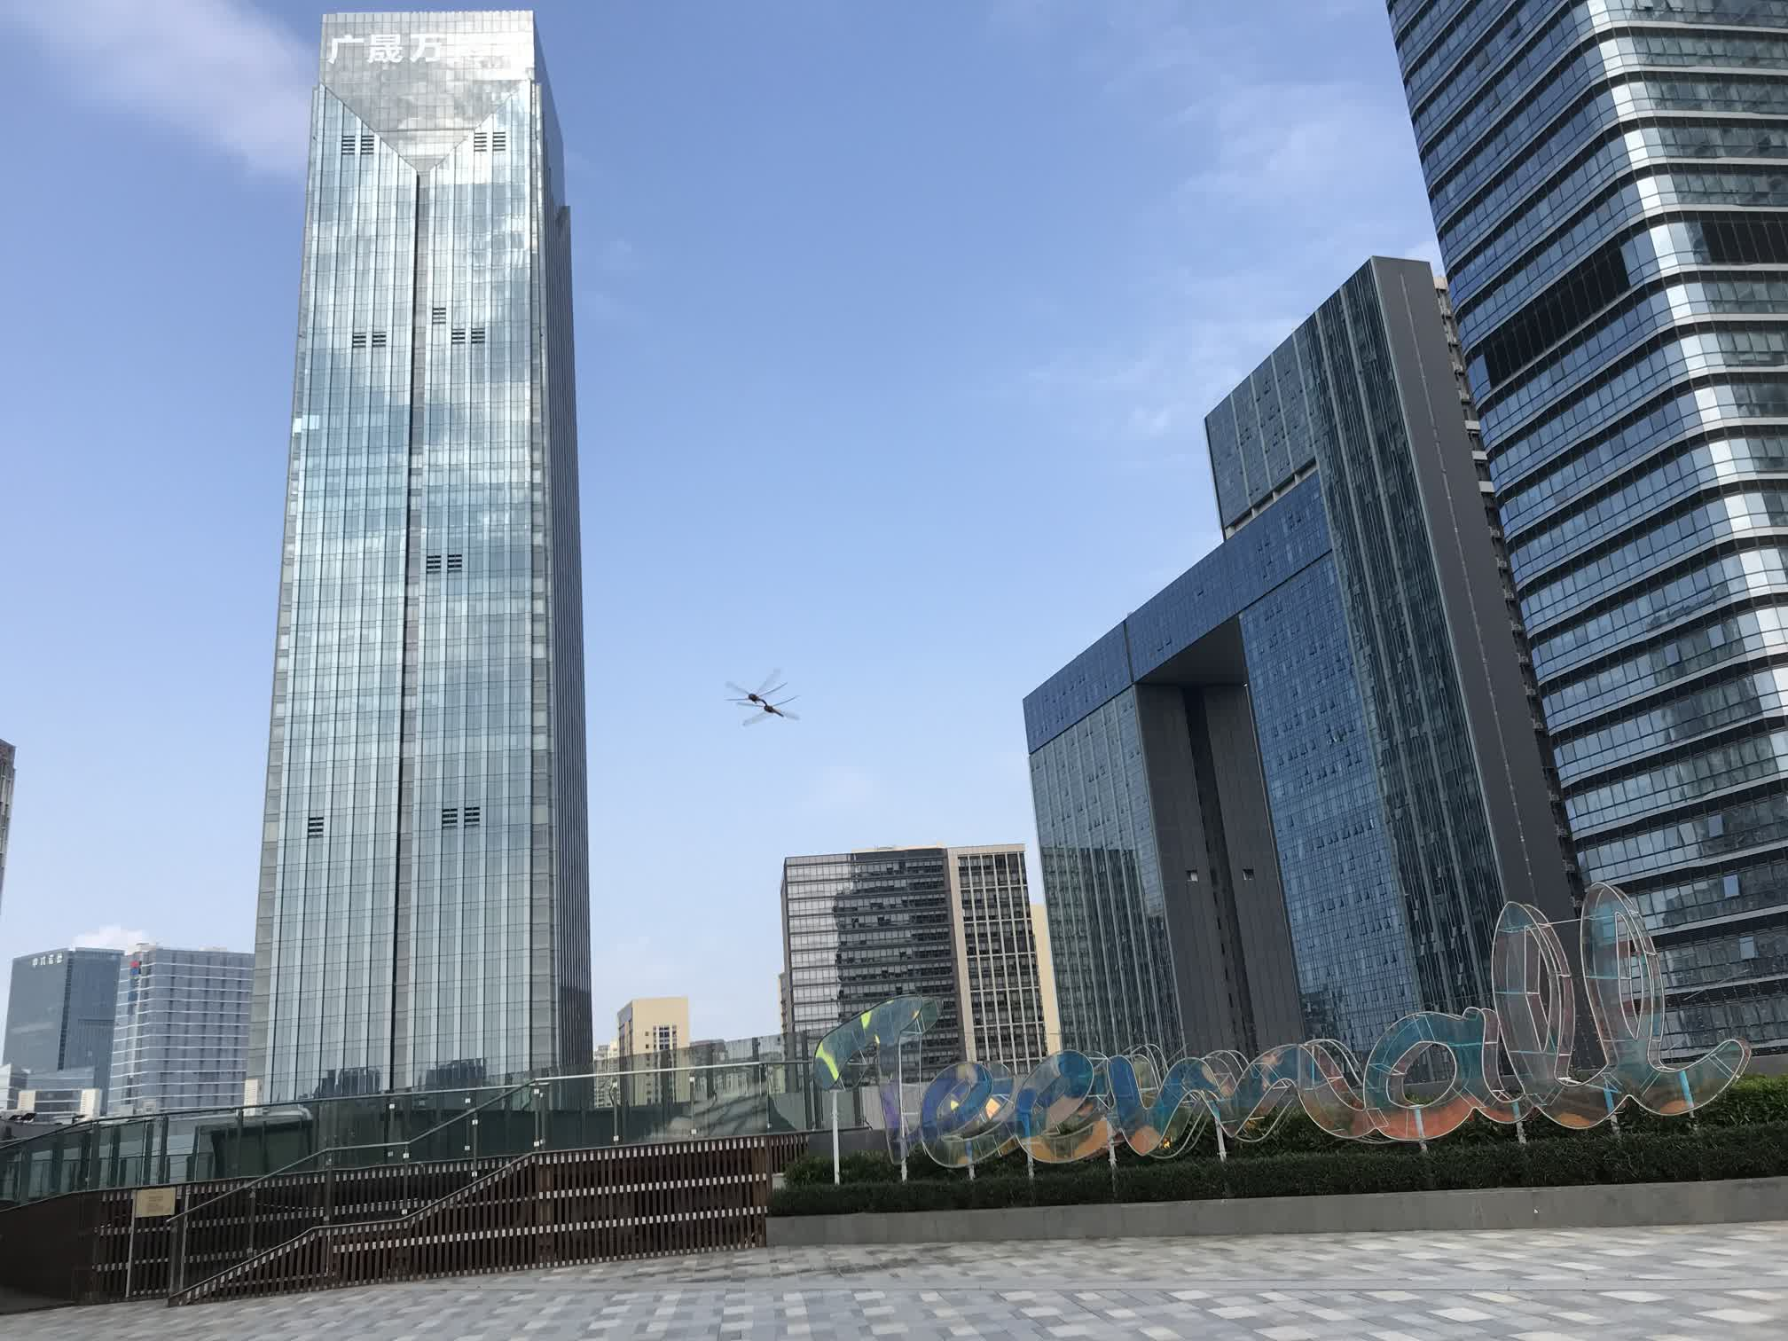

***Wanda***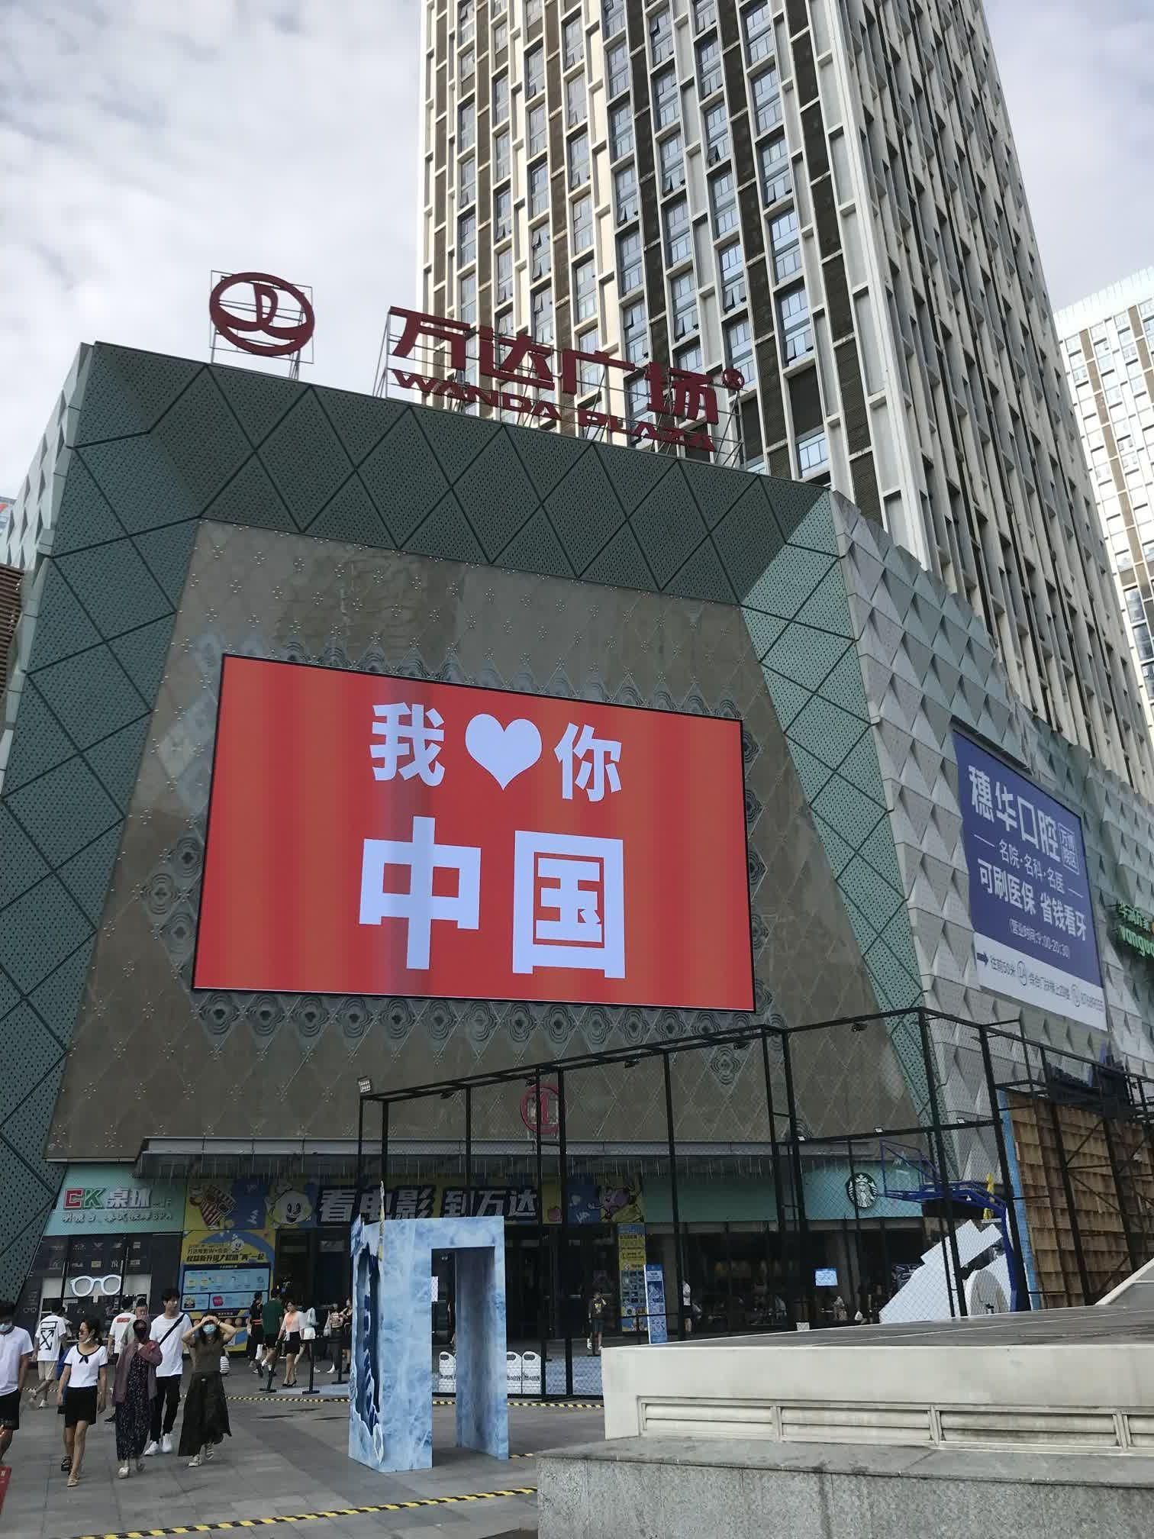

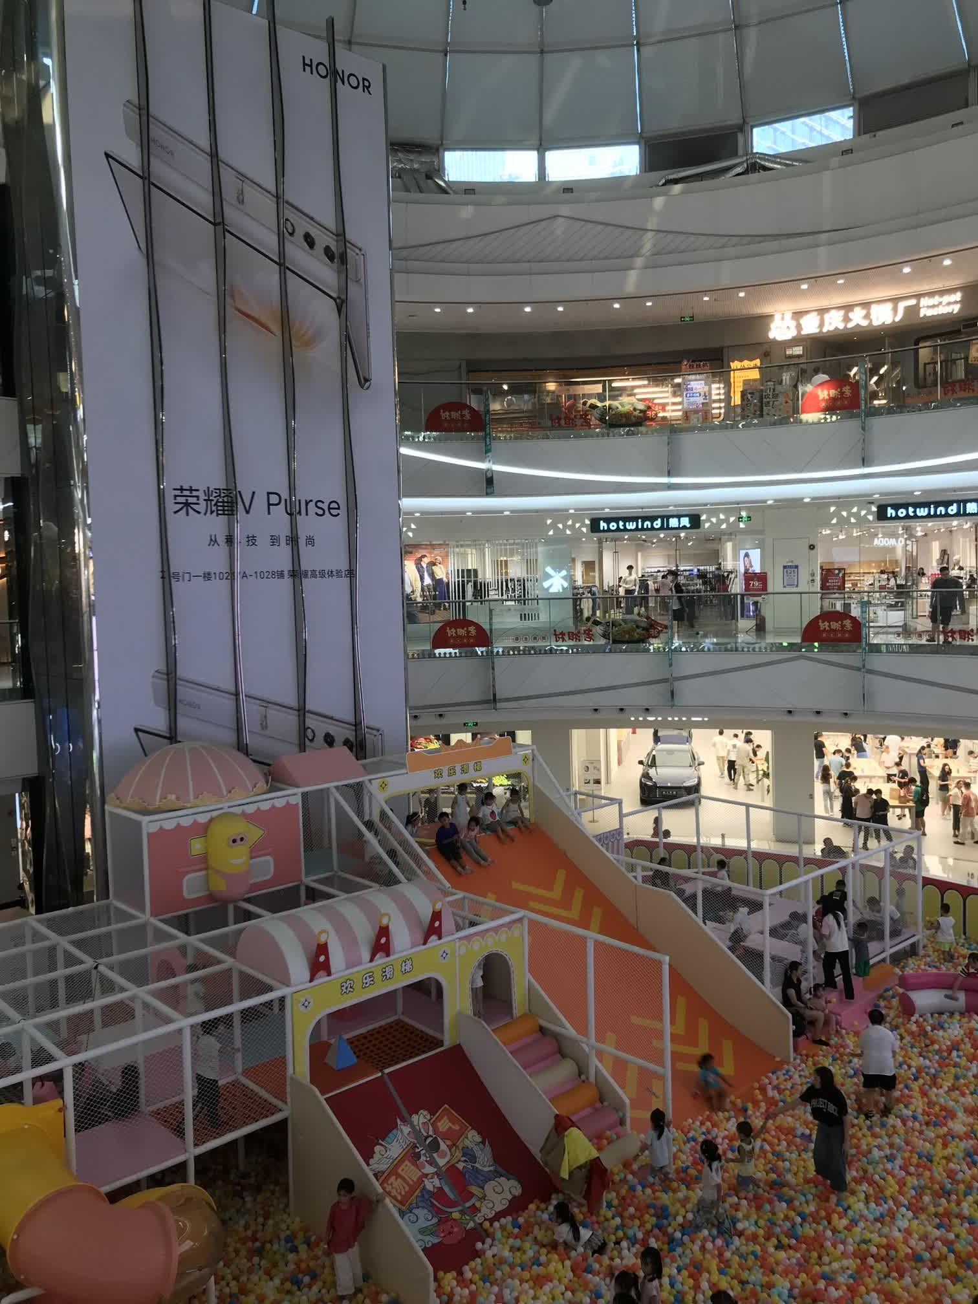

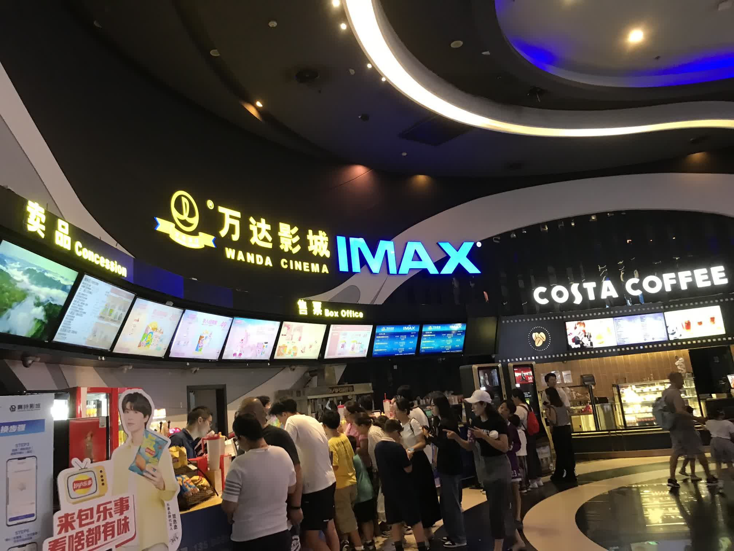

***SihaiCheng***