Họ tên: Ninh Duy Tuấn

Mã SV : FX11715

Link URL Website: http://tuannd.great-site.net/Project%204/

**BÀI ASSIGNMENT 4**

1. **Áp dụng kĩ thuật SEO nội dung**:
2. Trang index.html

1, Qua thẻ metatags:

Thẻ meta description:

    <meta name="description" content="Vivu halong is the address providing the top services for tourism in Ha Long ">

Thẻ meta keyword:

<meta name="keyword" content="tour Ha Long, tour Ninh Binh, vivu halong, ha long seafood , luxury tours, Ha Long travel , book tour, book hotel, book restaurant">

Thẻ meta robot:

<meta name="robots" content="noindex,nofollow">

2. qua thẻ title

<title>Vivu Halong</title>

3.qua alt tag

<a href="./index.html" title="vivu halong"><img src="./image/logo-vivu.png" alt="vivu ha long image"></a>

<img src="./image/banner.jpg" alt="banner 1">

<img src="./image/luxury cruise.png" alt="luxury cruise image">

<img src="./image/years experience.png" alt="years experience image">

<img src="./image/booking agency.png" alt="booking agency image">

 <p><a href="#" title="cruise"><img src="./image/Cruise 1.jpg" alt="cruise"></a></p>

<a href="#" title="review cruise"><img src="./image/review 2.webp" alt="review Ha Long cruise image"></a>

4.qua anchor title

<a href="#" title="about us"><i class="iconRight ti-angle-right"></i>About us</a>

<li> <a href="./tour HL.html" title="Ha Long tour">Ha Long Tour</a></li>

<li><a href="./tour NB.html" title ="Ninh Binh tour">Ninh Binh Tour</a></li>

<li> <a href="./sub-cruise-1.html" title="Luxury Cruise">Luxury Cruise</a></li>

<li><a href="./seafood.html" title="Ha Long seafood">SEA FOOD</a></li>

<li><a href="#" title="Testimonials"><i class="iconRight ti-angle-right"></i> Testimonial</a></li>

1. Trang About Us
2. Qua metatag

`Thẻ meta description

<meta name="description" content="We specialize in taking reservations, conducting tours to visit Ha Long Bay, Bai Tu Long Bay and Lan Ha Bay on luxury yachts.

     With a team of staff and consultants with over 10 years of experience, having many years of operation in the field of tourism,.. ">

Thẻ meta keyword:

<meta name="keyword" content="tour Ha Long, tour Ninh Binh, vivu halong, ha long seafood , luxury tours, Ha Long travel , address, service">

Thẻ meta robot:

<meta name="robots" content="noindex,nofollow">

2. qua thẻ title

<title>About Us</title>

3.qua alt tag

<a href="./index.html" title="vivu halong"><img src="./image/logo-vivu.png" alt="vivu ha long image"></a>

4.qua anchor title

<li> <a href="./tour HL.html" title="Ha Long tour">Ha Long Tour</a></li>

<li><a href="./tour NB.html" title ="Ninh Binh tour">Ninh Binh Tour</a></li>

<li> <a href="./sub-cruise-1.html" title="Luxury Cruise">Luxury Cruise</a></li>

<li><a href="./seafood.html" title="Ha Long seafood">SEA FOOD</a></li>

<a href="#" title="Testimonials"><i class="iconRight ti-angle-right"></i> Testimonials </a>

<a href="#" title="Career"><i class="iconRight ti-angle-right"></i>Career</a>

<a href="#" title="Events"><i class="iconRight ti-angle-right"></i>Events</a>

1. Trang Tours
2. Qua thẻ metatags:

Thẻ meta description

<meta name="description" content="Vivu halong is the address providing the top services for tourism in Ha Long ">

Thẻ meta keyword

<meta name="keyword" content="tour Ha Long, vivu halong, ha long seafood , luxury tours, Ha Long travel, tour Ninh Binh, Ninh Binh Travel">

Thẻ meta robot

<meta name="robots" content="noindex,nofollow">

2. qua thẻ title

<title>Tours</title>

<h1> Tours</h1>

3.qua alt tag

<img src="./image/Total tour 1.jpg" alt="Ha Long tour image"></a>

<img src="./image/Total tour 2.jpg" alt="Ha Long tour image"></a>

<img src="./image/Total tour 3.jpg" alt="Ha Long tour image"></a>

<img src="./image/Total tour 4.jpg" alt="Ninh Binh tour image"></a>

<img src="./image/Total tour 5.jpg" alt="Ninh Binh tour image"></a>

4. qua anchor title

 <a href="./tour.html" title="tours" class="active" >TOURS <i class="arrow-down ti-angle-down"></i></a>

 <a href="#" title="Ha Long tour"><img src="./image/Total tour 1.jpg" alt="Ha Long tour image"></a>

<a href="#" title="Ha Long tour"><img src="./image/Total tour 2.jpg" alt="Ha Long tour image"></a>

 <li><a href="#" title=”About Us”><i class="iconRight ti-angle-right"></i>

    About us</a> </li>

<li><a href="#"title="Terms of Payment"> <i class=" iconRight ti-angle-right"></i> Terms of Payment</a> </li>

1. Trang Ha Long Tour
2. Qua thẻ metatags

Thẻ meta description

<meta name="description" content="We specialize in taking reservations, conducting tours to visit Ha Long Bay, Bai Tu Long Bay and Lan Ha Bay on luxury yachts.

     With a team of staff and consultants with over 10 years of experience, having many years of operation in the field of tourism,..">

Thẻ meta keyword

<meta name="keyword" content="tour Ha Long, vivu halong, ha long seafood , luxury tours, Ha Long travel, book tour, book hotel, book restaurant">

Thẻ meta robot

<meta name="robots" content="noindex,nofollow">

1. Qua thẻ title

<title>Ha Long Tours</title>

<h1>Halong Tours</h1>

1. Qua alt tag

<a href="./index.html" title="vivu halong"><img src="./image/logo-vivu.png" alt="vivu ha long image"></a>

<img src="./image/Tour 1.jpg" alt="tour Ha Long image">

<img src="./image/Tour 2.jpg" alt="tour Ha Long image">

<img src="./image/Tour 3.jpg" alt="tour Ha Long image">

<img src="./image/Tour 4.jpg" alt="tour Ha Long image">

<img src="./image/Tour 5.jpg" alt="tour Ha Long image">

<img src="./image/Tour 6.jpg" alt="tour Ha Long image">

1. Qua anchor title

 <a href="./tour.html" title="tours " class="active" >TOURS <i class="arrow-down ti-angle-down"></i></a>

<a href="#" title="tour Ha Long image">Lan Ha Bay one day tour from Hanoi – 7 hour cruise</a>

<a href="#"title="tour Ha Long image"><img src="./image/Tour 2.jpg" alt="tour Ha Long image"></a>

<a href="#" title="tour Ha Long image">Halong Bay & Lan Ha Bay day tour on Serenity cruise (7 hour cruise)</a>

1. Ninh Binh Tour
2. Qua thẻ metatag

Thẻ meta description

<meta name="description" content="The day tour to Hoa Lu and Tam Coc (Ninh Binh) offers you the highlight of cultural relics and natural landscape of Ninh Binh.... ">

Thẻ meta keyword

<meta name="keyword" content="tour Ninh Binh, Ninh Binh Travel , luxury tour,book hotel, book tour">

Thẻ meta robot

<meta name="robots" content="noindex,nofollow">

1. Qua thẻ title

<title>Ninh Binh Tours</title>

<h1>Ninh Binh Tours</h1>

1. Qua thẻ alt tag

<img src="./image/tour NB 1.jpg" alt="tour Ninh Binh image">

<img src="./image/tour NB 2.jpg" alt="tour Ninh Binh image">

<img src="./image/logo-vivu.png" alt="vivu logo">

1. Qua anchor title

<li><a href="./tour NB.html" title ="Ninh Binh tour">Ninh Binh Tour</a></li>

<a href="#" title="tour Ninh Binh image"><img src="./image/tour NB 1.jpg" alt="tour Ninh Binh image"></a>

<a href="#" title="Testimonials"><i class="iconRight ti-angle-right"></i> Testimonials</a>

<a href="#" title="Career"><i class="iconRight ti-angle-right"></i> Career</a>

<a href="#" title="Events"><i class="iconRight ti-angle-right"></i> Events</a>

<a href="#" title="Terms of Payment"><i class="iconRight ti-angle-right"></i> Terms of Payment </a>

1. Trang Luxury Cruise
2. Qua thẻ metatag

Thẻ meta description

<meta name="description" content="Vivu halong is the address providing the top services for tourism in Ha Long ">

Thẻ meta keyword

<meta name="keyword" content="tour Ha Long, vivu halong, ha long seafood , luxury tours, Ha Long travel, Ha Long cruise">

Thẻ meta robot

<meta name="robots" content="noindex,nofollow">

1. Qua title

<title>Luxury Cruise</title>

<h1>Luxury Cruise</h1>

1. Qua alt tag

<img src="./image/sub-cruise 1.jpg" alt="tour cruise image">

<img src="./image/sub-cruise 2.jpg" alt="tour cruise image">

<img src="./image/sub-cruise 3.jpg" alt="tour cruise image">

<img src="./image/sub-cruise 4.jpg" alt="tour cruise image">

<img src="./image/sub-cruise 5.jpg" alt="tour cruise image">

<img src="./image/sub-cruise 6.jpg" alt="tour cruise image">

<img src="./image/logo-vivu.png" alt="vivu logo">

1. Qua anchor title

<li><a href="./tour HL.html" title="Ha Long tour">Ha Long Tour</a></li>

<a href="#" title="tour cruise image"><img src="./image/sub-cruise 1.jpg" alt="tour cruise image"></a>

<a href="#" title="tour cruise image"><img src="./image/sub-cruise 2.jpg" alt="tour cruise image"></a>

<a href="#" title="tour cruise image"><img src="./image/sub-cruise 3.jpg" alt="tour cruise image"></a>

<a href="#" title="tour cruise image">Mon Cheri Cruise</a>

<a href="#" title="tour cruise image">Serenity Cruise – Itineraries, Cruise details & Deals</a>

<a href="#" title="tour cruise image">La Regina Legend Luxury Cruise </a>

1. Trang Lan Ha Bay Cruise
2. Qua thẻ metatag

Qua meta description

<meta name="description" content="Vivu halong is the address providing the top services for tourism in Ha Long ">

Qua meta keyword

<meta name="keyword" content="tour Ha Long, vivu halong, ha long seafood , luxury tours, Ha Long travel, tour Ninh Binh, Ninh Binh Travel">

Qua meta robot

<meta name="robots" content="noindex,nofollow">

1. Qua thẻ title

<title>Lan Ha Bay Cruise</title>

<h1> Lan Ha Bay cruise</h1>

1. Qua alt tag

<img src="./image/sub2-cruise 1.jpg" alt="tour cruise image">

<img src="./image/sub2-cruise 2.jpg" alt="tour cruise image">

<img src="./image/sub2-cruise 3.jpg" alt="tour cruise image">

<img src="./image/sub2-cruise 4.jpg" alt="tour cruise image">

<img src="./image/sub2-cruise 5.jpg" alt="tour cruise image">

<img src="./image/sub2-cruise 6.jpg" alt="tour cruise image">

<img src="./image/logo-vivu.png" alt="vivu logo">

1. Qua anchor title

<a href="./sub-cruise-2.html" title="Lan Ha Bay Cruise">Lan Ha Bay Cruise</a>

<a href="#" title="tour cruise image"><img src="./image/sub2-cruise 1.jpg" alt="tour cruise image"></a>

<a href="#" title="tour cruise image">Scarlet Pearl Cruise</a>

<a href="#" title="tour cruise image"><img src="./image/sub2-cruise 2.jpg" alt="tour cruise image"></a>

<a href="#" title="tour cruise image">Capella Cruise </a>

1. Trang Seafood
2. Qua thẻ metatag

Thẻ meta description

<meta name="description" content="The famous specialty of Quang Ninh is known by a large number of people. Speaking of grilled cuttle,...">

Thẻ meta keyword

<meta name="keyword" content=",review Ha Long seafood,vivu halong, ha long seafood , Ha Long travel, Ha Long cruise, fish sauce, lizardfish , Goldfish, halibut fish">

Thẻ meta robot

<meta name="robots" content="noindex,nofollow">

1. Qua thẻ title

<title>Ha Long Seafood</title>

<h1>Ha Long Seafood</h1>

1. Qua alt tag

<img src="./image/seafood 1.jpg" alt="Ha Long seafood image">

<img src="./image/seafood 2.jpg" alt="Ha Long seafood image">

<img src="./image/seafood 3.jpg" alt="Ha Long seafood image">

<img src="./image/seafood 4.jpg" alt="Ha Long seafood image">

<img src="./image/seafood 5.jpg" alt="Ha Long seafood image">

<img src="./image/seafood 6.jpg" alt="Ha Long seafood image">

<img src="./image/seafood 7.jpg" alt="Ha Long seafood image">

<img src="./image/logo-vivu.png" alt="vivu logo">

1. Qua anchor title

<li><a class="active" href="./seafood.html" title="Ha Long seafood">SEA FOOD</a></li>

<a href="#" title="Ha Long seafood image"><img src="./image/seafood 1.jpg" alt="Ha Long seafood image"></a>

<a href="#" title="Ha Long seafood image">Cai Rong, Van Don fish sauce - Famous sea specialties </a>

<a href="#" title="Ha Long seafood image"><img src="./image/seafood 2.jpg" alt="Ha Long seafood image"></a>

<a href="#" title="Ha Long seafood image"> Van Don, Quang Ninh Goldfish</a>

<a href="#" title="Testimonials"><i class="iconRight ti-angle-right"></i> Testimonials</a>

<a href="#" title="Career"><i class="iconRight ti-angle-right"></i> Career</a>

<a href="#" title="Events"><i class="iconRight ti-angle-right"></i> Events</a>

<a href="#" title="Terms of Payment"><i class="iconRight ti-angle-right"></i> Terms of Payment </a>

1. Trang web được submit lên google để đánh chỉ mục

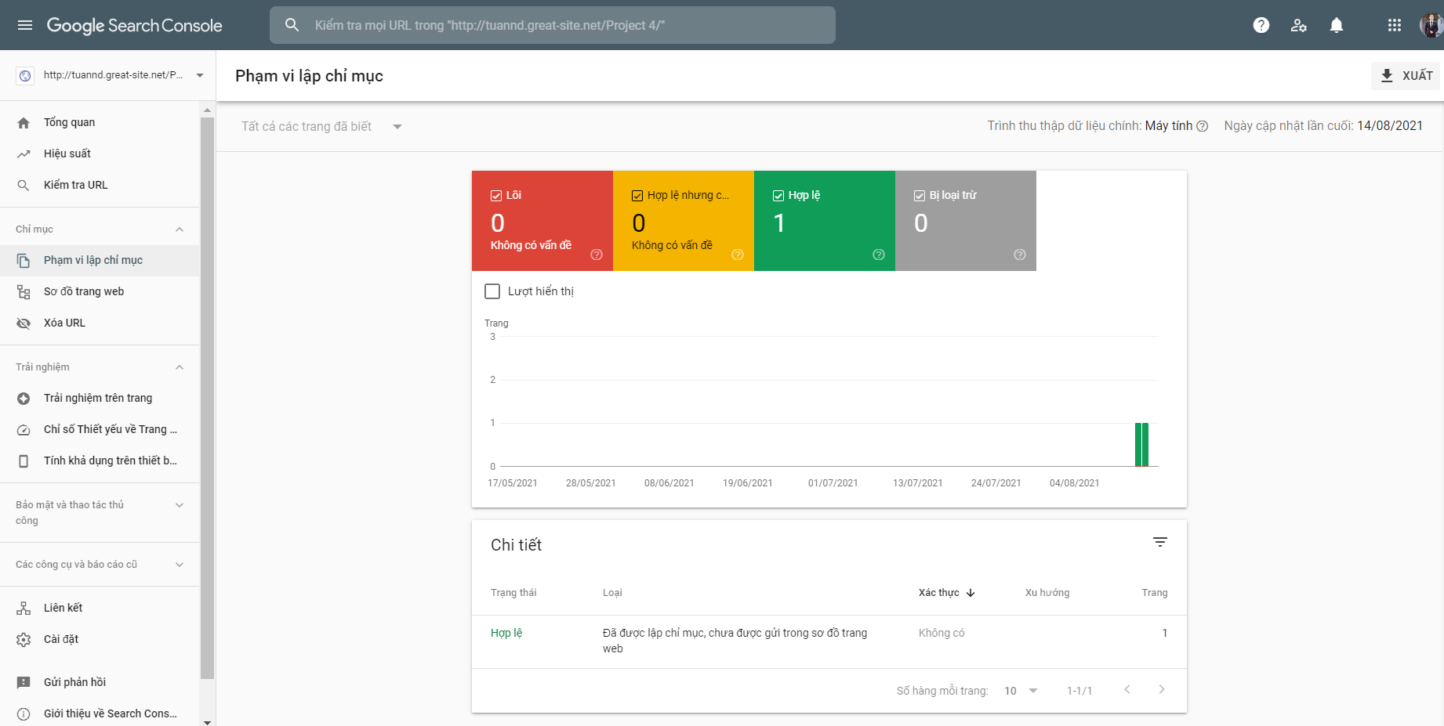

1. Tích hợp Google Analytics

