# Use case diagram

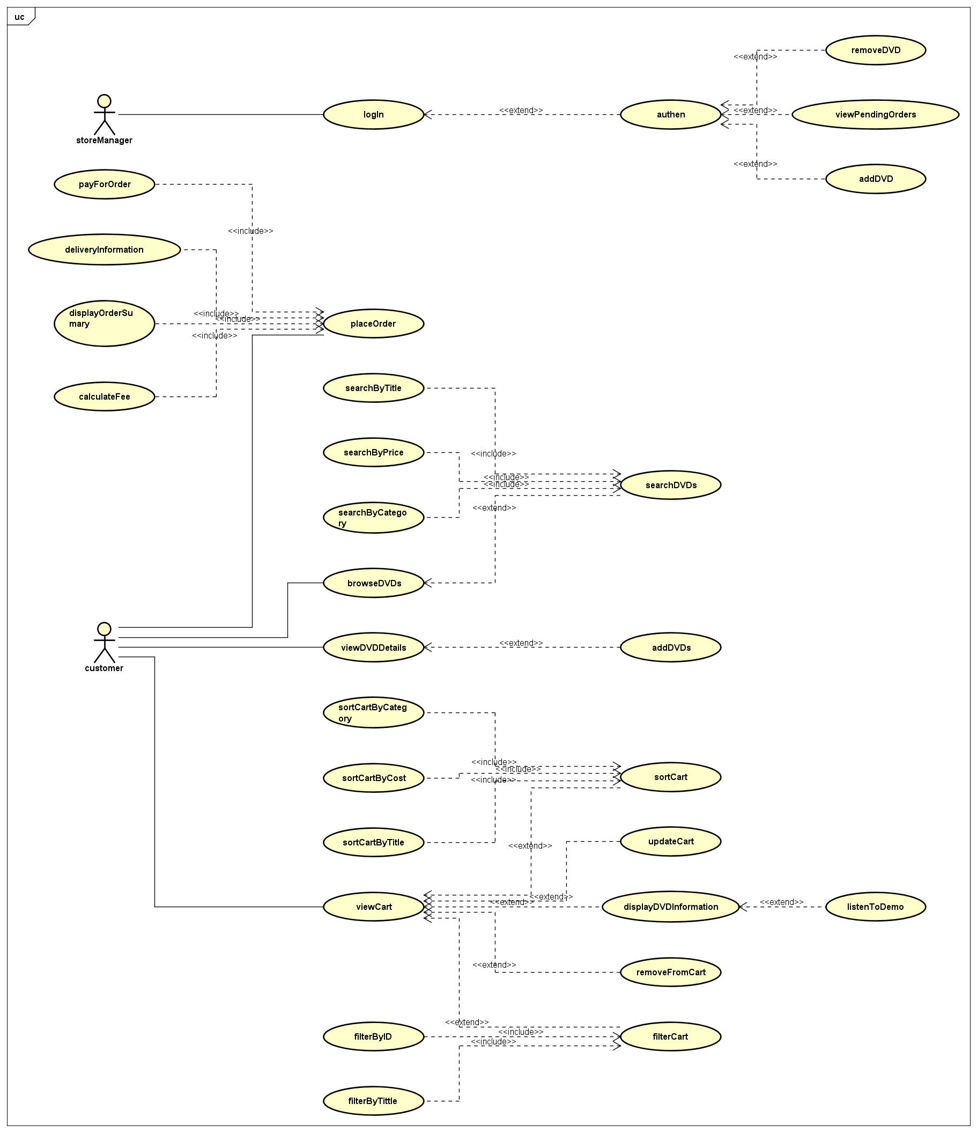

# Class diagram

# Reading assignment

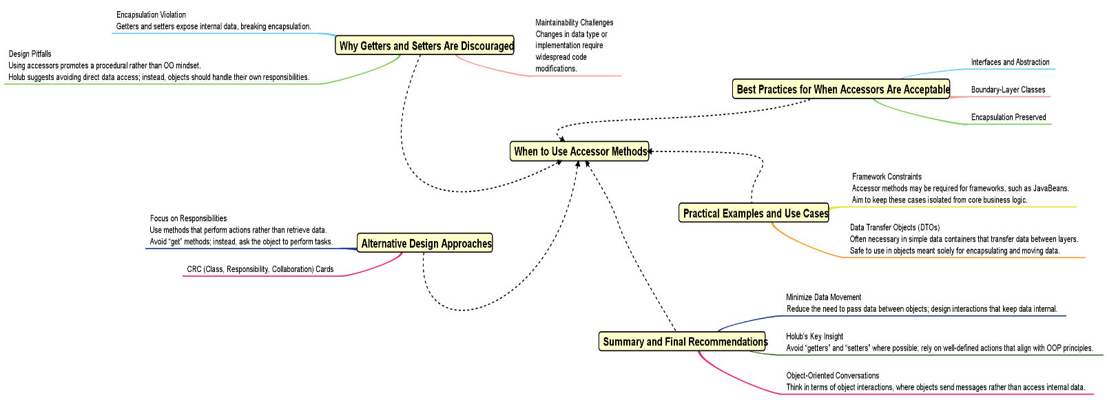

# Example program output

