 

**Placement Empowerment Program**

***Cloud Computing and DevOps Centre***

**DAY 12 TASK:**

Set Up a Cloud-Based Monitoring Service Enable basic cloud monitoring (e.g., Cloud Watch on AWS). View metrics like CPU usage and disk I/O for your cloud VM.

Name:NITHYASRI S.K

Department: ADS

**INTRODUCTION:**

In cloud computing, effective monitoring is crucial for ensuring the performance, reliability, and availability of cloud resources. AWS CloudWatch provides a comprehensive monitoring solution for AWS resources, enabling users to track various metrics in real-time. This Proof of Concept (PoC) focuses on leveraging CloudWatch to monitor the performance of an EC2 instance by enabling basic monitoring for key metrics such as CPU utilization and disk I/O. This PoC demonstrates how to enable, view, and analyze these metrics, giving insights into the health and performance of cloud based virtual machines.

**OVERVIEW:**

This PoC will walk through the process of setting up AWS CloudWatch to monitor an EC2 instance.

The main steps include:

1. Enabling basic cloud monitoring for an EC2 instance.

2. Viewing key metrics such as CPU utilization and disk read/write operations, to assess the performance of the instance.

3. Exploring how CloudWatch provides real-time insights into the instance’s resource usage, allowing administrators to identify performance bottlenecks or issues before they affect the service.

By completing this PoC, users will understand how to integrate CloudWatch monitoring for EC2 instances, enabling effective performance monitoring of virtual machines in the cloud.

**OBJECTIVE:**

The primary objective of this PoC is to enable basic cloud monitoring using AWS CloudWatch and view essential metrics for an EC2 instance.

Specific goals include:

Enabling CloudWatch monitoring for an EC2 instance.

Viewing CPU usage and disk I/O metrics to analyze the instance's performance.

Understanding how CloudWatch helps in real-time monitoring by providing visibility into cloud resource health.

**IMPORTANCE OF THIS POC:**

1. Performance Monitoring: By tracking CPU usage, disk I/O, and network traffic, CloudWatch provides crucial insights into the resource utilization of an EC2 instance, which helps in identifying and troubleshooting performance issues.

2. Real-time Visibility: Enabling CloudWatch monitoring ensures that administrators have access to real-time data about the instance's performance. This allows quick reactions to changes in resource consumption, preventing downtime or service degradation.

3. Resource Management: Understanding the resource consumption of the EC2 instance (such as CPU usage and disk I/O) helps in optimizing the instance’s capacity and managing resources efficiently, which can also lead to cost savings.

4. Proactive Issue Detection: CloudWatch allows the user to monitor and understand patterns in the system’s resource usage, helping detect performance anomalies or bottlenecks before they impact the system.

**STEP-BY-STEP OVERVIEW**:

**Step 1:** 1. Go to AWS Management Console.

**Step 2:** On the EC2 Dashboard, Launch Instances and enter a name for your instance. Leave other settings as default and Click Launch Instance.

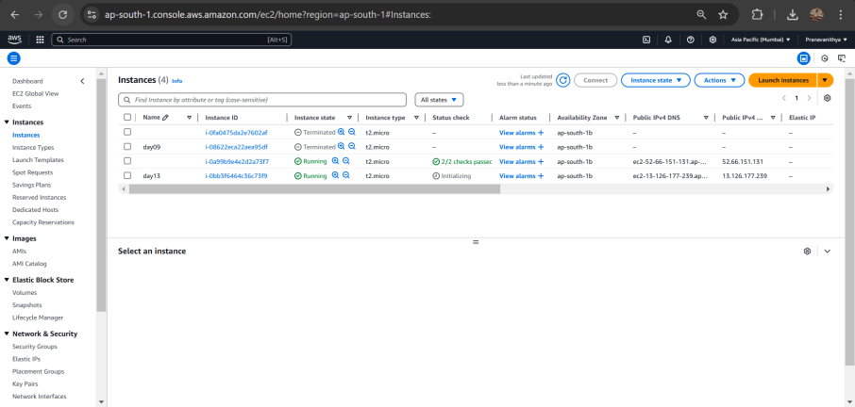

**Step 3:** Go to the EC2 Dashboard in the AWS Console. In the left menu, click volumes under Elastic Block Store (EBS). Click Create Volume.

**Step 4:** Once created, go to your Volumes list, select the newly created volume, and click Actions > Attach Volume

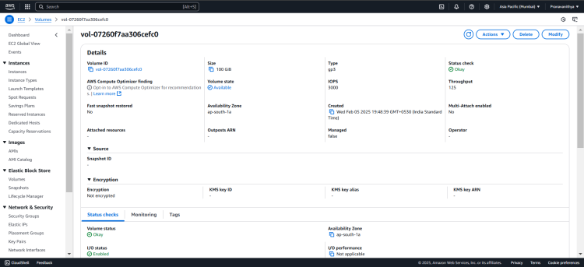

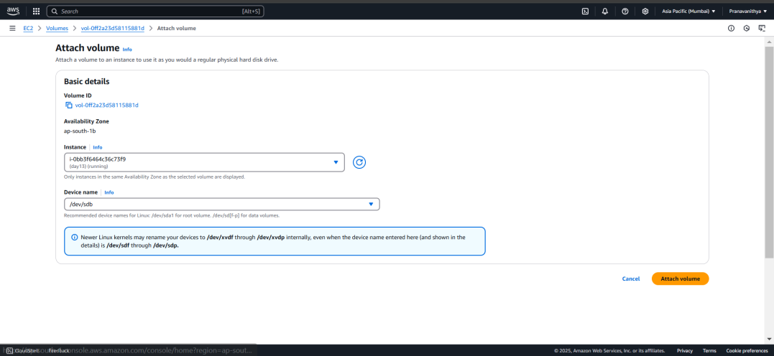

**Step 5:** Navigate to AWS Cloudwatch.

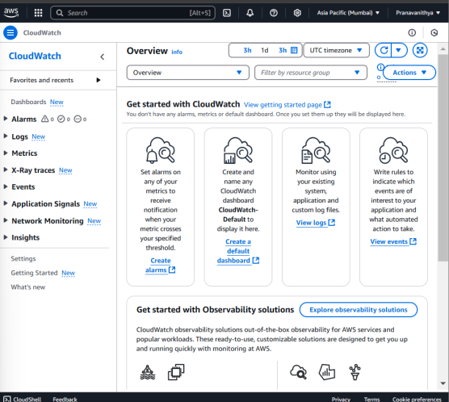

**Step 6:** In the CloudWatch dashboard, Click on Metrics. Under Browse, click on EC2. Then click on the Per-Instance Metrics

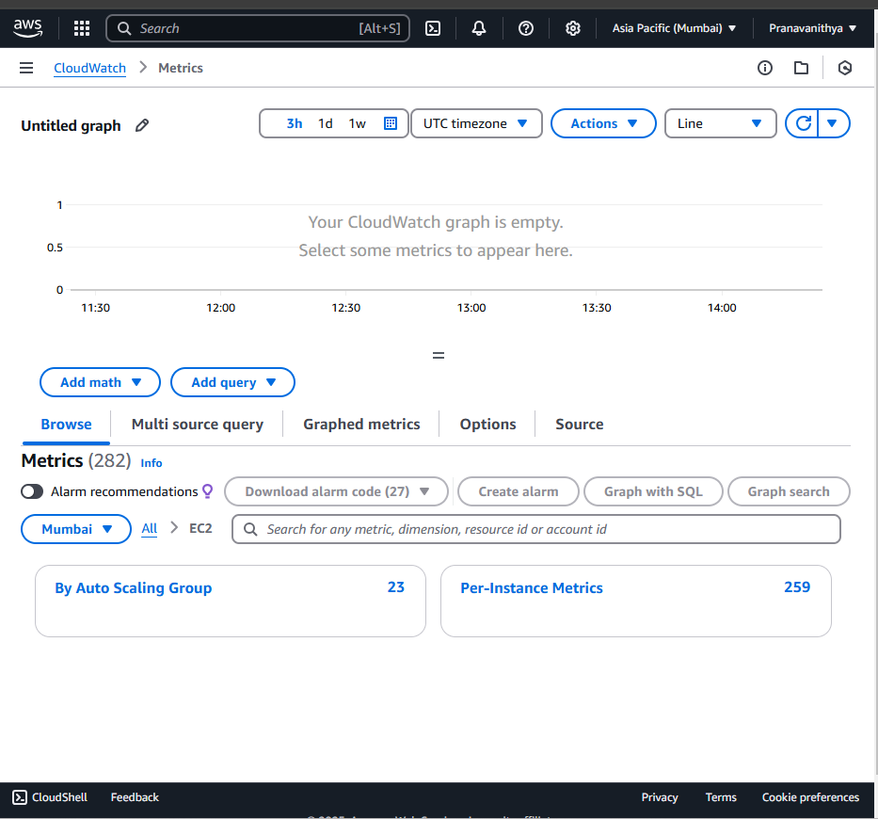

**Step 7:** You should now see a list of metrics for all your EC2 instances, such as:

CPUUtilization (CPU usage)

DiskReadOps / DiskWriteOps (Disk I/O)

Identify the specific EC2 instance you want to monitor (it will be listed by its instance ID).

Click on the metrics associated with your instance.

To view detail click Graphed metrics

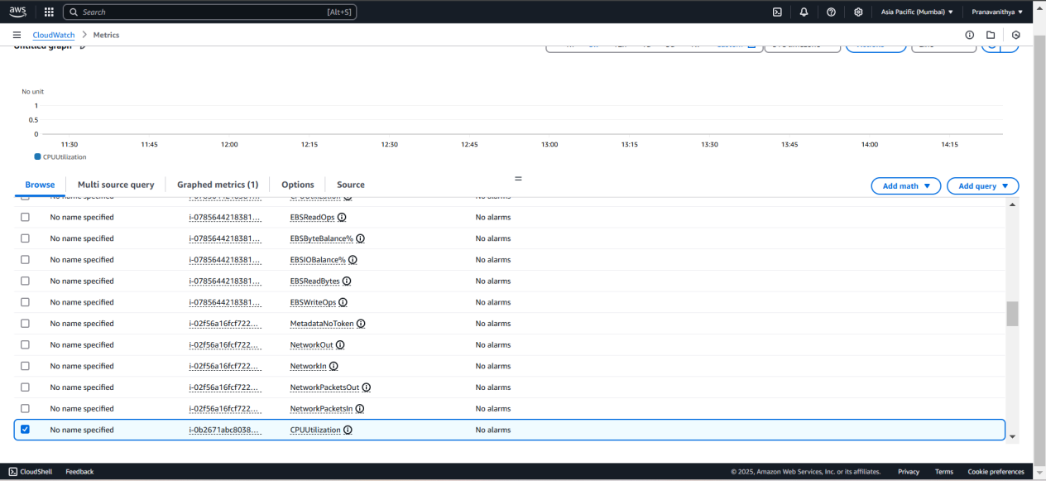

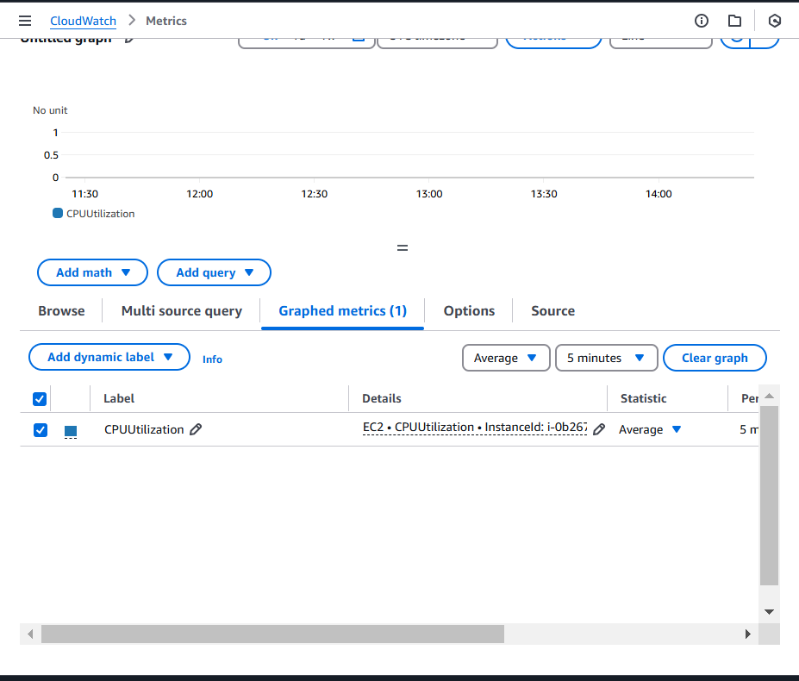

.

**OUTCOME :**

Here's the outcome of the PoC:

1. CloudWatch Setup: Successfully configured AWS CloudWatch to monitor EC2 instance metrics like CPU utilization and Disk I/O (DiskReadOps, DiskWriteOps).

2. Disk I/O Monitoring: Added an EBS volume to the EC2 instance to track DiskReadOps and DiskWriteOps metrics, which were visualized in CloudWatch.

3. Cost Efficiency: The EBS volume was within the AWS Free Tier limits (30 GB), and all metrics stayed within Free Tier usage, incurring no additional cost.