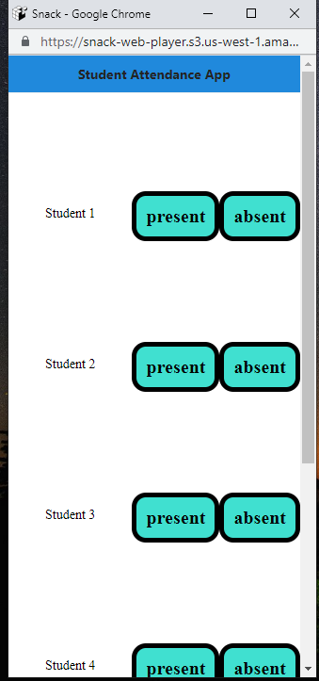

Home Screen has Student 1, Student 2, Student 3, Student 4(Minimum 4 students) along with Present and Absent Buttons (To bring Student 1, Absent and Present in one row, use flexDirection = ‘row’ in the styling of View which has TouchableOpacity, Student 1 text… Same for all the other views which hold Student2, Student3, Student 4) . Please have an app header.

A button which says “Go to Attendance Screen” or “Attendance Screen” is to be created at the bottom of home screen as shown in below screenshot.

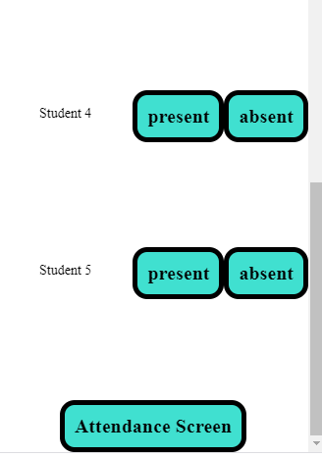

Create a Switch Navigator for Home Screen and Attendance Screen in App.js. On click of the above Attendance Screen button, it should take us to Attendance Screen. Do necessary changes in onPress event of the Touchable Opacity.

The Database should have the following node structure.

students

- student1

- absent : false

- present : false

- student2

- absent : false

- present : false

- student3

- absent : false

- present : false

- student4

- absent : false

- present : false

Get the config files and import it in Home Screen.

Write 2 functions isPresentPressed, isAbsentPressed which will update the corresponding nodes in database.

isPresentPressed = (student) => {

    var dbref = database.ref("students/" + student);

    dbref.update({

      present: true,

absent : false

    });

 };

These functions are to be called when the Present and Absent buttons are pressed.

(Example)

For Student 1 Present TouchableOpacity,

onPress={() => {

                this.isPresentPressed("student1");

              }}

In Attendance Screen as shown below(pls scroll down), You need to display an app header, the Present and Absent Students, a Reset button to reset the database and Go back button to go back to Home Screen.

1. Have 2 state variables presentStudents, absentStudents . They are arrays.
2. Write a function getStudentDetails. Create 2 empty arrays present and absent and read the data from db. (Reference to students node)
3. If present is true for a student. Push it to Present array
4. If absent is true for a student. Push it to absent array.
5. Finally set these arrays to State Variable Arrays.

for (var student in studentList) {

        if (studentList [student]['present'] === true) {

          present.push(student);

        } else if (studentList [student]['absent'] === true) {

                  absent.push(student);

        }

1. In render function, to display the student names, you have to use map function on the state variables and display Text Component. Please refer class file.

 {this.state.presentStudent.map((student) => (

             <Text style={styles.displayText}>Present : {student}</Text>

            ))}

Do necessary styling and submit ☺

