**Part I – Systems Analysis (& Design)**

1. **Executive Summary**

**Introduction:**

An extensive examination of the present appointment and registration is given in this executive summary. This executive summary provides a detailed analysis of the current appointment and registration system at Noah's Pet Clinic (NPC), a veterinary clinic located in a rural part of Manchester. The overview highlights the challenges that the current system's flaws cause for pet owners, receptionists, veterinarians, and vet nurses. This document proposes a comprehensive redesign of the appointment and registration system to increase accessibility and efficiency. The solution consists of an elegant procedure for pet owners to schedule visits and register their pets, a combined database that is accessible to all clinic employees, an easy-to-use interface, and the advantages of using the new system such as improved customer service, operational effectiveness, and data security.

**Purpose of our Report:**

This aim assists in addressing the issues or challenges NPC faces and renders them great information system & and database solutions. Thereafter, the goal here is to increase accessibility, efficiency, and accuracy of appointments and as well as registration processes, for both Clinic staff and pet owners.

**Problem Statement:**

The appointment and registration system at Noah's Pet Clinic (NPC) is currently experiencing several issues that affect both pet owners and clinic employees. These problems include inadequate or erroneous information on registration forms, trouble accessing and retrieving appointment details, and the absence of a centralised database for effective record-keeping. Furthermore, pet owners cannot easily schedule appointments with the current system's unintuitive interface, which could cause annoyance and inefficiency. Moreover, data security issues have been found, emphasising the necessity for improved safeguards to secure pet and owner data. All of these difficulties make it more difficult for the clinic to deliver smooth, effective services, which eventually affects client happiness and overall operational efficacy. Therefore, in order to solve these problems and enhance both the overall experience of pet owners and clinic employees at NPC, it is imperative that the appointment and registration system be upgraded.

**Key Points of the Report (Solution):**

To tackle the issues mentioned in the problem description, the subsequent fixes are suggested:

* Centralized database: To streamline procedures and lower the possibility of mistakes, install a centralized database that is available to all clinic employees. This will allow them to store and retrieve pet and appointment records.
* User-friendly interface: Make scheduling appointments for pet owners easier for receptionists, veterinarians, and veterinary nurses by creating an interface that is easy to use.
* Simplified registration: Make it easier for pet owners and front desk staff to register, lowering the possibility of incorrect or missing information being provided.
* Effective record-keeping: Create a simplified procedure to guarantee that all pertinent information is accurately and effectively recorded.
* Improved data security: Take steps to safeguard owner and pet data and keep it safe from unwanted access.

**Summary:**

In conclusion, this summary provides a comprehensive solution for NCP's challenges by prioritizing the implementation of an advanced information system and well-designed database. Also, by rendering plausible solutions this proposed system aims to improve the clinic's operational capacity and lastly, an enriched experience for both staff and pet owners.

2a) The main goals of the system for Noah's Pet Clinic are:

* Enhance accessibility: The new system aims to provide a centralized database that can be accessed by all clinic staff, making it easier for them to retrieve pet and appointment details.
* Improve efficiency: The proposed system includes a user-friendly interface for pet owners to book appointments, streamlining the process for receptionists, vet doctors, and vet nurses.
* Streamline registration and record-keeping: The new system aims to simplify the registration process for pet owners and receptionists, reducing the likelihood of errors and incomplete information. While ensuring that all relevant data is accurately recorded, it also aims to speed up the record-keeping process.
* Enhance data security: The proposed system includes measures to ensure the security of pet and owner data, protecting it from unauthorized access or loss.
* Improve customer satisfaction: By providing a more accessible and efficient appointment and registration system, NPC aims to enhance the overall experience for pet owners, ultimately improving customer satisfaction.

2b) **Functional Requirements**

**Pet Owners**

* Schedule an appointment.
* Cancel appointment.
* Book another appointment.
* Fill pet registration form
* Make follow-up appointment after seeing the doctor.

**Doctors**

* Fill in the consultation document form.
* Doctors make diagnostic advice about the illness and medication to take.
* Doctors estimate the cost of the medication.
* Doctors makes referrals and deferral.

**Nurses**

* Nurses give a hand during appointment.

**Receptionist**

* Answer calls
* Record appointment
* Making of note

**Appointment dairy**

* + The pet owner’s appointment is scheduled in the dairy of the receptionist.

**Non-functional requirement**

* Immediately after registration is done, the system schedules an appointment after 10 minutes.
* £5 charge is paid after every cancellation of the appointment.
* The system must provide a better means to retrieve both pet and appointment details by doctors and nurses.
* Transcribing should be done within 1 hour after registration has been done.
* The system should provide an easier method for data storage.
* The system should ensure that important field of the consultation form is made mandatory.
* The system should ensure that there are two nurses to assist the doctor during diagnosis.
* The system should ensure that a referral and deferral is provided when needed.

3a) Use Case Diagram (UCD)

3b) Chima Samuel Ucheoma

|  |
| --- |
| **Use Case: *Appointment*** |
| Owner: Pet owner |
| **Pre-Conditions** |
| Pet must be unwell or needs medical checkup. |
| **Post-Conditions** |
| If the pet owner and pet make it for the appointment, diagnosis, and medical advice is given. |
| **Primary Path** |
| 1. The pet owner rings the reception. 2. The pet owner books an appointment. 3. The system notes the appointment in the appointment diary. 4. The system assigns a pet doctor to attend to the pet. 5. The system notifies the pet owner of the appointment booking. 6. The pet owner and pet arrive on the appointment day. 7. A follow-up appointment is made. |
| **Alternate Path** |
| 1a) Appointment booking can be cancelled by the pet owner.  1b) A 5-pound cancellation fee is paid if the appointment was cancelled. |
| **Notes** |
|  |
|  |
|  |

Rahul Samnotra

|  |
| --- |
| **Use Case: *Pet Registration*** |
| Owner: Receptionist. |
| **Pre-Conditions** |
| The pet is unwell or needs a routine checkup. |
| **Post-Conditions** |
| If registration is successful, the pet owner gets a confirmation of registration. |
| **Primary Path** |
| 1. The pet owner books an appointment. 2. The owner fills out the Owner and Pet Registration Forms. 3. System stores the filled-out owner and pet registration forms in a virtual folder. 4. The system sorts the registration forms in alphabetical order. 5. The system places files in the right folder and names them correctly. |
| **Alternate Path** |
| 2a) If registration is not done online, it is done in person on paper.  b) Transcription of the filled registration of paper form is done by the receptionist.  4a) The system may not sort the filled registration forms in alphabetical order. |
| **Notes** |
|  |
|  |
|  |

Samuel Kofi Opoku

|  |
| --- |
| **Use Case: *Consultation*** |
| Owner: Doctor. |
| **Pre-Conditions** |
| The pet appointment date is due. |
| **Post-Conditions** |
| If the diagnosis is successful, medical advice is given, and drug prescriptions are made by the system. |
| **Primary Path** |
| 1. The Pet Owner and pet arrive for the appointment. 2. Appointment details and pet registration forms are retrieved from the system by the doctor and nurse. 3. The doctor fills out a consultation document form with details of the pet and pet owner where they should be. 4. The system places the consultation form in another virtual folder. 5. System conducts diagnosis on pet. 6. Medical advice is made. 7. The owner and pet leave the clinic. |
| **Alternate Path** |
| 4a) A referral or deferral is made based on the diagnosis. |
| **Notes** |
|  |
|  |
|  |

Deepak Gowda Nilavadi Rajamudi

|  |
| --- |
| **Use Case: *Medication*** |
| Owner: Doctor |
| **Pre-Conditions** |
| The pet owner and pet arrived for an appointment and the pet was diagnosed. |
| **Post-Conditions** |
| If successful, the proper action is taken about the pet’s medical condition, and the right medication is given. |
| **Primary Path** |
| 1. Diagnosis of the pet is done by the system. 2. The system makes proper medical advising. 3. A referral or deferral is recommended. 4. The right medication is prescribed. 5. The system indicates the cost of medication to take. 6. The system recommends the pharmacy for medication procurement. 7. The system charges the pet owner for the cost of the consultation and appointment cancellation fee. |
| **Alternate Path** |
| 7a) The system may not charge for cancellation fee if no cancellation was done. |
| **Notes** |
|  |
|  |
|  |

**Part II – Database Design & Implementation**

1. **Top-down Entity Relationship Diagram (ERD):**

1. **Normalisation: (Appointment diary, Pet consultation form, Pet registration form)** 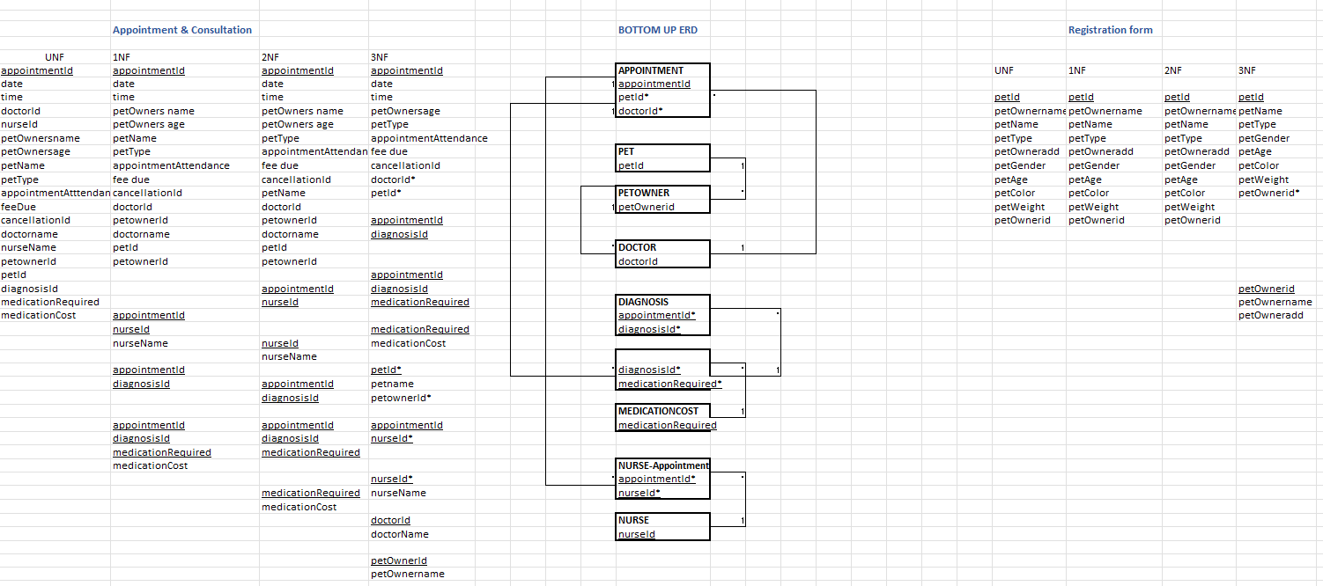
2. **Final ERD:** 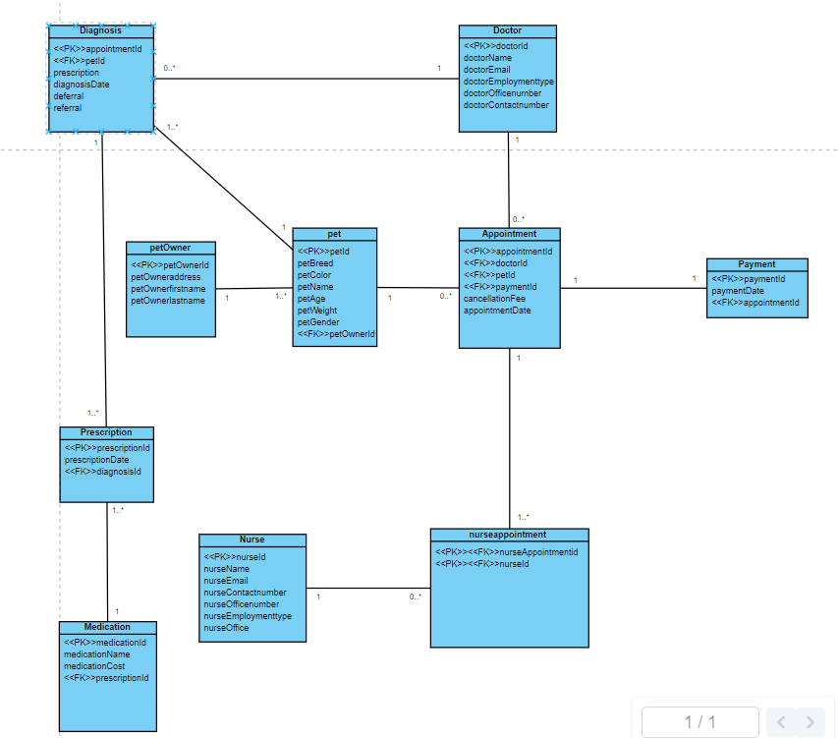

1. **Screenshots of the query results:**

Pet owner:

Doctor:

Nurse:

Appointment:

Payment:

Diagnosis:

Prescription:

Medication:

Nurse appointment:  
  
  
  
---------------------------------------------------------------------------------------------------------------------------  
The above-mentioned design presents the current design, which incorporates a centralized database that is available to all clinic personnel, an easy-to-use interface for pet owners to schedule appointments, streamlined procedures for registration and record-keeping, and improved data security measures. Nevertheless, the paper lacks detailed information about the database's current condition, including the kind of database management system being used, the schema's architecture, and the methods for storing and retrieving data. As a result, offering a thorough examination of the current database is challenging.

Database Redesign for a Bigger Client:

The following three approaches to database redesign are recommended to enhance the database for a larger client:

Firstly, a larger client's data volume and complexity may be beyond the scope of the existing architecture that is suggested in the design above. To guarantee scalability, the database needs to be changed. Two possible approaches are to use a cloud-based database management system or a distributed database architecture. This will guarantee that performance won't be compromised, and the database can manage the increased volume of data and user traffic.

Secondly, to obtain insights into their operations and customer behaviour, a larger business could need more sophisticated data analytics capabilities. So data analytics methods and machine learning, data mining should be incorporated into the database overhaul.

Moreover, the appointment and registration system must be integrated with any current databases and systems that a larger customer could have. To guarantee smooth integration with other systems and databases, the database should be changed. This can be done by using middleware or APIs. By doing this, the client will be able to take advantage of their current data assets and infrastructure, which will lower the cost and complexity of the integration process.

**Part III: Query Implementation**

1st query:

2nd query:

3rd query:

5th query:

6th query:   
 