Automatic Attendance System

Software Engineering Project

Report – Phase I

By

Anubhav Pandey

1301010

Indian Institute of Information Technology Guwahati

**INTRODUCTION**

The project is titled “Automatic Attendance System”. The project is based on deploying a web based system for automating attendance taking procedure and maintaining attendance sheets.

It gives users a web based GUI to interact with the system. The admins (teachers or employers) can take attendance, create attendance sheets, edit attendance sheets. The attendees (students and employees) can give attendance and see their current attendance

**PRODUCT DESCRIPTION**

**Features:**

#1 Home Page for Login and Register.

#2 Login for Teachers and other admins who wish to take attendance.

#3 Login for SuperUser who can see and edit every attendance sheet.

#4 A page for adding and preparing attendance sheet.

#5 A page for taking attendance.

Attendance can be taken in two ways either by directly entering the UID/Roll Numbers of absent students/employees

Or by clicking against the checkboxes of present student.

*If time permits functionality will also be added for taking attendance using QR codes and Facial Recognition.

#6 Logins for students/employees to know about their attendance and for giving attendance.

#7 Admins can see the attendance sheet and modify it.

#8 New users can register.

#9 If somebody forgets their password then providing ways to create new password.

#10 Attendance sheet will contain the time of attendance (when using QR code and Facial Recognition.)

#11 Weekly updates to users via mail

#12 Uploading the whole app to heroku.

#13 form check using javascript/html5 (e.g. is it the correct format for input)

#14 Create the same attendance sheet for next month.

#15 The attendance sheet will contain names of attendees their ROll numbers and date and day of that month.

Absent will be marked with A.

Present will be marked with P.

**The Use Case Diagram**

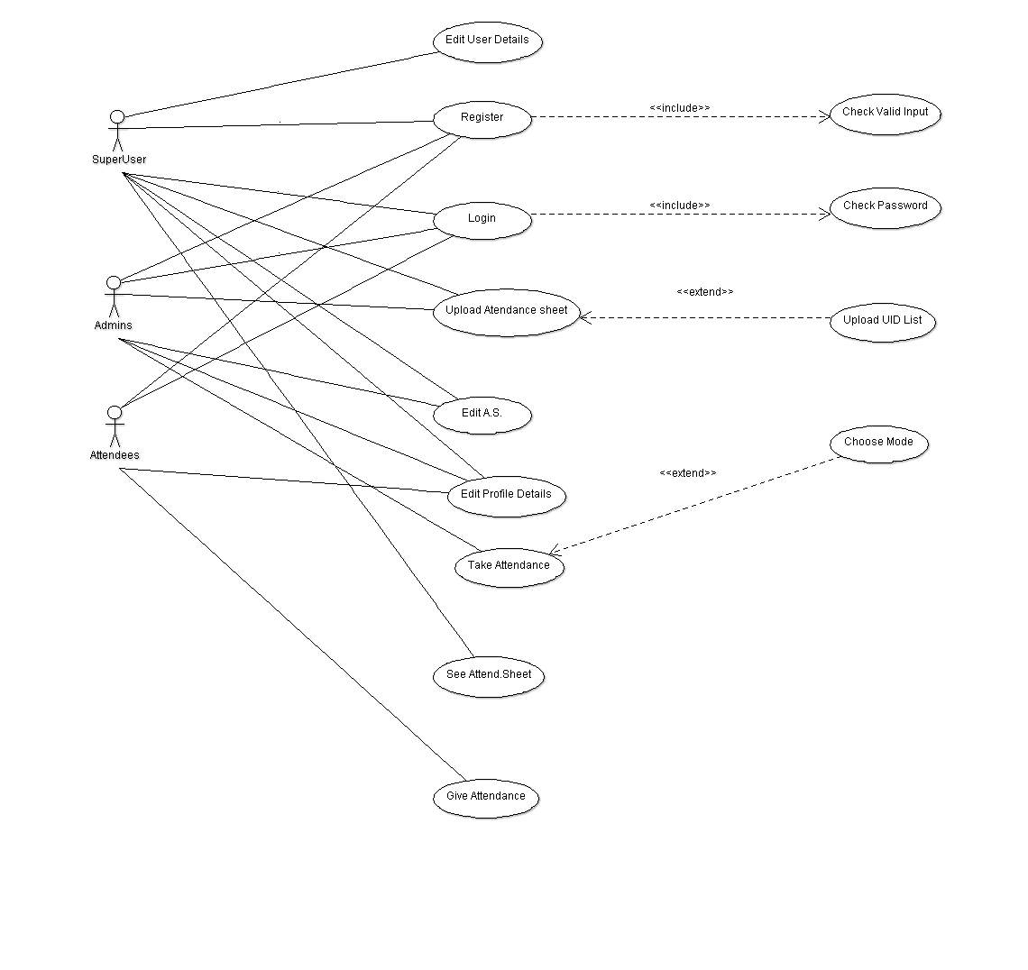

**Functional Requirements**

1. **User Registration**
   * **Description:** New user has to register with necessary details.
   * **Actor:** User
   * **Input:** The user has to provide all the necessary details present in the customer registration form of the application.
   * **Output:** All the details entered will be verified and accepted by the system into the database.
2. **User Login**
   * **Description:** Old user logs in to the application
   * **Actor:** User
   * **Input:** The user provides User Id and password for login
   * **Output:** User will be verified for authentication with the provided credentials. If those are matched, user is logged in. Otherwise, application returns login page with message of invalid credentials.
3. **Edit Profile Details**
   * **Description:** Users who are logged in can edit their details
   * **Actor:** User
   * **Input:** The user new details editing the old details provided during registration.
   * **Output:** Users will be displayed their new details.
4. **Create Attendance Sheets**
   * **Description:** Admins can create new attendance sheets
   * **Actor:** User(Admins)
   * **Input:** Admins provide list of UIDs ,day range and mode of attendance.
   * **Output:**Admins will be given an acknoledgemend and taken to their attendance sheet.
5. **Edit Attendance Sheets**
   * **Description:** Admins can edit their attendance sheets
   * **Actor:** User(Admins)
   * **Input:** The user adds new details editing the old details provided during creation of the attendance sheet.
   * **Output:** Users will be displayed their new attendance sheet.