**Assignment TP3 | Line Performance on Transmission Line**

A three phase 50Hz, 220kV transmission line having length of 600km. The line parameters per phase per unit length are found to be

1. Determine the line performance when load at the receiving end is 800 MW 0.8 power factor lagging 200kV.

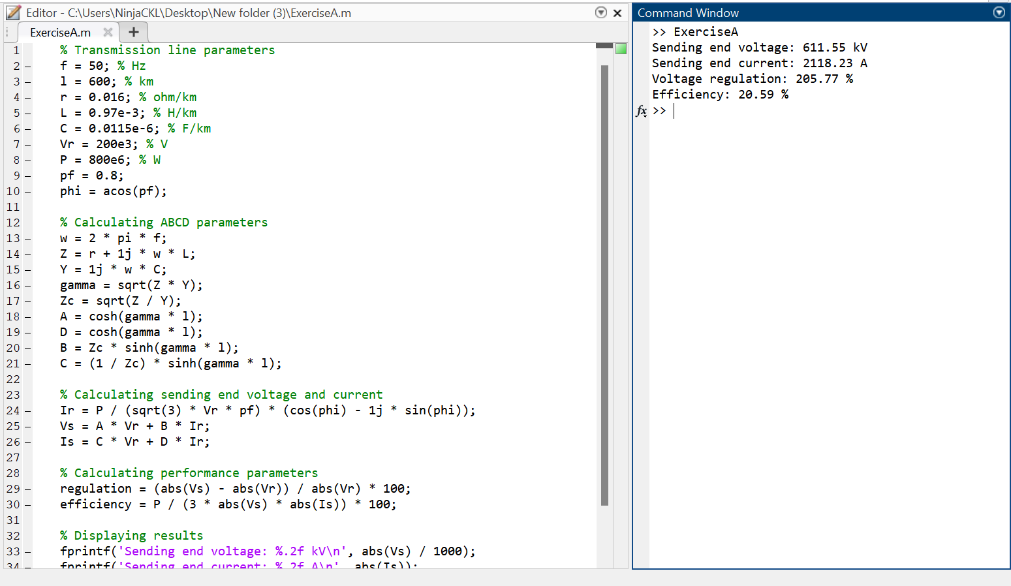

1. Determine the receiving end quantities and the line performance when 600MW and 400MVAr are being transmitted at 210kV from the sending end.

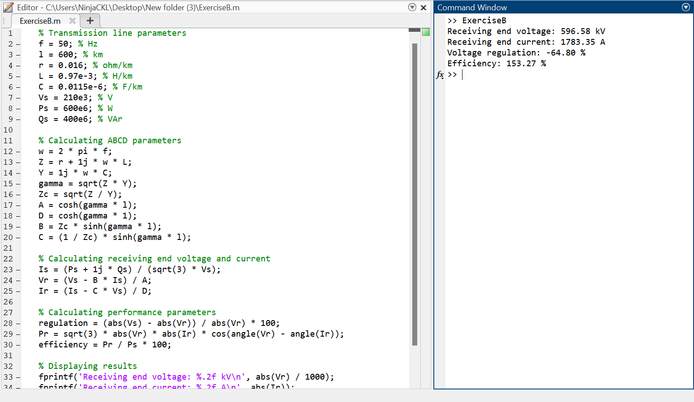

1. Determine the sending end quantities and the line performance when the receiving end load impedance is 2902 at 500kV.

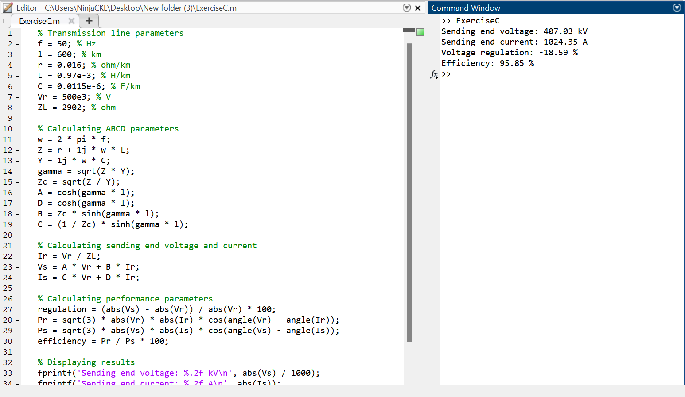

1. Find the receiving end quantities when the line is terminated in an open circuit and is energized with 500kV at the sending end. Also determine the reactance and the MVAR of three phase shunt reactors to be installed at the receiving end in order to limit the receiving end voltage to 500kV.

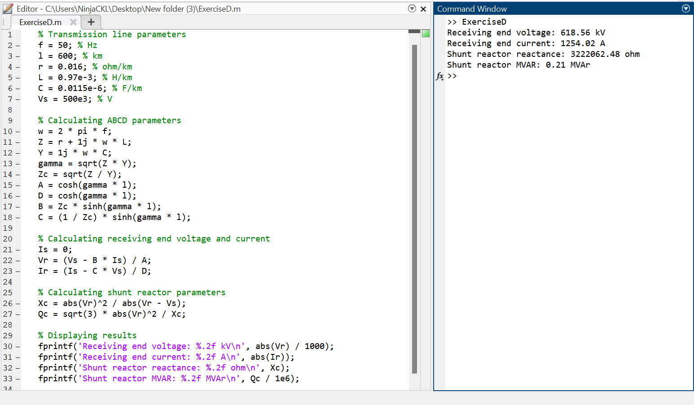

1. Draw the voltage profile for both compensated and uncompensated line.

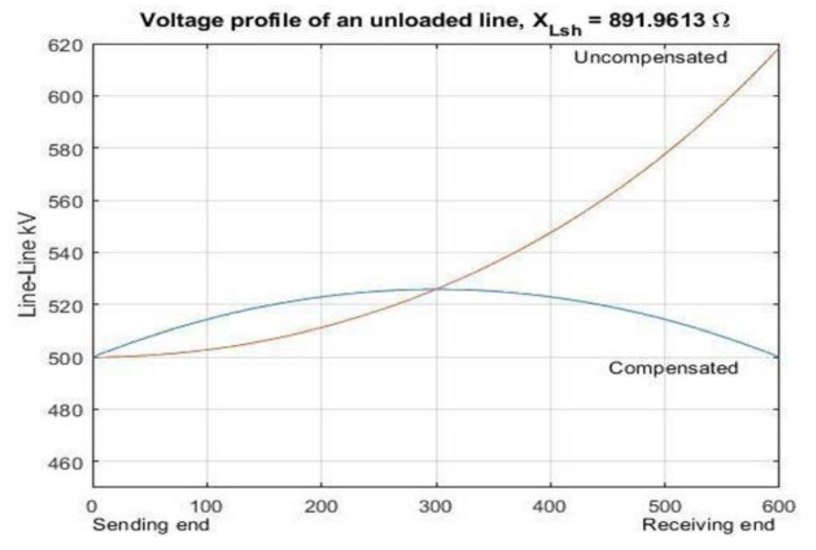

1. Find the receiving end and the sending end currents when the line is terminated at the short circuit.

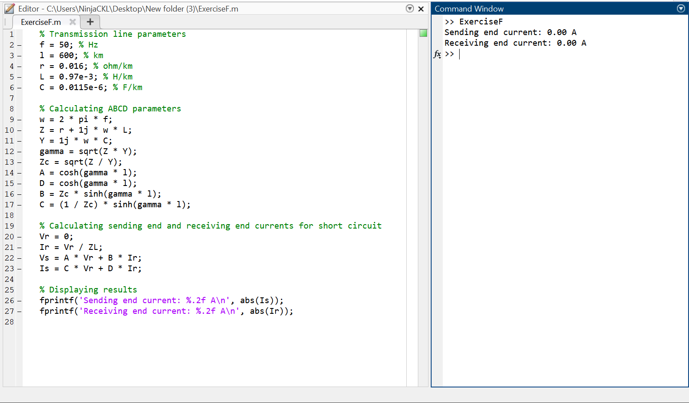

1. Construct the receiving end circle.

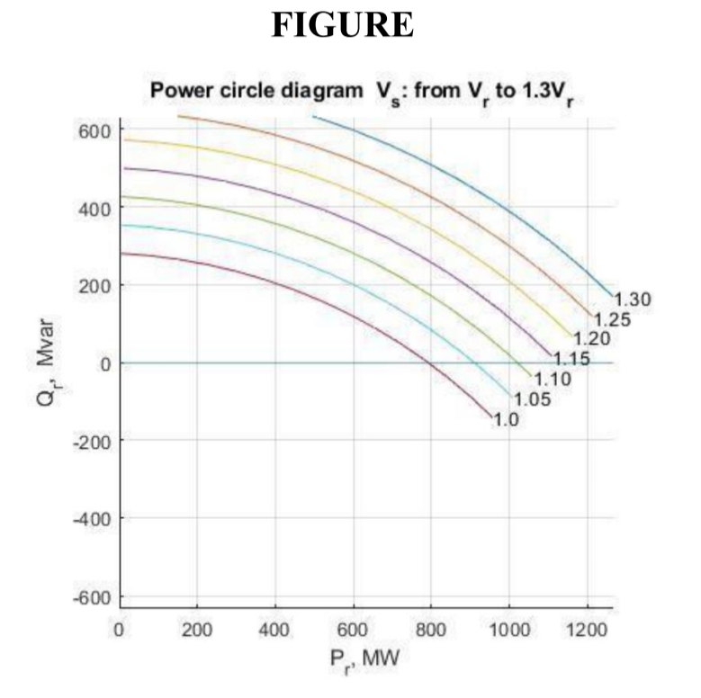

1. Determine the line voltage profile for the following cases.
   1. a. No load
   2. b. Rated load
   3. c. Line terminated in the SIL
   4. d. Short Circuited Line

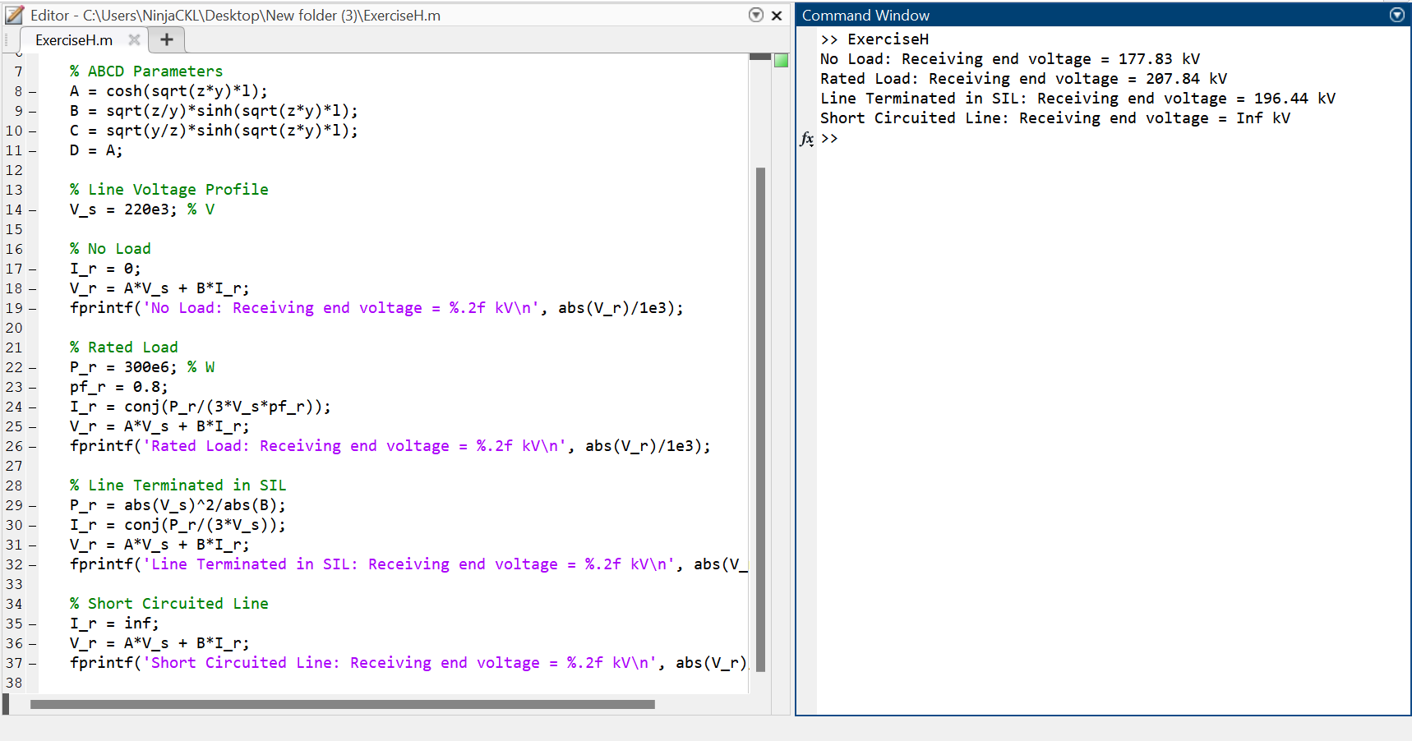

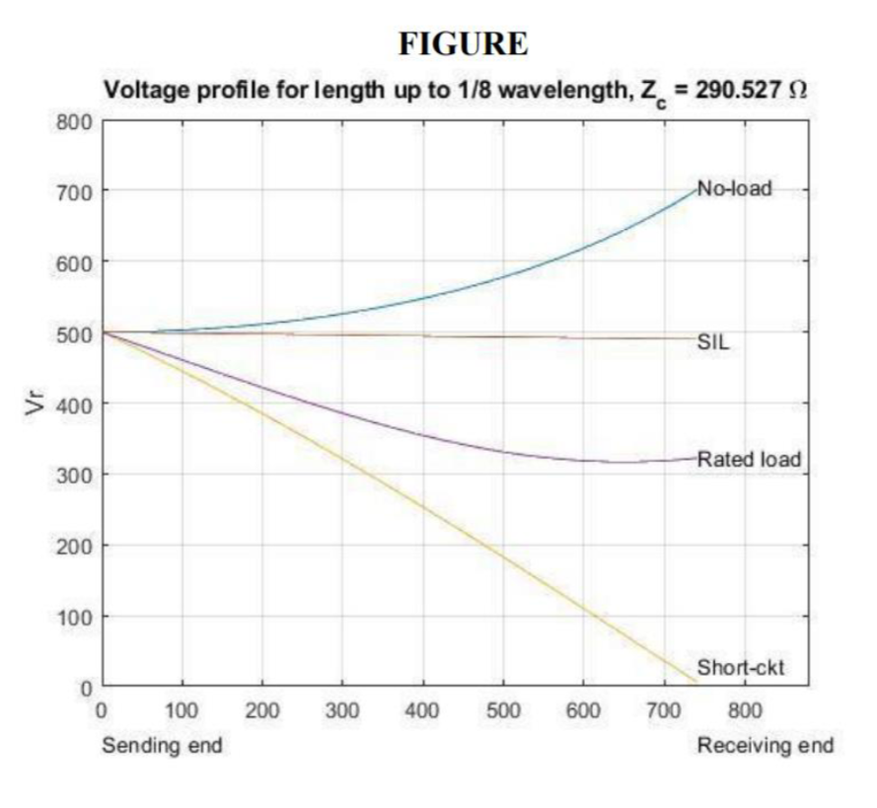

1. Obtain the line load ability curve

