Niranjan S-PL/SQL
Exercise 1: Control Structures
DROP TABLE Transactions;

DROP TABLE Accounts;

DROP TABLE Loans;

DROP TABLE Employees;

DROP TABLE Customers;
CREATE TABLE Customers (
CustomerID NUMBER PRIMARY KEY,
Name VARCHAR2(100),
DOB DATE,
Balance NUMBER,
LastModified DATE,
IsVIP VARCHAR2(5)
);
CREATE TABLE Accounts (
AccountID NUMBER PRIMARY KEY,
CustomerID NUMBER,
AccountType VARCHAR2(20),
Balance NUMBER,
LastModified DATE,
FOREIGN KEY (CustomerID)
REFERENCES Customers(CustomerID)
);
CREATE TABLE Transactions (
TransactionID NUMBER PRIMARY KEY,
AccountID NUMBER,
TransactionDate DATE,
Amount NUMBER,
TransactionType VARCHAR2(10),
FOREIGN KEY (AccountID)
REFERENCES Accounts(AccountID)
);
CREATE TABLE Loans (
LoanID NUMBER PRIMARY KEY,
CustomerID NUMBER,
LoanAmount NUMBER,
InterestRate NUMBER,
StartDate DATE,
EndDate DATE,
FOREIGN KEY (CustomerID)
REFERENCES Customers(CustomerID)
);
CREATE TABLE Employees (
EmployeeID NUMBER PRIMARY KEY,
Name VARCHAR2(100),
Position VARCHAR2(50),
Salary NUMBER,
Department VARCHAR2(50),
HireDate DATE
);
INSERT INTO Customers
VALUES (1,'John Doe',
TO_DATE('1955-05-15','YYYY-MM-DD'),
12000,
SYSDATE,
NULL);

INSERT INTO Customers
VALUES (2,'Jane Smith',
TO_DATE('1990-07-20','YYYY-MM-DD'),
1500,
SYSDATE,
NULL);

COMMIT;
INSERT INTO Accounts
VALUES (1,1,'Savings',12000,SYSDATE);

INSERT INTO Accounts
VALUES (2,2,'Checking',1500,SYSDATE);

COMMIT;
INSERT INTO Transactions
VALUES (1,1,SYSDATE,200,'Deposit');

INSERT INTO Transactions
VALUES (2,2,SYSDATE,300,'Withdrawal');

COMMIT;
INSERT INTO Loans
VALUES (1,1,5000,5,SYSDATE,SYSDATE+20);

INSERT INTO Loans
VALUES (2,2,10000,7,SYSDATE,SYSDATE+60);

COMMIT;
INSERT INTO Employees
VALUES (1,'Alice Johnson',
'Manager',
70000,
'HR',
TO_DATE('2015-06-15','YYYY-MM-DD'));

INSERT INTO Employees
VALUES (2,'Bob Brown',
'Developer',
60000,
'IT',
TO_DATE('2017-03-20','YYYY-MM-DD'));

COMMIT;
SET SERVEROUTPUT ON;
BEGIN
FOR rec IN (
SELECT l.LoanID,
c.DOB
FROM Loans l
JOIN Customers c
ON l.CustomerID = c.CustomerID
)
LOOP

IF FLOOR(MONTHS_BETWEEN(SYSDATE, rec.DOB)/12) > 60 THEN

UPDATE Loans
SET InterestRate = InterestRate - 1
WHERE LoanID = rec.LoanID;

DBMS_OUTPUT.PUT_LINE(
'Discount applied to Loan ID '
|| rec.LoanID
);

END IF;

END LOOP;

COMMIT;
END;
/
SELECT * FROM Loans;
SET SERVEROUTPUT ON;

BEGIN
FOR c IN (SELECT CustomerID, Balance FROM Customers)
LOOP
IF c.Balance > 10000 THEN
UPDATE Customers
SET IsVIP = 'TRUE'
WHERE CustomerID = c.CustomerID;

DBMS_OUTPUT.PUT_LINE
('VIP Customer: ' || c.CustomerID);
END IF;
END LOOP;

COMMIT;
END;
/
SELECT CustomerID, Name, Balance, IsVIP
FROM Customers;
BEGIN

FOR rec IN (
SELECT c.Name,
l.LoanID,
l.EndDate
FROM Customers c
JOIN Loans l
ON c.CustomerID=l.CustomerID
WHERE l.EndDate BETWEEN SYSDATE
AND SYSDATE+30
)
LOOP

DBMS_OUTPUT.PUT_LINE(
'Reminder: '
|| rec.Name
|| ' Loan '
|| rec.LoanID
|| ' due on '
|| TO_CHAR(rec.EndDate,'DD-MON-YYYY')
);

END LOOP;

END;
/
SELECT CustomerID, Name, Balance, IsVIP
FROM Customers;
BEGIN

FOR rec IN (
SELECT c.Name,
l.LoanID,
l.EndDate
FROM Customers c
JOIN Loans l
ON c.CustomerID=l.CustomerID
WHERE l.EndDate BETWEEN SYSDATE
AND SYSDATE+30
)
LOOP

DBMS_OUTPUT.PUT_LINE(
'Reminder: '
|| rec.Name
|| ' Loan '
|| rec.LoanID
|| ' due on '
|| TO_CHAR(rec.EndDate,'DD-MON-YYYY')
);

END LOOP;

END;
/
Scenario 1:
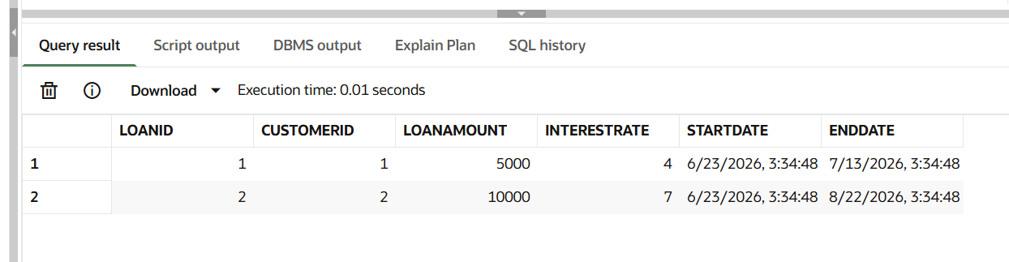
Scenario 2:
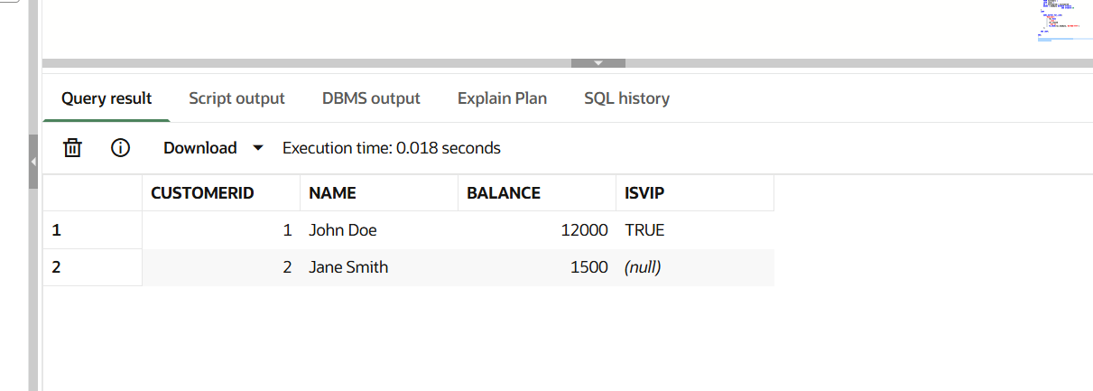
Scenario 3:
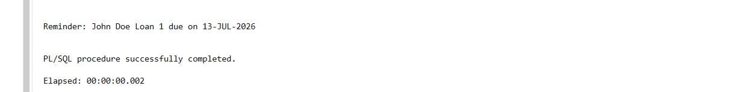

Exercise 2: Error Handling
CREATE OR REPLACE PROCEDURE SafeTransferFunds(
p_from_account NUMBER,
p_to_account NUMBER,
p_amount NUMBER
)
IS
v_balance NUMBER;
BEGIN

SELECT Balance
INTO v_balance
FROM Accounts
WHERE AccountID = p_from_account;

IF v_balance < p_amount THEN
RAISE_APPLICATION_ERROR(-20001,
'Insufficient Funds');
END IF;

UPDATE Accounts
SET Balance = Balance - p_amount
WHERE AccountID = p_from_account;

UPDATE Accounts
SET Balance = Balance + p_amount
WHERE AccountID = p_to_account;

COMMIT;

DBMS_OUTPUT.PUT_LINE('Transfer Successful');

EXCEPTION

WHEN OTHERS THEN
ROLLBACK;
DBMS_OUTPUT.PUT_LINE(
'Transfer Failed: ' || SQLERRM);

END;
/
BEGIN
SafeTransferFunds(1,2,500);
END;
/
SELECT AccountID, Balance
FROM Accounts;
BEGIN
SafeTransferFunds(2,1,5000);
END;
/
CREATE OR REPLACE PROCEDURE UpdateSalary(
p_empid NUMBER,
p_percentage NUMBER
)
IS
BEGIN

UPDATE Employees
SET Salary = Salary +
(Salary * p_percentage / 100)
WHERE EmployeeID = p_empid;

IF SQL%ROWCOUNT = 0 THEN
RAISE NO_DATA_FOUND;
END IF;

COMMIT;

DBMS_OUTPUT.PUT_LINE(
'Salary Updated Successfully');

EXCEPTION

WHEN NO_DATA_FOUND THEN
DBMS_OUTPUT.PUT_LINE(
'Employee ID Not Found');

WHEN OTHERS THEN
DBMS_OUTPUT.PUT_LINE(
'Error: ' || SQLERRM);

END;
/
BEGIN
UpdateSalary(1,10);
END;
/
SELECT EmployeeID,
Name,
Salary
FROM Employees;
BEGIN
UpdateSalary(100,10);
END;
/
CREATE OR REPLACE PROCEDURE AddNewCustomer(
p_id NUMBER,
p_name VARCHAR2,
p_dob DATE,
p_balance NUMBER
)
IS
BEGIN

INSERT INTO Customers
(CustomerID, Name, DOB,
Balance, LastModified, IsVIP)

VALUES
(p_id, p_name, p_dob,
p_balance, SYSDATE, NULL);

COMMIT;

DBMS_OUTPUT.PUT_LINE(
'Customer Added Successfully');

EXCEPTION

WHEN DUP_VAL_ON_INDEX THEN
DBMS_OUTPUT.PUT_LINE(
'Customer ID Already Exists');

WHEN OTHERS THEN
DBMS_OUTPUT.PUT_LINE(
'Error: ' || SQLERRM);

END;
/
BEGIN
AddNewCustomer(
3,
'Robert King',
TO_DATE('1988-01-10','YYYY-MM-DD'),
5000
);
END;
/
SELECT CustomerID,
Name,
Balance
FROM Customers;
BEGIN
AddNewCustomer(
3,
'Test User',
TO_DATE('1995-05-05','YYYY-MM-DD'),
2000
);
END;
/
BEGIN
AddNewCustomer(
3,
'Test User',
TO_DATE('1995-05-05','YYYY-MM-DD'),
2000
);
END;
/

Scenario 1:
Output:
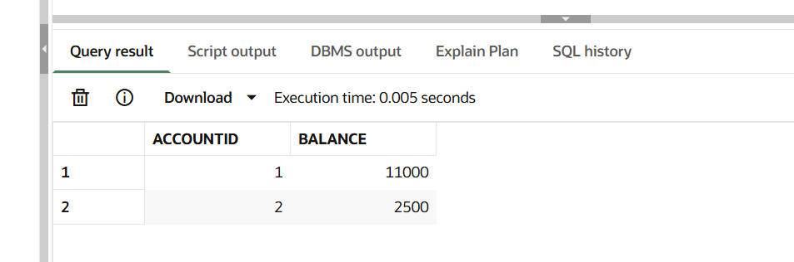
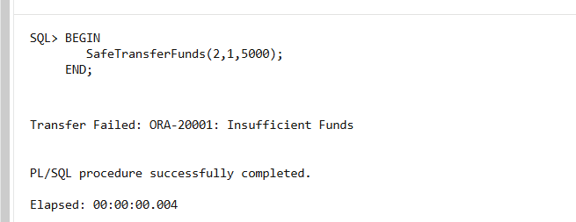

Scenario 2:
Output:
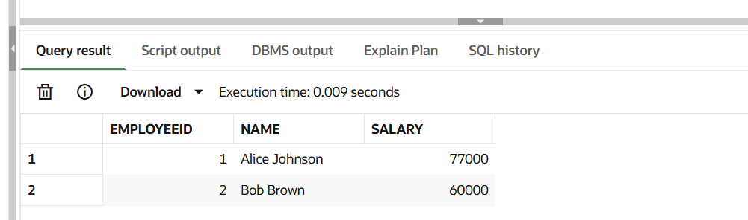

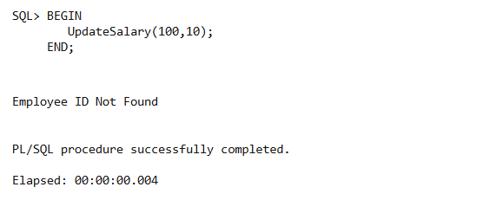
Scenario 3:
Output:
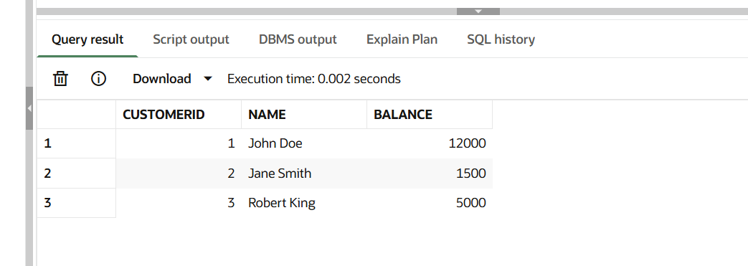
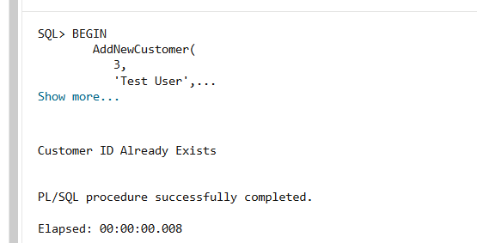

Exercise 3: Stored Procedures

CREATE OR REPLACE PROCEDURE ProcessMonthlyInterest
IS
BEGIN

UPDATE Accounts
SET Balance = Balance + (Balance * 0.01)
WHERE AccountType = 'Savings';

COMMIT;

DBMS_OUTPUT.PUT_LINE(
'Monthly Interest Applied Successfully'
);

END;
/

BEGIN
ProcessMonthlyInterest;
END;
/

SELECT AccountID,
AccountType,
Balance
FROM Accounts;

CREATE OR REPLACE PROCEDURE UpdateEmployeeBonus(
p_department VARCHAR2,
p_bonus_percent NUMBER
)
IS
BEGIN

UPDATE Employees
SET Salary = Salary +
(Salary * p_bonus_percent / 100)
WHERE Department = p_department;

COMMIT;

DBMS_OUTPUT.PUT_LINE(
'Bonus Updated Successfully'
);

END;
/

BEGIN
UpdateEmployeeBonus('IT',10);
END;
/

SELECT EmployeeID,
Name,
Salary,
Department
FROM Employees;

CREATE OR REPLACE PROCEDURE TransferFunds(
p_from_account NUMBER,
p_to_account NUMBER,
p_amount NUMBER
)
IS
v_balance NUMBER;
BEGIN

SELECT Balance
INTO v_balance
FROM Accounts
WHERE AccountID = p_from_account;

IF v_balance >= p_amount THEN

UPDATE Accounts
SET Balance = Balance - p_amount
WHERE AccountID = p_from_account;

UPDATE Accounts
SET Balance = Balance + p_amount
WHERE AccountID = p_to_account;

COMMIT;

DBMS_OUTPUT.PUT_LINE(
'Transfer Successful'
);

ELSE

DBMS_OUTPUT.PUT_LINE(
'Insufficient Balance'
);

END IF;

END;
/

BEGIN
TransferFunds(1,2,1000);
END;
/

SELECT AccountID,
Balance
FROM Accounts;

Scenario 1:
Output:
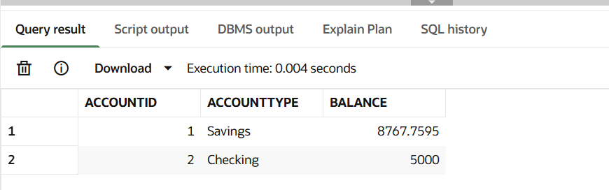
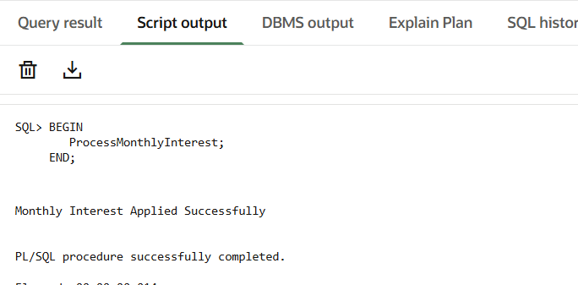

Scenario 2:
Output:
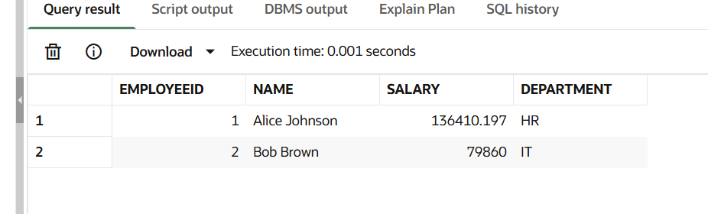
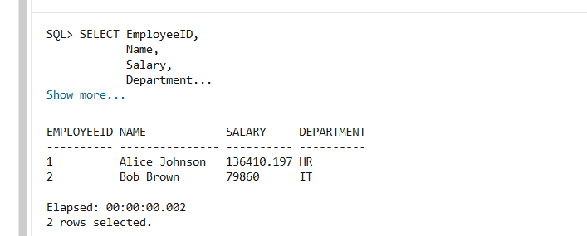

Scenario 3:
Output:
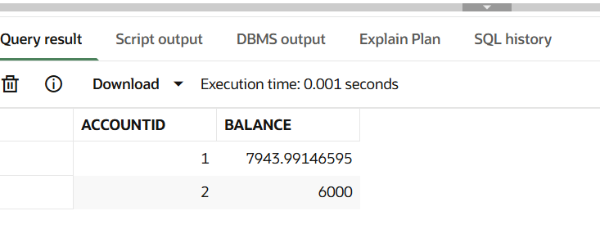

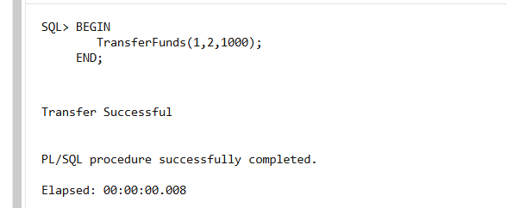

Exercise 4: Functions

CREATE OR REPLACE FUNCTION CalculateAge(
p_dob DATE
)
RETURN NUMBER
IS
v_age NUMBER;
BEGIN

v_age := FLOOR(
MONTHS_BETWEEN(SYSDATE, p_dob)/12
);

RETURN v_age;

END;
/

CREATE OR REPLACE FUNCTION CalculateMonthlyInstallment(
p_loan_amount NUMBER,
p_interest_rate NUMBER,
p_years NUMBER
)
RETURN NUMBER
IS
v_monthly_installment NUMBER;
BEGIN

v_monthly_installment :=
(p_loan_amount +
(p_loan_amount * p_interest_rate * p_years / 100))
/(p_years * 12);

RETURN ROUND(v_monthly_installment,2);

END;
/

CREATE OR REPLACE FUNCTION HasSufficientBalance(
p_account_id NUMBER,
p_amount NUMBER
)
RETURN VARCHAR2
IS
v_balance NUMBER;
BEGIN

SELECT Balance
INTO v_balance
FROM Accounts
WHERE AccountID = p_account_id;

IF v_balance >= p_amount THEN
RETURN 'TRUE';
ELSE
RETURN 'FALSE';
END IF;

EXCEPTION
WHEN NO_DATA_FOUND THEN
RETURN 'ACCOUNT NOT FOUND';

END;
/

SELECT Name,
CalculateAge(DOB) AS AGE
FROM Customers;

SELECT CalculateMonthlyInstallment(
5000,
5,
5
) AS MONTHLY_INSTALLMENT
FROM DUAL;

SELECT HasSufficientBalance(
1,
1000
) AS SUFFICIENT_BALANCE
FROM DUAL;

Scenario 1:
Output:
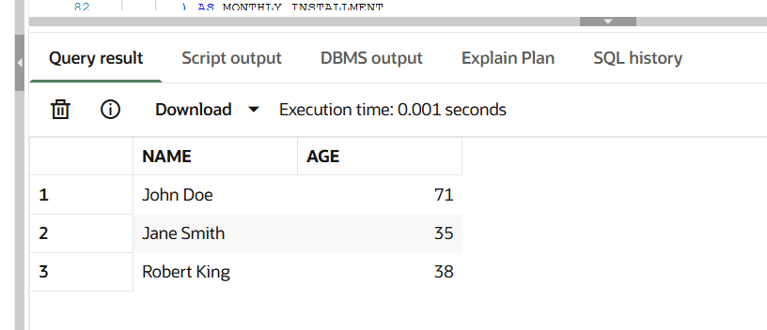

Scenario 2:
Output:
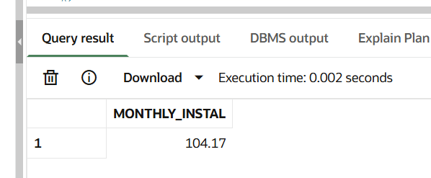
Scenario 3:
Output:
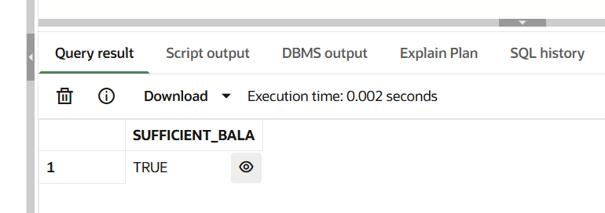

Exercise 5: Triggers

CREATE TABLE AuditLog (
LogID NUMBER GENERATED BY DEFAULT AS IDENTITY,
TransactionID NUMBER,
LogDate DATE,
Action VARCHAR2(50)
);

CREATE OR REPLACE TRIGGER UpdateCustomerLastModified
BEFORE UPDATE ON Customers
FOR EACH ROW
BEGIN
:NEW.LastModified := SYSDATE;
END;
/

CREATE OR REPLACE TRIGGER LogTransaction
AFTER INSERT ON Transactions
FOR EACH ROW
BEGIN

INSERT INTO AuditLog(
TransactionID,
LogDate,
Action
)
VALUES(
:NEW.TransactionID,
SYSDATE,
'Transaction Inserted'
);

END;
/

CREATE OR REPLACE TRIGGER CheckTransactionRules
BEFORE INSERT ON Transactions
FOR EACH ROW

DECLARE
v_balance NUMBER;
BEGIN

SELECT Balance
INTO v_balance
FROM Accounts
WHERE AccountID = :NEW.AccountID;

IF :NEW.TransactionType = 'Withdrawal' THEN

IF :NEW.Amount > v_balance THEN
RAISE_APPLICATION_ERROR(
-20001,
'Withdrawal exceeds balance');
END IF;

ELSIF :NEW.TransactionType = 'Deposit' THEN

IF :NEW.Amount <= 0 THEN
RAISE_APPLICATION_ERROR(
-20002,
'Deposit amount must be positive');
END IF;

END IF;

END;
/
UPDATE Customers
SET Balance = 13000
WHERE CustomerID = 1;

COMMIT;
SELECT CustomerID,
Name,
LastModified
FROM Customers;
INSERT INTO Transactions
VALUES(
3,
1,
SYSDATE,
500,
'Deposit'
);

COMMIT;

SELECT *
FROM AuditLog;
INSERT INTO Transactions
VALUES(
4,
1,
SYSDATE,
1000,
'Deposit'
);
INSERT INTO Transactions
VALUES(
5,
1,
SYSDATE,
-100,
'Deposit'
);
INSERT INTO Transactions
VALUES(
6,
1,
SYSDATE,
50000,
'Withdrawal'
);

Scenario 1:
Output:
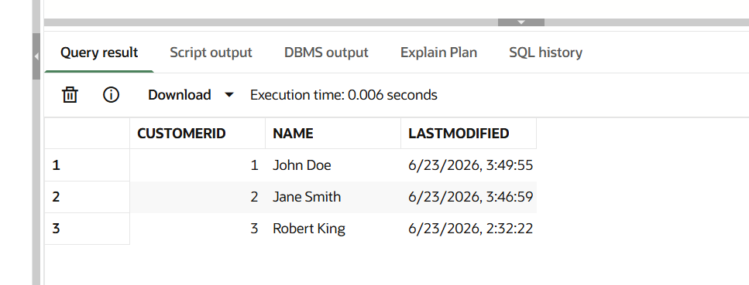
Scenario 2:
Output:
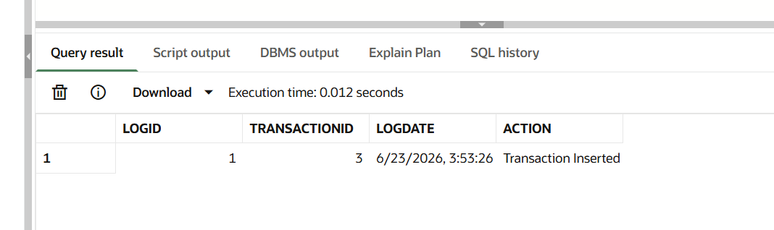

Scenario 3:
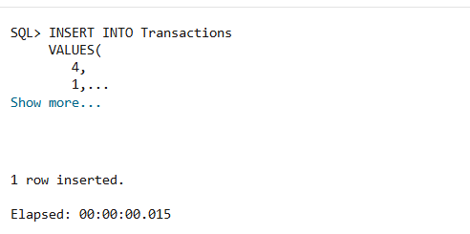

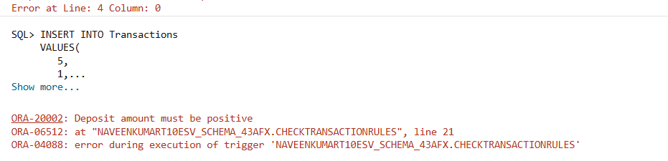

Exercise 6: Cursors

DECLARE

CURSOR GenerateMonthlyStatements IS
SELECT c.Name,
t.TransactionID,
t.Amount,
t.TransactionType,
t.TransactionDate
FROM Customers c
JOIN Accounts a
ON c.CustomerID = a.CustomerID
JOIN Transactions t
ON a.AccountID = t.AccountID
WHERE EXTRACT(MONTH FROM t.TransactionDate)
= EXTRACT(MONTH FROM SYSDATE)
AND EXTRACT(YEAR FROM t.TransactionDate)
= EXTRACT(YEAR FROM SYSDATE);

v_rec GenerateMonthlyStatements%ROWTYPE;

BEGIN

OPEN GenerateMonthlyStatements;

LOOP
FETCH GenerateMonthlyStatements
INTO v_rec;

EXIT WHEN GenerateMonthlyStatements%NOTFOUND;

DBMS_OUTPUT.PUT_LINE(
'Customer: ' || v_rec.Name ||
', Transaction ID: ' || v_rec.TransactionID ||
', Amount: ' || v_rec.Amount ||
', Type: ' || v_rec.TransactionType
);

END LOOP;

CLOSE GenerateMonthlyStatements;

END;
/

DECLARE

CURSOR ApplyAnnualFee IS
SELECT AccountID
FROM Accounts;

v_accountid Accounts.AccountID%TYPE;

BEGIN

OPEN ApplyAnnualFee;

LOOP

FETCH ApplyAnnualFee
INTO v_accountid;

EXIT WHEN ApplyAnnualFee%NOTFOUND;

UPDATE Accounts
SET Balance = Balance - 100
WHERE AccountID = v_accountid;

END LOOP;

CLOSE ApplyAnnualFee;

COMMIT;

DBMS_OUTPUT.PUT_LINE(
'Annual Fee Applied Successfully'
);

END;
/

SELECT AccountID,
Balance
FROM Accounts;

DECLARE

CURSOR UpdateLoanInterestRates IS
SELECT LoanID,
InterestRate
FROM Loans;

v_loanid Loans.LoanID%TYPE;
v_rate Loans.InterestRate%TYPE;

BEGIN

OPEN UpdateLoanInterestRates;

LOOP

FETCH UpdateLoanInterestRates
INTO v_loanid,
v_rate;

EXIT WHEN UpdateLoanInterestRates%NOTFOUND;

UPDATE Loans
SET InterestRate = InterestRate + 0.5
WHERE LoanID = v_loanid;

END LOOP;

CLOSE UpdateLoanInterestRates;

COMMIT;

DBMS_OUTPUT.PUT_LINE(
'Loan Interest Rates Updated'
);

END;
/

SELECT LoanID,
InterestRate
FROM Loans;

Scenario 1:
Output:
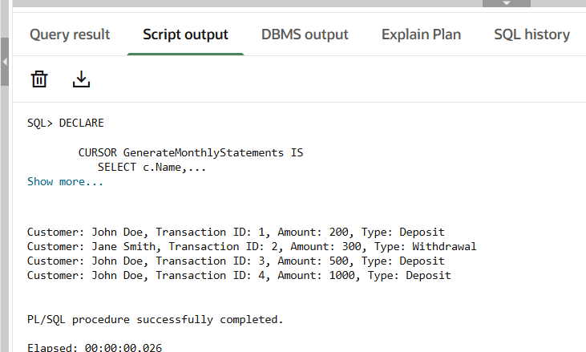

Scenario 2:
Output:
Before:
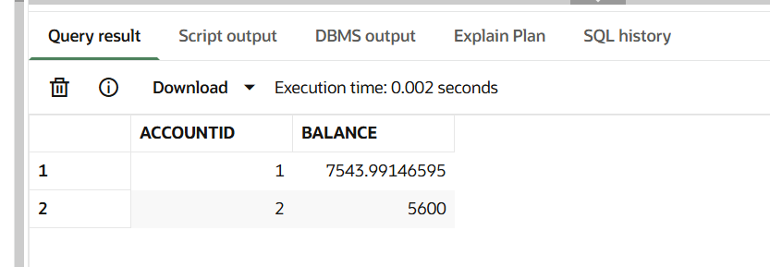

After:
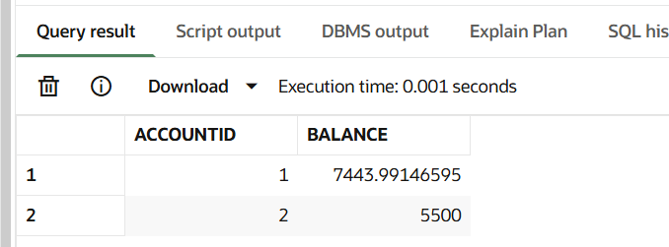

Scenario 3:
Output:
Before:
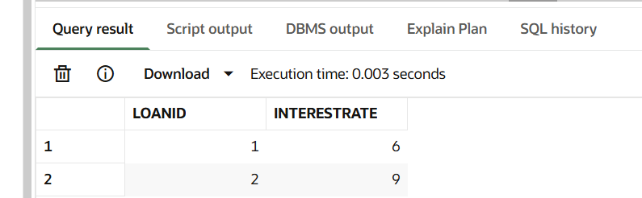

After:
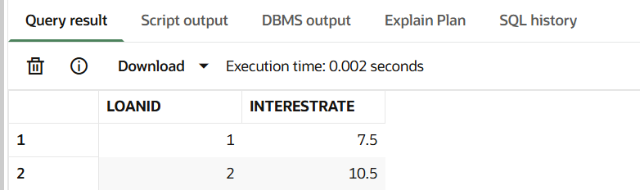

Exercise 7: Packages

CREATE OR REPLACE PACKAGE CustomerManagement AS

PROCEDURE AddCustomer(
p_id NUMBER,
p_name VARCHAR2,
p_dob DATE,
p_balance NUMBER
);

PROCEDURE UpdateCustomer(
p_id NUMBER,
p_balance NUMBER
);

FUNCTION GetCustomerBalance(
p_id NUMBER
) RETURN NUMBER;

END CustomerManagement;
/

CREATE OR REPLACE PACKAGE BODY CustomerManagement AS

PROCEDURE AddCustomer(
p_id NUMBER,
p_name VARCHAR2,
p_dob DATE,
p_balance NUMBER
)
IS
BEGIN
INSERT INTO Customers
VALUES(
p_id,
p_name,
p_dob,
p_balance,
SYSDATE,
NULL
);
COMMIT;
END;

PROCEDURE UpdateCustomer(
p_id NUMBER,
p_balance NUMBER
)
IS
BEGIN
UPDATE Customers
SET Balance = p_balance
WHERE CustomerID = p_id;

COMMIT;
END;

FUNCTION GetCustomerBalance(
p_id NUMBER
) RETURN NUMBER
IS
v_balance NUMBER;
BEGIN

SELECT Balance
INTO v_balance
FROM Customers
WHERE CustomerID = p_id;

RETURN v_balance;

END;

END CustomerManagement;
/
BEGIN
CustomerManagement.AddCustomer(
5,
'Rahul',
TO_DATE('1995-05-10','YYYY-MM-DD'),
8000
);
END;
/

SELECT CustomerManagement.GetCustomerBalance(5)
AS BALANCE
FROM DUAL;

CREATE OR REPLACE PACKAGE EmployeeManagement AS

PROCEDURE HireEmployee(
p_id NUMBER,
p_name VARCHAR2,
p_position VARCHAR2,
p_salary NUMBER,
p_dept VARCHAR2
);

PROCEDURE UpdateEmployee(
p_id NUMBER,
p_salary NUMBER
);

FUNCTION CalculateAnnualSalary(
p_id NUMBER
) RETURN NUMBER;

END EmployeeManagement;
/

CREATE OR REPLACE PACKAGE BODY EmployeeManagement AS

PROCEDURE HireEmployee(
p_id NUMBER,
p_name VARCHAR2,
p_position VARCHAR2,
p_salary NUMBER,
p_dept VARCHAR2
)
IS
BEGIN

INSERT INTO Employees
VALUES(
p_id,
p_name,
p_position,
p_salary,
p_dept,
SYSDATE
);

COMMIT;

END;

PROCEDURE UpdateEmployee(
p_id NUMBER,
p_salary NUMBER
)
IS
BEGIN

UPDATE Employees
SET Salary = p_salary
WHERE EmployeeID = p_id;

COMMIT;

END;

FUNCTION CalculateAnnualSalary(
p_id NUMBER
) RETURN NUMBER
IS
v_salary NUMBER;
BEGIN

SELECT Salary
INTO v_salary
FROM Employees
WHERE EmployeeID = p_id;

RETURN v_salary * 12;

END;

END EmployeeManagement;
/
SELECT EmployeeManagement.CalculateAnnualSalary(1)
AS ANNUAL_SALARY
FROM DUAL;

CREATE OR REPLACE PACKAGE AccountOperations AS

PROCEDURE OpenAccount(
p_accountid NUMBER,
p_customerid NUMBER,
p_type VARCHAR2,
p_balance NUMBER
);

PROCEDURE CloseAccount(
p_accountid NUMBER
);

FUNCTION GetTotalBalance(
p_customerid NUMBER
) RETURN NUMBER;

END AccountOperations;
/

--------------------------------------------------
-- PACKAGE BODY
--------------------------------------------------

CREATE OR REPLACE PACKAGE BODY AccountOperations AS

PROCEDURE OpenAccount(
p_accountid NUMBER,
p_customerid NUMBER,
p_type VARCHAR2,
p_balance NUMBER
)
IS
BEGIN

INSERT INTO Accounts
VALUES(
p_accountid,
p_customerid,
p_type,
p_balance,
SYSDATE
);

COMMIT;

END;

PROCEDURE CloseAccount(
p_accountid NUMBER
)
IS
BEGIN

DELETE FROM Accounts
WHERE AccountID = p_accountid;

COMMIT;

END;

FUNCTION GetTotalBalance(
p_customerid NUMBER
) RETURN NUMBER
IS
v_total NUMBER;
BEGIN

SELECT SUM(Balance)
INTO v_total
FROM Accounts
WHERE CustomerID = p_customerid;

RETURN NVL(v_total,0);

END;

END AccountOperations;
/
SELECT AccountOperations.GetTotalBalance(1)
AS TOTAL_BALANCE
FROM DUAL;

Scenario 1:
Output:
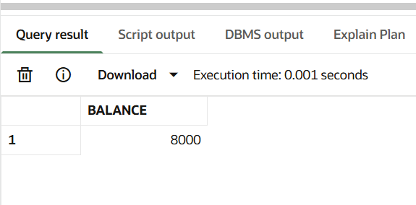

Scenario 2:
Output:
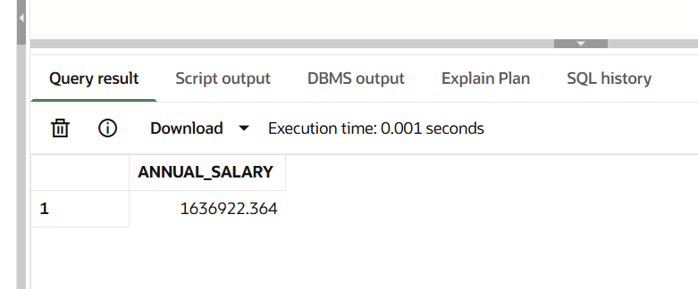

Scenario 3:
Output:
