ninja-recorder v2 — Implementation and Design Document
Project | ninja-recorder (github.com/NinjaGoldfinch/ninja-recorder)
Document | v2 implementation plan: what to build, in what order, and how each piece is shaped
Companion | ninja-recorder v2 — Architecture and Tech Stack Design Document (13 Sep 2026), which decides what changes; this document decides how
Baseline | main at 32dcd41, app version 0.8.0 (declared 1.1.0), 24,822 lines of Rust / 447 tests, 12,797 lines of TypeScript / 0 tests
Date | 13 September 2026
Status | Draft for review — rev 2 (Option B is the target; licence exit is a goal)

Contents
1. Summary
2. Starting point — what v1 already provides
2.1 Carried forward unchanged
2.2 Repository findings that shape the plan
3. Target architecture
3.1 Component view
3.2 Process lifecycle
3.3 The recording lifecycle inside the daemon
3.4 Repository layout after v2
4. Detailed designs
4.1 Contract and code generation
4.2 Transport: JSON-RPC over a named pipe
4.3 The daemon process
4.4 Persistence
4.5 Capture backend — the P0 arms
4.6 Frontend
4.7 Toolchain and quality gates
5. Workstreams and task breakdown
WS0 — Baseline and measurement
WS1 — Capture backend
WS2 — Generated contract
WS3 — Daemon / UI split
WS4 — Svelte 5 strangler
WS5 — Toolchain and gates
WS6 — SQLite
WS7 — Measure and ship
WS8 — Remove libobs and relicense (v2.1.0)
6. Testing and verification
7. Risks specific to implementation
8. Definition of done for v2.0.0
9. Open questions and inputs needed
Appendix A — command inventory (v1 `dispatch_table!`, 29 rows)
Appendix B — draft event enum
Appendix C — libobs trim candidates, in verification order
Appendix D — file map: v1 module → v2 destination

1. Summary
The design document settles the stack: keep Tauri, Rust, SQLite, files-as-truth, H.264/AAC in fragmented MP4, and the Recorder trait; change the frontend, the IPC contract, the process model, the quality gates and the capture backend. This document turns those decisions into work.
One decision the design document left open is closed here. The maintainer intends to leave GPL-2.0 so that a closed-source or source-available distribution remains possible later. Every libobs configuration keeps the shipped binary GPL, so the own-backend path (Option B: WGC → D3D11 → Media Foundation) is the target, not a candidate. Trimmed libobs (A-trim) is retained only as the fallback if the P0c spike fails its go/no-go gates, and as a selectable second backend for exactly one release while Option B proves itself on real hardware. The licence changes at v2.1, when libobs is deleted — not before.
v2 is eight workstreams, three of which can start on day one with no dependency on anything else:
WS | What | Gated by | Rough effort
WS0 | Baseline measurement (install size, idle RAM by Private Bytes) | — | 1 week, part-time
WS1 | Capture backend: P0c go/no-go spike, then build Option B; A-trim as fallback and one-release safety net | — (spike); gate (build) | 3 weeks spike + 4 weeks build
WS2 | Generated contract: commands and events declared once in Rust, TypeScript client generated | — | 2–3 weeks
WS3 | Daemon / UI split over a named-pipe JSON-RPC transport | WS2, WS6 | 3 weeks
WS4 | Svelte 5 strangler migration, player last as an imperative island | WS2 | 5–6 weeks
WS5 | Toolchain pin, edition 2024, Biome, Vitest, svelte-check, cargo-deny in CI | — | 2 weeks
WS6 | SQLite WAL, busy_timeout, writer + reader pool, query_only UI connection | — | 1 week
WS7 | Measure against C3 and ship v2.0.0 (Option B default, libobs selectable, still GPL-2.0) | everything | 1 week
WS8 | Remove libobs, audit derived code and contributors, relicense, ship v2.1.0 | one release of WS7 in the field | 1–2 weeks

Total is on the order of five months of part-time work to v2.0.0, plus a short v2.1.0 that removes libobs and relicenses. The P0c gate (~week 4) is the only hard fork: if the process-loopback stage fails, per-application game audio is not achievable without libobs, and the licence goal has to be weighed against that product loss before continuing. Everything downstream is sequenced so that the answer changes which backend is linked into the daemon and nothing else.
Three things in the repository make this cheaper than a plan written from the design document alone would suggest, and they are worth stating up front:
- `launch.rs` already parses `--daemon` and refuses it with "not built yet". The launch mode, the --hidden flag, the autostart wiring and the tray all exist; WS3 fills in the process rather than inventing it.
- libobs already runs out of process. The fork's extprocess_recorder.exe is a separate worker driven over IPC from LibObsRecorder. "Confine libobs to the daemon" (A-split) is therefore about which process owns that worker, not about pushing FFI across a process boundary for the first time.
- `core::dispatch` is roughly 80% of the command half of the contract, exactly as the design document says. The macro table, the normalize/parse helpers and the every_command_round_trips test are all reusable; what is missing is the TypeScript generator and the event half.

2. Starting point — what v1 already provides
Measured from the clone at 32dcd41. Figures the design document quotes are confirmed; two are refined below.
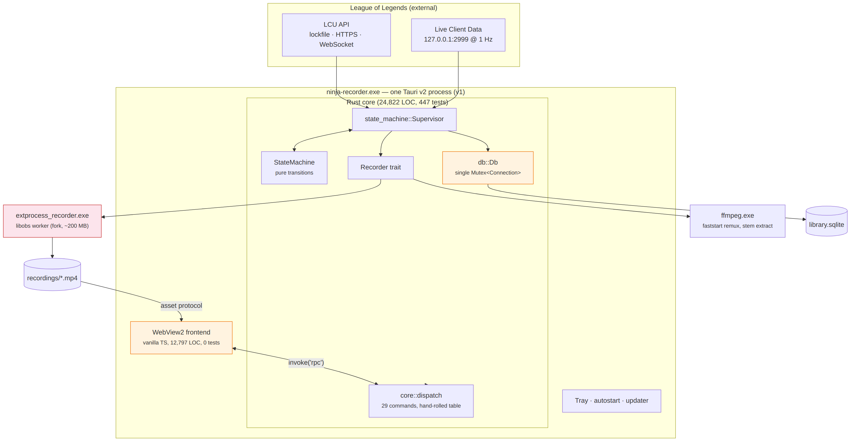
Figure 1 — v1 as it is. Orange is what v2 changes; red is what P0 decides.

2.1 Carried forward unchanged
Asset | Where | Why it matters to the plan
Pure state machine + async supervisor | state_machine/machine.rs (408 LOC), supervisor.rs (1,944 LOC) | Moves into the daemon as-is. Its Action list is already the seam the event enum hangs off
Recorder trait with prepare/release | recorder/mod.rs, libobs/, stub.rs | Every P0 arm plugs in behind it. The stub keeps the whole app testable off Windows
core module with no tauri types | core/mod.rs (801 LOC), core/dispatch.rs (594 LOC) | The daemon's command surface exists today; only the transport is missing
LCU + Live Client clients, fixtures, dev portal | lcu/, live_client/, fixtures/, dev/ | Unchanged. The dev portal moves to talking to the daemon over the same pipe
SQLite schema with 11 migrations | db/mod.rs (2,446 LOC) | Appended to, never edited. WS6 changes connection handling, not the schema
Retention, reconcile, backfill, match summary, trim | retention.rs, db/reconcile.rs, backfill.rs, match_summary.rs, trim.rs | Daemon-side. None of it touches the UI directly
CI version scheme, alpha channel, signed updater | .github/workflows/ci.yml, scripts/release.mjs | Unchanged. WS5 adds steps to test; WS3 changes what the updater runs in
Decision log | DEVELOPMENT.md (137 KB), docs/*.md | Section numbers are cited from ~35 source comments — append, never renumber
ffmpeg (LGPL static build, -c copy only, separate process) | CI staging step, lib.rs::ffmpeg_command | The only copyleft component that survives WS8, and it is compatible with a proprietary distribution as long as it stays a separate process doing stream copies

2.2 Repository findings that shape the plan
Finding | Consequence
#[tauri::command] appears 53 times: 29 production commands go through rpc, the other ~24 are dev_* commands still registered directly | The generator has to cover both. Dev commands stay feature-gated but should join the same declaration so the portal's drift banner can be deleted too
PRAGMA appears in db/mod.rs only for user_version; foreign_keys is set at open | WS6 is additive: three pragmas plus a connection split
docs/windows-verification.md records idle RAM at 9 MB working set (app idle, no League) and install at 248 MB | The design document says idle RAM was never measured; it was, but as working set with the window closed. WS0 re-measures as Private Bytes, daemon-only, and records both
tauri.devtools.conf.json overrides productName but not identifier, so a dev build and a release share app_data_dir(), the DB and the recordings folder | The pipe name and the single-instance mutex must be scoped by build identity, or a dev daemon and a release daemon will fight over one pipe
Every ffmpeg spawn goes through lib.rs::ffmpeg_command (sets CREATE_NO_WINDOW); ffmpeg is the lgpl build | Moves to the daemon crate unchanged. The lgpl build stays valid under every capture outcome because every call is -c copy
The main window is created in setup, not tauri.conf.json (app.windows: []), so --hidden creates none | The UI process in v2 always creates its window; --hidden becomes an alias for "start the daemon only" and can be retired after one release
frontend.md documents escapeHtml/escapeAttr as load-bearing because reconcile imports untrusted filenames | A framework's default text interpolation replaces both. The Svelte migration must not use {@html} on any recording-derived string
Clippy runs without --all-targets deliberately | Keep that. A generated event_names() used only by tests needs the same cfg_attr(allow(dead_code)) pattern command_names() already uses

3. Target architecture

3.1 Component view
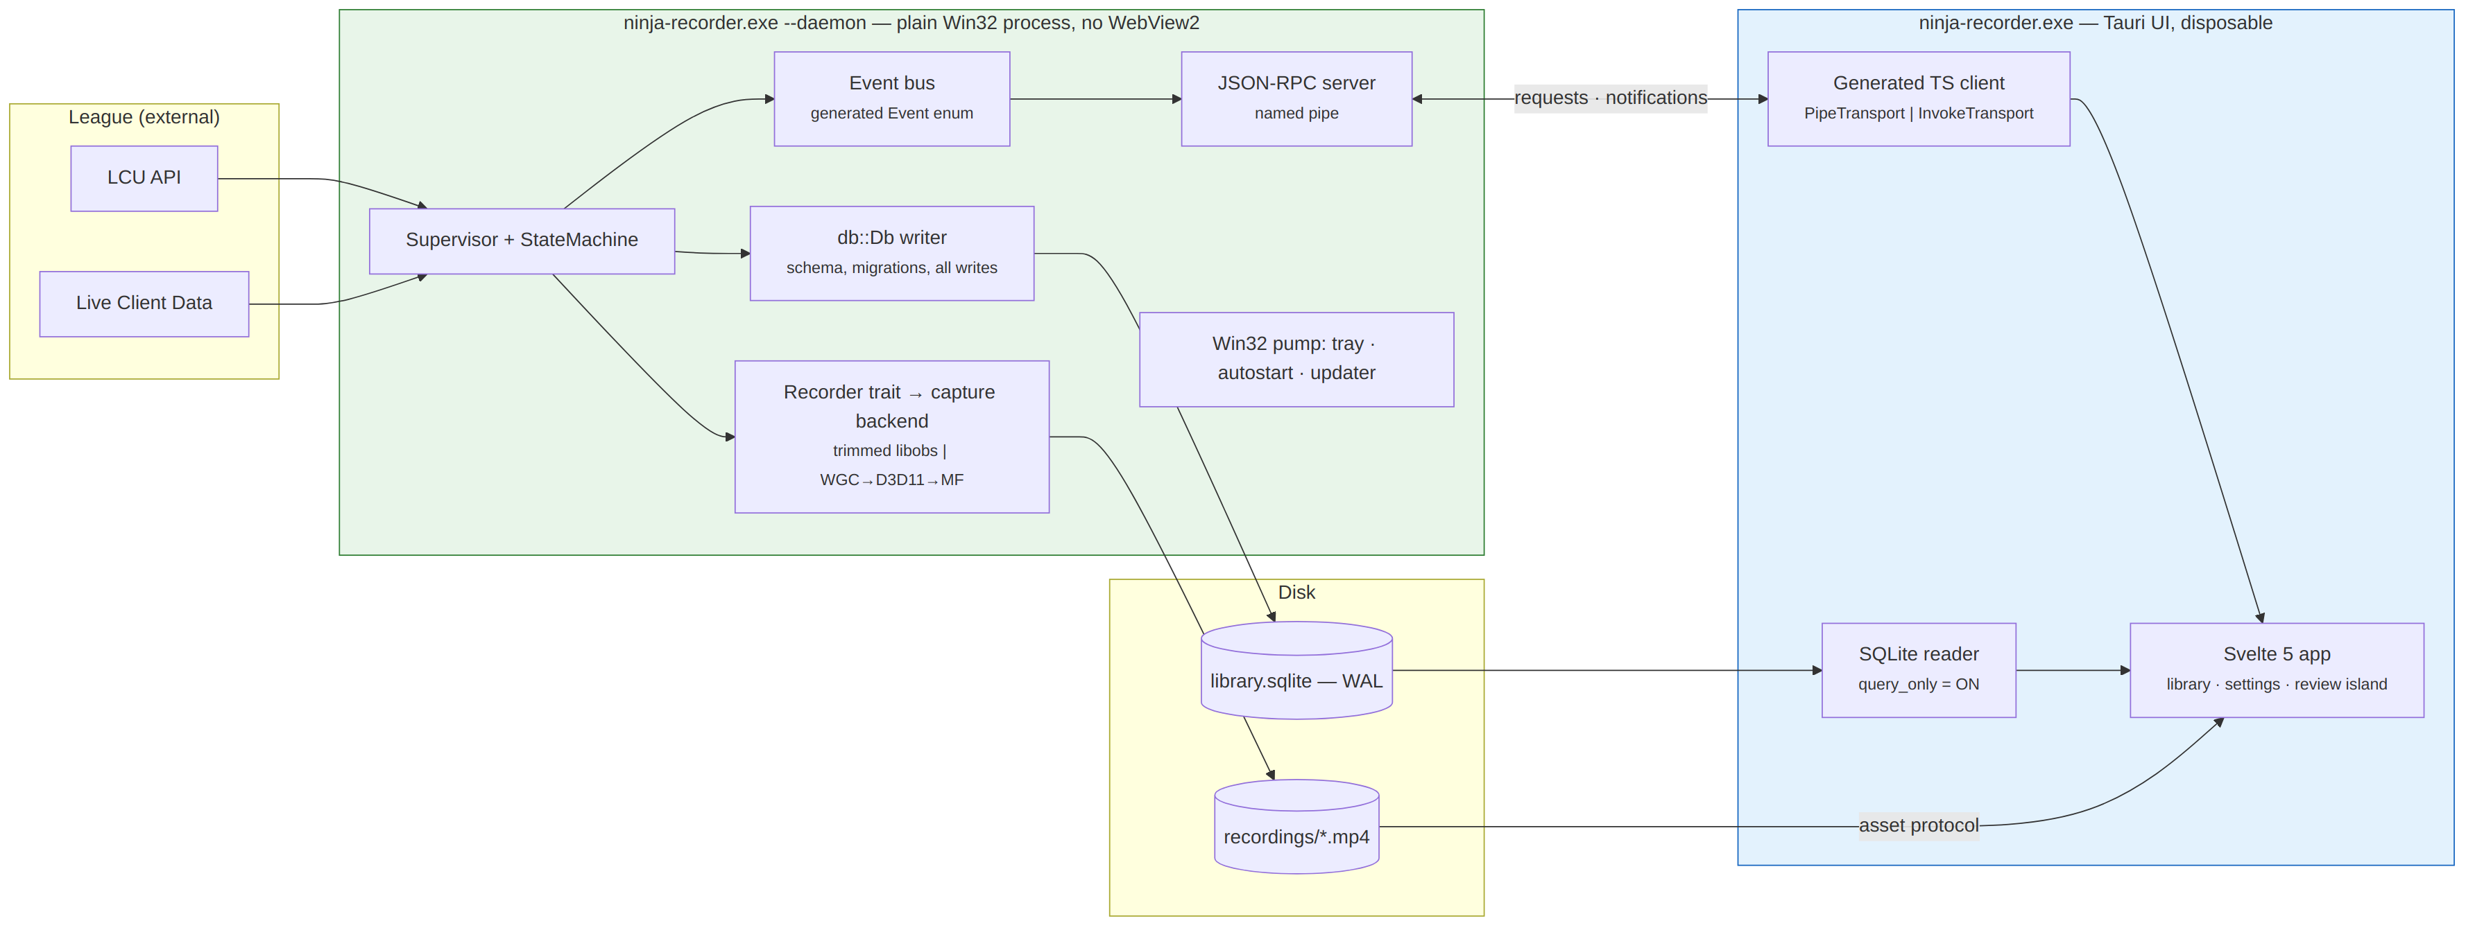
Figure 2 — recommended v2 architecture. One binary, two modes. The daemon owns everything that must survive the UI; the UI owns presentation and the two shell integrations that need the foreground session.
Ownership, stated once:
Concern | Daemon | UI
Supervisor, state machine, LCU/Live Client watchers | owns | receives state.changed events
Recorder and the capture backend (libobs worker or own backend) | owns | never links it
SQLite schema, migrations, every write | owns | own connection, query_only = ON, reads library/markers/samples directly
Tray icon, autostart Run key, update check + install | owns (needs Win32 pump) | shows update status from events; "Install" is an RPC
Log file (log.rs) | owns daemon.log | owns ui.log; both under app_data_dir()/logs/
Desktop notifications | owns (recording started/ended) | —
open_recordings_folder, window management | — | owns
Dev portal (devtools feature) | serves dev_* over the pipe | hosts dev.html

3.2 Process lifecycle
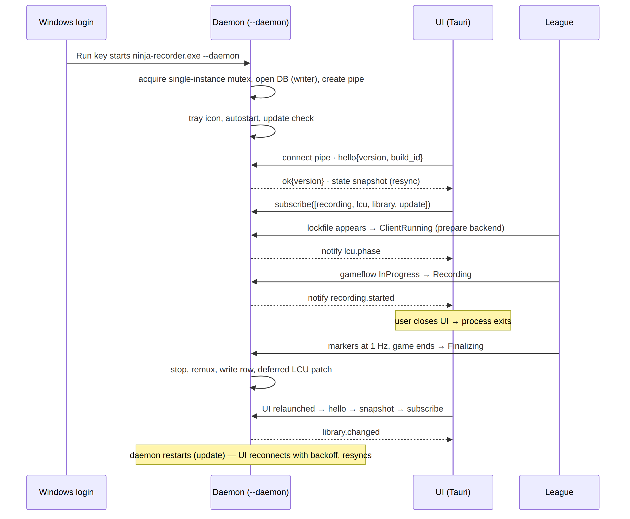
Figure 3 — a normal session. The UI attaching mid-recording is the common case, which is why the snapshot on connect is mandatory rather than an optimisation.
Startup rules
- The Run key points at --daemon. tauri-plugin-autostart already writes the path plus a flag; the flag changes from --hidden to --daemon.
- Launching the UI with no daemon present starts one (CreateProcess on its own path with --daemon, detached) and then connects with backoff. This is the recovery path, not the primary one.
- A second --daemon launch finds the named mutex held and exits 0 silently. It never signals the running daemon to quit — it might be recording.
- The UI refuses to attach to a daemon whose hello reports a different app version or build identity, shows "restart required", and offers nothing else. The design document's version-skew argument for one binary only holds if this check exists.

3.3 The recording lifecycle inside the daemon
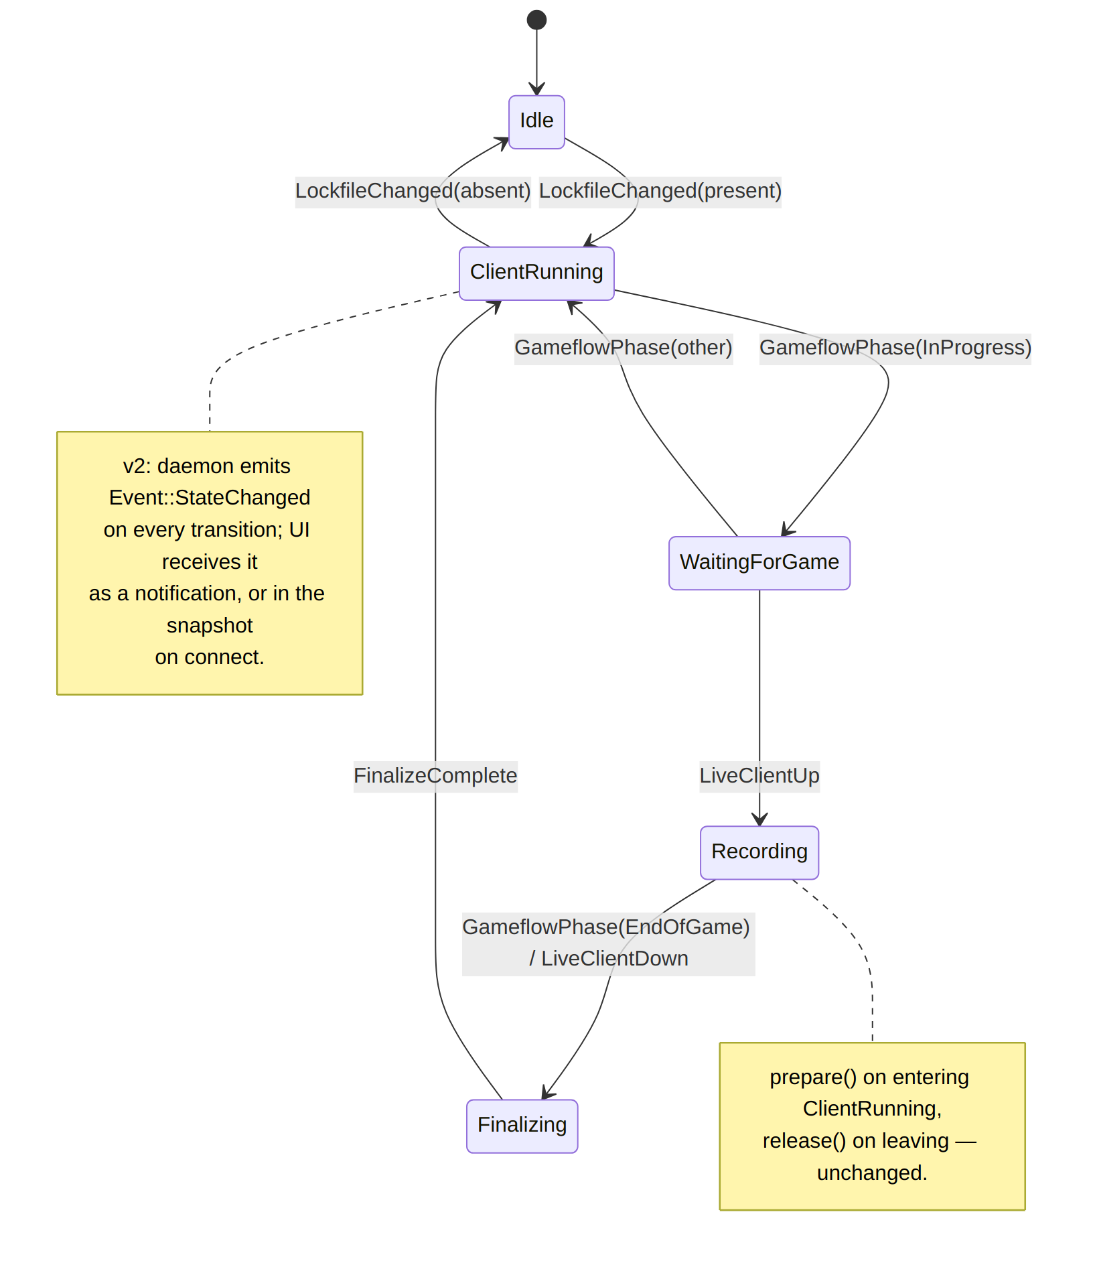
Figure 4 — the v1 state machine, unchanged. What v2 adds is that every transition is also an event on the wire.
The machine, the supervisor and the marker pipeline do not change. The one addition is a hook: Supervisor gains an EventSink (a trait object, same pattern as set_library_changed_notifier) and calls it on every state transition, marker, LCU phase change and library mutation. In cargo test the sink is a Vec; in the daemon it is the RPC server's broadcast channel.

3.4 Repository layout after v2
ninja-recorder/
├── src-tauri/ # the Rust project (workspace root for cargo)
│ ├── rust-toolchain.toml # NEW — pinned exact version, rustfmt + clippy
│ ├── deny.toml # NEW — cargo-deny licences + advisories
│ ├── Cargo.toml # edition = "2024"
│ └── src/
│ ├── main.rs # dispatches on Launch: Daemon | Ui
│ ├── launch.rs # --daemon now real
│ ├── daemon/ # NEW
│ │ ├── mod.rs # run(): mutex, DB, pipe, pump, tokio
│ │ ├── pump.rs # Win32 message loop + tray (from tray.rs)
│ │ ├── rpc.rs # pipe listener, framing, session, subscriptions
│ │ ├── snapshot.rs # full-state snapshot for hello/resync
│ │ └── spawn.rs # UI-side helper: start daemon if absent
│ ├── contract/ # NEW — the single declaration
│ │ ├── mod.rs # re-exports; #[contract::command] fns live in core
│ │ ├── events.rs # #[derive(ContractEvent)] enum Event
│ │ └── gen.rs # TS emitter (cargo run --bin gen-contract)
│ ├── core/ # unchanged logic; dispatch.rs generated from contract
│ ├── state_machine/ # + EventSink hook
│ ├── recorder/ # + own/ (Option B, default); libobs/ trimmed, deleted in WS8
│ ├── db/ # + pool.rs (writer + readers), pragmas
│ ├── ui/ # NEW — Tauri setup, window, invoke transport, open_recordings_folder
│ └── ... # lcu, live_client, retention, log, dev — unchanged
├── src/ # frontend
│ ├── main.ts # vanilla shell, shrinking during WS4
│ ├── lib/ # NEW — Svelte 5
│ │ ├── App.svelte, Library.svelte, Settings.svelte, Review.svelte, Timeline.svelte
│ │ ├── stores/ # $state driven by snapshot + events
│ │ ├── contract/ # GENERATED — types.ts, client.ts, events.ts (committed, CI-checked)
│ │ ├── transport/ # pipe.ts, invoke.ts, mock.ts (Vitest)
│ │ └── styles/tokens.css # design tokens replacing the 2,013-line global sheet
│ └── dev/ # portal, now against the generated client
├── biome.json, vitest.config.ts # NEW
└── .github/workflows/ci.yml # + biome ci, vitest run, svelte-check, cargo deny, gen-contract --check

4. Detailed designs

4.1 Contract and code generation
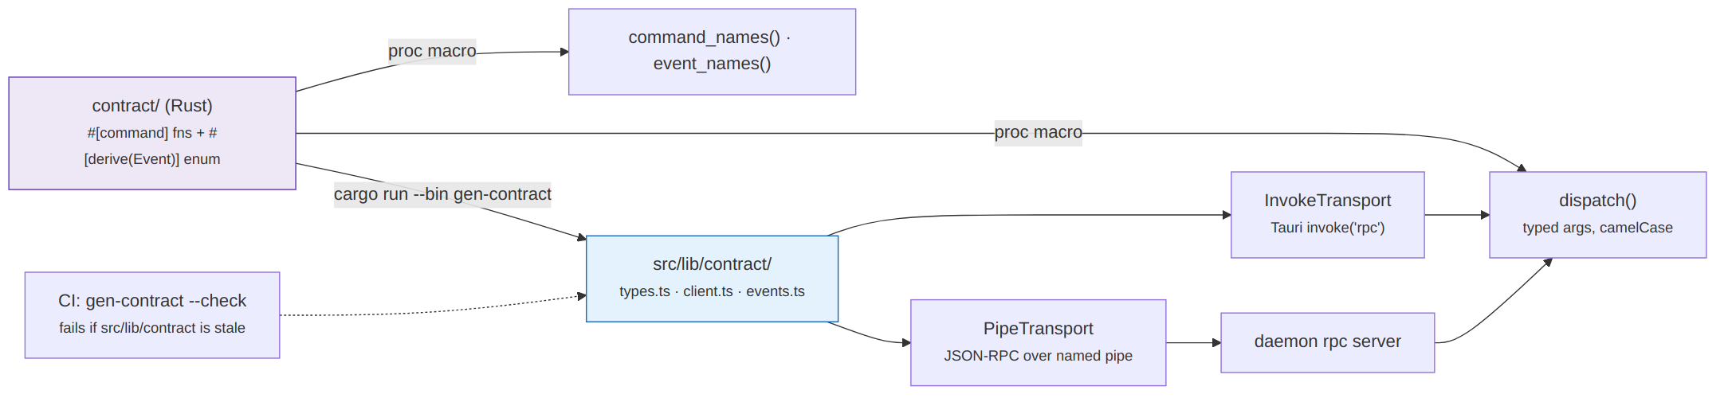
Figure 5 — one declaration, both sides generated, and a CI check that the committed TypeScript matches.
Approach: finish the existing macro rather than adopt tauri-specta. The design document lists tauri-specta as "near term" and JSON-RPC as target state. Adopting specta would generate a client that is Tauri-shaped and then need replacing when the pipe lands. The dispatch_table! macro is already the declaration; extending it to emit metadata is less work than migrating to a framework and then off it.
What the declaration carries. Each row of the table gains what the generator needs and the runtime already has: the argument names and types (present), the return type (currently inferred, must become explicit), and an optional doc string for the TypeScript. The ctx_result/bare_async shape tokens stay.
// src-tauri/src/core/dispatch.rs — the same table, now the only declaration
dispatch_table! {
/// Start a recording now, regardless of game state.
ctx_result start_recording() -> RecordingStarted;
ctx_result get_recording_markers(recording_id: i64) -> Vec<Marker>;
ctx_result set_retention_policy(policy: RetentionPolicy) -> ();
ctx_async backfill_match_metadata() -> BackfillReport;
// ...29 rows, plus the dev_* rows under #[cfg(feature = "devtools")]
}

The macro emits, in addition to today's dispatch/dispatch_blocking/command_names/is_async_command, a pub fn contract_manifest() -> Manifest describing every command's name, argument list and Rust type names. Type shapes come from ts-rs derives on the serde structs (#[derive(TS)] on Marker, RetentionPolicy, AudioPreset, and so on — roughly 40 types across db, recorder::audio, live_client::shapes, ddragon, update). ts-rs is chosen over writing a type walker because it already handles Option, enums with serde tagging, and rename_all, which is precisely the nested-case-mismatch failure F3 describes.
The event half. A new enum, one variant per thing the daemon pushes, with the same derives:
// src-tauri/src/contract/events.rs
#[derive(Serialize, Deserialize, TS, ContractEvent)]
#[serde(tag = "type", rename_all = "snake_case")]
pub enum Event {
StateChanged { state: GameState, since: i64 },
LcuPhase { phase: Option<GameflowPhase>, client_present: bool },
RecordingStarted { recording_id: i64, path: String, started_at: i64 },
RecordingStopped { recording_id: i64, outcome: StopOutcome },
MarkerAdded { recording_id: i64, marker: Marker },
SampleBatch { recording_id: i64, samples: Vec<Sample> },
LibraryChanged { reason: LibraryChangeReason },
RetentionRan { deleted: u32, freed_bytes: u64 },
UpdateStatus { status: UpdateStatus },
DaemonShuttingDown { reason: ShutdownReason },
}

ContractEvent is a small derive that produces Event::topic(&self) -> Topic (the subscription key: recording, lcu, library, update, daemon) and event_names(). Appendix B has the full draft.
Subscriptions and the snapshot. The UI subscribes by topic after hello. Every event carries a monotonic seq. The snapshot returned by hello carries seq_at_snapshot, so a client can detect a gap after reconnect and re-hello rather than trusting a partial stream. SampleBatch exists so the 1 Hz advantage samples do not arrive as 2,000 individual notifications over a 35-minute game; the daemon batches every 5 s while a subscriber is present.
Generation and CI. cargo run --bin gen-contract -- --out src/lib/contract writes three files; --check regenerates to a temp dir and diffs. CI fails on drift. The generated files are committed so the frontend builds without a Rust toolchain in the loop, which is the property the vanilla setup had and Vite users expect.
Transport interface. The generated client takes a transport at construction:
// src/lib/transport/index.ts
export interface Transport {
call<T>(method: string, params: unknown): Promise<T>;
subscribe(topics: Topic[], onEvent: (e: Event) => void): () => void;
onDisconnect(cb: (reason: string) => void): void;
}
// invoke.ts wraps invoke("rpc", { command, args }) + listen("event") — v1 behaviour, kept through WS4
// pipe.ts is the JSON-RPC client over a Tauri command that proxies the pipe (WS3)
// mock.ts is scripted responses for Vitest

Because WebView2 cannot open a named pipe directly, the UI process's Rust side owns the pipe and the webview reaches it through two thin Tauri commands (rpc_call, rpc_subscribe) plus a Tauri event for notifications. That is the same shape as today's rpc command, so bridge.ts changes by one import when WS3 lands.
Exit criterion. every_command_round_trips and src/dev/registry.ts's hand-maintained mirror are deleted, replaced by gen-contract --check and a single generated-client smoke test in Vitest.

4.2 Transport: JSON-RPC over a named pipe
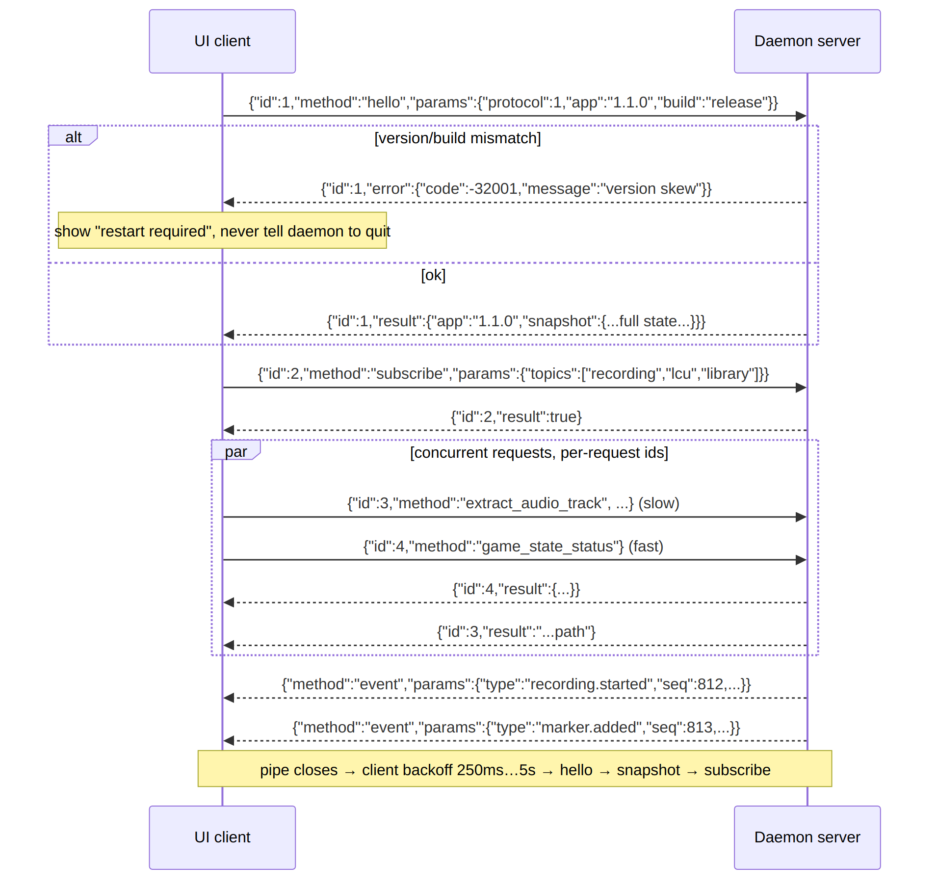
Figure 6 — one session on the wire. Per-request ids are what stop a slow stem extraction from blocking a status poll.
Decision | Choice | Reason
Wire format | JSON-RPC 2.0, one JSON object per line (\n-delimited) | serde_json already on both sides; line framing is trivially debuggable with a pipe client and needs no length prefix
Pipe name | \\.\pipe\ninja-recorder.<identifier>.<build> e.g. ...com.ninjarecorder.app.release / .devtools | Scoped by build identity because dev and release share app_data_dir()
Pipe ACL | Current user only (SECURITY_ATTRIBUTES with a DACL granting the interactive user; no Everyone) | The daemon can delete recordings; nothing else on the machine should be able to ask it to
Concurrency | Multiple clients (UI, dev portal, a future CLI); one tokio task per connection; requests dispatched via existing dispatch/dispatch_blocking on spawn_blocking | Already the split is_async_command exists for
Handshake | hello is mandatory first; anything else before it is -32002 not ready | Version skew check and snapshot in one round trip
Notifications | JSON-RPC notification (method: "event", no id) | Standard; the generated events.ts is the discriminated union
Backpressure | Bounded broadcast channel (256); a client that falls behind gets DaemonShuttingDown-style event.lagged { dropped } and must re-hello | A stuck UI must never stall the supervisor
Reconnect | Client: exponential backoff 250 ms → 5 s, jittered, indefinitely; on connect, hello → apply snapshot → subscribe | The exit criterion for WS3 is literally this loop working while a recording is in flight
Error model | -32601 unknown method, -32602 bad args (the current "bad arguments for X: ..." string), -32001 version skew, -32002 not ready, -32000 command error with the Result<_, String> message | Maps 1:1 onto what dispatch already returns

Named pipes on Windows via tokio::net::windows::named_pipe (ServerOptions/ClientOptions) — already in the tokio version in use, no new dependency. On non-Windows dev boxes the same code paths compile against a Unix domain socket under #[cfg(unix)], which keeps the daemon and its RPC tests runnable in the seconds-long loop.

4.3 The daemon process
The daemon is a plain Win32 process: no Wry, no WebView2, no window. Because it owns the tray icon it needs a message pump, which is the concrete reason it is not just #[tokio::main].
// src-tauri/src/daemon/mod.rs (shape, not final code)
pub fn run(cfg: DaemonConfig) -> anyhow::Result<()> {
let _guard = SingleInstance::acquire(&cfg.mutex_name)?; // exits 0 if held
log::init(cfg.logs_dir.join("daemon.log"))?;
let db = db::Pool::open_writer(&cfg.db_path)?; // migrations run here, once
let ctx = core::Ctx::new(recorder, supervisor, db, ...); // unchanged type
let rt = tokio::runtime::Builder::new_multi_thread().build()?;
let (events_tx, _) = broadcast::channel(256);
ctx.supervisor.set_event_sink(Box::new(BroadcastSink(events_tx.clone())));
rt.spawn(rpc::serve(cfg.pipe_name, ctx.clone(), events_tx.clone()));
rt.spawn(update::schedule(ctx.clone())); // moved from lib.rs
pump::run(tray::build(ctx.clone()))?; // blocks on GetMessage until WM_QUIT
ctx.supervisor.shutdown_blocking(); // stop recording cleanly, release backend
Ok(())
}

Tray. tray.rs today uses Tauri's TrayIconBuilder. Without Tauri the choice is the tray-icon crate directly (the same crate Tauri wraps, by the same authors) plus muda for the menu, and a GetMessage/DispatchMessage loop on the main thread. Menu actions post to a std::sync::mpsc the pump drains; "Open" spawns the UI process, "Quit" asks the supervisor whether a recording is in flight and confirms via a notification before posting WM_QUIT.
Updater. tauri-plugin-updater is Tauri-bound. The daemon needs the same behaviour without an AppHandle: fetch latest.json/alpha.json, verify the minisign signature against the baked public key, download the NSIS installer, and run it with /S once no recording is in flight and the UI has been told to close. Two options, in preference order:
- Use tauri-plugin-updater's underlying logic through a tauri::App built headless in the daemon — rejected, because it drags Wry into the daemon binary and the dead-at-load comctl32 problem core was designed to avoid.
- Reimplement the ~200-line check/verify/download/launch path with reqwest + minisign-verify (a tiny crate) — chosen. update.rs already isolates the state machine (Unsupported | Idle | Available | Downloading | Ready); only the fetch/verify/launch seam changes.
The rule "never install during a recording" is now enforced by the process that knows about the recording, which is the whole point of moving it.
Shutdown ordering. WM_QUIT → stop accepting RPC → emit DaemonShuttingDown → Supervisor::shutdown (stops the recorder, which runs the faststart remux, then finalizes the row) → drop the writer connection (WAL checkpoint) → exit. Killing the daemon with a recording in flight leaves a playable fragmented MP4 and a row reconcile will pick up, which is today's crash behaviour and stays the guarantee.
What the UI process keeps. ui/mod.rs holds today's lib.rs minus the supervisor: window creation, the rpc_call/rpc_subscribe proxies, open_recordings_folder, dev_open_portal, the asset protocol scope, and the "start the daemon if absent" recovery. It opens its own query_only SQLite connection for reads (§4.4) so the library view does not round-trip 1,000 rows through the pipe.

4.4 Persistence
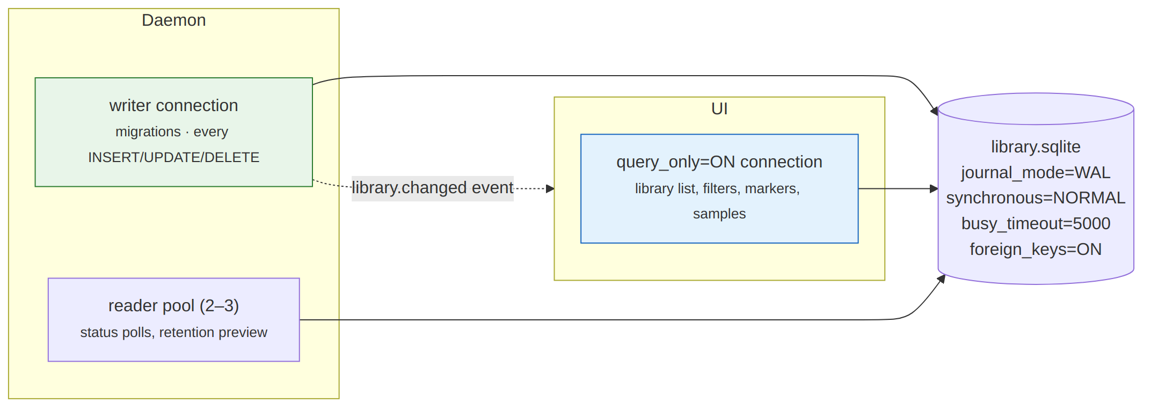
Figure 7 — one writer, several readers, WAL in between.
Changes to db/mod.rs, in order:
- Pragmas on every connection at open: journal_mode = WAL (persistent; set once by the writer), synchronous = NORMAL, busy_timeout = 5000, foreign_keys = ON. The UI adds query_only = ON. Migrations continue to run on the writer only, guarded by the user_version check that already exists.
- `db::Pool` replaces Mutex<Connection>: one Mutex<Connection> for writes plus an r2d2-free hand-rolled pool of two or three read connections (a Vec<Mutex<Connection>> with round-robin is enough at this scale). Db's public API is unchanged; write methods take the writer, read methods take a reader. That is a mechanical audit of ~60 methods.
- Reads in the UI go through the same Db type opened in reader mode. list_recordings, get_recording_markers, get_recording_samples, get_disk_usage and the filter/stat queries are answered locally; the UI still invalidates off LibraryChanged. Every mutating command stays an RPC.
- Retention and `reconcile` are daemon-only and unchanged.
The design document's warning stands: do not open the UI connection read-only at the file level. query_only is the discipline; the shm index needs write access to exist.

4.5 Capture backend — the P0 arms
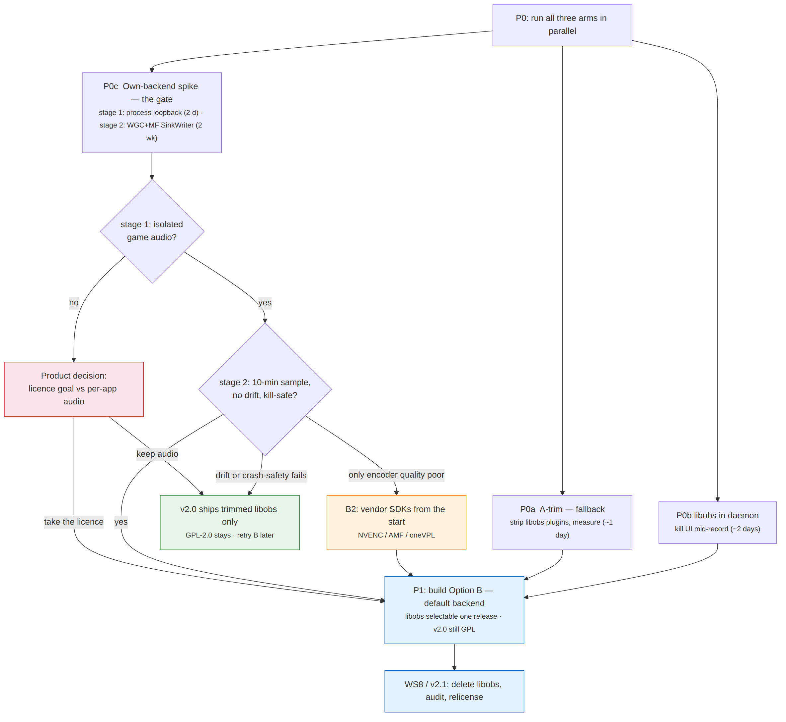
Figure 8 — the P0 gate. Blue is the target; green is the fallback. Both share every other workstream.

Why Option B is the target
GPL-2.0 is inherited from libobs and from nothing else. A closed-source or source-available future is impossible while libobs ships in the installer, whatever process it lives in — the arms-length argument in the design document is contested and is not relied on here. The maintainer's own code in src-tauri/ and src/ can be relicensed at any time by its copyright holder; the only constraint is that a libobs-linked build cannot be distributed under anything but GPL-2.0. So the sequence is fixed: build the own backend, ship it alongside libobs for one release, delete libobs, then change the licence. Trimmed libobs is kept purely as insurance, because it records real games today and Option B does not yet.

P0a — trim the libobs bundle (≈1 day, build-script work) — fallback arm
Still worth running: if P0c fails, this is what ships, and it must be under 200 MB either way for the one release in which both backends coexist. The CI step "Stage libobs capture backend" copies the fork's entire build-helper/libobs_<ver>/ directory. The task is a keep-list applied after that copy, then a real recording from the result.
Keep | Drop
obs.dll, obs-frontend-api is not needed, libobs-d3d11.dll, libobs-winrt.dll (WGC), w32-pthreads.dll | obs-browser/ and its CEF payload (the single largest item)
plugins: win-capture, win-wasapi, obs-ffmpeg, obs-outputs, obs-x264 only if the no-silent-fallback rule needs it present to enumerate (it does not — drop), obs-nvenc, obs-qsv11, enc-amf / obs-amf | obs-vst, obs-websocket, obs-filters, obs-transitions, image-source, text-freetype2, obs-text, vlc-video, decklink, rtmp-services, aja, every locale except en-US
data/libobs/ effect files (.effect), data/obs-plugins/<kept>/ | data/obs-plugins/<dropped>/, data/obs-studio/themes, docs
ffmpeg DLLs the kept plugins import (avcodec, avformat, avutil, swresample, swscale) | avfilter, avdevice, postproc if nothing imports them (verify with dumpbin /dependents)
ffmpeg.exe (lgpl static build, for remux) | —

Method: apply the keep-list in a PowerShell step behind LIBOBS_TRIM=1, build the devtools installer, install, record a full game, check the log for plugin-load failures, then Get-ChildItem -Recurse | Measure-Object Length -Sum. If the number is under 200 MB with a clean recording, A-trim passes. Appendix C carries the candidate list with the verification order.

P0b — libobs in the daemon (≈2 days)
Move LibObsRecorder construction from lib.rs::setup into daemon::run behind the same cfg(windows), launch the UI, start a recording (dev portal), kill the UI process from Task Manager, and confirm the recording continues and finalizes. Record daemon-only Private Bytes and Working Set at idle, and the two-process total with the UI open. This arm is cheap because the worker is already a separate process; the work is ownership, not FFI.

P0c — own-backend spike (2 days + 2 weeks) — the go/no-go gate
Stage 1, process loopback (2 days). A standalone cargo run --bin spike-loopback on Windows: ActivateAudioInterfaceAsync with AUDIOCLIENT_ACTIVATION_TYPE_PROCESS_LOOPBACK, PROCESS_LOOPBACK_MODE_INCLUDE_TARGET_PROCESS_TREE, root PID = League of Legends.exe (found the way recorder/libobs/window.rs already finds the window, then GetWindowThreadProcessId). Capture 60 s to a WAV while the game runs with Discord open. Pass if the WAV contains game audio and no Discord audio. This answers the first open question in the design document's §9 directly, including which PID is the root: the game process, not the client the LCU tracks.
Stage 2, WGC → D3D11 → MF SinkWriter (2 weeks). Extend the spike: GraphicsCaptureItem for the game window, Direct3D11CaptureFramePool (BGRA), a compute/pixel shader pass to NV12, IMFSinkWriter with MF_TRANSCODE_CONTAINERTYPE = MPEG4, MF_MP4_FRAGMENTED-style output via MFCreateFMPEG4MediaSink, H.264 via MFT_ENUM_FLAG_HARDWARE with vendor-ID check (refuse on none), AAC per track, a cadence thread duplicating frames to hold 60 fps CFR, and a resampler placing mic, loopback and system audio on one clock. Record 10 minutes; pass if audio drift against video is under one frame at the end, the file is playable when the process is killed at minute 5, and the encoder enumeration identifies NVENC/AMF/QSV on at least two vendors.
Gate rule. Option B proceeds to P1 if both P0c stages pass. If stage 1 (process loopback) fails, per-application game audio cannot be delivered without libobs; that is a product regression across every audio preset, and the maintainer must choose between the licence goal and the feature before anything else in WS1 continues. If stage 2 fails only on encoder quality, Option B continues with the B2 variant (direct NVENC/AMF/oneVPL) from the start. If stage 2 fails on drift or crash-safety, trimmed libobs ships as v2.0's only backend, the licence stays GPL-2.0, and the spike is archived under docs/spikes/ with its measurements for a second attempt. Under no outcome does v2 ship a branch-pinned private fork.
The spike is not throwaway on the pass path: its pipeline is the seed of recorder/own/, so write it under edition 2024 rules (WS5 lands first) and keep the audio clock-alignment code testable off Windows with recorded WASAPI timestamps.

P1 — build Option B (≈4 weeks)
- `recorder/own/` implements Recorder with the spike's pipeline: capture.rs (WGC item + frame pool), convert.rs (BGRA→NV12 shader, cross-adapter copy when capture and encode devices differ), pacing.rs (CFR cadence thread), audio/ (per-endpoint WASAPI capture, process loopback, resampling onto the video clock), encode.rs (MFT enumeration with vendor-ID check, refuse on none), mux.rs (SinkWriter, fragmented MP4, per-track AAC), remux.rs (existing ffmpeg faststart pass, unchanged).
- Same contract above the trait. RecordConfig, AudioLayout and RecordingOutput do not change, so the library, the stem picker and the review player cannot tell which backend wrote a file.
- Backend selection via a settings_kv key (capture_backend = own | libobs), default own, surfaced in Settings → Advanced with a one-line explanation. This is the design document's "keep libobs selectable for one release cycle" mitigation and it is what makes v2.0 shippable before Option B has months of field time.
- Trimmed libobs as the fallback: the P0a keep-list becomes the CI staging step; libobs-recorder pinned to a tag on a published crate (or upstream after the two patches land), never a branch; LibObsRecorder moves into the daemon crate. Its removal is WS8.
- Diagnostics record backend in diagnostics_json (the column already exists) so a bad recording can be attributed.

4.6 Frontend
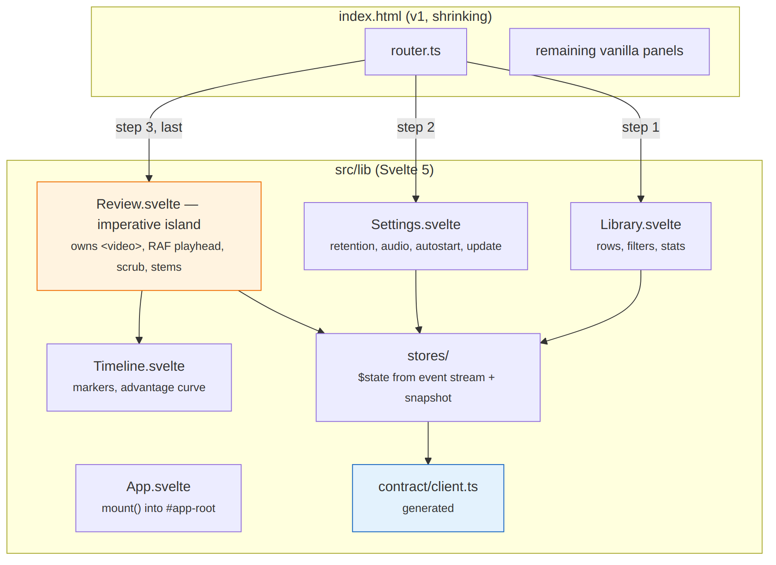
Figure 9 — the strangler. Each view is replaced at its root DOM node; the router keeps working throughout.
Setup (WS4, first week). @sveltejs/vite-plugin-svelte, svelte 5, svelte-check. index.html keeps its markup; each view's root element becomes the target of a mount() call when the router switches to it, and unmount() on leave. Nothing else in main.ts changes on day one.
Order and why:
- Library (library.ts, 855 LOC → Library.svelte + Row.svelte + Filters.svelte + Stats.svelte). Highest churn, most templating, most escapeHtml calls; the biggest immediate win and the easiest to check against fixtures — the dev portal's seed panel produces every row shape the format helpers document.
- Settings + update (settings.ts 540 LOC, update.ts 280 LOC). Forms, which a framework does best. The retention preview and audio preset picker are RPCs already.
- Review player last (review.ts, 1,547 LOC, ~30 module-scope mutables). Review.svelte is an imperative island: it binds <video> and the timeline canvas via bind:this, runs the RAF playhead, scrub handling and stem <audio> synchronisation in plain functions exactly as today, and exposes only props (recording, markers, samples) and events (seek, clip). Svelte manages its lifetime and nothing inside it. The timeline clustering and marker grouping move to pure functions under src/lib/timeline/ first, with Vitest coverage, before the port — that is the regression net the design document's risk register asks for.
Stores. One $state object per topic (recordingState, lcuState, library, update), populated from the hello snapshot and mutated by events. Components read stores; they never call the client for state they can be told about. Reads that are genuinely on demand (get_recording_markers for the selected VOD) go through the generated client.
Styling. src/lib/styles/tokens.css carries the custom properties theme.ts already switches on html[data-theme]; component styles are scoped. The 2,013-line styles.css shrinks as each view moves and is deleted with the last vanilla panel. theme.ts's matchMedia listener is kept verbatim.
Safety. No {@html} anywhere a recording-derived string can reach. Biome's noDangerouslySetInnerHtml-equivalent for Svelte is not available, so a two-line Vitest test greps src/lib for {@html and fails if it appears outside an allow-list.
Dev portal. src/dev/ is left vanilla for v2 — it is a debugging surface with 3,700 lines and no user-facing pressure. It does move onto the generated client (registry.ts is deleted; its help text becomes doc comments in the Rust declaration).

4.7 Toolchain and quality gates
Change | Concretely | Notes
Pin the compiler | src-tauri/rust-toolchain.toml: channel = "1.9x.y", components = ["rustfmt","clippy"]; CI uses dtolnay/rust-toolchain with no version argument so it reads the file | Bump in its own PR; new lints are the expected content of that diff
Edition 2024 | cargo fix --edition from src-tauri/, then edition = "2024", then fix the unsafe_op_in_unsafe_fn backlog in recorder/libobs/, recorder/devices.rs, worker_log.rs; restructure any static mut | Land before WS1's P1 so the new capture code is written under the new rules
cargo-deny | deny.toml with [licenses] allow = ["MIT", "Apache-2.0", "BSD-*", "ISC", "Zlib", "Unicode-3.0"], deny = ["GPL-*", "AGPL-*"], and a single named exception for libobs-recorder until WS8 removes it; [advisories]; cargo deny check in CI | Makes the licence exit mechanical: deleting the exception is what proves no GPL dependency remains
Biome | biome.json with the recommended set plus noNonNullAssertion off (the DOM code uses it deliberately); biome ci . in CI | One binary for lint and format; replaces nothing because nothing exists
Vitest | vitest.config.ts; first targets are the pure modules: format.ts (242 LOC), the timeline clustering and marker grouping once extracted, router.ts; then component tests in browser mode for Row.svelte and Filters.svelte | Mocked transport from src/lib/transport/mock.ts
svelte-check | npx svelte-check --tsconfig ./tsconfig.json alongside tsc --noEmit | tsc does not see .svelte files; without this the type gate silently narrows
Contract drift | cargo run --bin gen-contract -- --check | Replaces every_command_round_trips and the registry banner

CI test job after WS5, in order: npm ci → biome ci . → tsc --noEmit → svelte-check → vitest run → cargo deny check → cargo run --bin gen-contract -- --check → the four existing cargo steps. Clippy still runs without --all-targets, and the reason stays documented in CLAUDE.md.

5. Workstreams and task breakdown
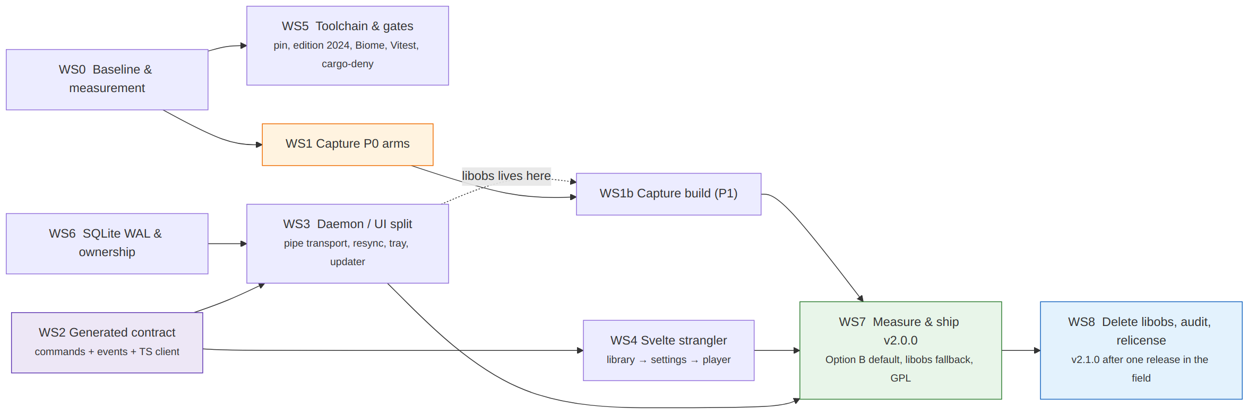
Figure 10 — dependencies. WS0, WS1, WS2, WS5 and WS6 have no upstream and can all start in week one. WS8 is deliberately a separate release.
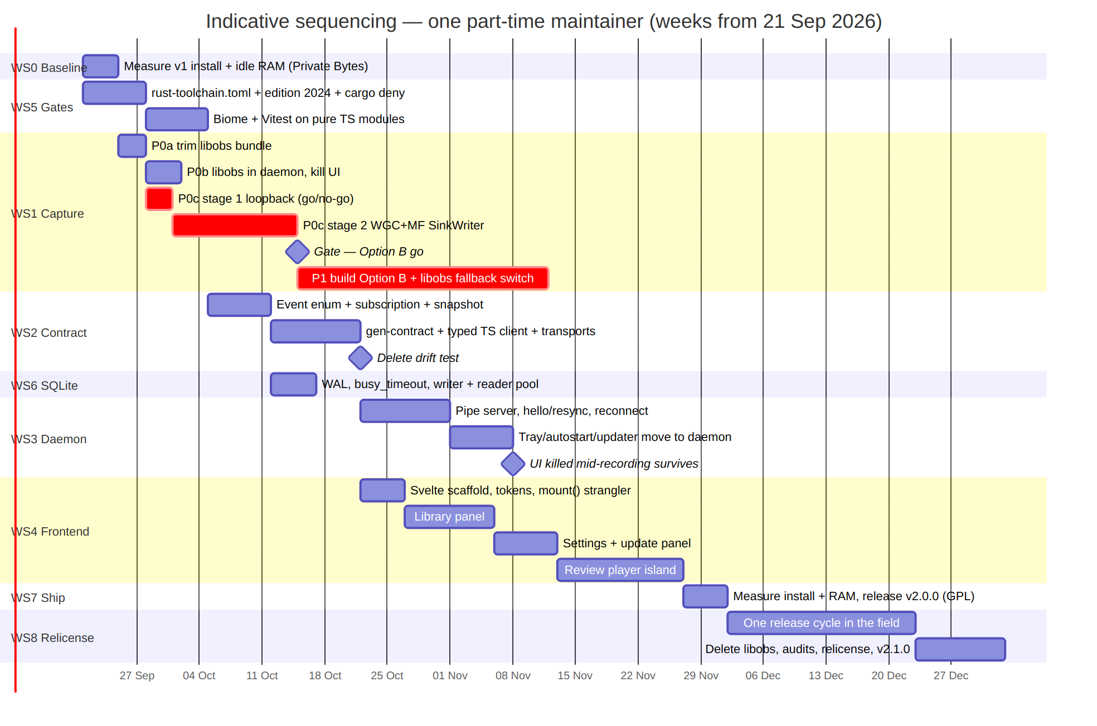
Figure 11 — an indicative calendar. Durations are calendar days at part-time effort, not engineering days. The critical path runs through WS1.

WS0 — Baseline and measurement
# | Task | Exit criterion
0.1 | Add docs/measurement.md with the Appendix A method from the design document (Private Bytes headline, Working Set alongside, daemon-only resting state, two-process total separately) | Merged
0.2 | Measure v1 0.8.0: install size, Private Bytes and Working Set with window closed, with window open, with League client open (backend warm) | Three rows recorded in docs/windows-verification.md §5
0.3 | Script the measurement (scripts/measure.ps1) so WS7 repeats it identically | Script committed and run once

WS1 — Capture backend
# | Task | Exit criterion
1.1 | P0a keep-list PowerShell step behind LIBOBS_TRIM=1; devtools installer; real game | Recording plays; size recorded; plugin-load log clean
1.2 | P0b LibObsRecorder constructed by a --daemon process; UI killed mid-record | Recording finalizes; daemon-only RAM recorded
1.3 | P0c-1 loopback spike binary; 60 s WAV with Discord open | Game audio present, Discord absent, root PID documented
1.4 | P0c-2 WGC+MF spike; 10-minute sample; kill at minute 5 | Drift < 1 frame; killed file playable; vendor detection on ≥2 GPUs
1.5 | Gate outcome recorded in DEVELOPMENT.md §16 (new section; do not renumber): loopback root PID, drift figure, encoder vendors seen, decision | Merged
1.6 | P1: recorder/own/ behind Recorder in the daemon crate, default backend | Full game on real hardware from a CI-built installer, isolated game audio, seekable after remux
1.7 | Fallback: trimmed libobs staged from the P0a keep-list; fork pin replaced by a tag; capture_backend switch in Settings | Both backends record the same game; windows-verification.md gains a backend-comparison table
1.8 | B2 path only if 1.4 flagged encoder quality: direct NVENC/AMF/oneVPL behind encode.rs | Quality-per-bitrate within 10% of libobs at 8 Mbps by visual comparison of the same game

WS2 — Generated contract
# | Task | Exit criterion
2.1 | Add -> ReturnType to every dispatch_table! row; macro emits contract_manifest() | cargo test green, no behaviour change
2.2 | ts-rs derives on every type crossing the boundary (~40); #[ts(export)] disabled in favour of the generator collecting them | Types compile
2.3 | contract/events.rs with Event, Topic, ContractEvent derive; EventSink on Supervisor; emit on every transition, marker, LCU phase, library change, retention run, update status | Unit test asserts one event per state transition against the fixture-driven supervisor test
2.4 | contract/snapshot.rs: Snapshot { seq, state, lcu, current_recording, update, prefs } assembled from Ctx | Round-trips through serde
2.5 | gen-contract binary: emits types.ts, client.ts (one method per command, camelCase args, typed return), events.ts (discriminated union + Topic); --check mode | Generated output committed; --check passes
2.6 | src/lib/transport/{invoke,mock}.ts; bridge.ts becomes a thin re-export of the client over InvokeTransport | Frontend behaviour unchanged; tsc green
2.7 | Delete every_command_round_trips, src/dev/registry.ts and the portal's drift banner; move help text to doc comments | Merged; CI has gen-contract --check

WS3 — Daemon / UI split
# | Task | Exit criterion
3.1 | daemon/rpc.rs: pipe listener, line framing, hello/subscribe, per-request ids, spawn_blocking for sync commands, bounded broadcast for events, lag handling | Integration test over a Unix socket on the dev box: 100 interleaved requests, events delivered in order
3.2 | daemon/mod.rs: single-instance mutex, DB writer, supervisor, runtime; launch.rs --daemon no longer refuses | ninja-recorder --daemon runs headless on Windows and records via the dev portal
3.3 | daemon/pump.rs: tray-icon + muda menu on a Win32 message loop; Open/Settings/Quit; quit-while-recording confirmation | Tray behaviour matches windows-verification.md §5.0.1
3.4 | ui/: rpc_call/rpc_subscribe Tauri commands proxying the pipe; PipeTransport in TS; reconnect with backoff; snapshot applied to stores; version-skew refusal | UI killed and relaunched mid-recording shows the live recording within one reconnect
3.5 | Autostart flag --hidden → --daemon; UI starts daemon if absent | Login starts a daemon only
3.6 | Updater in daemon (reqwest + minisign-verify); UI shows status from UpdateStatus events; install is an RPC refused during recording | Alpha-channel update applied end to end from the daemon
3.7 | Dev portal over the pipe (dev_* join the declaration under cfg(feature = "devtools")) | Every portal panel works against a separate daemon process
3.8 | Daemon killed mid-recording → UI shows "daemon not running", restarts it, resyncs; recording file playable, row reconciled | Documented in windows-verification.md §4

WS4 — Svelte 5 strangler
# | Task | Exit criterion
4.1 | Vite plugin, svelte 5, svelte-check, tokens.css; mount() hook in router.ts | An empty App.svelte mounts and unmounts without affecting vanilla views
4.2 | Extract pure functions from review.ts and library.ts (clusterMarkers, groupByProximity, stem sync offset math, filter predicates) into src/lib/timeline/ and src/lib/library/; Vitest on all | ≥ 80% line coverage on the extracted modules
4.3 | Library.svelte and children; parity against dev-portal seed fixtures (every row shape in frontend.md's fallback table) | library.ts deleted
4.4 | Settings.svelte, Update.svelte; retention preview, audio preset, autostart, theme, about | settings.ts, update.ts deleted
4.5 | Review.svelte imperative island + Timeline.svelte; scrub, stems, clip, dead-end skipping | review.ts deleted; fixture MP4 review session identical by manual checklist
4.6 | Delete dom.ts (el, escapeHtml, escapeAttr), index.html markup down to <div id="app-root">, styles.css | Only main.ts, theme.ts, desktop.ts remain vanilla
4.7 | {@html guard test; Biome clean; frontend.md rewritten for the component tree | CI green

WS5 — Toolchain and gates
# | Task | Exit criterion
5.1 | rust-toolchain.toml; CI reads it | Two CI runs a week apart use the same compiler
5.2 | cargo fix --edition; edition 2024; unsafe backlog; static mut audit | Clippy -D warnings green on both feature sets
5.3 | deny.toml; cargo deny check in CI | Green with the current tree
5.4 | biome.json; biome ci in CI; one formatting commit | Green
5.5 | Vitest config + first tests on format.ts, router.ts | vitest run in CI
5.6 | svelte-check in CI (lands with 4.1) | Green
5.7 | CLAUDE.md, docs/ci-and-releases.md updated with the new gate list | Merged

WS6 — SQLite
# | Task | Exit criterion
6.1 | Pragmas at open; WAL set by the writer | Existing tests green; library.sqlite-wal appears on Windows
6.2 | db::Pool (writer + reader Vec); audit every Db method for read vs write | Test: a long read on a reader does not block a write
6.3 | Reader mode with query_only = ON; test that a write on it errors | Green
6.4 | Concurrency test: daemon writing markers at 1 Hz while a reader lists recordings in a loop for 60 s | Zero SQLITE_BUSY

WS7 — Measure and ship
# | Task | Exit criterion
7.1 | Run scripts/measure.ps1 on the release candidate | Install size and daemon-only Private Bytes recorded against C3 in windows-verification.md
7.2 | Full verification pass per windows-verification.md §1–§5 plus the new §4 daemon cases | Signed off
7.3 | npm run release -- next 2.0.0; alpha soak for one week; npm run release -- cut | v2.0.0 on the stable channel; README.md status blockquote updated

WS8 — Remove libobs and relicense (v2.1.0)
Runs after v2.0.0 has had one release cycle in the field with Option B as the default.
# | Task | Exit criterion
8.1 | Contributor audit: git shortlog -sne on the full history; written agreement from every non-maintainer author, or rewrite their hunks | Recorded in docs/licensing.md
8.2 | Derived-code audit: everything in recorder/libobs/, worker_log.rs, and any identifier or comment lifted from the libobs-recorder fork; delete or rewrite from the public Windows API documentation, not from the fork | grep for fork identifiers returns nothing; audit checklist in docs/licensing.md
8.3 | Delete recorder/libobs/, the CI staging steps, tauri.windows.conf.json resources, the capture_backend switch; remove the deny.toml exception | cargo deny check green with GPL denied; install size re-measured
8.4 | Choose and apply the target licence (see §9, Q1); update Cargo.toml, package.json, LICENSE, README, the About panel, and the release-notes caveat block | One commit, tagged v2.1.0
8.5 | ffmpeg stays the LGPL static build, invoked as a separate process for -c copy only; document that this is the only remaining copyleft component and why it is compatible with a proprietary distribution | docs/licensing.md
8.6 | Historical releases remain GPL-2.0 and remain available; the tag v2.0.0 is the last GPL release and README says so | Merged

On the target licence. Any permissive licence (MIT, Apache-2.0, or the dual) or a source-available licence (BUSL-1.1, PolyForm) is compatible with a later closed-source distribution, because the maintainer keeps the copyright. Past releases stay under whatever they were released under; that cannot be revoked and does not need to be. If the intent is closed source soon, the simplest v2.1 is "all rights reserved" with the source repository made private; if the intent is to keep the repository public while reserving the option, Apache-2.0 (patent grant, contributor licence clarity) is the conventional choice. Either way, from v2.1 onward the repository should carry a CONTRIBUTING.md with a contributor licence agreement, or accept no outside contributions, so the copyright stays consolidated.

6. Testing and verification
Layer | Today | v2 | Runs where
Pure Rust (state machine, reconcile, retention, events→markers) | 447 tests | + event emission tests, snapshot round-trip, contract manifest | dev box + CI
RPC server | — | integration test over Unix socket (dev box) / named pipe (CI Windows): handshake, skew refusal, interleaving, lag, reconnect | dev box + CI
SQLite concurrency | — | writer/reader contention test (6.4) | dev box + CI
Contract | round-trip test + registry banner | gen-contract --check; generated client smoke test | CI
Frontend pure logic | none | Vitest on format, timeline, library predicates, router | CI
Components | none | Vitest browser mode on Row, Filters, Settings forms with mock transport | CI
Capture | manual, windows-verification.md | unchanged in kind; new cases: UI killed mid-record, daemon killed mid-record, daemon restart via update, two-vendor encoder detection | Windows box, per release
Footprint | install size only | install size + Private Bytes (daemon-only) + two-process total, scripted | Windows box, per release

The dev portal stays the primary manual harness. Its state-machine injection and seed panels are what make "UI killed mid-recording" reproducible without a game.

7. Risks specific to implementation
These are in addition to the design document's register, which is carried forward unchanged.
Risk | Likelihood | Impact | Mitigation
ts-rs output does not match serde's wire shape for a tagged enum (AudioPreset is internally tagged on preset) | Medium | Medium | Generated-client smoke test calls every command with the fixture payloads the deleted round-trip test used
Tray without Tauri behaves differently (icon theme, menu focus) | Medium | Low | tray-icon is the crate Tauri wraps; verify against windows-verification.md §5.0.1
Reimplemented updater diverges from tauri-plugin-updater's manifest handling | Low | High | Same latest.json; signature verified with the same public key; alpha channel soak before stable
Reader/writer audit misses a write on a reader connection | Medium | Medium | query_only makes it a loud runtime error, and 6.3's test covers the mechanism
mount() into existing markup fights the vanilla router (double event handlers) | Medium | Low | One view at a time; unmount() on route leave; Vitest browser test for mount/unmount idempotency
WebView2 asset-protocol scope changes when the UI process no longer owns app_data_dir() writes | Low | Medium | Scope is path-based, not ownership-based; verified in 3.4
Two-process idle RAM exceeds 100 MB while the UI is open | High | Low | C3's ceiling is defined as daemon-only; the two-process figure is recorded, not gated
Windows named-pipe DACL blocks the dev portal when run as a different elevation | Low | Low | Document "run both un-elevated"; windows-verification.md §0
Process loopback yields silence for League of Legends.exe (wrong root PID, or Vanguard interference) | Medium | High | It is the first thing P0c tests, at two days' cost; failure is a product decision, not an engineering one — see the gate rule in §4.5
Option B regresses a recording that libobs would have made | Medium | High | capture_backend switch for one release; diagnostics_json.backend for attribution; libobs deleted only in WS8
A future outside contributor's code blocks relicensing | Low | High | WS8.1 now; CLA or no-contributions policy from v2.1
Fork-derived code survives into the relicensed tree | Medium | High | WS8.2 audit; rewrite from Microsoft documentation, never by reading the fork
Own backend written before edition 2024 lands, doubling the unsafe backlog | Medium | Low | WS5.2 is sequenced before P1

8. Definition of done for v2.0.0
- A CI-built installer records a full Vanguard-protected game on real hardware from a daemon that was started at login with no UI open.
- Killing the UI, killing the daemon, and applying an alpha-channel update mid-recording each leave a playable file and a correct library row.
- Install size and daemon-only Private Bytes are recorded in windows-verification.md; install is under 200 MB or the miss is documented with the number.
- Option B is the default capture backend; trimmed libobs is selectable, under 200 MB combined, and pinned to a tag — no branch-pinned fork in Cargo.toml.
- deny.toml denies GPL with exactly one named exception, so v2.1's licence exit is a deletion, not an audit.
- src/lib/contract/ is generated and CI-checked; registry.ts and the round-trip test are gone.
- library.ts, settings.ts, update.ts, review.ts, dom.ts, styles.css are deleted.
- CI runs Biome, Vitest, svelte-check, cargo-deny and gen-contract --check, on a pinned toolchain, edition 2024.
- DEVELOPMENT.md gains §16 (capture gate and Option B, measured), §17 (contract and transport) and §18 (licensing exit plan); no existing section is renumbered.
Definition of done for v2.1.0: no libobs in the tree or the installer, cargo deny check green with GPL denied, contributor and derived-code audits recorded, licence changed in one tagged commit, install size and idle RAM re-measured.

9. Open questions and inputs needed
On the offer of API specs. For this plan, the LCU and Live Client Data specs are not required — v1's thin clients (lcu/, live_client/) and the captured fixtures under fixtures/ already define the surface the daemon consumes, and nothing in v2 changes what is fetched. They would become useful at two points:
- WS2, task 2.3 — if the Event::LcuPhase variant should carry the full gameflow-phase enumeration rather than the subset lcu/gameflow.rs models today, the LCU swagger is the authoritative list. Worth having then.
- Any later work on the deferred LCU patch or backfill — the match-history document schema, for typed shapes in lcu/match_data.rs. Out of v2 scope.
So: not needed now; the LCU swagger would be welcome when WS2 starts. The Live Client Data spec adds nothing over the captured allgamedata fixtures.
Questions for the maintainer before WS1 starts:
# | Question | Blocks
Q1 | Answered: leaving GPL-2.0 is required, to keep a closed-source path open. Remaining sub-question: which licence at v2.1 — permissive (Apache-2.0 / MIT), source-available (BUSL-1.1), or all-rights-reserved with a private repo? | 8.4
Q1a | If P0c stage 1 fails (no per-app loopback), does the licence goal outweigh losing isolated game audio? Decide the answer before the spike runs, so the result is not litigated afterwards | Gate rule in §4.5
Q2 | Which two GPU vendors are available for the P0c encoder-detection check? | 1.4
Q3 | Has the libobs-recorder maintainer been approached about upstreaming window_capture + multi-track? | 1.6
Q4 | Is the Windows box available for roughly one session a week through WS1 and WS3? The plan assumes it | Calendar
Q5 | Should the --hidden flag be kept as an alias for one release, or removed at 2.0.0? | 3.5
Q6 | Retire the dev portal's vanilla UI in v2, or leave it (this plan leaves it)? | 4.x scope

Appendix A — command inventory (v1 dispatch_table!, 29 rows)
Group | Commands | Daemon or UI in v2
Recording control | start_recording, stop_recording, is_recording, game_state_status | Daemon RPC; is_recording and game_state_status become snapshot/event and are kept only for the dev portal
Library reads | list_recordings, get_recording_markers, get_recording_samples, get_disk_usage, get_recordings_dir | UI reads locally via query_only; kept as RPC for the portal and non-Windows dev
Library writes | rescan_recordings, set_pinned, delete_recording, extract_audio_track, backfill_match_metadata | Daemon RPC
Retention | get_retention_policy, set_retention_policy, preview_retention_policy | Daemon RPC (preview is a read but runs the policy — stays daemon-side)
Preferences | get_ui_prefs, set_ui_pref | Daemon RPC (writes); prefs arrive in the snapshot
Audio | get_audio_preset, set_audio_preset, list_audio_inputs | Daemon RPC; list_audio_inputs is bare_result and needs no Ctx
Integration | lcu_status, resolve_icons | Daemon RPC; resolve_icons writes the ddragon cache, so daemon
Autostart | get_autostart, set_autostart | Daemon RPC (it owns the Run key)
Updates | get_update_status, check_for_update, install_update | Daemon RPC; status is an event

Plus ~24 dev_* commands under cfg(feature = "devtools"), which join the same declaration.

Appendix B — draft event enum
Variant | Topic | Emitted when | Payload
StateChanged | recording | every StateMachine::handle that changes state | state, since
LcuPhase | lcu | gameflow phase change, lockfile appear/vanish | phase?, client_present
RecordingStarted | recording | Recorder::start returns Ok | recording_id, path, started_at
RecordingStopped | recording | finalize completes | recording_id, outcome (clean / crashed / refused reason)
MarkerAdded | recording | MarkerTracker produces one | recording_id, marker
SampleBatch | recording | every 5 s while subscribed | recording_id, samples[]
MatchSummaryPatched | library | deferred LCU patch lands | recording_id
LibraryChanged | library | any row mutation, reconcile, retention | reason
RetentionRan | library | enforcement pass | deleted, freed_bytes
UpdateStatus | update | status transition | status
DaemonShuttingDown | daemon | before WM_QUIT handling | reason (quit / update / error)
Lagged | daemon | client fell behind the broadcast buffer | dropped

Topic is recording | lcu | library | update | daemon. The dev portal subscribes to all five; the main UI subscribes to all but daemon's Lagged, which the transport handles itself by re-helloing.

Appendix C — libobs trim candidates, in verification order
Verify each removal by recording a game and reading the daemon log for obs_load_module failures, in this order — cheapest and safest first:
- obs-plugins/64bit/obs-browser* and the cef*/libcef*/chrome_* payload beside it — the largest single cut; nothing in the recorder references a browser source.
- All locales except en-US under data/obs-plugins/*/locale/ and data/libobs/.
- obs-vst, obs-websocket, decklink, aja, vlc-video, rtmp-services, image-source, text-freetype2, obs-text, obs-transitions, obs-filters — sources and filters the recorder never creates. Check obs-filters last; the fork's multi-track patch may attach a gain filter.
- obs-x264 — with the no-silent-fallback rule the encoder is never selected; confirm available_encoders() still enumerates hardware encoders without it.
- ffmpeg DLLs not imported by kept plugins (avfilter, avdevice, postproc) — verify with dumpbin /dependents on every kept .dll.
- obs-ffmpeg internals: it links a full codec set; a rebuilt minimal ffmpeg is a larger project and only worth it if steps 1–5 leave the bundle over 200 MB.
The floor is obs.dll + libobs-d3d11 + libobs-winrt + win-capture + win-wasapi + obs-ffmpeg + obs-outputs + the three hardware encoder plugins + data/libobs/*.effect + the ffmpeg DLLs they import + ffmpeg.exe.

Appendix D — file map: v1 module → v2 destination
v1 | v2 | Change
lib.rs (1,007 LOC) | ui/mod.rs + daemon/mod.rs | split by process
tray.rs | daemon/pump.rs | Tauri tray → tray-icon + Win32 loop
update.rs | daemon/update.rs | plugin → reqwest + minisign-verify
launch.rs | launch.rs | --daemon implemented
core/dispatch.rs | core/dispatch.rs + contract/gen.rs | table gains return types; generator added
state_machine/supervisor.rs | same | + EventSink
db/mod.rs | db/mod.rs + db/pool.rs | pragmas, writer/readers
recorder/libobs/ | recorder/own/ (target); recorder/libobs/ trimmed until WS8 deletes it | Option B
src/bridge.ts | src/lib/contract/client.ts (generated) | deleted
src/dev/registry.ts | doc comments in Rust | deleted
src/library.ts, settings.ts, update.ts, review.ts | src/lib/*.svelte | rewritten
src/dom.ts, src/styles.css, index.html markup | — | deleted
src/format.ts, router.ts, theme.ts, desktop.ts, prefs.ts | same, with Vitest | kept

