Gantt Chart Planning

This document includes the Gantt chart that was produced in order to keep track of the tasks that must be completed. It helped us to great extend and we tried to stick to it as much as possible. There were delays in the completion of a few tasks, and the reason is mainly the underestimation of the time that will take to complete each task or its difficulty level. Tackling the delays was a priority and in doing so we learned how to plan the next stage more efficiently so every task is complete due time and with good quality content. The image of the chart is rotated for the days and tasks to be clearly visible. The description of each task is provided to understand the correlation of each task and its description.

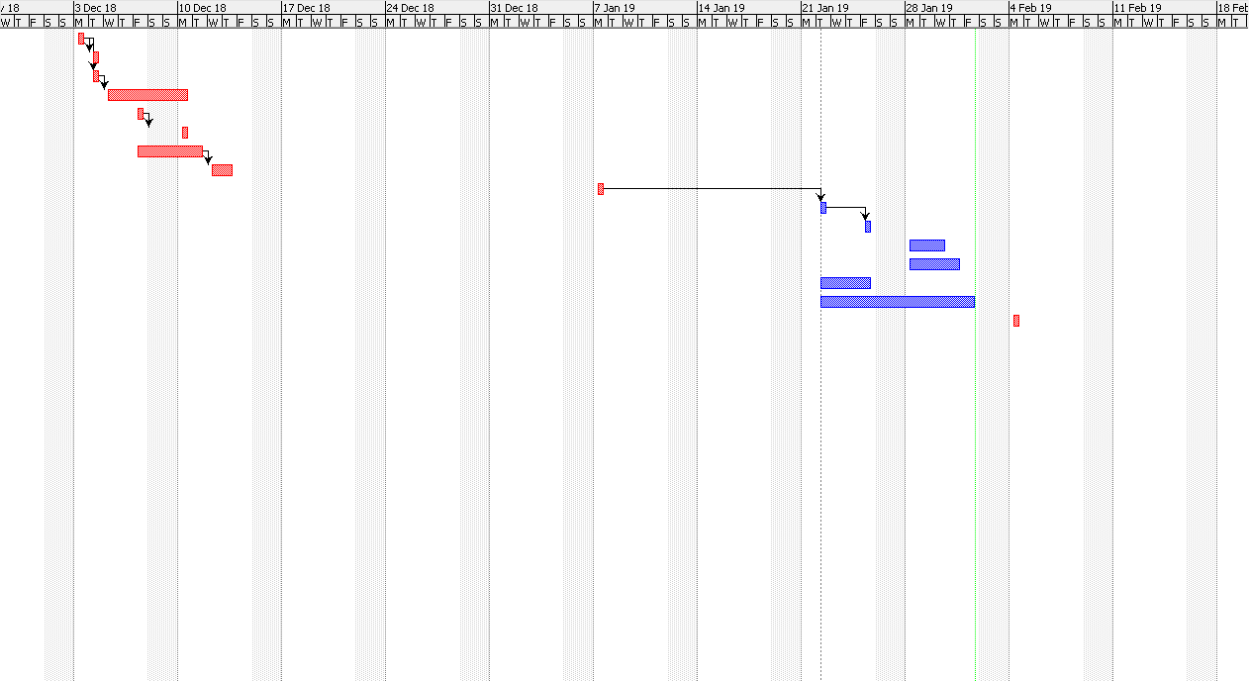

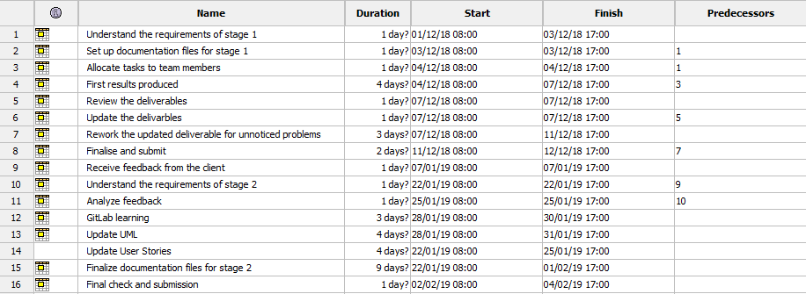

Comments: some of the tasks are considered as one in order to avoid confusion. For example, the Update UML refers to all the UML diagrams that are required. The particular task includes the sequence diagrams, use case scenarios and class diagrams.