**README**

- This test was done using Eclipse IDE and Apache Tomcat server

- Open up Eclipse IDE

- To setup Eclipse we need to first add the ability to use dynamic web projects, navigate to Help > install new software >

work with: 2021-03 - http://download.eclipse.org/releases/2021-03 > tick; Web, XML, JAVA EE … and install.

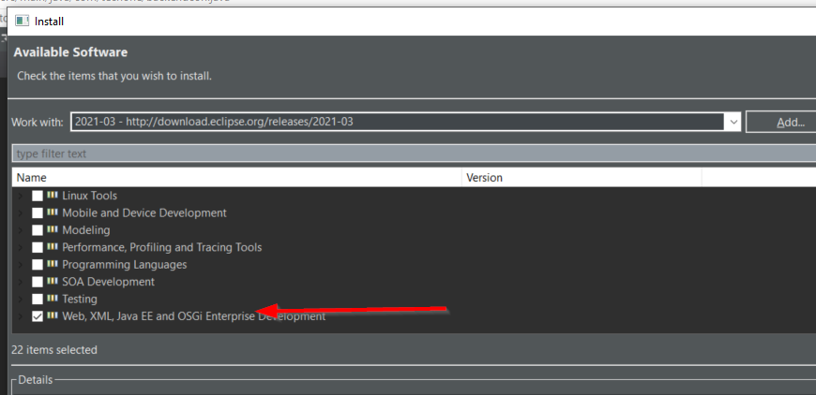

- Navigate in File > Import > Web > WAR file > Next > Browse > Find the TechOneTest.war file > Finish

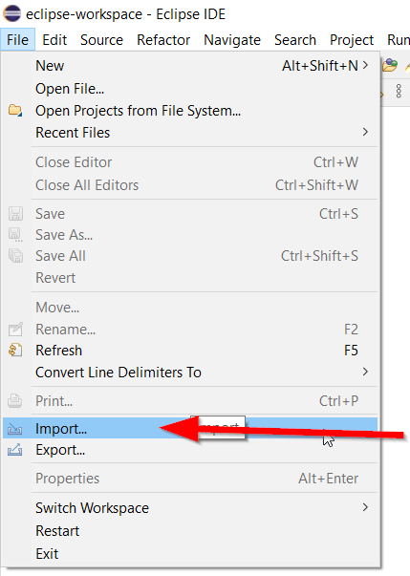

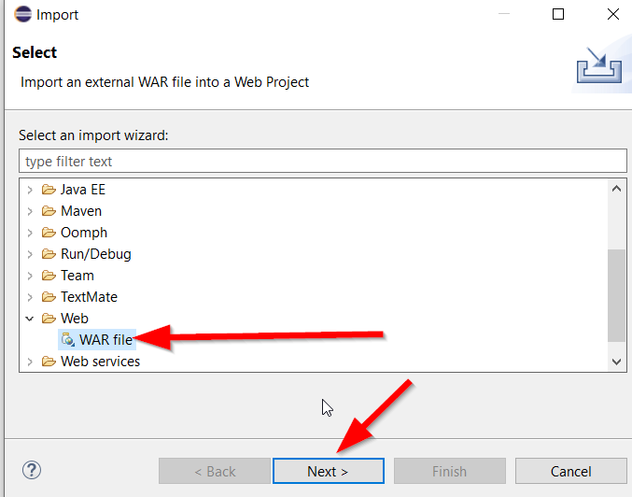

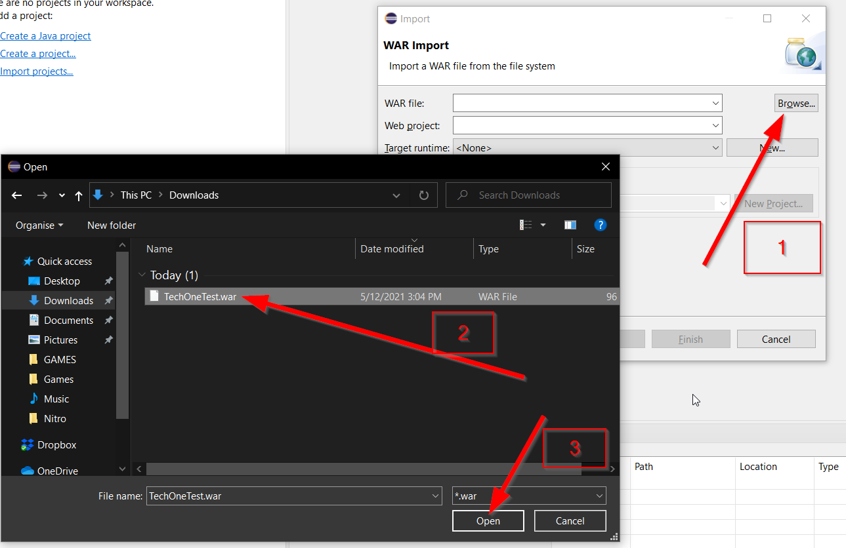

- NOTE: If Target runtime is empty we need to create a server, navigate to > New > Apache > Apache Tomcat v9.0 > tick Create a new local server > Next

> Choose an Installation directory > click download and install > install > finish

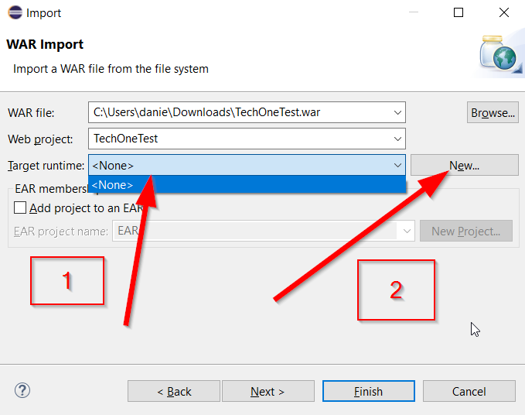

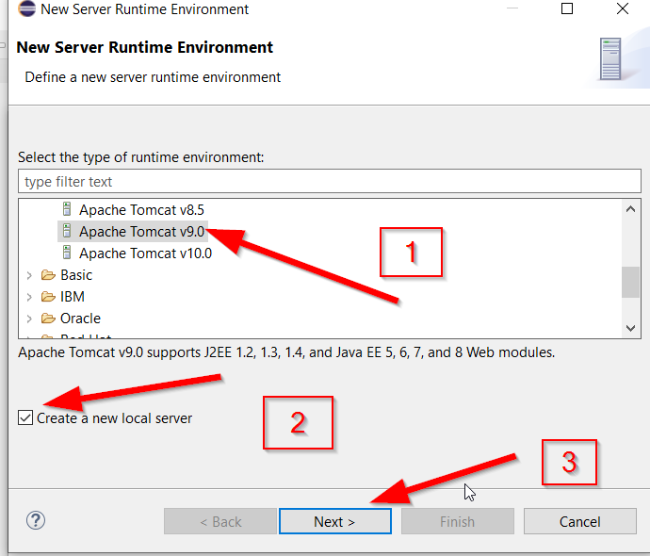

- NOTE: Apache Tomcat can also be downloaded from their original website at(https://tomcat.apache.org/download-90.cgi) and setup through server tab on eclipse

>if downloaded manually or server not showing in server tab, to add the server right click in the server tab down screen > new > server > find Apache > Tomcat 9.0 >

next > navigate and select folder, manual(program files/Apache software Foundation/Tomcat 9.0) > finish

- On bottom panel Servers > double click Tomcat v9.0 > make sure Tomcat admin port = any other port other than "-"

- On Project Explorer on left side of screen, Right Click on TechOneTest > Run as > Run on Server. This will open the project in Eclipse browser which is terrible btw

so instead, on Servers tab down the screen, right click Tomcat v9.0 > Start

- Now open browser > type in address bar: http://localhost:8080/TechOneTest

- For best representation of the website please turn of any dark reader, or dark mode and reduce page zoom to 75% on laptops.

- Follow Test Plan