About

Project Description
This project is a demonstration of a WPF application built with the MVVM design pattern. It implements MVVM using Microsoft Prism Library 6.0 for WPF using MefBootstapper. The premise is to allow users to input up to 3 directories and then display the aggregate sum of all the file sizes within the specified directories recursively using Task Parallel Library (TPL). The business logic is contained in a shared library and is also used by other projects in the solution. There is another shared library that is shared by the Prism modules. All the code was written using C# from the ground up. (No templates or wizards were used.)

UI Layout
The main window of this application is a blank shell. The shell has two areas which are flagged by Prism as Regions.

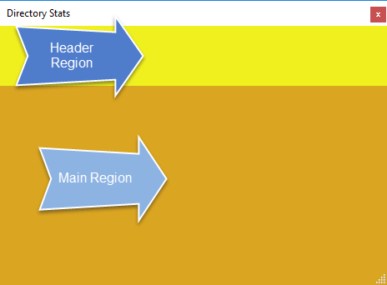

Any of the Prism modules’ views in this solution can be injected into any region in the shell. In this case, we have a “Header” and a “Home” module. At startup, the Header module’s view is injected into the Header Region, and the Home module’s view is injected into the Main Region. This is how our app looks at startup:

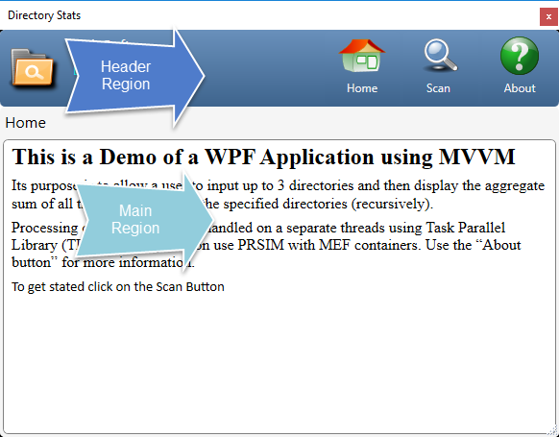

The Header View has three buttons which provide us with our page navigation. Each Prism module in this project has a controller. The controller listens for “page changed” events. Each of the buttons in the header bar fire one of these events. When the controller responds to one of these events, it creates a view and a ViewModel. Then the model is bound to the view and the view is injected into the Region. This is the basis of the MVVM pattern (Model-view-viewmodel).

Business Logic
As stated earlier, the business logic for computing the summary data is contained in a common library. In the scan page the directory path input box is bound to the ViewModel. When these paths change, the ViewModel asynchronously invokes a new instance of a helper class. This helper class implements Lock-free parallel tasks pattern design (using the Task Parallel Library (TPL)) and returns the results back to the view model. WPF data binding then binds the data to the view, and thus the page is rendered.

Other Points of Interest
Logging for this project and other projects in this solution uses log4net. The log4net implementation allows us to configure can change the logging configuration on the fly. That is, you can change the logging behavior without having to restart the application. This is very useful in trouble shooting production issues.
The directory files size calculations run recursively on their own threads using asynchronous methods. Asynchronous programing can increase performance of your application however it introduces the risk of race conditions, live lock, dead locks and other types of issues. The most common pitfall is a race condition. The easiest way to prevent a race condition is to lock the shared resources. This works fine but is not efficient. This project was designed with a lock-free approach. There is a Unit Test in the solution used to test async operation to insure the accuracy of the results and verifies that no race conditions exist. The unit test first runs the calculations using synchronous execution and then runs the same calculation using asynchronous operations. Then the output from both operations are compared and are the same.
A word about MEF (no, not the drug): Managed Extensibility Framework (MEF) is used throughout the code in this project and its combination with Prism provides us with Inversion of Control (IOC) for all of modules and ViewModels constructs.

