This is a guide on how to make Mii maker/any Mii work in citra.

Miis are broken in citra, all of them showing a crossed out box face instead of whatever you make. There is a simple enough solution, however.
First, we need to find your CITRA folder.
Go ahead and open up citra, then right click on a game and go to its save data.
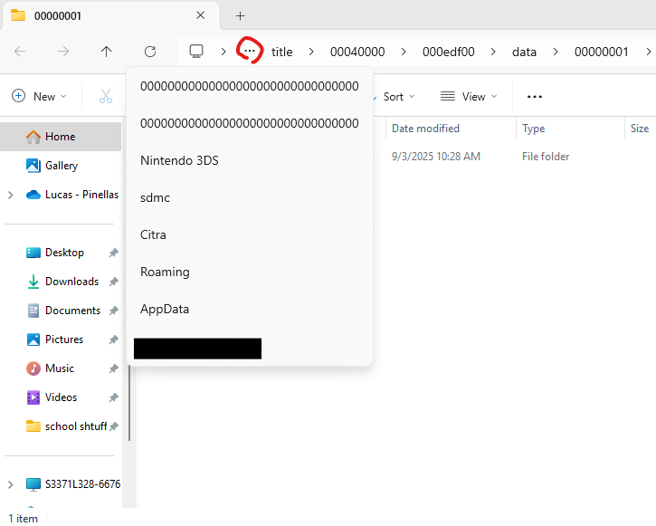
Click on the three dots, then on the text CITRA
Download and export the Mii_fix file, inside there is a folder named “nand.”
Drag the “nand” folder from the fix file into your citra folder, where you should see another folder named “nand.”
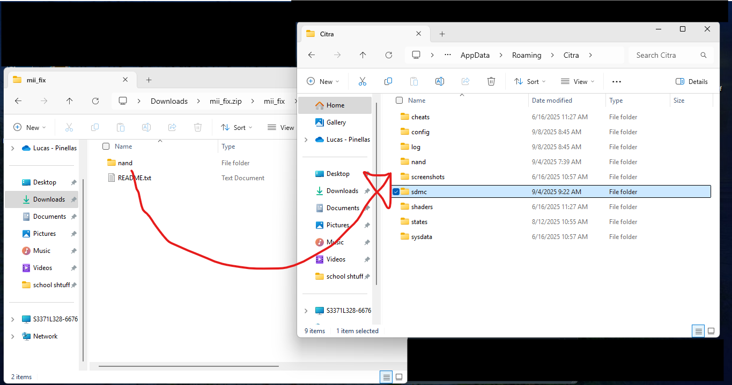
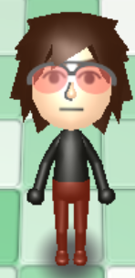
It will ask you if you’d like to replace the file, and that’s what we want.
Now if you open Mii maker, or another game with Miis in it you should be able to see/edit your miis!
V ! V Continued below V ! V
If you’re having problems, there’s a video made by this lady named Humaira Isha, which is also in the Mii Maker folder. Find her on youtube and subscribe if you’d like, she’s the reason I know how to do this.
She does make a mistake, replacing all of the files instead of just the nand folder, so keep that in mind.

