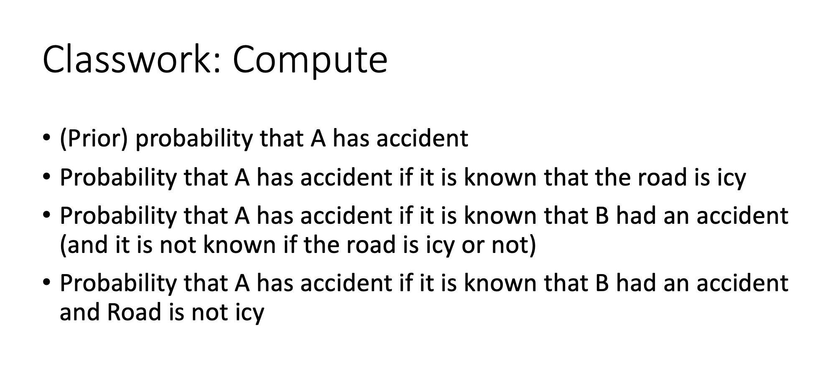
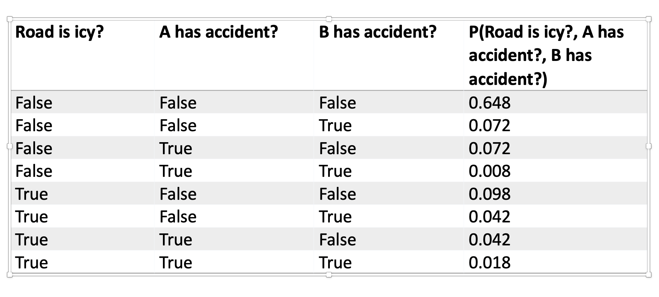
P(A=true):
P(+a|+icy)P(+icy) + P(+a|¬icy)P(¬icy) = (0.3)(0.2) + (0.1)(0.8) = 0.06 + 0.08 = 0.14
0.072 + 0.008 + 0.042 + 0.018 = 0.14

P(A=true | Road=icy) = 0.3

P(A=true | B=true) = 0.026 / 0.14 = 13/70 ≈ 0.186

P(A=true | B=true, Road=false) = 0.008 / (0.072 + 0.008) = 0.008/0.080 = 0.1 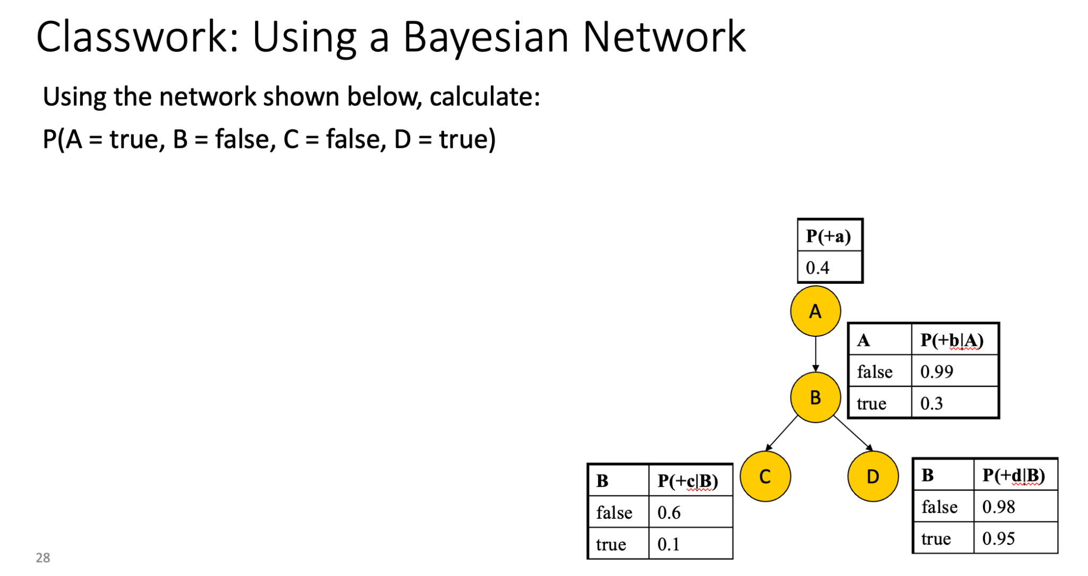

P(+a) |  | 0.4
P(¬b | +a) | complement of P(+b|A=true) = 0.3 inverse 1−0.3 | 0.7
P(¬c | ¬b) | complement of P(+c|B=false) = 0.6 inverse 1−0.6 | 0.4
P(+d | ¬b) |  | 0.98
.4 * .7 * .4 * .98 = 0.10976

Markovs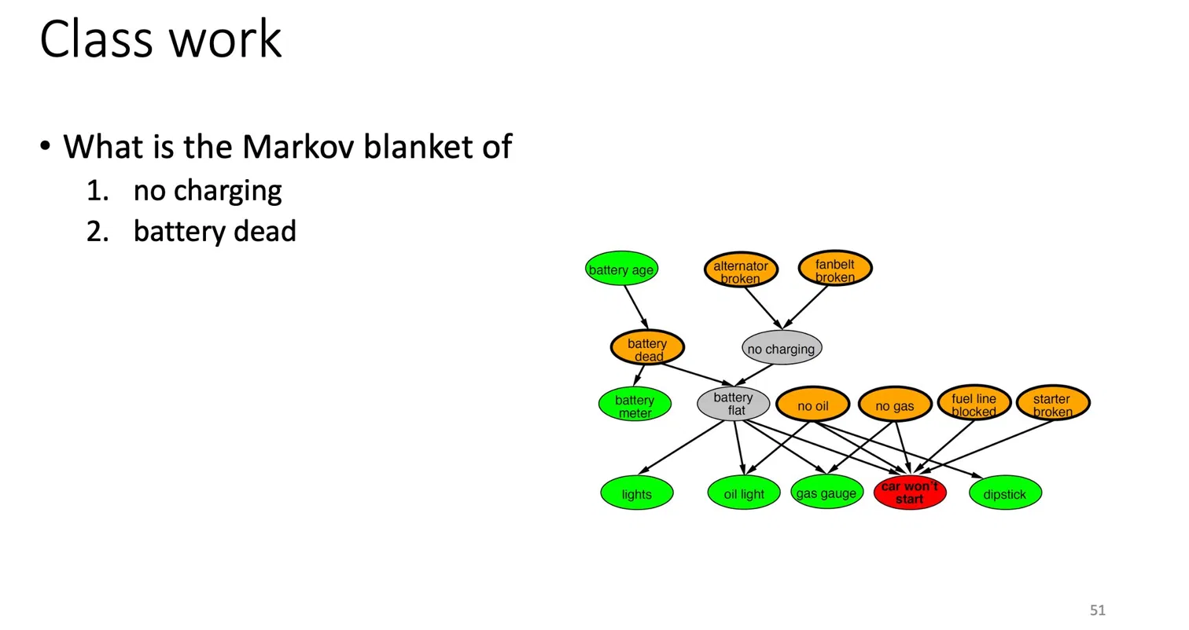

- No Charging: All of the inputs are alternator broken and fanbelt broken. The outputs is only battery life. Total of 3
- Battery Dead: Total 3

