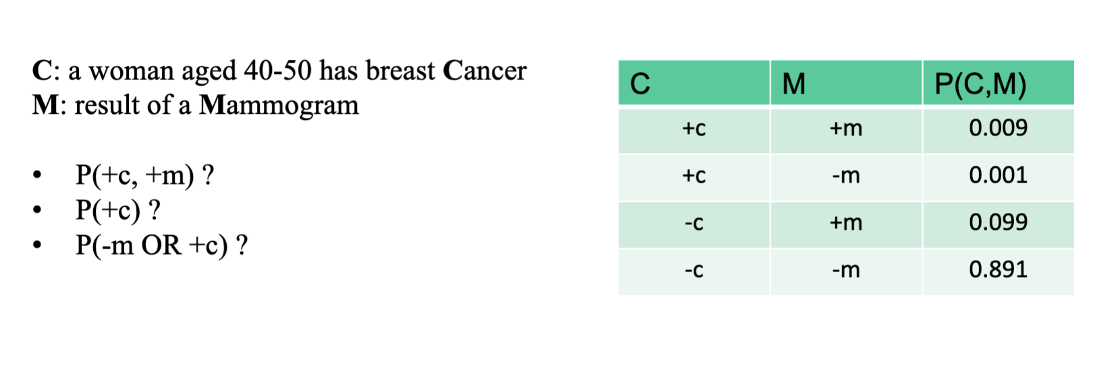
- Direct Lookup P(+c, +m) = read from table → 0.009
- Marginalization: 0.009+0.001=0.010
- Inclusion-Exclusion: P(−mu+c)=0.892+0.010−0.001=0.90

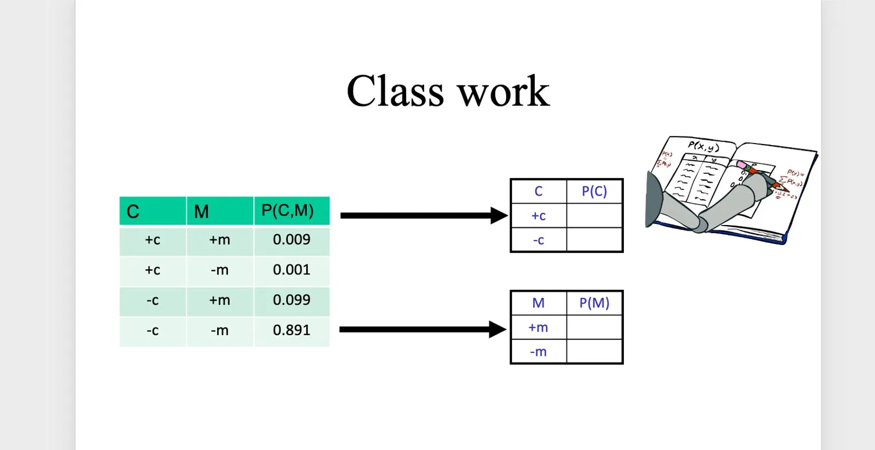

+------+-------+-------------------------+  | C | P(C) | Calculation |  +------+-------+-------------------------+  | +c | 0.010 | 0.009 + 0.001 |  | -c | 0.990 | 0.099 + 0.891 |  +------+-------+-------------------------+  | SUM | 1.000| | | +------+-------+-------------------------+  | M | P(M) | Calculation |  +------+-------+-------------------------+  | +m | 0.108 | 0.009 + 0.099 |  | -m | 0.892 | 0.001 + 0.891 |  +------+-------+-------------------------+  | SUM|1.000| |  +------+-------+-------------------------+
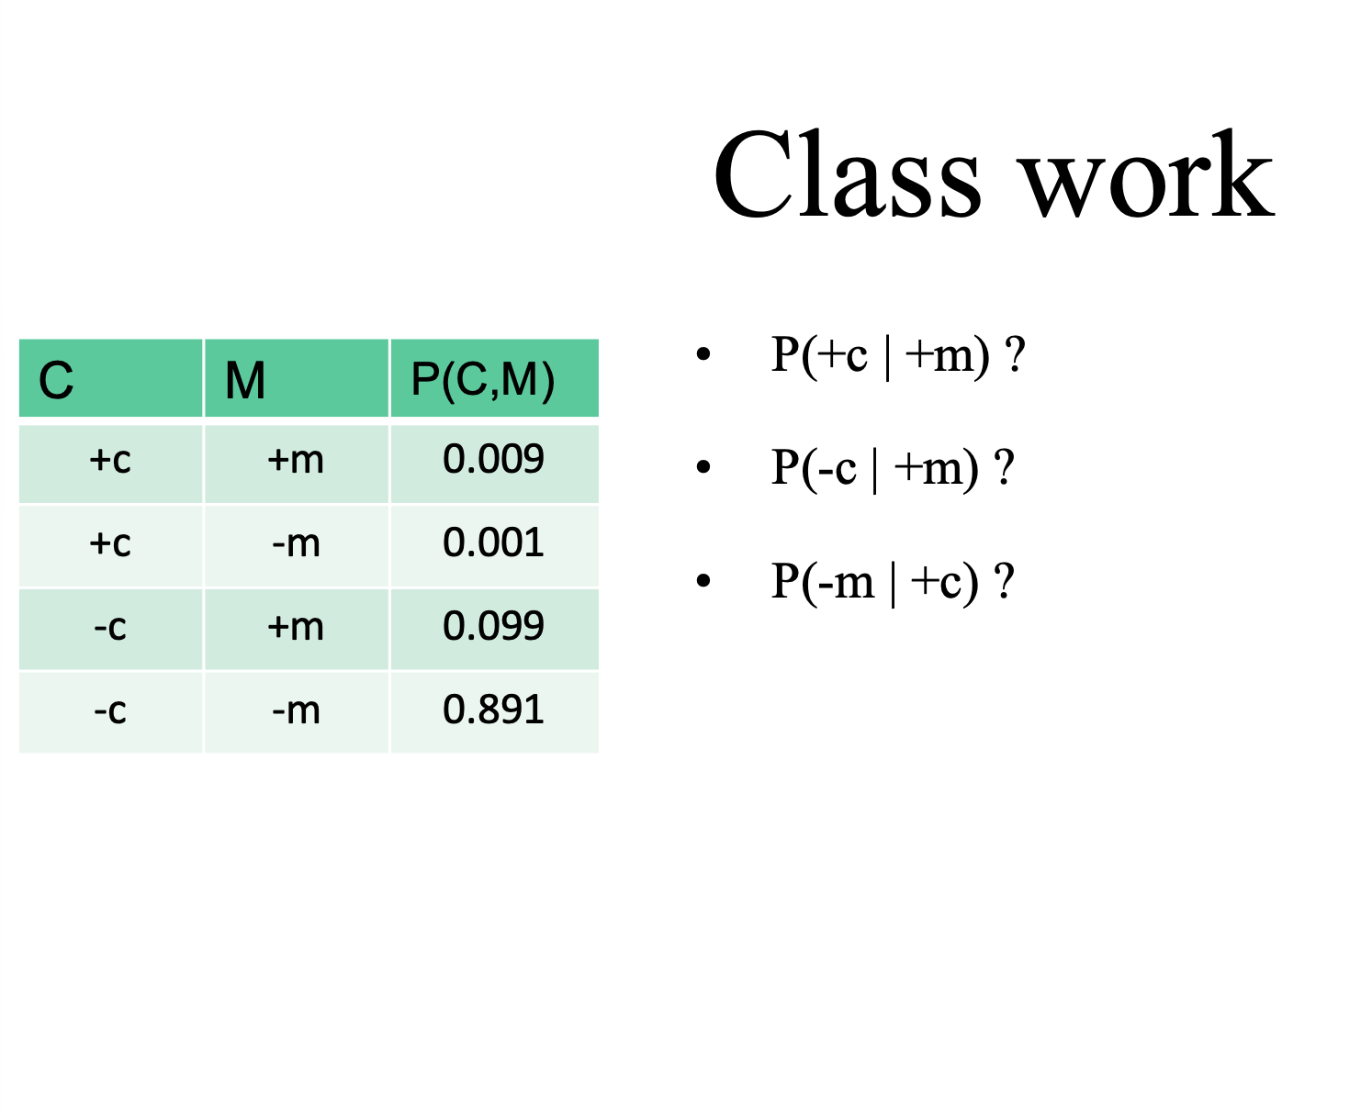

P(+c | +m) = P(+c, +m) / P(+m) = 0.009 / 0.108 = 0.0833
P(-c | +m) = P(-c, +m) / P(+m) = 0.099 / 0.108 = 0.9167
P(-m | +c) = P(-m, +c) / P(+c) = 0.001 / 0.010 = 0.100

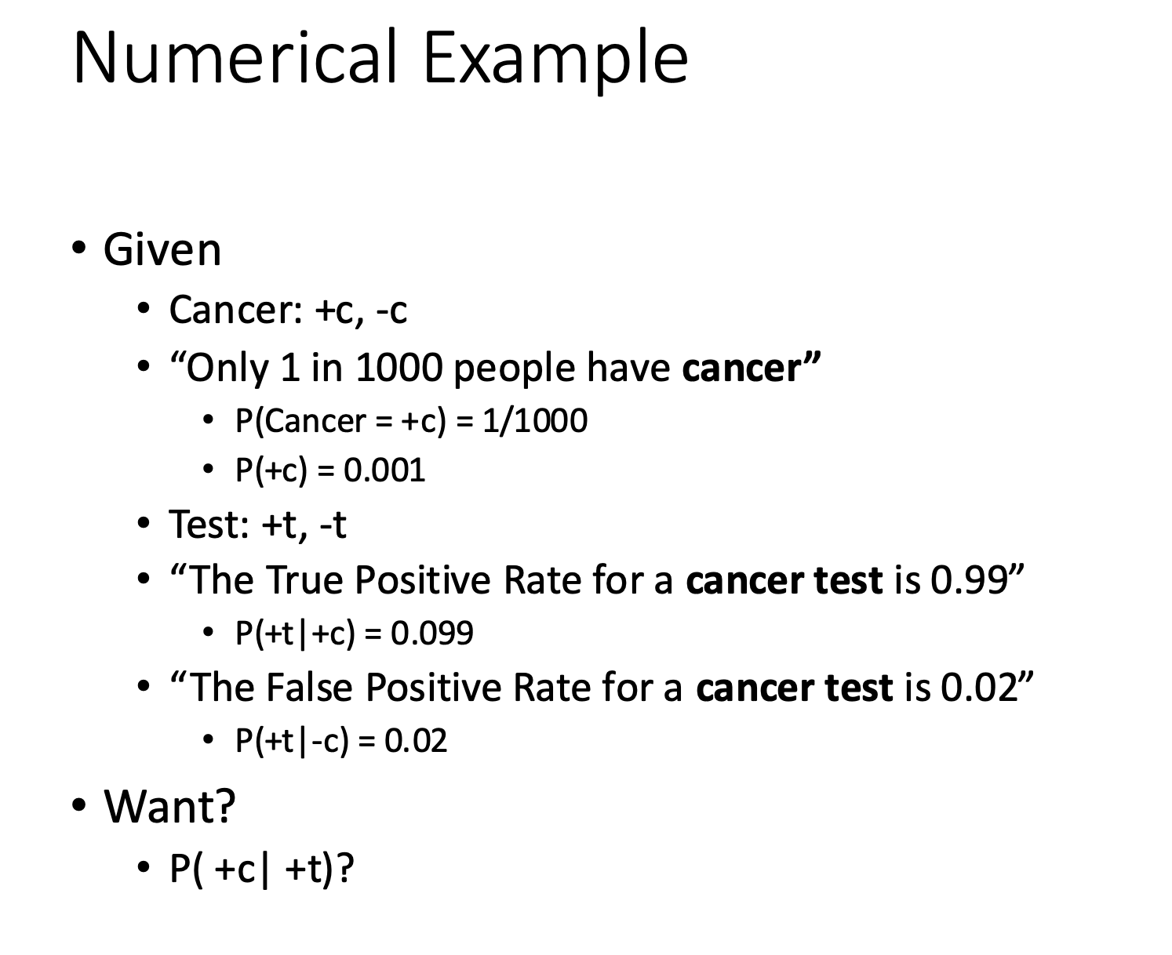

ANSWER: P(+c | +t) ≈ 4.7%

Even with a 99% accurate test,
only 4.7% of positive results
are actual cancer cases.

Why so low? Because cancer is
so rare (0.1%) that false positives
(2% of 99.9%) drown out true positives.

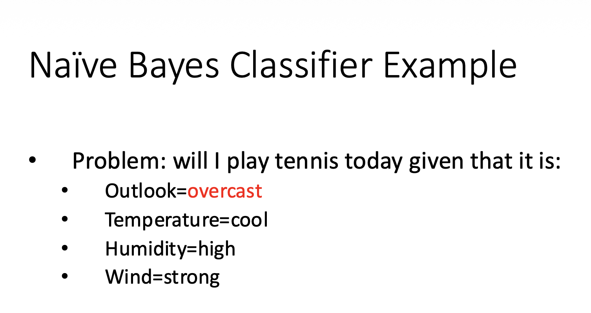

COUNTS FROM TRAINING DATA:
+----------+---------+--------+
| Feature | P(f|yes)| P(f|no)|
+----------+---------+--------+
| overcast | 4/9 | 0/5 |
| cool | 3/9 | 1/5 |
| high | 3/9 | 4/5 |
| strong | 3/9 | 3/5 |
+----------+---------+--------+

P(yes) = 9/14 * 4/9 * 3/9 * 3/9 * 3/9 = 0.01058
P(no) = 5/14 * 0/5 * 1/5 * 4/5 * 3/5 = 0.0

Answer: YES (but zero probability problem exists for P(overcast|no))
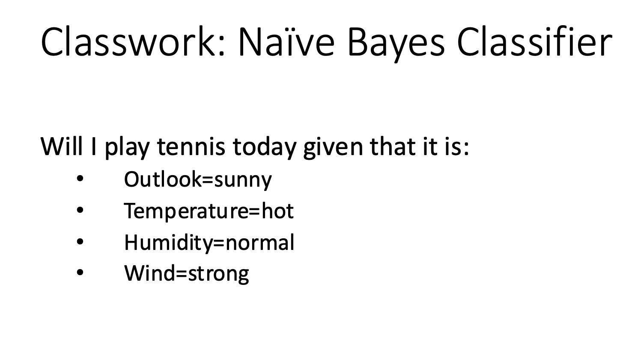
YES days: 3,4,5,7,9,10,11,12,13 = 9 total
NO days: 1,2,6,8,14 = 5 total

P(yes) = 9/14 * 2/9(sunny) * 2/9 (hot)* 6/9(normal) * 3/9(strong) = 0.643 * 0.222 * 0.222 * 0.667 * 0.333
= 0.00706

P(no) = 5/14 * ⅗ not sunny* 2/5 (not hot) * ⅕ not normal * ⅗(not strong) = 0.357 * 0.600 * 0.400 * 0.200 * 0.600
= 0.01029

P(yes | conditions) = 0.00706 / 0.01735 = 40.7%
P(no | conditions) = 0.01029 / 0.01735 = 59.3%

ANSWER → NO, don't play tennis (59.3%)

Sunny + hot + normal humidity + strong wind historically leads to not playing.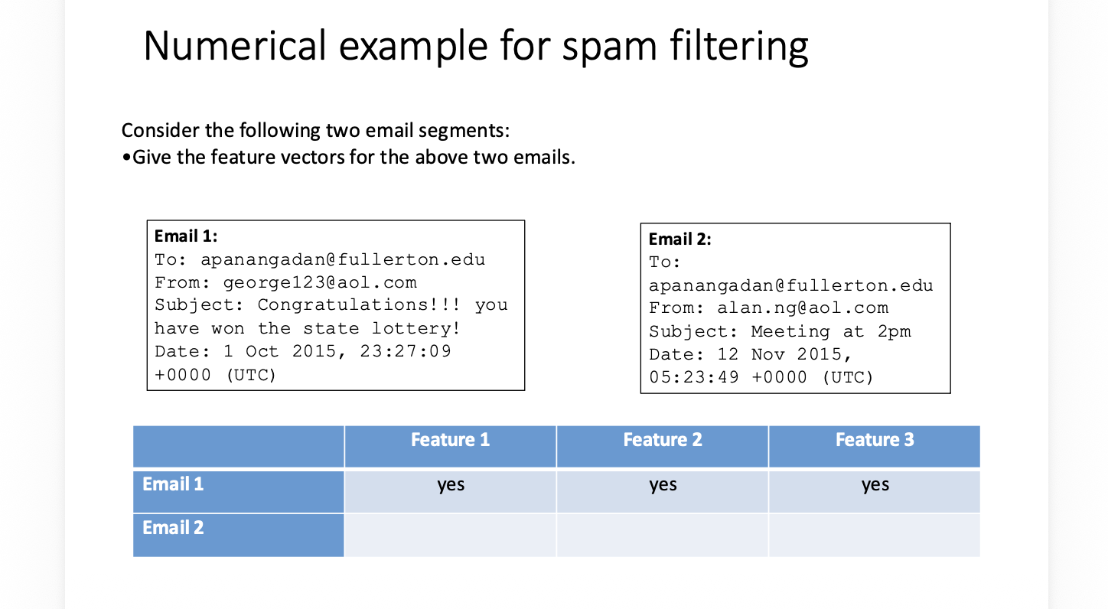
GIVEN:
P(spam) = 0.70
P(not spam) = 0.30

Feature 1: domain = aol.com
P(F1=yes | spam) = 0.4
P(F1=yes | not spam) = 0.2

Feature 2: username has numbers
P(F2=yes | spam) = 0.8
P(F2=yes | not spam) = 0.4

Feature 3: subject has !
P(F3=yes | spam) = 0.8
P(F3=yes | not spam) = 0.1

