Dataset | Originally | Rows | Columns | Purpose
Iris | Collected by Edgar Anderson and then popularized by Ronald A Fisher 2k page | 150 | 5 (4 features + species) | Predict species setosa, versicolor virginica
MNIST | Yann LeCun, Corinna cortes, Christopher Burges, assembled from NIST databases of digits written by US Consensus Bureau | 70k (60k train + 10 K test) | 784 features (28 x 28 pixels) + 1 label | Predict the digit 0-9
Pima Indians Diabetes | National Insitute of Diabetes and Digestive and kidney Diseases | 768 ( all females > 21 years) | 9 (8 features + 1 outcome ) | Predict Outcome diabetes within 5 years (0/1)
Auto MPG | StatLib library at Carnegie Mellon by Ross Quinlan | 398 (or 392 after drooping some missing data from rows) | 9 (mpg + 7 numeric features + car name) | Predict mpg fuel efficiency (regression)
Titanic | Passenger records from the British Board of Trade inquiry used by Kaggle | 891 (train.csv) or 1309 if dont correctly | 12 | Predict Survived (binary 0/1)
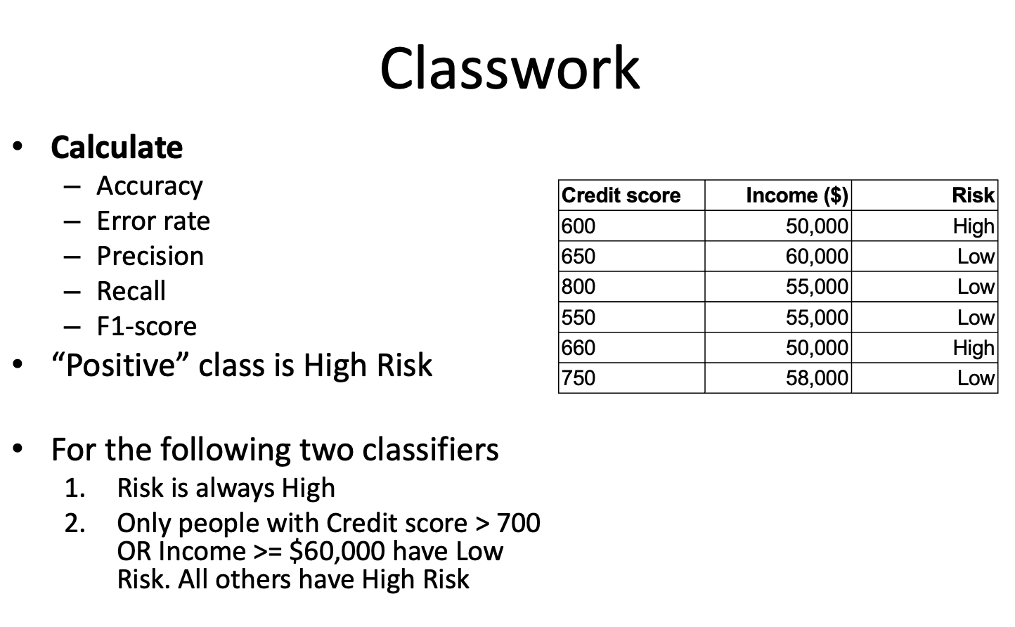

 | Pred high | Pred Low
Actual High | TP = 2 | FN = 0
Actual Low | FP = 2 | TN = 0

Accuracy: 2 + 0 / 6 = 33.3%
Error Rate = 1 - 0.333 = 4/6 66.7%
Precision = 2 / 2 + 4 = 33.3%
Recall = 2 / 2 + 0 = 100%
F1 = 2(0.333)(1.0)/(0.333+1.0) = .5 50%

What if you classify as low:

 | Pred high | Pred Low
Actual High | TP = 2 | FN = 0
Actual Low | FP = 1 | TN = 3

Accuracy: 2 + 3 / 6 = 0.833
Error Rate = 1 - 0.833 = 16.7%
Precision = 2 / 2 + 1 = 66.7%
Recall = 2 / 2 + 0 = 100%
F1 = 2(0.667)(1.0)/(0.667+1.0) = 0.8 80%

