𝘼 𝙋𝙍𝙊𝙐𝘿 𝙈𝙊𝙈𝙀𝙉𝙏 𝙏𝙊 𝘾𝙀𝙇𝙀𝘽𝙍𝘼𝙏𝙀!
The Computer Studies Society proudly extends its warmest congratulations to our esteemed faculty member, Ma’am Aliza Lyca Gonzales-Lacson, on her well-deserved achievement of earning her Master of Science in Computer Science (MSCS)!
On behalf of the Computer Studies Society, we are immensely proud of you, Ma’am Lyca! Your achievement is not only a personal milestone but also an inspiration to your students, colleagues, and the entire Computer Studies community.
𝘾𝙤𝙣𝙜𝙧𝙖𝙩𝙪𝙡𝙖𝙩𝙞𝙤𝙣𝙨, 𝙈𝙖’𝙖𝙢 𝘼𝙡𝙞𝙯𝙖 𝙇𝙮𝙘𝙖 𝙂𝙤𝙣𝙯𝙖𝙡𝙚𝙨-𝙇𝙖𝙘𝙨𝙤𝙣!
#CongratulationsMaamLyca
#MasterOfScienceInComputerScience
#ComputerStudiesSociety
#MichaeleanInnovators
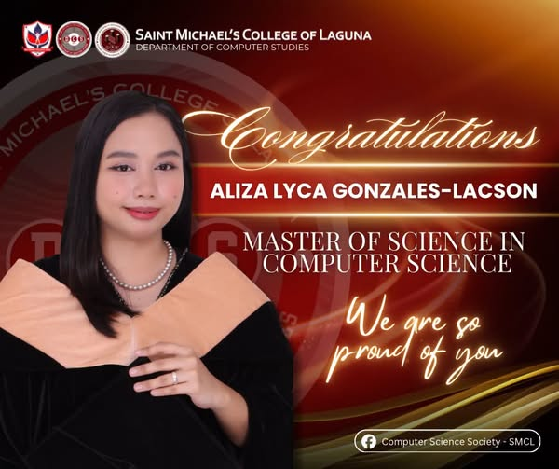
===============================================================================
𝐇𝐔𝐄𝐅𝐄𝐒𝐓: 𝐓𝐇𝐄 𝐏𝐋𝐀𝐘𝐋𝐈𝐒𝐓 𝐎𝐅 𝐎𝐔𝐑 𝐆𝐄𝐍𝐄𝐑𝐀𝐓𝐈𝐎𝐍
𝐓𝐡𝐞 𝐩𝐥𝐚𝐲𝐥𝐢𝐬𝐭 𝐢𝐬 𝐬𝐞𝐭. 𝐓𝐡𝐞 𝐜𝐨𝐥𝐨𝐫𝐬 𝐚𝐫𝐞 𝐫𝐞𝐚𝐝𝐲. 𝐀𝐧𝐝 𝐧𝐨𝐰, 𝐢𝐭’𝐬 𝐭𝐢𝐦𝐞 𝐭𝐨 𝐦𝐚𝐤𝐞 𝐬𝐨𝐦𝐞 𝐦𝐞𝐦𝐨𝐫𝐢𝐞𝐬, 𝐌𝐢𝐜𝐡𝐚𝐞𝐥𝐞𝐚𝐧𝐬!
Get ready to sing your heart out, dance like nobody’s watching, and meet the people who might just become your favorite part of this school year. From the first beat to the last song, HUEFest is where every vibe, every color, and every Michaelean comes together.
Because every generation has a playlist — and this one is ours.
𝐒𝐨, 𝐌𝐢𝐜𝐡𝐚𝐞𝐥𝐞𝐚𝐧𝐬, 𝐚𝐫𝐞 𝐲𝐨𝐮 𝐫𝐞𝐚𝐝𝐲 𝐭𝐨 𝐩𝐫𝐞𝐬𝐬 𝐏𝐋𝐀𝐘?
#TEDMeetandMingle2026
#HUEFest2026ThePlaylistOfOurGeneration
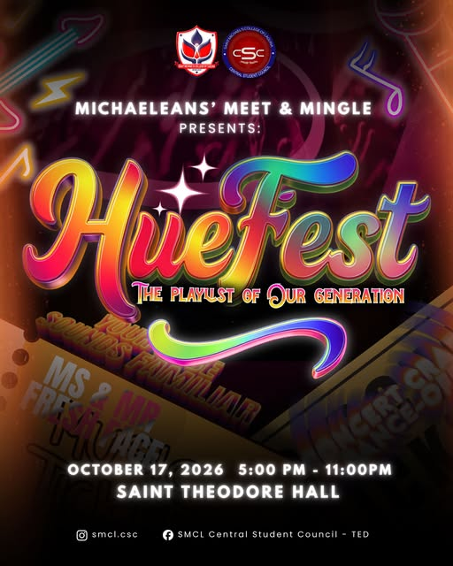
===============================================================================
LOOK | Saint Michael’s College of Laguna’s Angelic Innovators secured the 1st Runner-Up title and a ₱50,000 prize at the 5th Annual Poland-Philippines IT Business Summit: 24-Hour Hackathon 2026, held from October 6 to 7 at iACADEMY in Makati City.
The team, composed of Nicolas Emanuel R. Santos, Josh Ariad P. Dilla, John Gabriel P. Galino, Don Gabriel M. Dolate, and King Robby I. Flores, represented SMCL in a 24-hour competition challenging student innovators to develop technological solutions for real-world urban challenges.
Organized through a Poland-Philippines collaboration, the summit brought together technology, business, and young Filipino innovators under one platform.
The event also highlighted and welcomed the President of the Republic of Poland Karol Nawrocki who personally greeted the participants and witnessed their project building firsthand.
Angelic Innovators claimed the 1st Runner-up title, just behind iACADEMY’s Lakad Kinetic Development, which bagged the ₱100,000 Grand Prize Champion title.
This achievement highlighted the contribution of SMCL’s Computer Science Department with three of its students among the five members guiding the team throughout the competition.
With their 24-hour challenge ending in a spot among the competition’s top teams, Angelic Innovators proudly carried SMCL’s name and the Biñan pride onto the hackathon stage.
Congratulations, Angelic Innovators!
Written by: Don Gabriel Dolatre
Photos from: @prezydent_pl IG, iAcademy, and Don Gabriel Dolatre
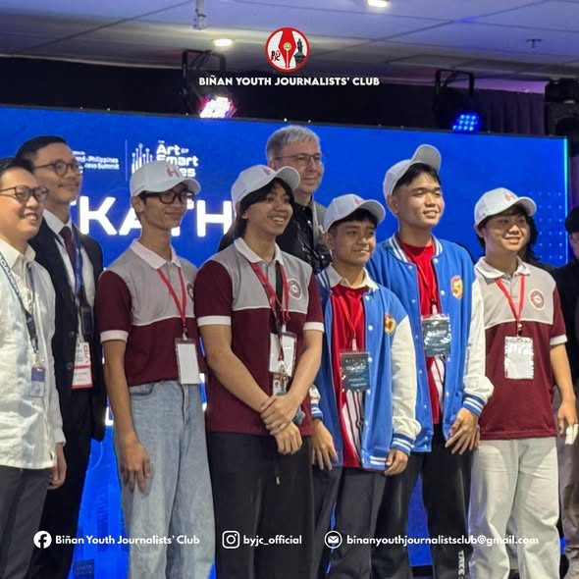
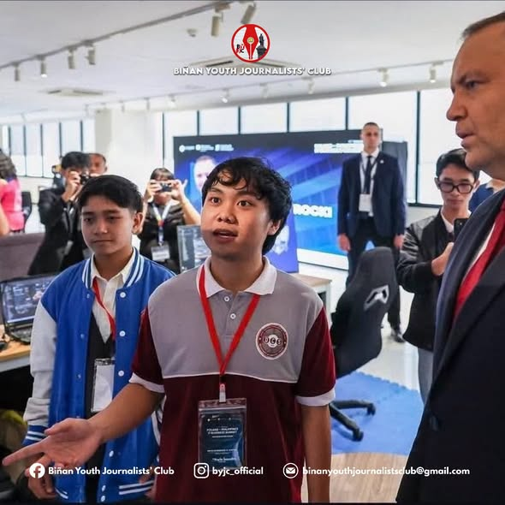
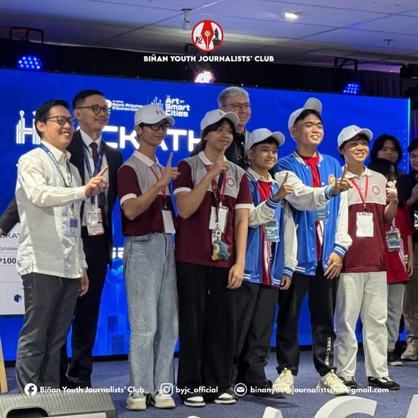
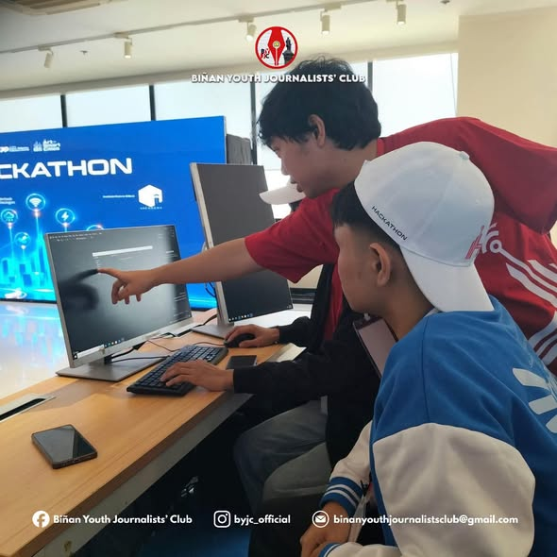
===============================================================================
𝗟𝗘𝗩𝗘𝗟 𝗨𝗣 𝗬𝗢𝗨𝗥 𝗜𝗗𝗘𝗔𝗦, 𝗖𝗥𝗘𝗔𝗧𝗘 𝗬𝗢𝗨𝗥 𝗙𝗨𝗧𝗨𝗥𝗘!
Are you tired of doomscrolling and losing track of time? Instead of fighting against technology, how can we use it to our advantage?
As part of 𝗦𝗕𝗠𝗜𝗧 𝗙𝗲𝘀𝘁 𝟮𝟬𝟮𝟲, the 𝗗𝗲𝗽𝗮𝗿𝘁𝗺𝗲𝗻𝘁 𝗼𝗳 𝗖𝗼𝗺𝗽𝘂𝘁𝗲𝗿 𝗦𝘁𝘂𝗱𝗶𝗲𝘀 (𝗗𝗖𝗦) brings you 𝗧𝗵𝗲 𝗗𝗖𝗦 𝗜𝗻𝗻𝗼𝘃𝗮𝘁𝗶𝗼𝗻 𝗖𝗼𝗻𝘁𝗲𝘀𝘁! We are challenging all Junior High School and Senior High School students to think outside the box and present creative, tech-based solutions to combat digital fatigue and boost student productivity.
Got an idea for a cool app, study tool, or smart hack? Gather your crew and turn those ideas into reality!
𝗛𝗢𝗪 𝗧𝗢 𝗝𝗢𝗜𝗡:
1. 𝗧𝗲𝗮𝗺 𝗨𝗽: Form a group of 𝟯 𝗺𝗲𝗺𝗯𝗲𝗿𝘀 from your school (JHS or SHS category).
2. 𝗕𝗿𝗮𝗶𝗻𝘀𝘁𝗼𝗿𝗺 & 𝗗𝗲𝘀𝗶𝗴𝗻: Answer the innovation question and prepare a title, brief description, process flow, and a 𝟭-𝗺𝗶𝗻𝘂𝘁𝗲 𝗽𝗿𝗼𝘁𝗼𝘁𝘆𝗽𝗲 𝘃𝗶𝗱𝗲𝗼 (paper sketches, Canva mock-ups, or clickable slides are all welcome—no complex coding required!).
3. 𝗦𝘂𝗯𝗺𝗶𝘁: Upload your details and entry on or before the deadline.
𝗪𝗛𝗔𝗧’𝗦 𝗜𝗡 𝗜𝗧 𝗙𝗢𝗥 𝗬𝗢𝗨?
• 𝗖𝗮𝘀𝗵 𝗣𝗿𝗶𝘇𝗲: ₱3,000.00 for the winning team!
• 𝗥𝗲𝗰𝗼𝗴𝗻𝗶𝘁𝗶𝗼𝗻: Showcased during SBMIT Fest and featured on the official Computer Science Society Facebook page.
• 𝗜𝗺𝗽𝗮𝗰𝘁: Help your fellow students reclaim their focus and level up their study habits!
𝗦𝗨𝗕𝗠𝗜𝗦𝗦𝗜𝗢𝗡 𝗗𝗘𝗔𝗗𝗟𝗜𝗡𝗘: October 23, 2026 | 11:59 PM
𝗪𝗜𝗡𝗡𝗘𝗥 𝗔𝗡𝗡𝗢𝗨𝗡𝗖𝗘𝗠𝗘𝗡𝗧: October 28, 2026 (SBMIT Fest)
𝗦𝗨𝗕𝗠𝗜𝗧 𝗬𝗢𝗨𝗥 𝗘𝗡𝗧𝗥𝗬 𝗛𝗘𝗥𝗘: https://forms.gle/wwnVtanCvenRSeg67
𝙁𝙤𝙧 𝙢𝙤𝙧𝙚 𝙙𝙚𝙩𝙖𝙞𝙡𝙨 𝙖𝙗𝙤𝙪𝙩 𝙨𝙪𝙗𝙢𝙞𝙨𝙨𝙞𝙤𝙣 𝙢𝙚𝙘𝙝𝙖𝙣𝙞𝙘𝙨 𝙖𝙣𝙙 𝙜𝙚𝙣𝙚𝙧𝙖𝙡 𝙜𝙪𝙞𝙙𝙚𝙡𝙞𝙣𝙚𝙨, 𝙘𝙡𝙞𝙘𝙠 𝙝𝙚𝙧𝙚: https://bit.ly/4xvM3N5
Free registration. Bring your best ideas—let’s innovate together!
#SBMITFest2026
#DCSInnovationContest
#LevelUpYourIdeas
#DepartmentofComputerStudies
#SMCL


