SCHOOL NEWS
𝗥𝗜𝗦𝗜𝗡𝗚 𝗧𝗢 𝗧𝗛𝗘 𝗢𝗖𝗖𝗔𝗦𝗜𝗢𝗡
Congratulations to the 𝗔𝗥𝗖𝗛𝗔𝗡𝗚𝗘𝗟𝗦 𝗩𝗢𝗟𝗟𝗘𝗬𝗕𝗔𝗟𝗟 𝗧𝗘𝗔𝗠 for their outstanding performance at the 𝗕𝗿𝗲𝗻𝘁 𝗩𝗼𝗹𝗹𝗲𝘆𝗯𝗮𝗹𝗹 𝗣𝗼𝗰𝗸𝗲𝘁 𝗧𝗼𝘂𝗿𝗻𝗮𝗺𝗲𝗻𝘁 𝟮𝟬𝟮𝟲!
𝗗𝗶𝘃𝗶𝘀𝗶𝗼𝗻 𝟮 𝗛𝗶𝗴𝗵 𝗦𝗰𝗵𝗼𝗼𝗹 𝗕𝗼𝘆𝘀 — 𝟭𝘀𝘁 𝗥𝘂𝗻𝗻𝗲𝗿-𝗨𝗽
𝗗𝗶𝘃𝗶𝘀𝗶𝗼𝗻 𝟮 𝗛𝗶𝗴𝗵 𝗦𝗰𝗵𝗼𝗼𝗹 𝗚𝗶𝗿𝗹𝘀 — 𝟭𝘀𝘁 𝗥𝘂𝗻𝗻𝗲𝗿-𝗨𝗽
This achievement reflects the teams’ dedication, teamwork, and determination on the court. Congratulations, Archangels, on this well-earned finish!
The entire SMCL Family is proud of all of you!
#SMCLAmazingAngels #OurHomeandPride #ChampioningExcellence #MichaeleanPride

===============================================================================
𝗠𝗜𝗖𝗛𝗔𝗘𝗟𝗘𝗔𝗡 𝗜𝗡𝗡𝗢𝗩𝗔𝗧𝗜𝗢𝗡 𝗔𝗡𝗗 𝗘𝗫𝗖𝗘𝗟𝗟𝗘𝗡𝗖𝗘
Congratulations to 𝗔𝗻𝗴𝗲𝗹𝗶𝗰 𝗜𝗻𝗻𝗼𝘃𝗮𝘁𝗼𝗿𝘀 for securing 𝟭𝘀𝘁 𝗥𝘂𝗻𝗻𝗲𝗿-𝗨𝗽 and receiving a 𝗣𝗵𝗣 𝟱𝟬,𝟬𝟬𝟬 𝗰𝗮𝘀𝗵 𝗽𝗿𝗶𝘇𝗲 at the 𝗶𝗔𝗰𝗮𝗱𝗲𝗺𝘆 𝟮𝟰-𝗛𝗼𝘂𝗿 𝗛𝗮𝗰𝗸𝗮𝘁𝗵𝗼𝗻, held on October 6–7, 2026, at the iACADEMY Nexus Campus in Makati City!
𝗦𝗽𝗲𝗰𝗶𝗮𝗹 𝗔𝘄𝗮𝗿𝗱𝘀:
- 𝟭𝘀𝘁 𝗙𝘂𝗻𝗰𝘁𝗶𝗼𝗻𝗮𝗹 𝗣𝗿𝗼𝘁𝗼𝘁𝘆𝗽𝗲
- 𝗕𝗲𝘀𝘁 𝗶𝗻 𝗟𝗶𝘃𝗲 𝗗𝗲𝗺𝗼𝗻𝘀𝘁𝗿𝗮𝘁𝗶𝗼𝗻
- 𝗕𝗲𝘀𝘁 𝗶𝗻 𝗥𝗲𝗮𝗹-𝗪𝗼𝗿𝗹𝗱 𝗔𝗽𝗽𝗹𝗶𝗰𝗮𝘁𝗶𝗼𝗻
𝗧𝗵𝗲 𝗔𝗻𝗴𝗲𝗹𝗶𝗰 𝗜𝗻𝗻𝗼𝘃𝗮𝘁𝗼𝗿𝘀:
• 𝗡𝗶𝗰𝗼𝗹𝗮𝘀 𝗘𝗺𝗮𝗻𝘂𝗲𝗹 𝗦𝗮𝗻𝘁𝗼𝘀 – BSCS, 3rd Year
• 𝗝𝗼𝗵𝗻 𝗚𝗮𝗯𝗿𝗶𝗲𝗹 𝗚𝗮𝗹𝗶𝗻𝗼 – ACT, 2nd Year
• 𝗝𝗼𝘀𝗵 𝗔𝗿𝗶𝗮𝗱 𝗣. 𝗗𝗶𝗹𝗹𝗮 – ACT, 2nd Year
• 𝗞𝗶𝗻𝗴 𝗥𝗼𝗯𝗯𝘆 𝗜. 𝗙𝗹𝗼𝗿𝗲𝘀 – Senior High School, Grade 11
• 𝗗𝗼𝗻 𝗚𝗮𝗯𝗿𝗶𝗲𝗹 𝗠. 𝗗𝗼𝗹𝗮𝘁𝗿𝗲 – Senior High School, Grade 11
With their adviser, 𝗗𝗿. 𝗔𝗻𝗻𝗮 𝗟𝗶𝘇𝗮 𝗔. 𝗥𝗮𝗺𝗼𝘀, the team demonstrated creativity, collaboration, and a commitment to developing innovative solutions.
The event was organized with the support of the Polish Investment and Trade Agency (PAIH), the Embassy of Poland in Manila, Spiderhook Inc., and iACADEMY.
The entire SMCL Family is proud of all of you!
#SMCLAmazingAngels #OurHomeandPride #ChampioningExcellence
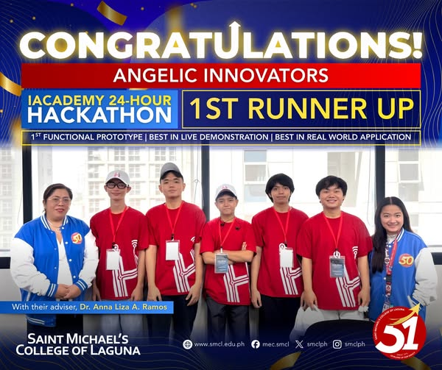
===============================================================================
𝗠𝗜𝗖𝗛𝗔𝗘𝗟𝗘𝗔𝗡 𝗘𝗫𝗖𝗘𝗟𝗟𝗘𝗡𝗖𝗘 𝗜𝗡 𝗣𝗦𝗬𝗖𝗛𝗢𝗟𝗢𝗚𝗬
Congratulations to our new 𝗠𝗶𝗰𝗵𝗮𝗲𝗹𝗲𝗮𝗻 𝗥𝗲𝗴𝗶𝘀𝘁𝗲𝗿𝗲𝗱 𝗣𝘀𝘆𝗰𝗵𝗼𝗺𝗲𝘁𝗿𝗶𝗰𝗶𝗮𝗻𝘀!
Our 𝗣𝘀𝘆𝗰𝗵𝗼𝗹𝗼𝗴𝘆 𝗴𝗿𝗮𝗱𝘂𝗮𝘁𝗲𝘀 achieved an outstanding 𝟭𝟬𝟬% 𝗽𝗮𝘀𝘀𝗶𝗻𝗴 𝗿𝗮𝘁𝗲 in the 𝗦𝗲𝗽𝘁𝗲𝗺𝗯𝗲𝗿 𝟮𝟬𝟮𝟲 𝗣𝘀𝘆𝗰𝗵𝗼𝗺𝗲𝘁𝗿𝗶𝗰𝗶𝗮𝗻 𝗟𝗶𝗰𝗲𝗻𝘀𝘂𝗿𝗲 𝗘𝘅𝗮𝗺𝗶𝗻𝗮𝘁𝗶𝗼𝗻 (𝗣𝗺𝗟𝗘), surpassing the 𝟵𝟭.𝟳𝟮% 𝗻𝗮𝘁𝗶𝗼𝗻𝗮𝗹 𝗽𝗮𝘀𝘀𝗶𝗻𝗴 𝗿𝗮𝘁𝗲.
Continue to shine in your profession and uphold the values of excellence, compassion, and service. You are our pride!
#SMCLAmazingAngels #OurHomeandPride #ChampioningExcellence #MichaeleanPride #PMLE2026 #RegisteredPsychometricians
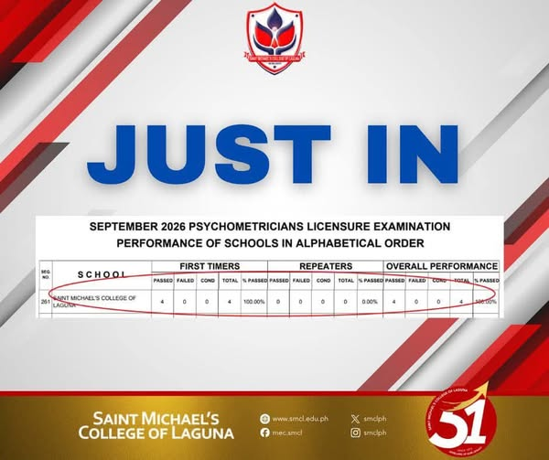
===============================================================================
The entire Michaelean Community joins the Christendom in honoring the Archangels on their feast day, September 29, 2026, through the celebration of Michaelmas at Saint Theodore Hall. The celebration will be presided over by Msgr. Mario Rafael Castillo.
In observance of the feast, September 30, 2026 will be a self-directed day. There will be no onsite business transactions, and entry to the school campus will be restricted.
May the intercession of Saint Michael the Archangel continue to guide, protect, and inspire the entire Michaelean Community.
Happy Feast of Saint Michael the Archangel!
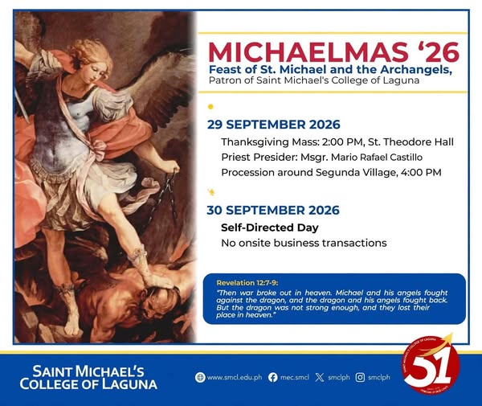
===============================================================================
We are honored to introduce 𝗗𝗿. 𝗔𝗴𝗻𝗲𝘀 𝗟. 𝗟𝗹𝗮𝗺𝗮𝘀𝗮𝗿𝗲𝘀-𝗖𝗮𝘀𝘁𝗶𝗹𝗹𝗼 as the keynote speaker for the 𝟳𝘁𝗵 𝗠𝗶𝗹𝗮𝗴𝗿𝗼𝘀 𝗟. 𝗟𝗶𝗺𝗮𝗰𝗼 𝗠𝗲𝗺𝗼𝗿𝗶𝗮𝗹 𝗣𝗮𝗽𝗲𝗿 𝗣𝗿𝗲𝘀𝗲𝗻𝘁𝗮𝘁𝗶𝗼𝗻.
With her extensive experience in research and academe, she brings valuable expertise and insights that will enrich this celebration of research, innovation, and academic excellence.
𝗔𝗴𝗻𝗲𝘀 𝗟. 𝗟𝗹𝗮𝗺𝗮𝘀𝗮𝗿𝗲𝘀-𝗖𝗮𝘀𝘁𝗶𝗹𝗹𝗼, 𝗣𝗵.𝗗, 𝗥𝗣𝗵
Professor, University of Santo Tomas, Manila, Philippines
Researcher, Research Center for the Natural and Applied Sciences, UST
Research Awardee – FACES of PACOP (2025)
NRCP Achievement Awardee – Division IV, Pharmaceutical Sciences (2025)
𝗢𝗰𝘁𝗼𝗯𝗲𝗿 𝟵, 𝟮𝟬𝟮𝟲
𝟴:𝟬𝟬 𝗔𝗠–𝟰:𝟬𝟬 𝗣𝗠
𝗦𝗮𝗶𝗻𝘁 𝗧𝗵𝗲𝗼𝗱𝗼𝗿𝗲 𝗛𝗮𝗹𝗹
We look forward to an inspiring exchange of knowledge and ideas as we continue to advance research excellence through innovation and collaboration.
#SMCLAmazingAngels #OurHomeandPride #ChampioningExcellence #7thMilagrosLLimacoMemorialPaperPresentation #LevellingUpOurLegacy
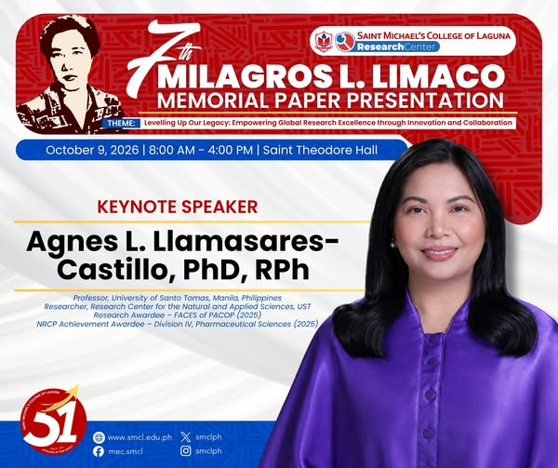
===============================================================================
𝐁𝐄𝐘𝐎𝐍𝐃 𝐓𝐇𝐄 𝐂𝐎𝐋𝐃, 𝐌𝐈𝐂𝐇𝐀𝐄𝐋𝐄𝐀𝐍𝐒 𝐅𝐎𝐔𝐍𝐃 𝐓𝐇𝐄𝐈𝐑 𝐅𝐈𝐑𝐄 𝐈𝐍 𝐁𝐀𝐆𝐔𝐈𝐎.
Three Michaeleans journeyed to Baguio carrying more than just their names — they carried SMCL, CALABARZON, and the courage to take their place on the national stage. They returned home with stories worth telling, experiences worth remembering, and achievements worth celebrating.
𝐑𝐞𝐚𝐝 𝐭𝐡𝐞𝐢𝐫 𝐬𝐭𝐨𝐫𝐲. 𝐅𝐢𝐧𝐝 𝐭𝐡𝐞𝐢𝐫 𝐟𝐢𝐫𝐞. 𝐌𝐚𝐲𝐛𝐞, 𝐢𝐠𝐧𝐢𝐭𝐞 𝐲𝐨𝐮𝐫𝐬.
#BIDABayani
#BeTheChange
#PITLC2026
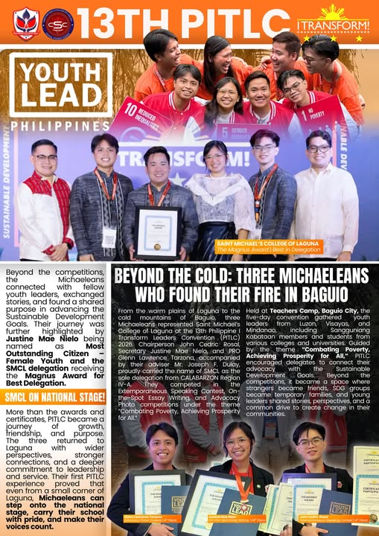
===============================================================================
𝗠𝗜𝗖𝗛𝗔𝗘𝗟𝗘𝗔𝗡 𝗘𝗫𝗖𝗘𝗟𝗟𝗘𝗡𝗖𝗘 𝗜𝗡 𝗣𝗦𝗬𝗖𝗛𝗢𝗟𝗢𝗚𝗬
Congratulations to our new 𝗠𝗶𝗰𝗵𝗮𝗲𝗹𝗲𝗮𝗻 𝗥𝗲𝗴𝗶𝘀𝘁𝗲𝗿𝗲𝗱 𝗣𝘀𝘆𝗰𝗵𝗼𝗺𝗲𝘁𝗿𝗶𝗰𝗶𝗮𝗻𝘀!
Our 𝗣𝘀𝘆𝗰𝗵𝗼𝗹𝗼𝗴𝘆 𝗴𝗿𝗮𝗱𝘂𝗮𝘁𝗲𝘀 achieved an outstanding 𝟭𝟬𝟬% 𝗽𝗮𝘀𝘀𝗶𝗻𝗴 𝗿𝗮𝘁𝗲 in the 𝗦𝗲𝗽𝘁𝗲𝗺𝗯𝗲𝗿 𝟮𝟬𝟮𝟲 𝗣𝘀𝘆𝗰𝗵𝗼𝗺𝗲𝘁𝗿𝗶𝗰𝗶𝗮𝗻 𝗟𝗶𝗰𝗲𝗻𝘀𝘂𝗿𝗲 𝗘𝘅𝗮𝗺𝗶𝗻𝗮𝘁𝗶𝗼𝗻 (𝗣𝗺𝗟𝗘), surpassing the 𝟵𝟭.𝟳𝟮% 𝗻𝗮𝘁𝗶𝗼𝗻𝗮𝗹 𝗽𝗮𝘀𝘀𝗶𝗻𝗴 𝗿𝗮𝘁𝗲.
Continue to shine in your profession and uphold the values of excellence, compassion, and service. You are our pride!
#SMCLAmazingAngels #OurHomeandPride #ChampioningExcellence #MichaeleanPride #PMLE2026 #RegisteredPsychometricians
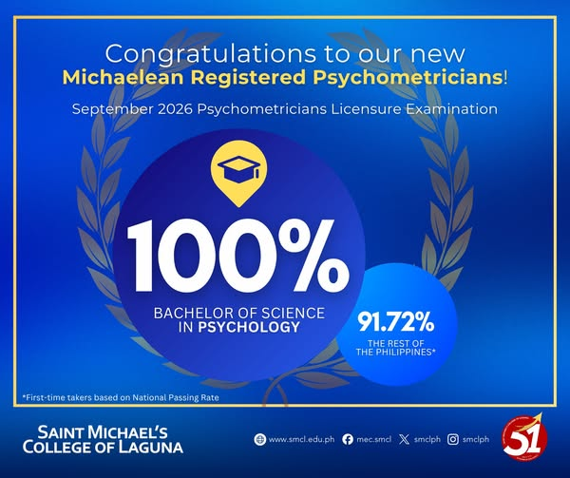
===============================================================================
Saint Michael’s College of Laguna, through the 𝗥𝗲𝘀𝗲𝗮𝗿𝗰𝗵 𝗖𝗲𝗻𝘁𝗲𝗿, presents the 𝟳𝘁𝗵 𝗠𝗶𝗹𝗮𝗴𝗿𝗼𝘀 𝗟. 𝗟𝗶𝗺𝗮𝗰𝗼 𝗠𝗲𝗺𝗼𝗿𝗶𝗮𝗹 𝗣𝗮𝗽𝗲𝗿 𝗣𝗿𝗲𝘀𝗲𝗻𝘁𝗮𝘁𝗶𝗼𝗻.
Guided by the theme, “𝗟𝗲𝘃𝗲𝗹𝗹𝗶𝗻𝗴 𝗨𝗽 𝗢𝘂𝗿 𝗟𝗲𝗴𝗮𝗰𝘆: 𝗘𝗺𝗽𝗼𝘄𝗲𝗿𝗶𝗻𝗴 𝗚𝗹𝗼𝗯𝗮𝗹 𝗥𝗲𝘀𝗲𝗮𝗿𝗰𝗵 𝗘𝘅𝗰𝗲𝗹𝗹𝗲𝗻𝗰𝗲 𝘁𝗵𝗿𝗼𝘂𝗴𝗵 𝗜𝗻𝗻𝗼𝘃𝗮𝘁𝗶𝗼𝗻 𝗮𝗻𝗱 𝗖𝗼𝗹𝗹𝗮𝗯𝗼𝗿𝗮𝘁𝗶𝗼𝗻,” the event highlights the importance of research in generating new knowledge, fostering innovation, and creating meaningful solutions for communities and society.
Join us as we bring together researchers and members of the academic community to share ideas, present meaningful research, and celebrate excellence in research and innovation.
𝗢𝗰𝘁𝗼𝗯𝗲𝗿 𝟵, 𝟮𝟬𝟮𝟲
𝟴:𝟬𝟬 𝗔𝗠–𝟰:𝟬𝟬 𝗣𝗠
𝗦𝗮𝗶𝗻𝘁 𝗧𝗵𝗲𝗼𝗱𝗼𝗿𝗲 𝗛𝗮𝗹𝗹
Let us come together to celebrate research that informs, inspires, and helps shape a better future.
#SMCLAmazingAngels #OurHomeandPride #ChampioningExcellence #7thMilagrosLLimacoMemorialPaperPresentation #LevellingUpOurLegacy


