Migration of .NET-to-.NET core and containerization using Docker and Kubernetes
Abhishek Hurakadli
Department of Computer Science, R V College of Engineering
Bengaluru
abhishekh.cs21@rvce.edu
Philips
Bengaluru, Karnataka, India
²second.a

Abstract— Legacy software systems often struggle to meet modern demands for scalability, cross-platform compatibility, and streamlined deployment. This paper presents a structured approach to modernizing such applications by migrating from the traditional .NET Framework to the lightweight and modular .NET Core platform. The migration process involves decoupling monolithic components, refactoring service logic, and enhancing maintainability through modular architecture. Following migration, the application is containerized using Docker, ensuring consistent behavior across development, testing, and production environments. Kubernetes is employed to orchestrate and manage these containers, enabling automated deployment, scaling, and fault tolerance. The proposed approach significantly improves deployment speed, resource utilization, and application resilience. Experimental results highlight the effectiveness of this strategy in aligning legacy applications with contemporary cloud-native practices.

Keywords— .NET Core, Legacy Application Migration, Containerization, Docker, Kubernetes, Microservices, Cloud-Native Architecture, Software Modernization, Orchestration, Application Scalability
- Introduction
Enterprise applications developed on the .NET Framework have long been foundational in many industries. However, as software requirements evolve toward microservices, containerization, and cloud-native architectures, legacy systems often face significant limitations. These include platform dependency, limited scalability, and challenges in continuous integration and deployment. To remain competitive and maintainable, it becomes essential to transition such systems to more modern frameworks and deployment paradigms.

.NET Core, an open-source and cross-platform successor to the .NET Framework, offers a lightweight and modular environment that supports high-performance, scalable applications. Its compatibility with modern development practices makes it a suitable choice for legacy system modernization.

In parallel, containerization has emerged as a pivotal technology in simplifying deployment and maintaining consistency across different environments. Docker provides an efficient way to package applications with their dependencies, while Kubernetes, a leading orchestration platform, automates container deployment, scaling, and management.

This paper presents a systematic approach to migrating a monolithic application from the .NET Framework to .NET Core, followed by its containerization using Docker and orchestration through Kubernetes. The objective is to achieve improved portability, enhanced performance, simplified deployments, and seamless scalability, thus aligning the application with modern DevOps and cloud-native strategies.
- Related Work
[1] The transformation of legacy systems into cloud-native architectures has been explored extensively in recent research. Balalaie et al. highlighted the role of microservices in enabling DevOps practices during the transition to cloud-native environments. Their study emphasized how service decomposition supports faster deployment cycles and operational independence.

Rademacher et al. [2] discussed the complexity involved in designing microservices using domain-driven design (DDD). Their work introduced a model-driven perspective to better structure and define service boundaries, which is especially useful during system refactoring and modularization.

Docker, as introduced by Merkel [3], has emerged as a fundamental technology for containerization. It enables consistent development and deployment across different environments by encapsulating applications along with their dependencies. This has significantly simplified software delivery pipelines.

Burns et al. [4] compared various container orchestration systems such as Borg, Omega, and Kubernetes. Their insights into Kubernetes highlight its robust support for automated scaling, rollout management, and self-healing, making it an ideal choice for orchestrating containerized applications.

Buyya et al. [5] explored cloud computing paradigms and discussed the evolution from traditional hosting models to scalable cloud environments. Their framework supports understanding infrastructure abstraction and service management, which are relevant in container-based systems.

Adzic and Chatley [6] evaluated serverless computing as an architectural alternative, focusing on cost and operational impact. While not directly applied in this work, their research provides context for architectural decisions involving containerization versus serverless models.

Richards [7] offered an overview of event-driven architecture fundamentals, which complements microservice communication in distributed systems. Although this paper does not implement event-driven models, understanding asynchronous interaction patterns is crucial in modern system design.
- Methodology
The migration of a legacy application built on the .NET Framework to a modern, containerized architecture involved a multi-phase methodology. Each stage was designed to incrementally transition the application while maintaining functionality and minimizing system disruption.

A. Analysis of Legacy System
Initially, the architecture of the existing .NET Framework-based system was analyzed. Core modules were identified and classified based on their interdependencies. This step helped in defining service boundaries for modularization and refactoring.

B. Migration to .NET Core
The application components were ported to .NET Core in a layered approach. Dependencies were evaluated for compatibility, and incompatible libraries were replaced or rewritten. Services were restructured to align with clean architecture principles—separating concerns across data access, business logic, and presentation layers.

C. Containerization with Docker
Post-migration, each functional module was containerized using Docker. Dockerfiles were created to encapsulate the application code, runtime, and environment settings. Docker Compose was utilized to manage multiple containers locally, allowing us to replicate the production environment's behavior.

D. Orchestration Using Kubernetes
Once containerized, the system was deployed on a Kubernetes cluster. Kubernetes manifests (YAML files) were written to define deployments, services, ingress rules, and volume claims. Horizontal Pod Autoscalers and ConfigMaps were integrated to manage runtime configurations and load scalability.

E. CI/CD Integration
To support automated build and deployment pipelines, GitHub Actions was configured. This ensured that each code commit triggered Docker image builds, pushed to a container registry, and deployed to the Kubernetes cluster with version tagging.
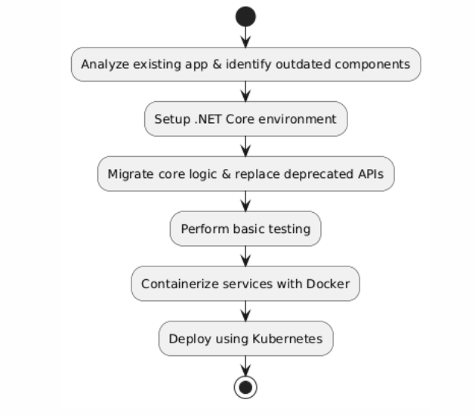
- Implimentation

A. Environment Setup
Development was carried out on a Windows 10 environment using Visual Studio and Visual Studio Code. Git was used for version control, with GitHub as the remote repository. Docker Desktop served as the local container runtime, and Kubernetes (Minikube or Docker Desktop Kubernetes) was used to simulate a production-like orchestration environment during testing.

B. Codebase Migration
The legacy .NET Framework solution was separated into logical layers: user interface, business logic, and data access. Each module was independently reviewed and migrated to .NET Core. Any outdated or incompatible libraries were replaced with .NET Core-compliant alternatives. The backend APIs were rebuilt using ASP.NET Core Web API, while configuration files were shifted from web.config to appsettings.json.

C. Dockerization
After successful migration, Dockerfiles were created for each module. These files defined the base images, dependencies, build steps, and entry points. Multi-stage builds were used to optimize image size. Docker Compose was used to manage multiple services during local testing and integration.

Example Dockerfile snippet for the API service: Dockerfile
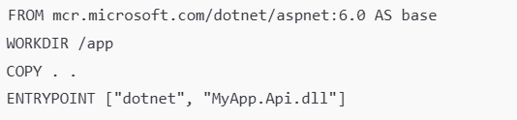

D. Kubernetes Deployment
The Docker images were pushed to a container registry and pulled by the Kubernetes cluster during deployment. Kubernetes YAML manifests were defined for:Deployments to manage container replicas.

- Services to expose pods internally and externally.
- ConfigMaps to manage application settings.
- Ingress Controllers for routing external HTTP traffic.

E. CI/CD Pipeline
A basic CI/CD pipeline was configured using GitHub Actions. On every push to the main branch:

- Code was built and tested.
- Docker images were created and tagged.
- Images were pushed to a Docker registry.
- Kubernetes manifests were applied to the cluster.

Acknowledgment
The author would like to express sincere gratitude to the internal guide, Dr. Pratiba D., Associate Professor, Department of Computer Science and Engineering, for her valuable guidance, feedback, and encouragement throughout the course of this project. Appreciation is also extended to my Manager Tirumale Raghavan, External Mentor, for his technical insights and continuous support during the development and implementation phases.
The author is grateful to the Department of Computer Science and Engineering, R.V. College of Engineering, Bengaluru, for providing the necessary infrastructure and resources. Finally, heartfelt thanks to peers, faculty members, and family for their constant motivation and support throughout the duration of this work.

References
[1] A. Balalaie, A. Heydarnoori, and P. Jamshidi, Microservices Architecture Enables DevOps: Migration to a Cloud-Native Architecture, IEEE Software, vol. 33, no. 3, pp. 42–52, May–June 2016.
[2] F. Rademacher, J. Sorgalla, and S. Sachweh, Challenges of Domain-Driven Microservice Design: A Model-Driven Perspective, IEEE Software, vol. 35, no. 3, pp. 36–43, May–June 2018.
[3] D. Merkel, Docker: Lightweight Linux Containers for Consistent Development and Deployment, Linux Journal, no. 239, pp. 2–11, Mar. 2014.
[4] B. Burns, B. Grant, D. Oppenheimer, E. Brewer, and J. Wilkes, Borg, Omega, and Kubernetes: Lessons Learned from Three Container-Management Systems over a Decade, ACM Queue, vol. 14, no. 1, pp. 70–93, Jan. 2016.
[5] R. Buyya, J. Broberg, and A. M. Goscinski, Cloud Computing: Principles and Paradigms, 1st ed. Hoboken, NJ, USA: Wiley, 2011, pp. 1–36.
[6] G. Adzic and R. Chatley, Serverless Computing: Economic and Architectural Impact, in Proc. 11th Joint Meeting on Foundations of Software Engineering, Paderborn, Germany, Sept. 2017, pp. 884–889.
[7] M. Richards, Fundamentals of Event-Driven Architecture, Sebastopol, CA, USA: O’Reilly Media, 2020, pp. 1–28.
[8] A. Balalaie, A. Heydarnoori, and P. Jamshidi, Microservices Architecture Enables DevOps: Migration to a Cloud-Native Architecture, IEEE Software, vol. 33, no. 3, pp. 42–52, May–June 2016.
[9] F. Rademacher, J. Sorgalla, and S. Sachweh, Challenges of Domain-Driven Microservice Design: A Model-Driven Perspective, IEEE Software, vol. 35, no. 3, pp. 36–43, May–June 2018.
[10] D. Merkel, Docker: Lightweight Linux Containers for Consistent Development and Deployment, Linux Journal, no. 239, pp. 2–11, Mar. 2014.
[11] B. Burns, B. Grant, D. Oppenheimer, E. Brewer, and J. Wilkes, Borg, Omega, and Kubernetes: Lessons Learned from Three Container-Management Systems over a Decade, ACM Queue, vol. 14, no. 1, pp. 70–93, Jan. 2016.
[12] R. Buyya, J. Broberg, and A. M. Goscinski, Cloud Computing: Principles and Paradigms, 1st ed. Hoboken, NJ, USA: Wiley, 2011, pp. 1–36.
[13] G. Adzic and R. Chatley, Serverless Computing: Economic and Architectural Impact, in Proc. 11th Joint Meeting on Foundations of Software Engineering, Paderborn, Germany, Sept. 2017, pp. 884–889.
[14] M. Richards, Fundamentals of Event-Driven Architecture, Sebastopol, CA, USA: O’Reilly Media, 2020, pp. 1–28.
[15] S. M. Metev and V. P. Veiko, Laser Assisted Microtechnology, 2nd ed., R. M. Osgood, Jr., Ed. Berlin, Germany: Springer-Verlag, 1998.

