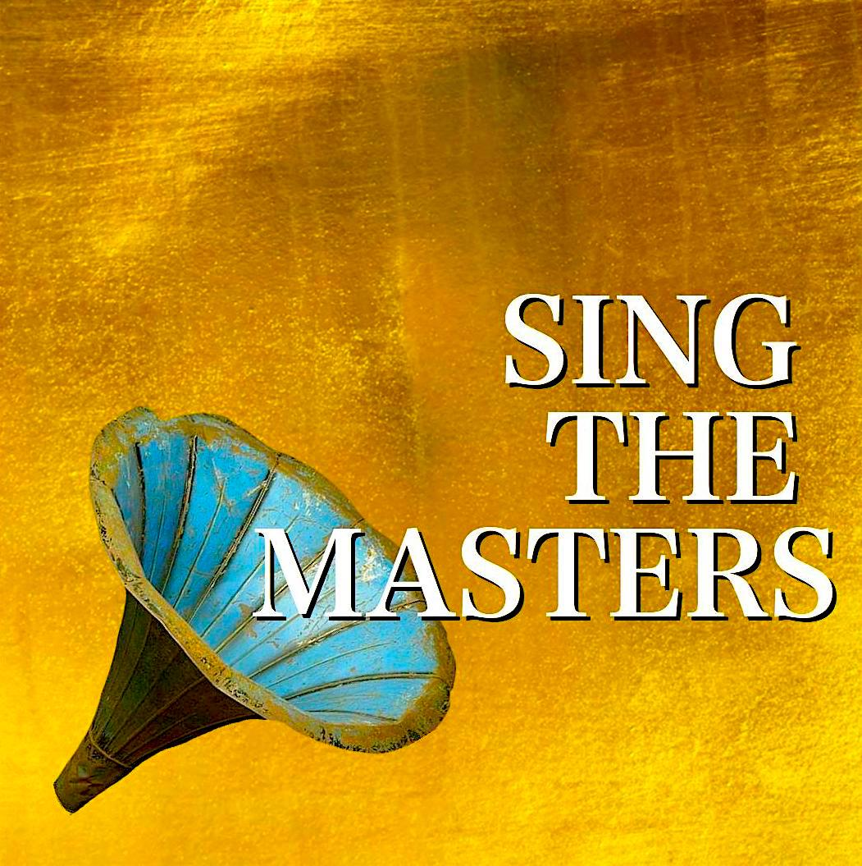
APPLY FOR OPERA CLASSICA EUROPA’S
“CALLAS” GRAND DEBUT PRIZE

SING IN ALTE OPER FRANKFURT

TELL US YOUR PERSONAL DETAILS (By filling out this form and emailing it to Opera Classica Europa, you automatically give consent for your personal data to be processed.)

NAME

ADDRESS

CITY | COUNTRY | POST CODE
EMAIL | HOME PHONE | MOBILE PHONE

TELL US WHAT VOICE YOU ARE

VOICE TYPE

PLEASE ADD TWO YOUTUBE LINKS OF ARIAS BY WAGNER:

LINK 1 | LINK 2

PLEASE EMAIL THIS FORM TO:

ocepp@outlook.com

PLEASE ATTACH A SHORT BIOG NOT LONGER THAN 400 WORDS TO THIS EMAIL.

IF YOU ARE STILL IN COLLEGE, PLEASE ATTACH 1 REFERENCE TO THIS EMAIL.

IF YOU DO NOT RECEIVE A CONFIRMATION EMAIL OF RECEIPT WITHIN 10 DAYS, PLEASE CONTACT US BY TEXT ONLY ON +306993665448.

THANK YOU AND GOOD LUCK!

